* 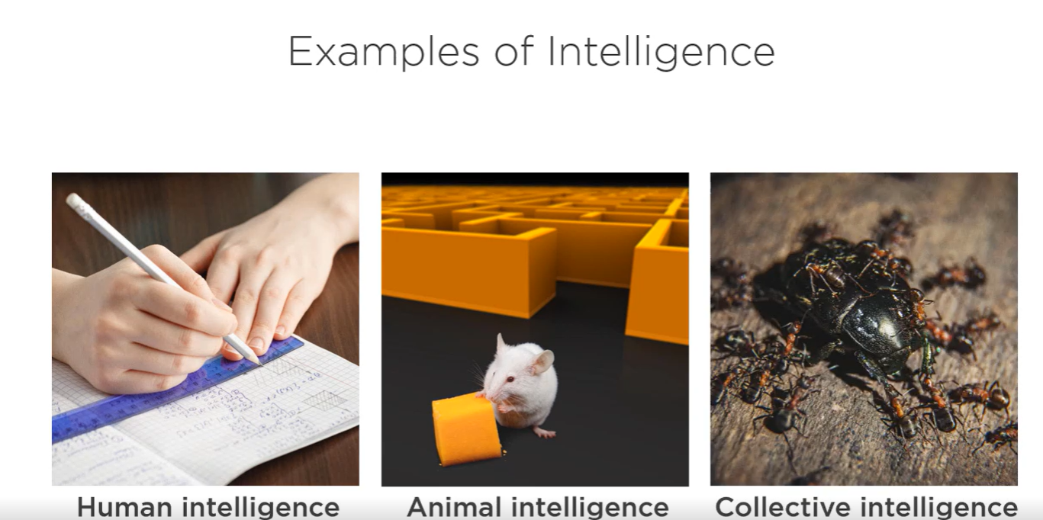
  + In all the above 3, Human being wanted to pass the exam , Mouse wanted to eat cheese and ant army wanted to eat the bug.
  + All these above 3 have below things in common i.e.. an agent.
* 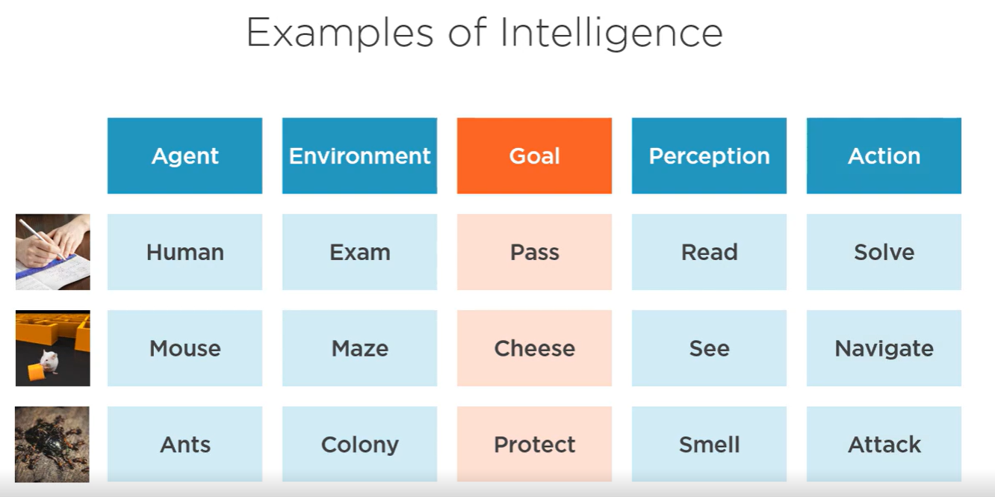
* **Intelligence 🡪** The ability of the agent to perceive an environment and to choose actions that increases the chances of achieving the goal.
  + **Natural Intelligence 🡪** This is acquired naturally by humans, animals by birth or over their lives.
  + **Artificial Intelligence 🡪** This is created by humans, it is ability of machines to replicate human intelligence. It is the ability of the agent to perceive the environment to choose actions that have higher changes of achieving the goal.
* **Types of AI 🡪** 
  + **Artificial Narrow Intelligence 🡪** This type of intelligence narrowly delivers a task like ChatGPT answering a question, Amazon Alexa responding to basic voice commands etc.,
  + **Artificial General Intelligence 🡪** This type of intelligence can solve wide variety of problems. General AI is present mostly in sentient robots like in films etc., Many argue that some LLMs from OpenAI, Anthropic and Google are beginning to exhibit generalized intelligence.
  + **Artificial Super Intelligence 🡪** This is futuristic AI that is far superior than human intelligence. Once we completely achieve General Intelligence achieving Super Intelligence becomes quite easy. This is because general intelligence will recursively self improve itself and is not subject to limitations of biological brain.
* **Components of AI 🡪**

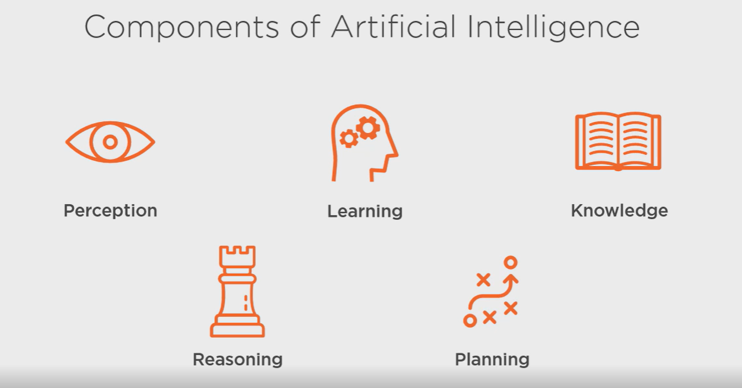

* + **Perception 🡪** It is the ability of the agent to understand the state of environment. It does this by getting information from sensory data like cameras, microphones, radars etc., It takes this data and observes for patterns in this data. Based on that it will detect features of the environment like walls, objects, people etc., The aspects of these features like size, position and velocity make up the current state of the environment.
  + **Learning 🡪** It is the ability to extract knowledge from the stream of data. It takes data as input and produces a decision, prediction or an action as output.
  + **Knowledge 🡪** It is the ability of the agent to collect the information it has learned and represent this knowledge in the form of statistical model, knowledge graphs etc.,
  + **Reasoning 🡪** It is the ability of the agent to infer conclusions from available knowledge. Reasoning agents employ techniques like deduction to reach a specific conclusion from available knowledge or uses induction which generalizes from a set of observations to a more general rule. It is how an agent solves the problem without having to resort to trial and error for every new situation.
  + **Planning 🡪** It is the ability of the agent to plan, set and achieve a goal. It can set some sub goals to achieve the primary goal. It also involves an agent being able to visualize future states of an environment. The agent must be able to predict on how a series of actions can change the state of the environment and laid it either closer to or further away from its goal.

**Machine Learning 🡪** It’s a type of AI that allows machines to learn on how to make predictions given a full set of data. We make a machines learn from the set of data it has been given to it without being explicitly programmed to do so. The machines are able to do this by identifying statistical patterns in the data. We use existing data and training algorithm to feed the data. Next we will use new set of data and will ask to make predictions on the new data. For example: Imagine we have a conveyor belt of fruit of different sizes. We need to separate the apples from the bananas as they go by. However, we only have sensor readings of each fruit's length and height. How would we build a model to predict which fruit is an apple and which fruit is a banana? First, we would need to create a table of data called a training set. This dataset contains the lengths and heights of a bunch of randomly selected apples and bananas. When recording these data, a human would label each type of fruit in each row as either an apple or banana based on visual inspection. Next, we would feed these data into a machine learning training algorithm. The algorithm would inspect each row of data containing the length, height, and type of fruit. The algorithm would learn how length and height correlate with each type of fruit. Apples are more round, and bananas are more elongated. The machine learning training algorithm captures the statistical relationship as a mathematical model. Finally, if we've done everything correctly, we can use this data to make predictions. We can feed this model a new apple or banana that it's never seen before, and the model will tell us whether the new fruit is an apple or a banana. More precisely, it will tell us a statistical likelihood that the new fruit is either an apple or a banana.

Classification 🡪 is where we make a decision or prediction involving two or more categories or outcomes.

Regression 🡪 is where attempt to predict a numeric outcome based on one or more input variables.

Clustering 🡪 is grouping of objects based on similarities in their data.

Anomaly Detection 🡪 It is the feature to detect something unusual from the normal data.

Deep Learning 🡪 A type of machine learning that maps complex inputs to complex outputs. It stacks multiple machine learning models on top of each other. We typically create a deep learning models using a neural network.

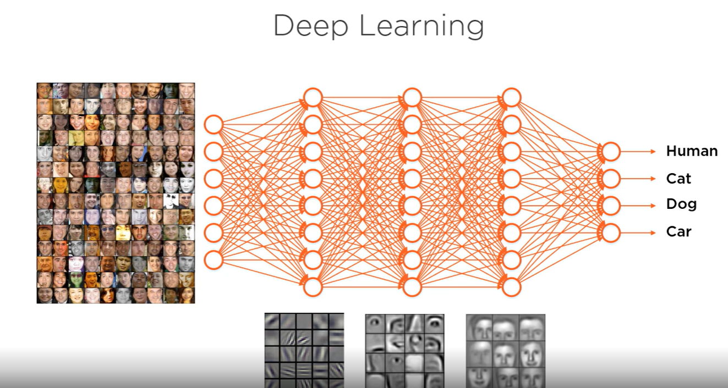

A neural network is a graph of nodes and edges that connect with each other. Each node represents a neuron in the organic brain and edges represent the connections between these neurons. First we feed data to the neural network using its input neurons. Next mathematical operations are performed on each of these neurons with each neuron forwarding it’s resulting value to other neurons its connected to. We repeat this process for all the hidden layers in the neural network. Finally the network produces a prediction based from its output neurons.

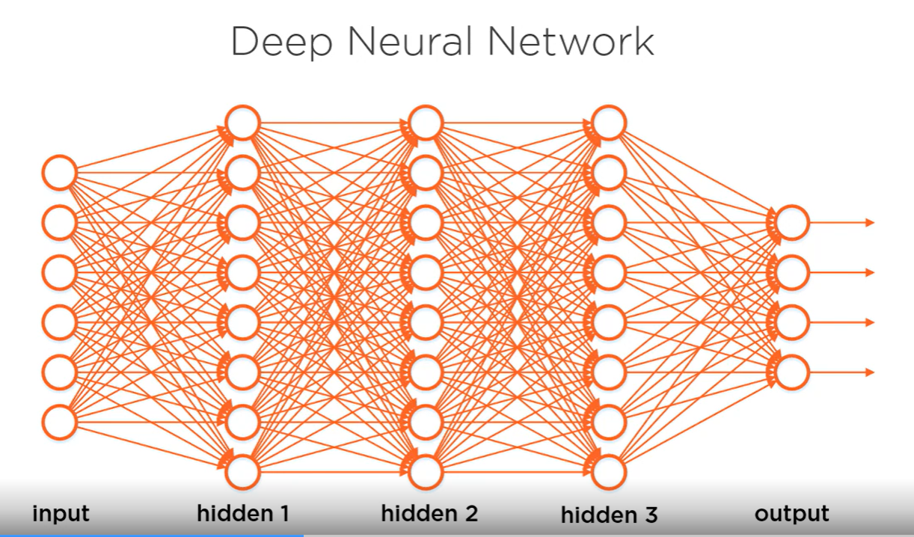

Reinforcement Learning 🡪 A type of machine learning that tries to solves the problem with a trail and error. 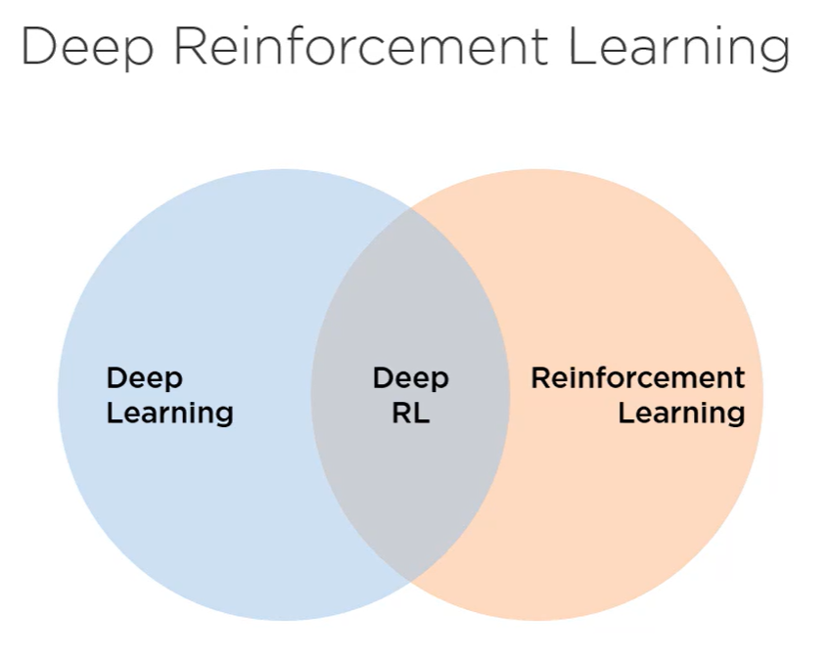

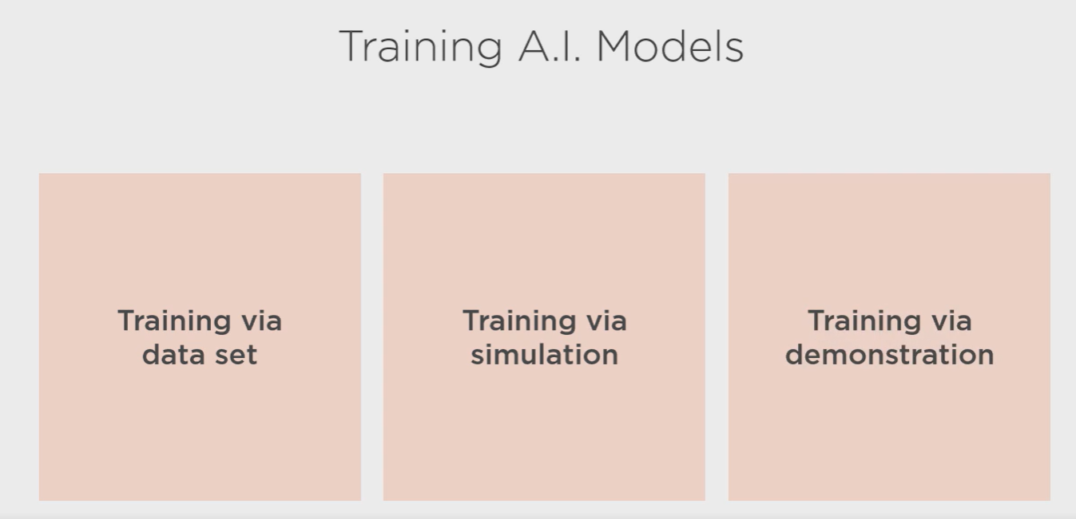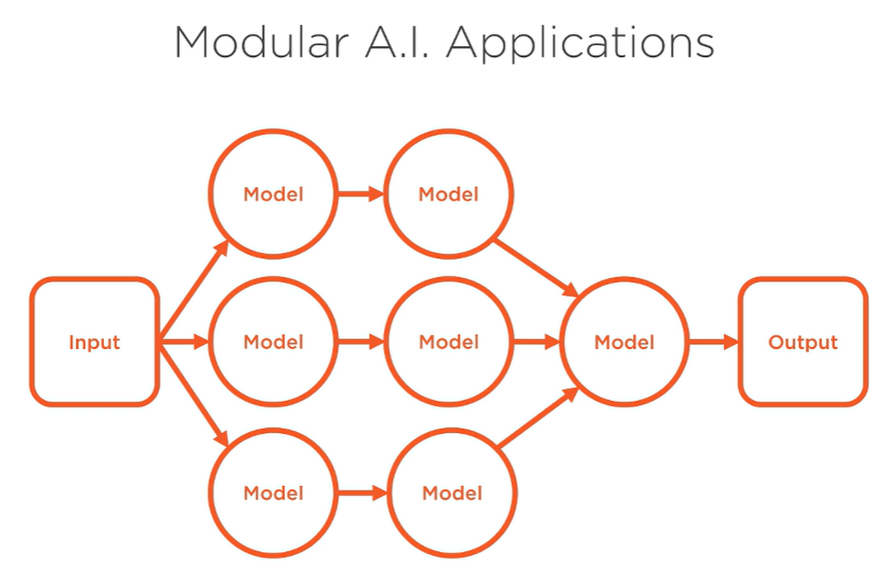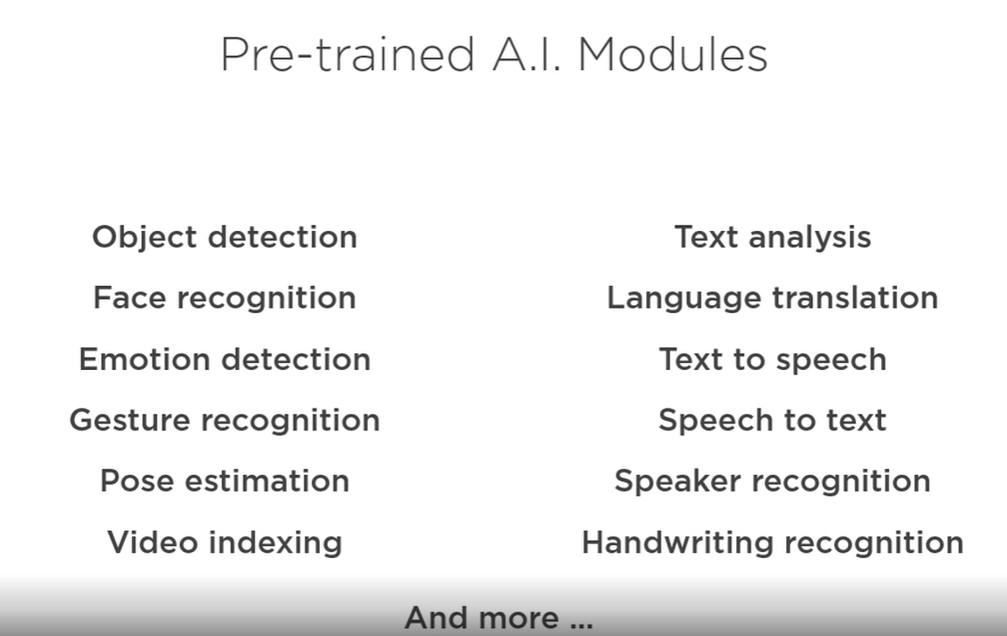

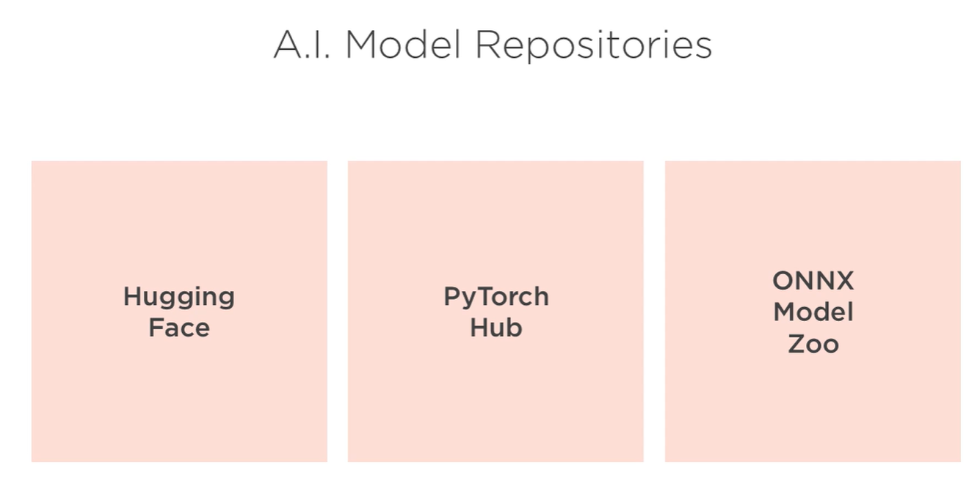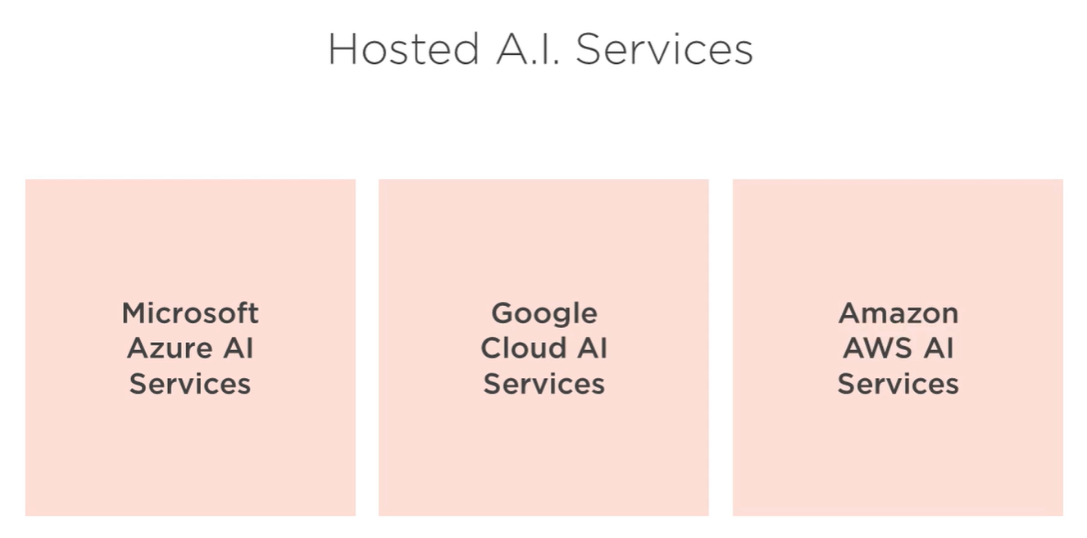

 For non‑developers, there are low code and no‑code tools like n8n, Power Automate, and Copilot Studio. These tools allow you to build composable AI systems without having to write any code. You simply drag the pre‑trained models onto the canvas, wire them together, test, and deploy your app or you just tell an AI agent what you need and it creates a workflow, selects the models, wires everything together, and tests the results.

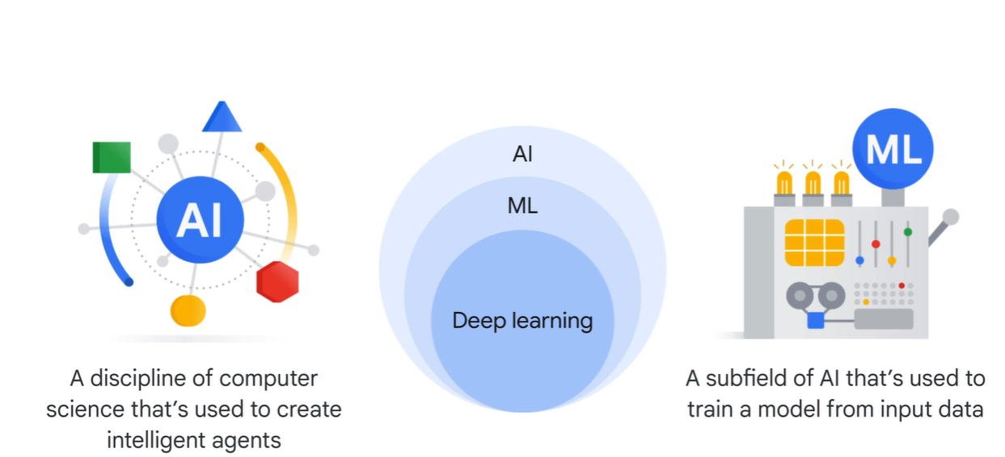

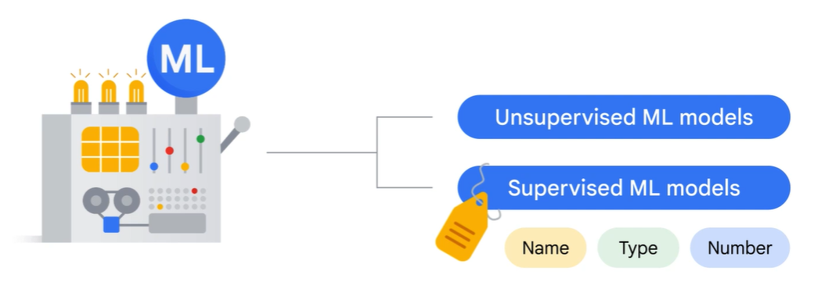

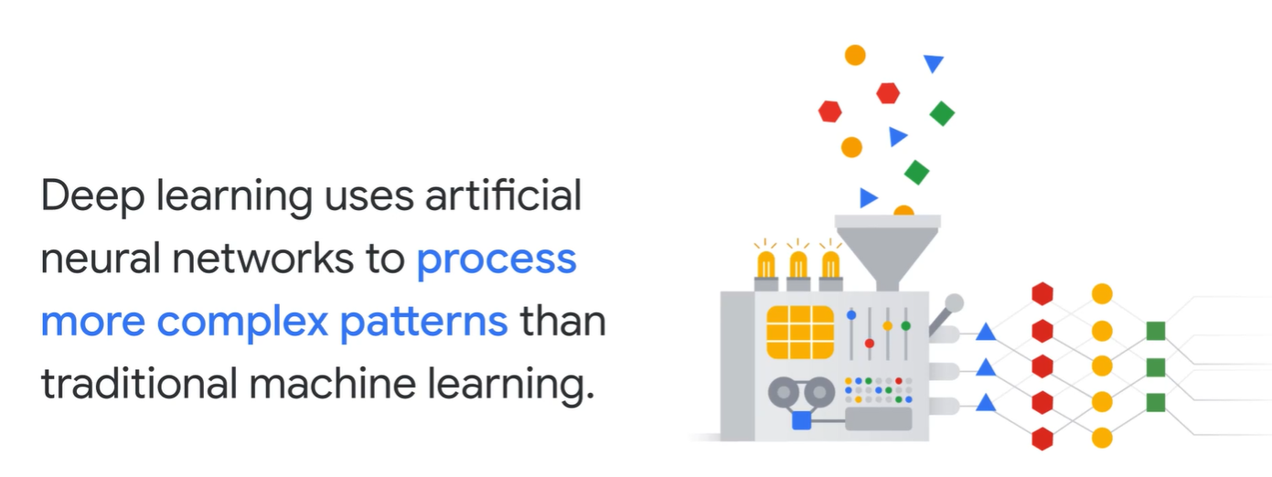

A supervised model learns from past examples to predict future values. Unsupervised models can aim for discovery and identify patterns in raw data. Deep learning uses artificial neural networks to process more complex patterns than traditional machine learning.

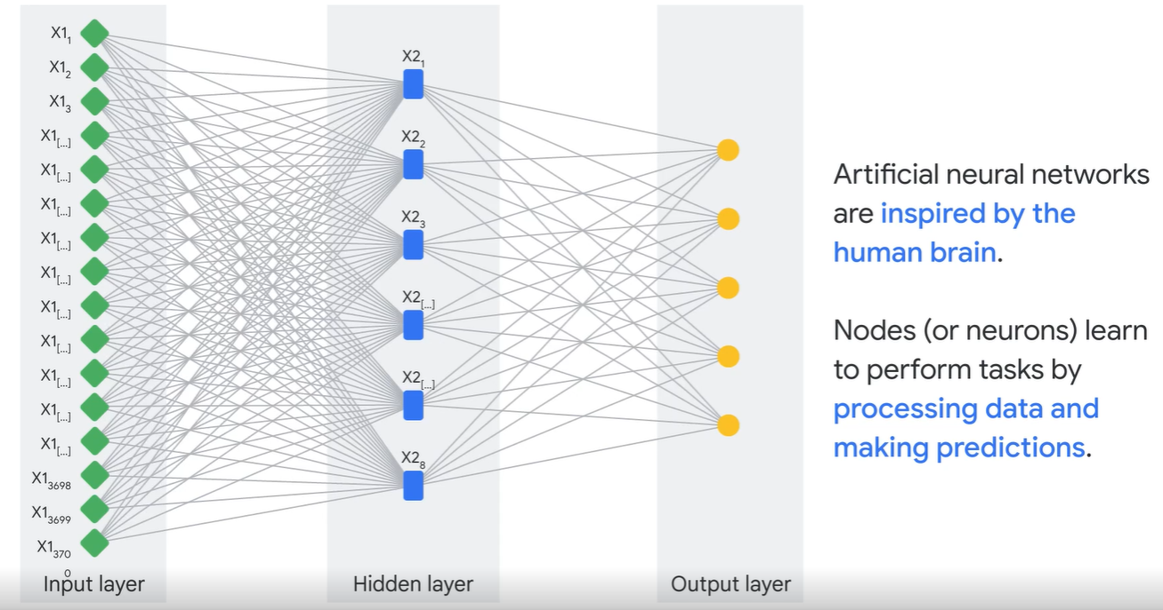

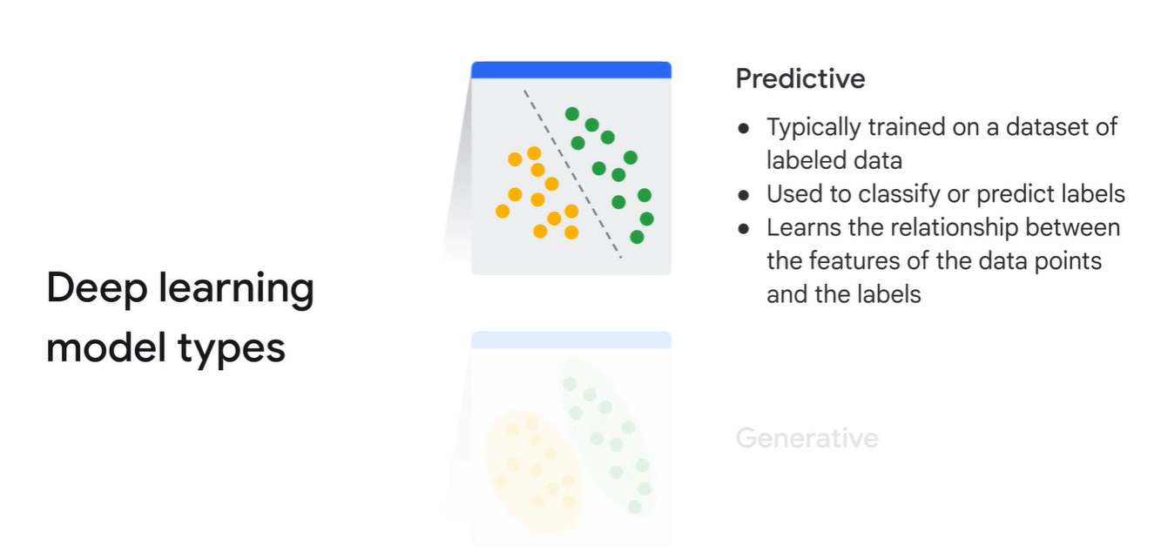

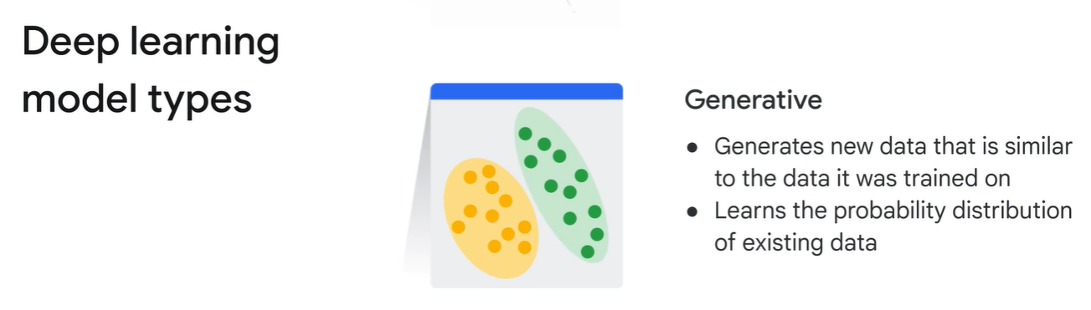

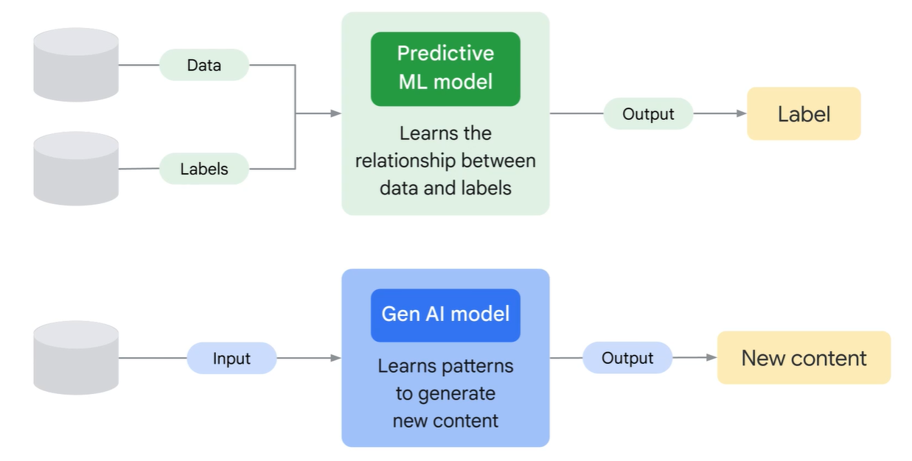

Gen AI is a subset of Deep learning model that uses label, unlabeled data using supervised, unsupervised, semi-supervised methods.

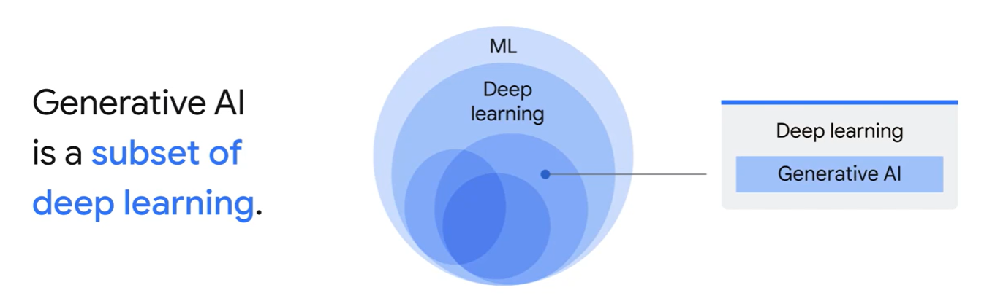

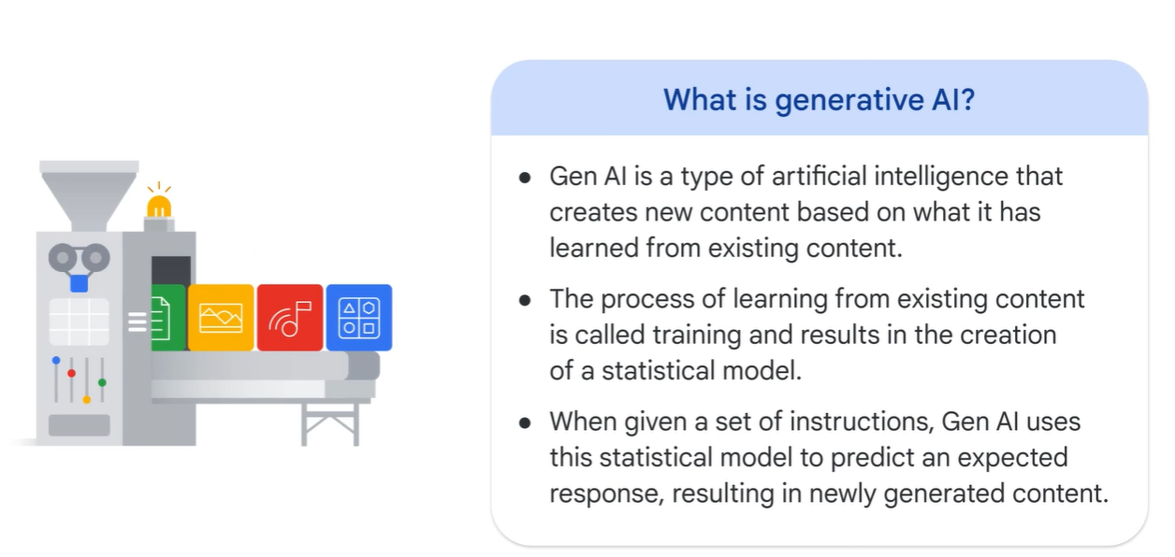

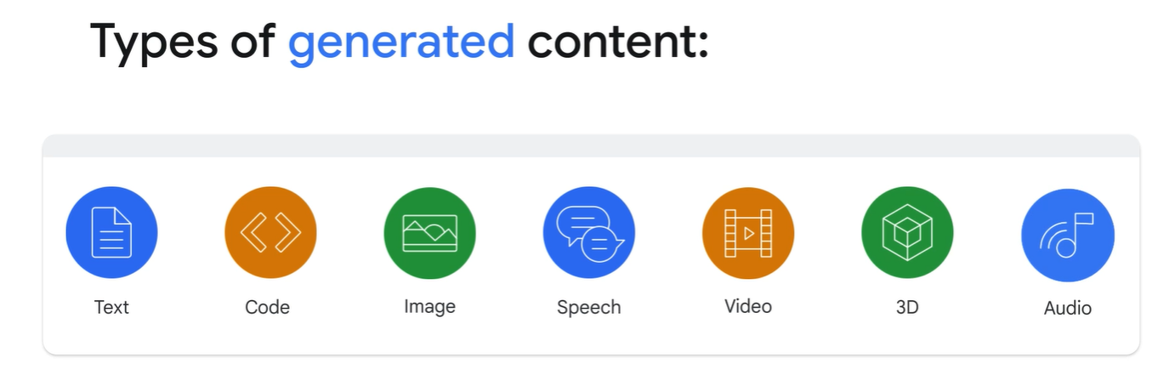

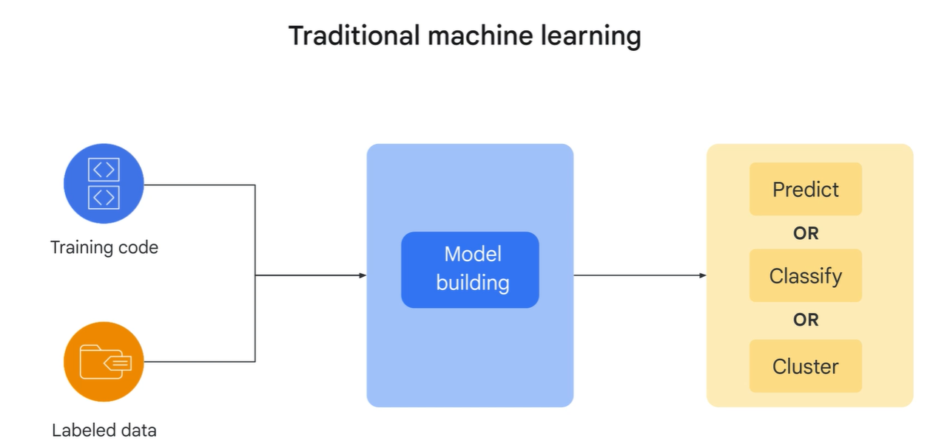

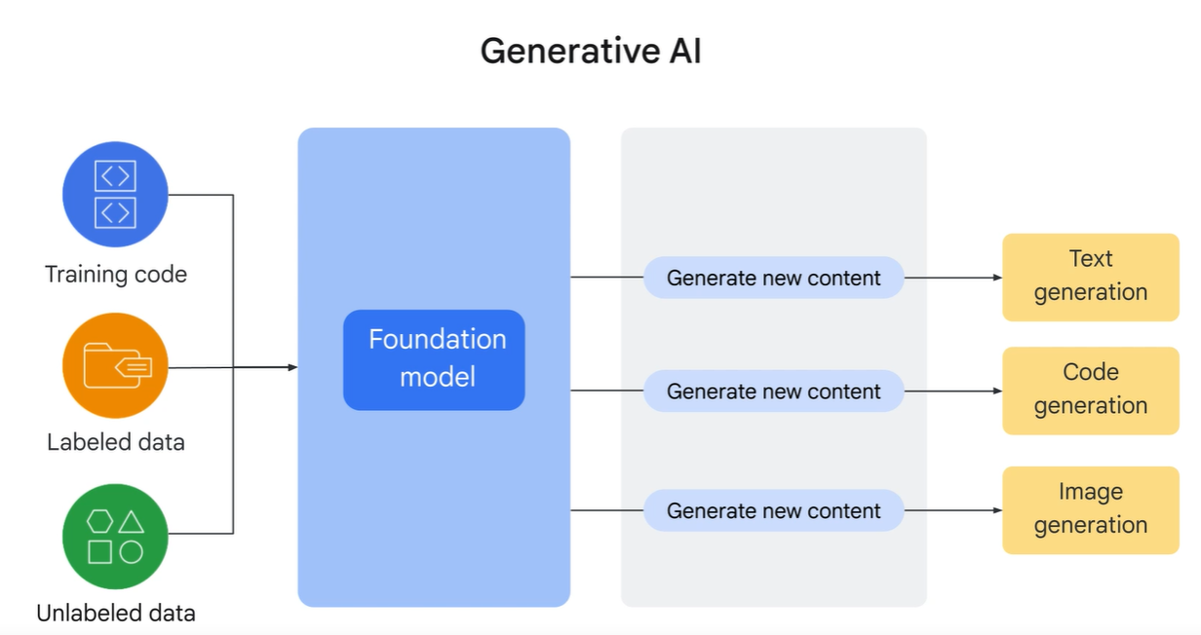

There are several types of Gen AI models:

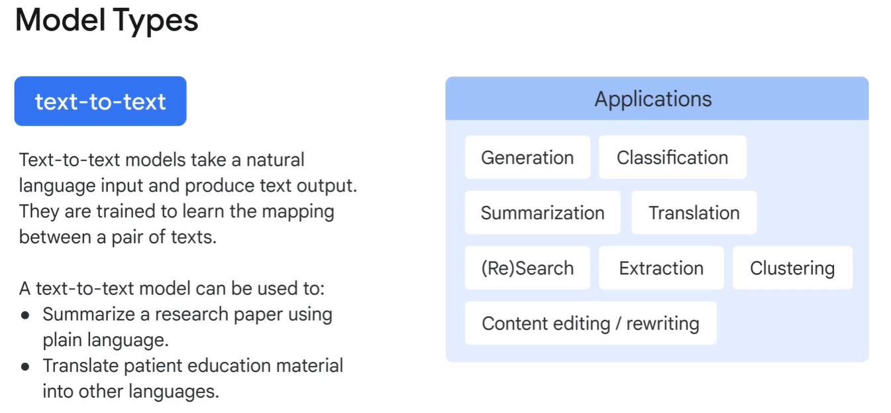

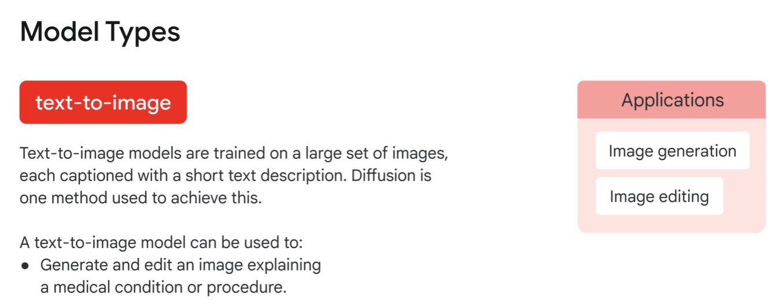

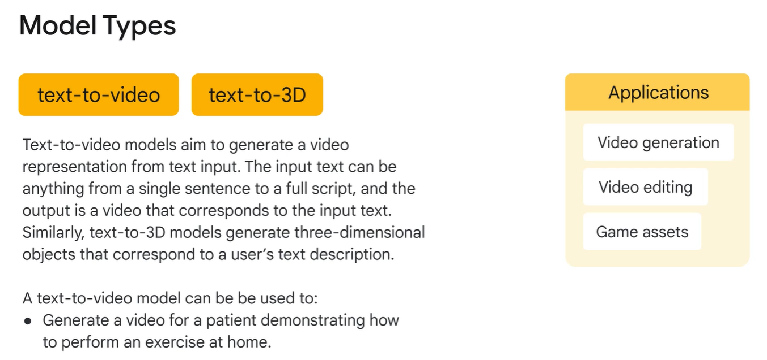

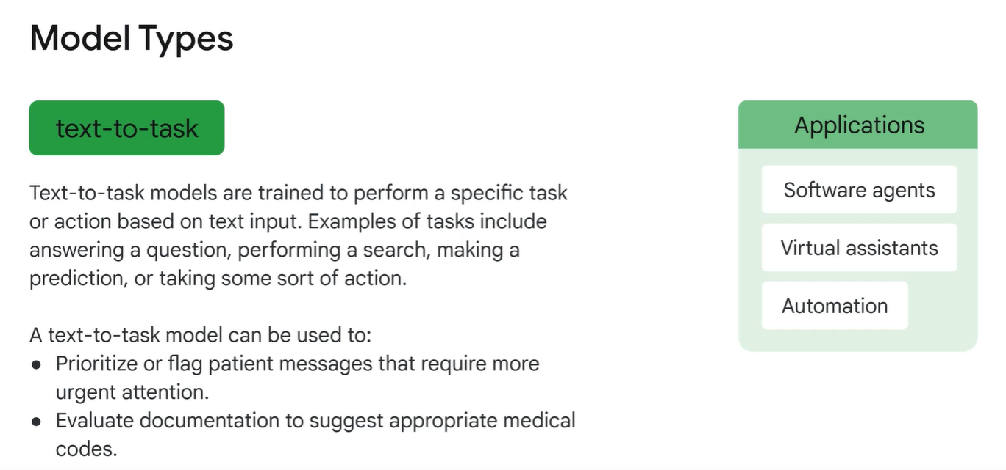

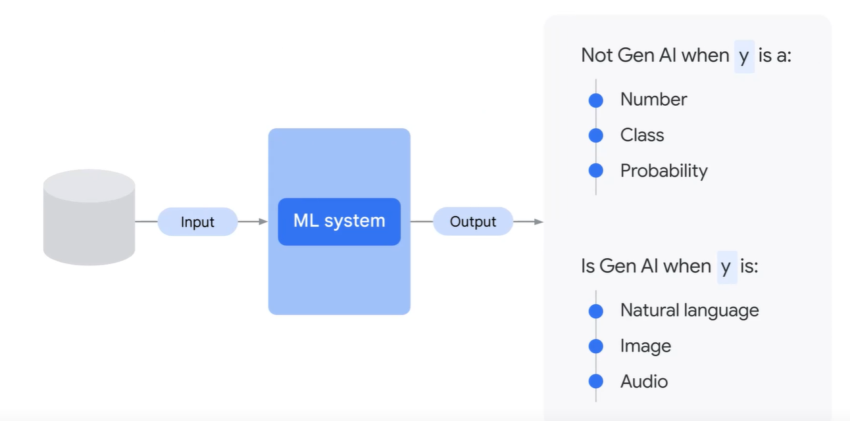

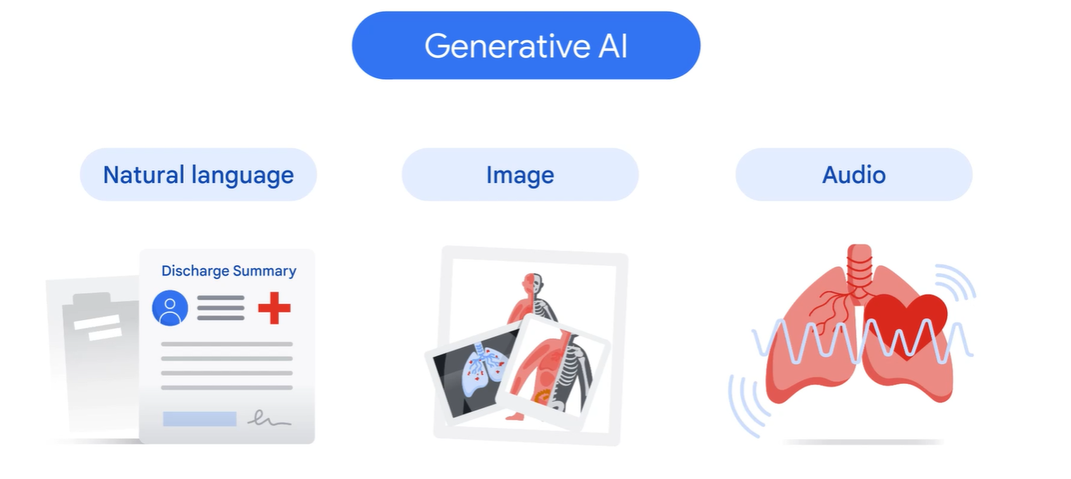

**Large Language Models (LLMs)**

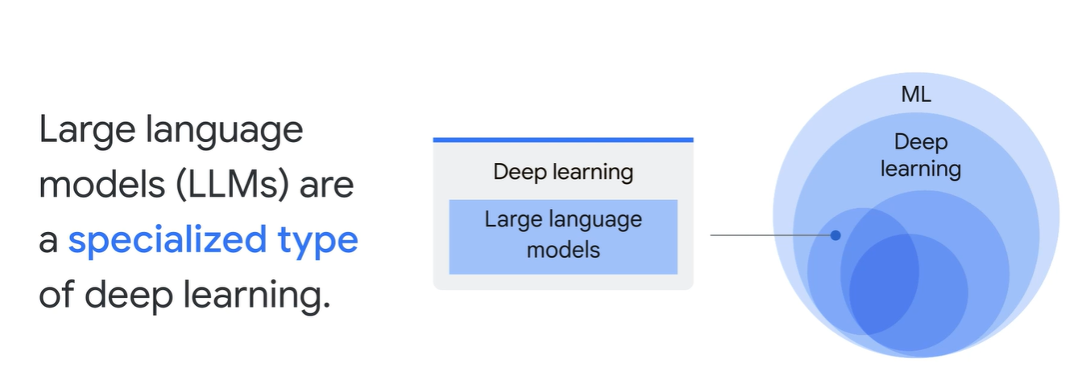

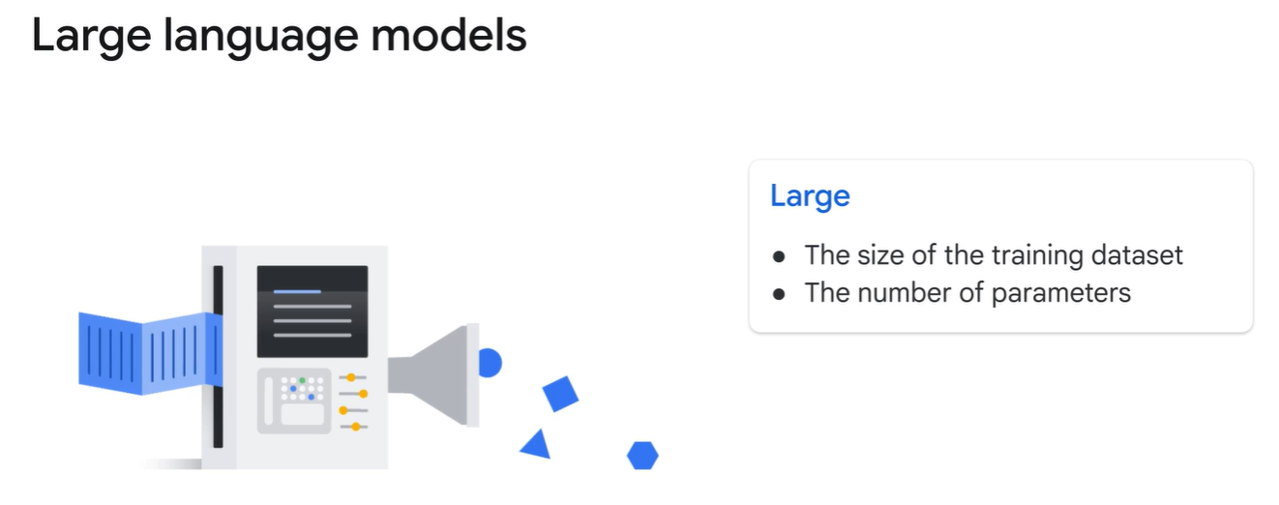

Let’s suppose we want to train a dog like sit, come, down, stay etc., these are basic commands that makes the dog a good dog. This is pre-training. Pre-training is just like giving a LLM general education with a typical large dataset.

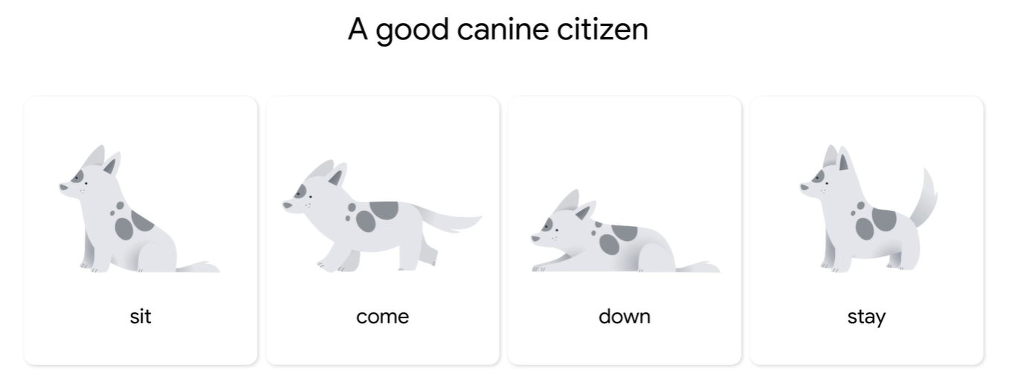

Now if we want to fine tune and specially train the dog for specific purpose like police dog, guide dog etc., it needs special training for a pre-trained dog.

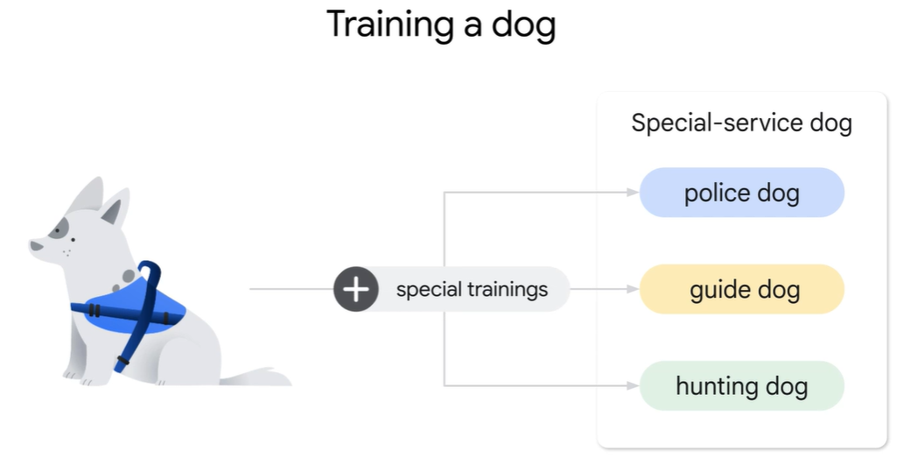

Fine tuning is making a pretrained dog adapt to a specific task. Gen AI relies on LLMs to generate text, audio, video , images, synthetic data to solve specific problems. These LLMs can be trained with field-specific datasets to solve challenges optimizing medication management for patients with complex chronic conditions. This creates a new model that is suitable for our needs.

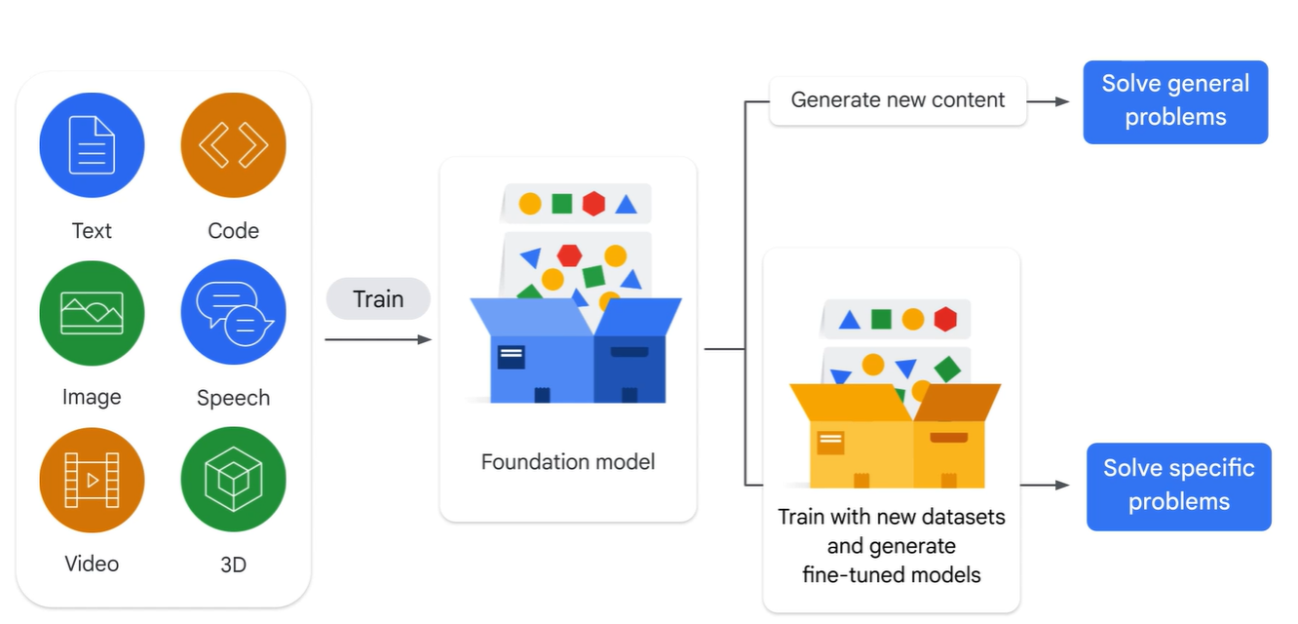

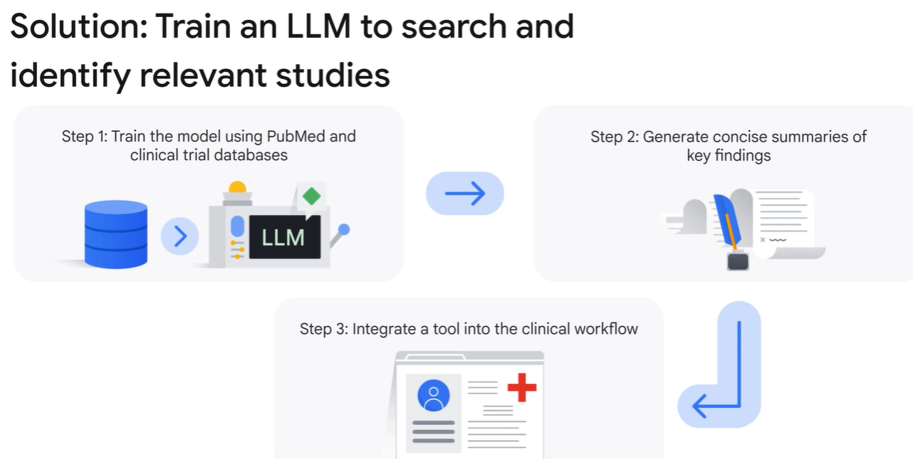

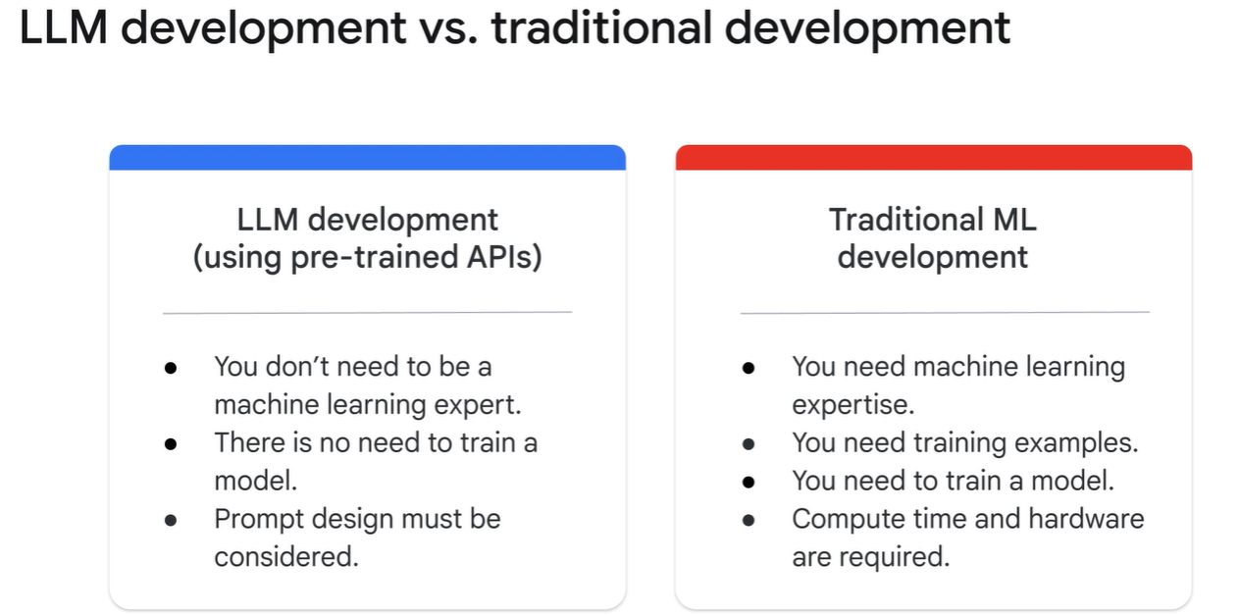

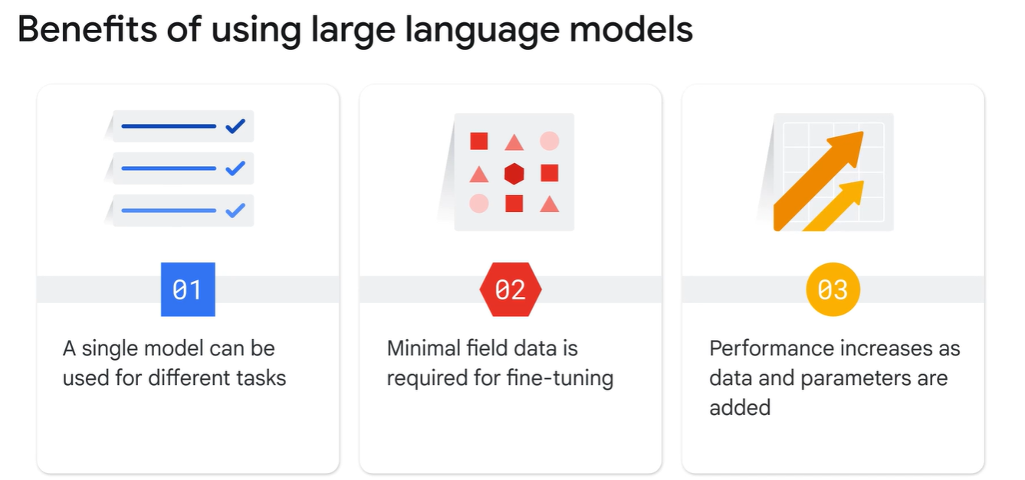

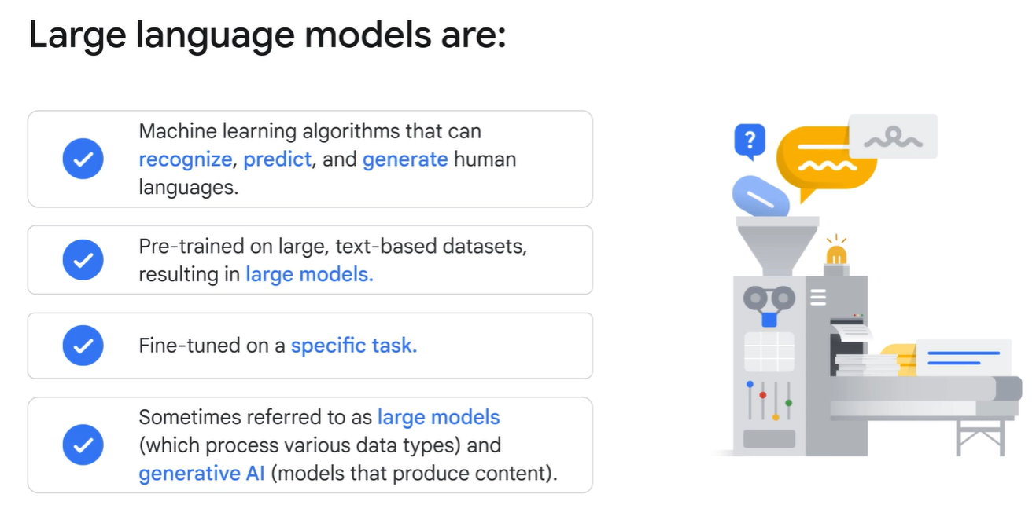

**Prompts 🡪** 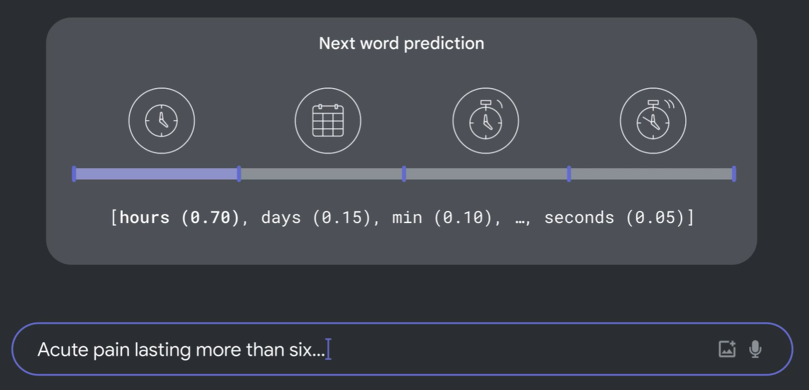

The probability of word ‘hours’ being input is more than ‘days’ and ‘seconds’. How does the model know how to do this? Well, the sequence of words entered so far provide context and the model will predict what comes next. In addition to next word prediction, large language models can also generate text based on your instructions.

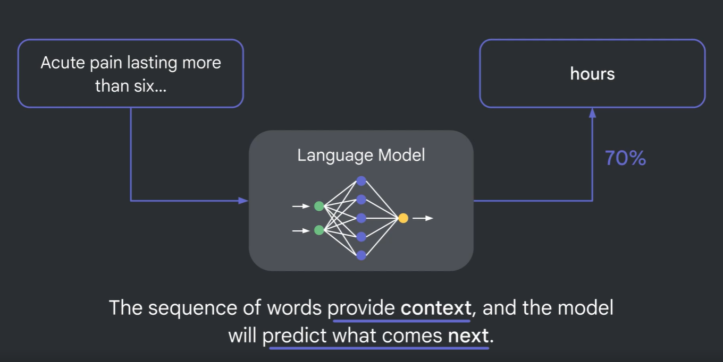

**Multi-personal LLM 🡪** To implement a multi-personal LLM we first need to train the model with comprehensive datasets from various sources and then fine tuning.

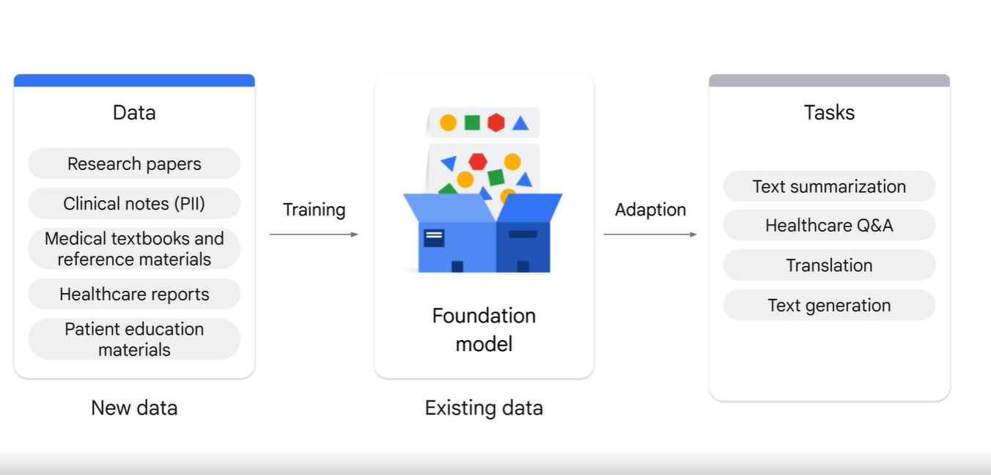

**Prompt Design 🡪** The quality of input prompt determines the quality of response.

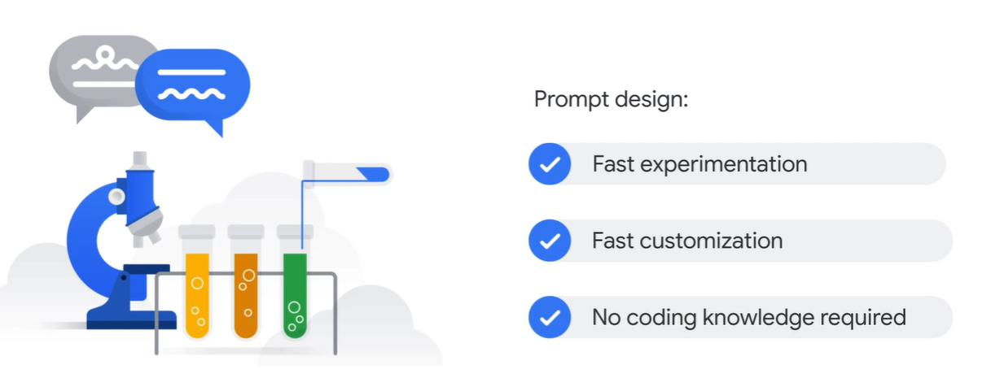

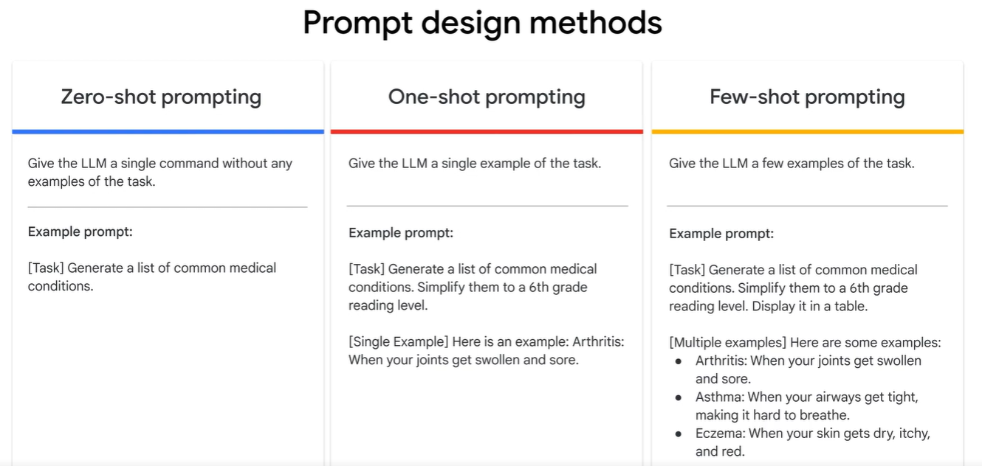

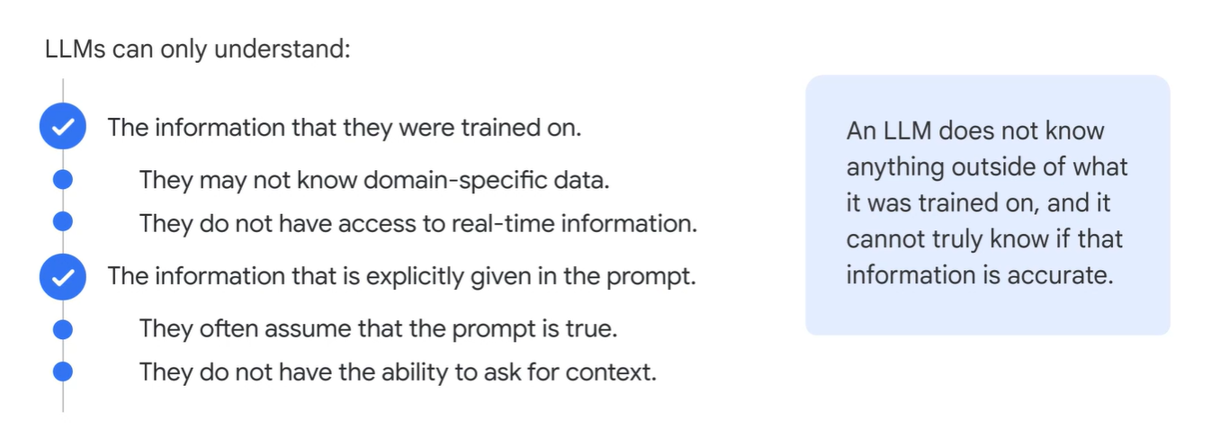

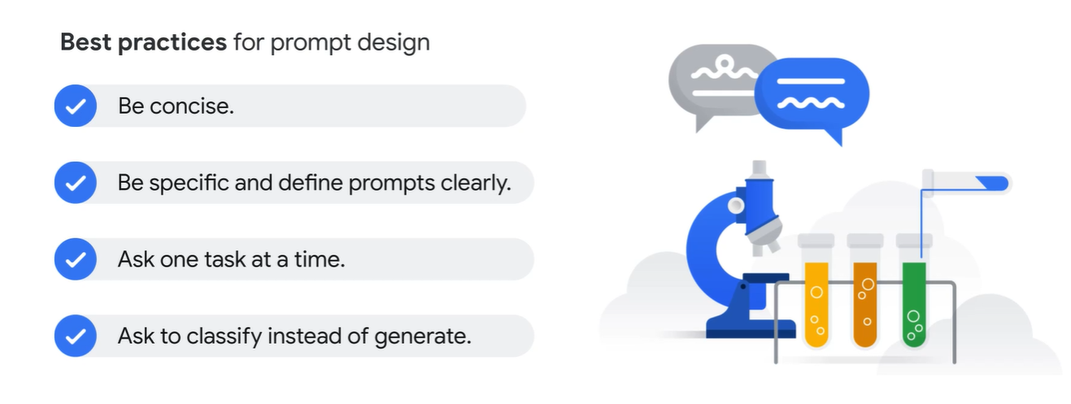

**Concepts of Machine Learning**

A Machine Learning algorithm should be able to learn from the data. The output of the algorithm changes based on the data it has been trained. We will feed about millions of records of data to the algorithm then this algorithm needs to find some interesting patterns in this data. Once these patterns are found we want this algorithm to make some intelligent decisions based on the patterns it has found.

Classification 🡪 It is a ML technique which involves identifying which category or categories a particular observation belongs to.

There are the two phases of a machine learning model. The first is the training phase, where you feed in a large corpus of data having the right classifications or categorization. The training phase is where the model extracts insights or finds patterns in the data. Once you have a trained model, then comes the prediction phase. This is where your model can be used to classify new instances or make predictions on new instances which it hasn't encountered before.

If the decision variables are many in number and they are sensitive to the data that you feed in and need to change as new information is received, that's a case for ML. ML models will not work unless we have huge amount of data being trained to them.

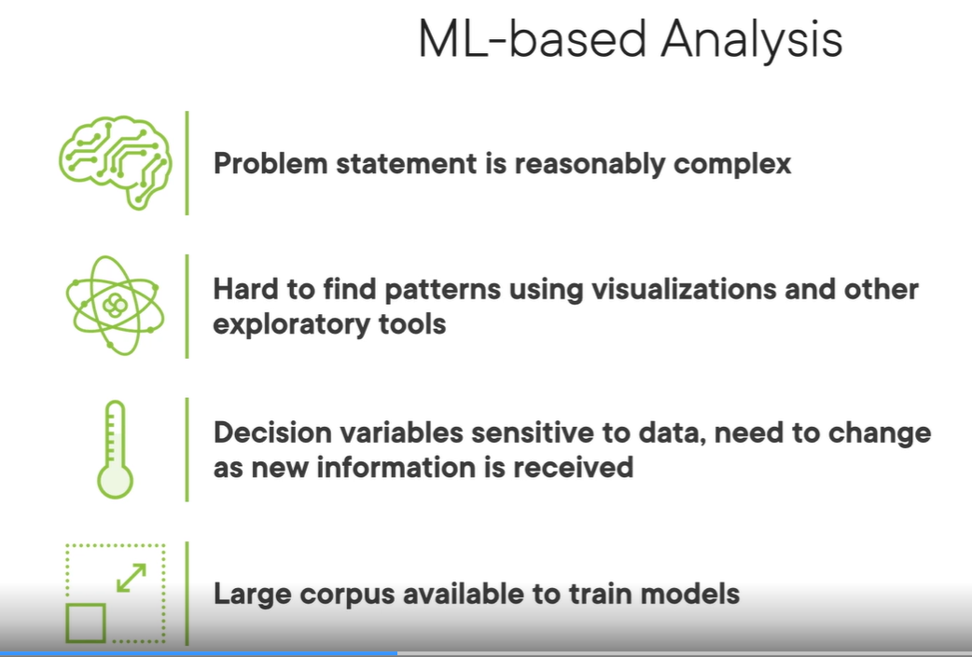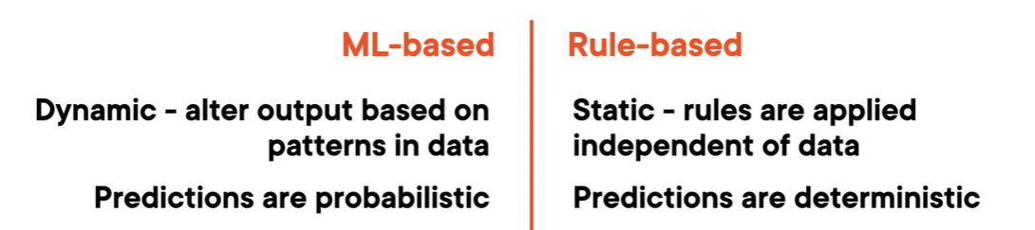

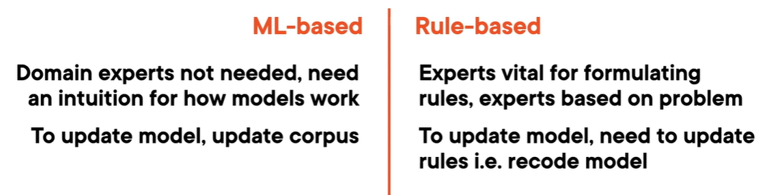 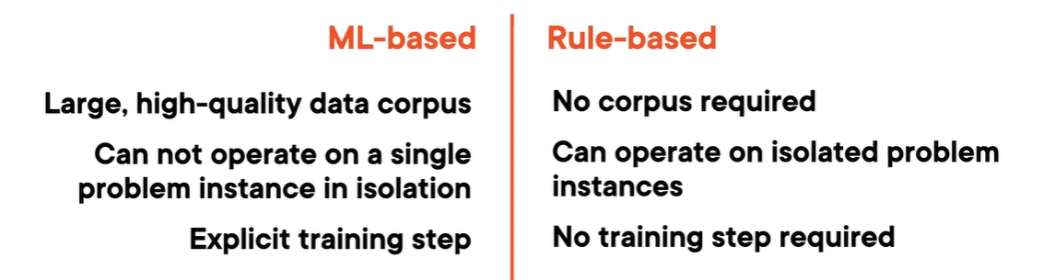

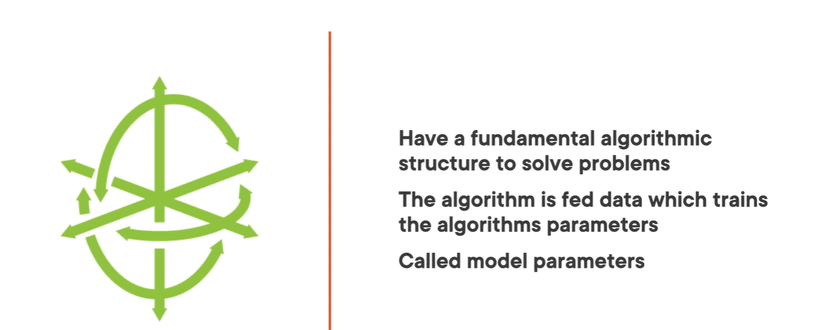 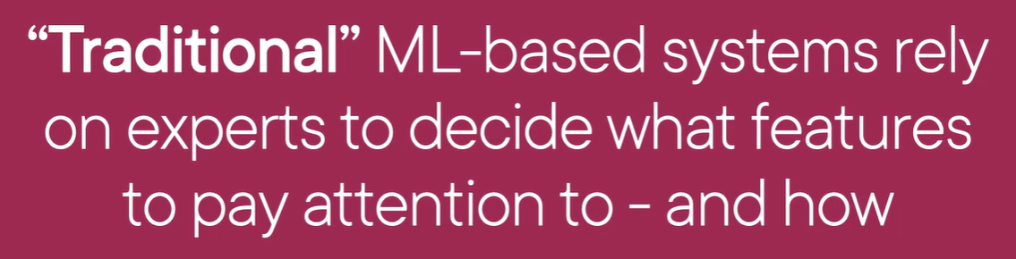

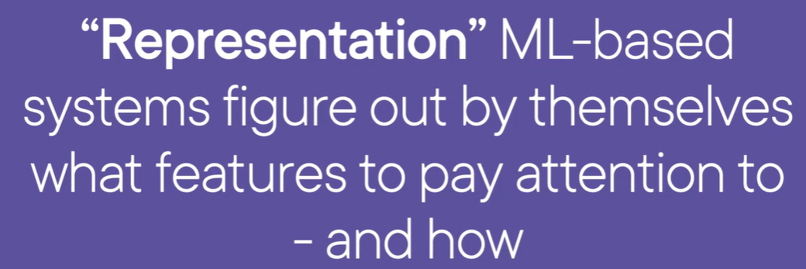

Neural Networks 🡪 Neural networks belong to a category of algorithms that we refer to as deep learning. These are representation ML‑based systems. These are algorithms that learn what features matter. They're able to extract significant or latent features in the data. They can comprise of many layers that add depth to the model. The basic building blocks that make up the neural networks are **neurons**.

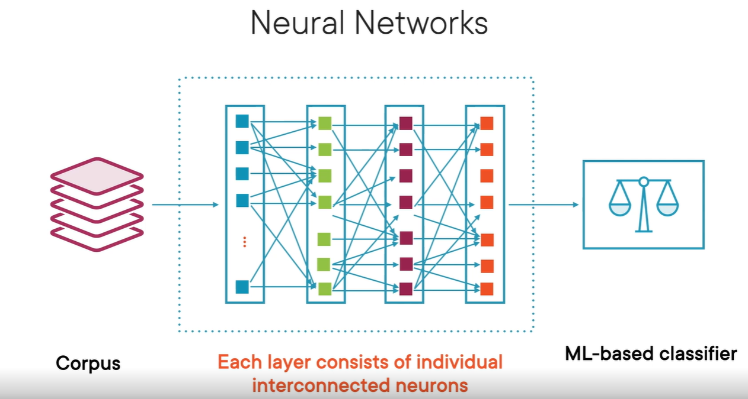 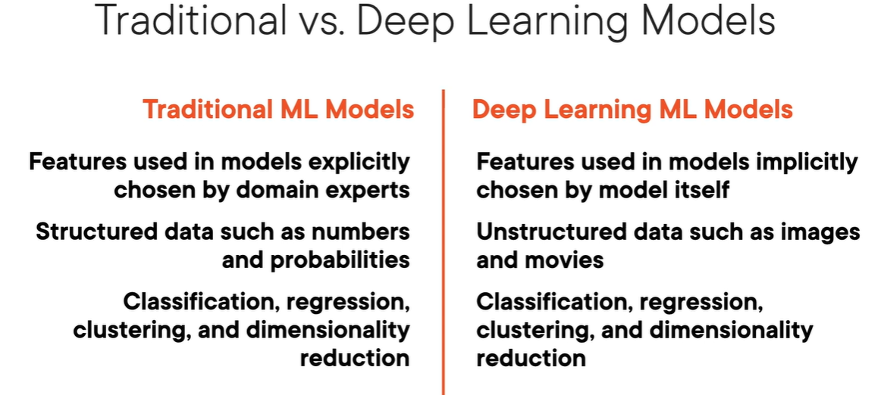

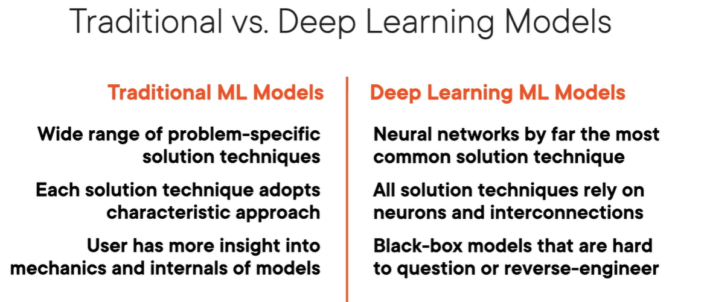

ML algorithms can be divided into 4 types 🡪 Classification, Regression, Clustering & Dimensionality reduction.

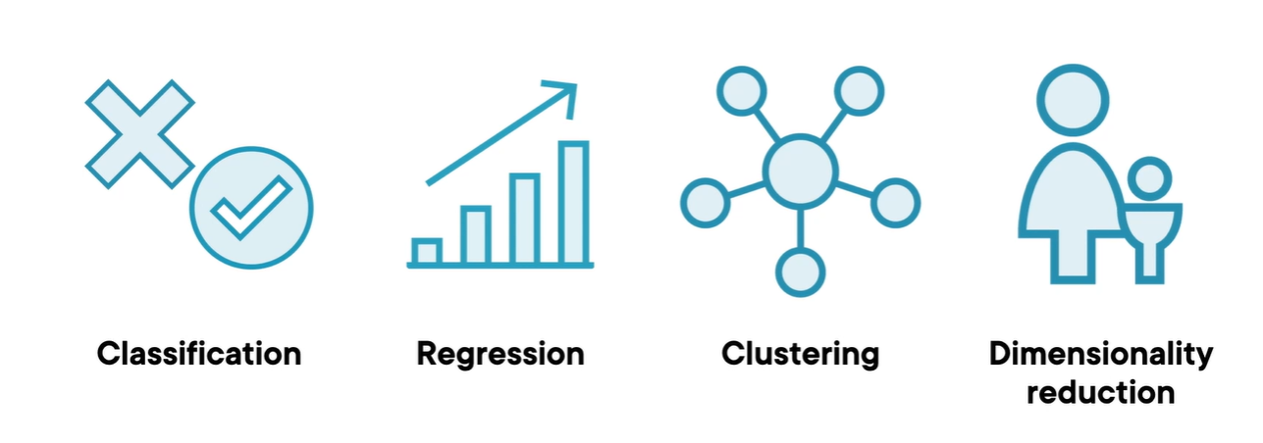

Classification 🡪 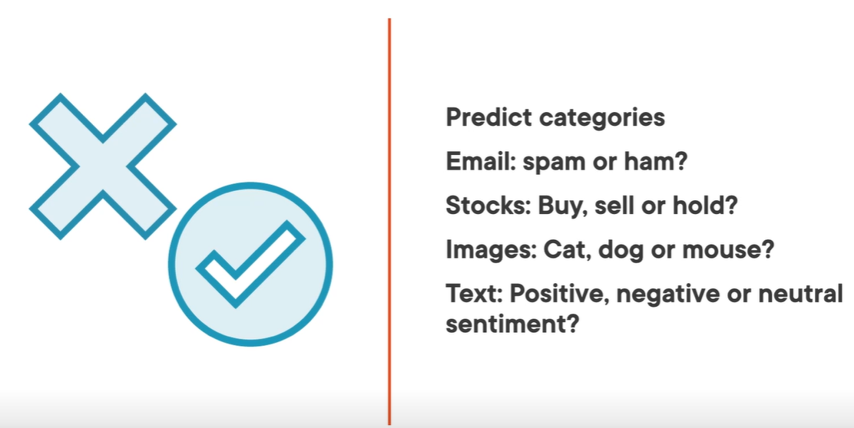 Regression 🡪 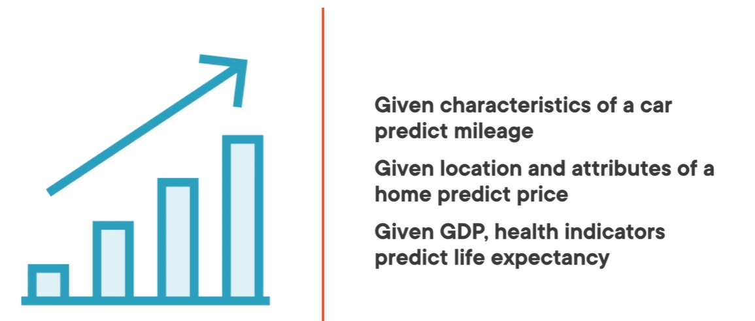

Clustering 🡪 It is used to identify patterns and logical grouping in the data. Let’s say in social media ads we can target group of users who have a particular interest in the sports, films etc., 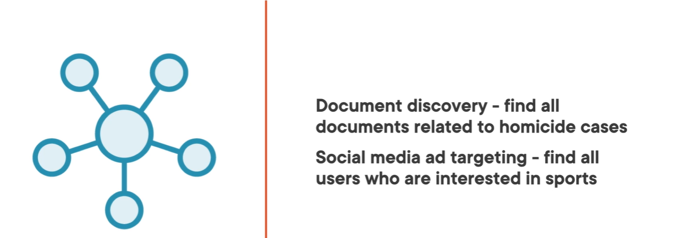

Dimensional Reduction 🡪 It looks at the X variables, or features that you feed in to extract latent or significant features from data.

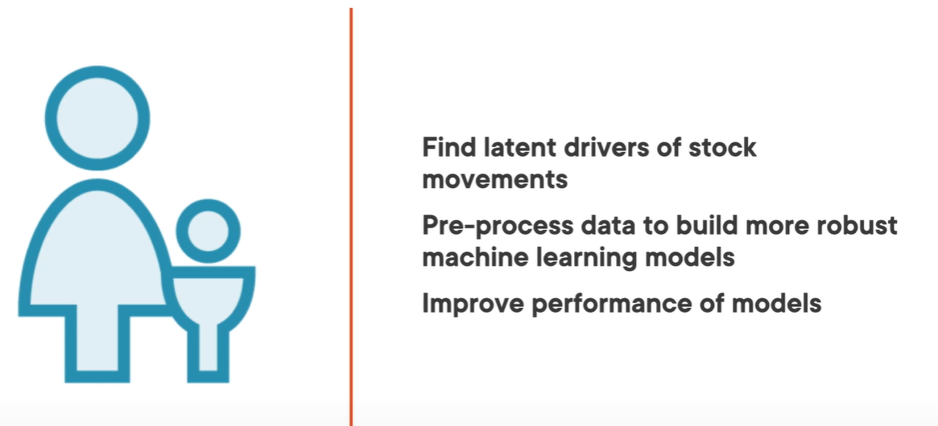

Supervised vs Unsupervised Learning 🡪 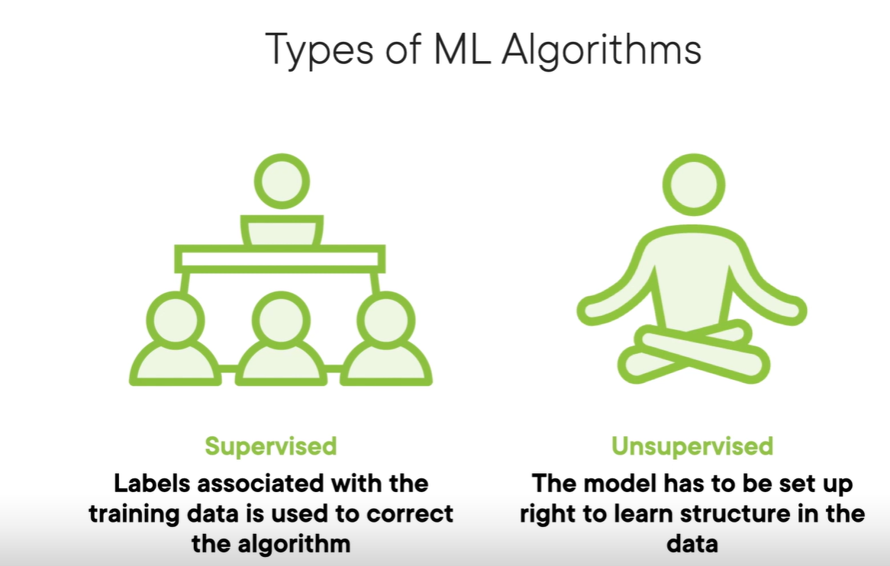 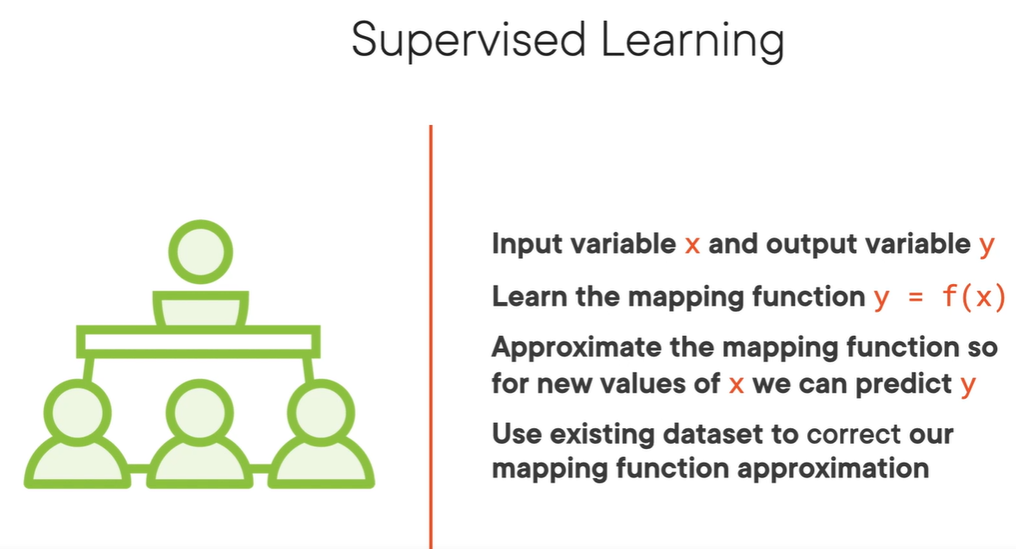 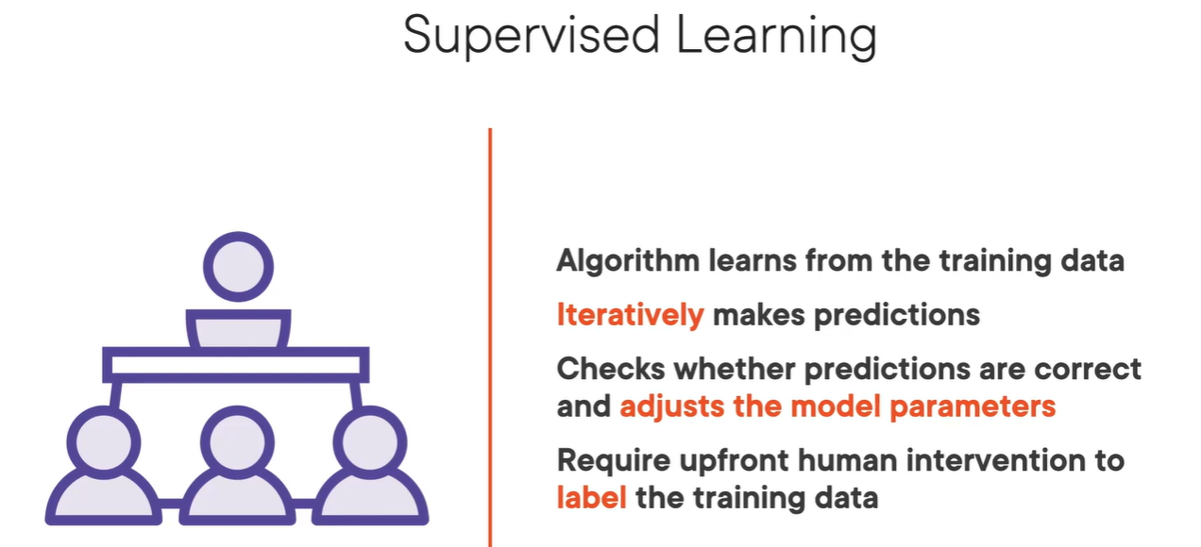

When we train ML algorithm with huge corpus of data it outputs classification which is again then fed to the algorithm to improve the model parameters. This is Supervised learning. Here we know that there is relationship between input variables x and output variables y. i.e.. y = f(x). Here we use labels associated with the training data are used to correct the algorithm. Use of labels is what helps the algorithm to predict in the right way.

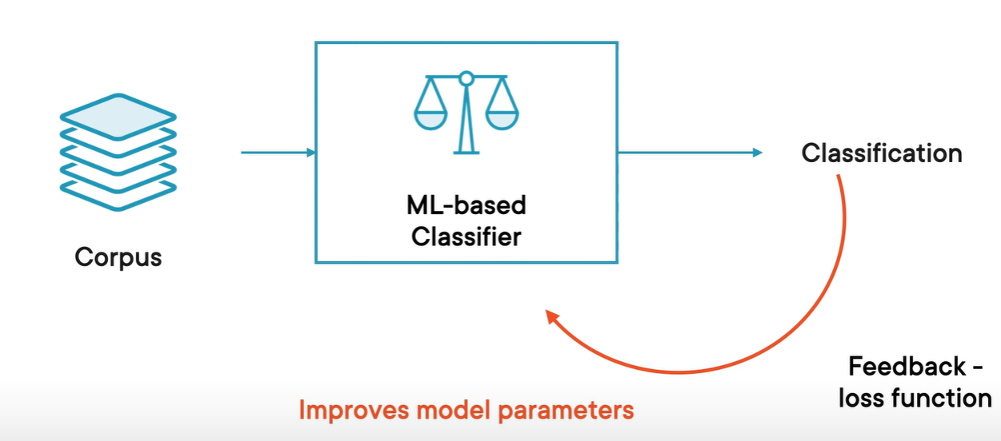.

Here most ML algorithms seek to learn from the function that links features and labels.

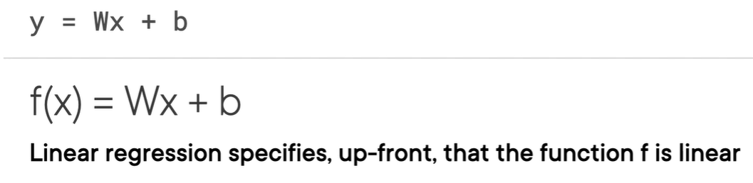 where x is the slope of the line and b is the intercept.

Unsupervised learning learns to find existing patterns in the data without any labeled corpus.

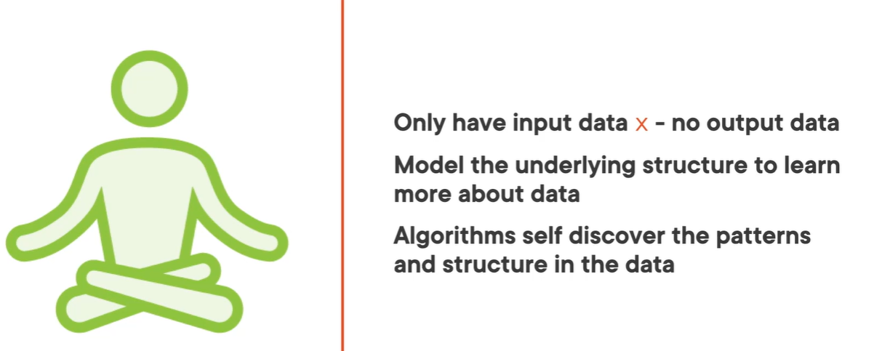 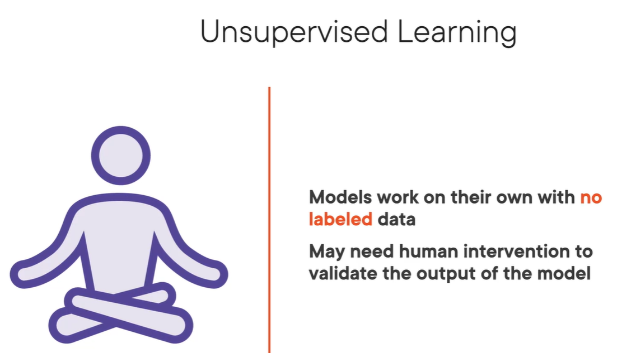

Classification, Regression are examples of **Supervised Learning**

Clustering, Dimensional reduction are examples of **Unsupervised Learning**

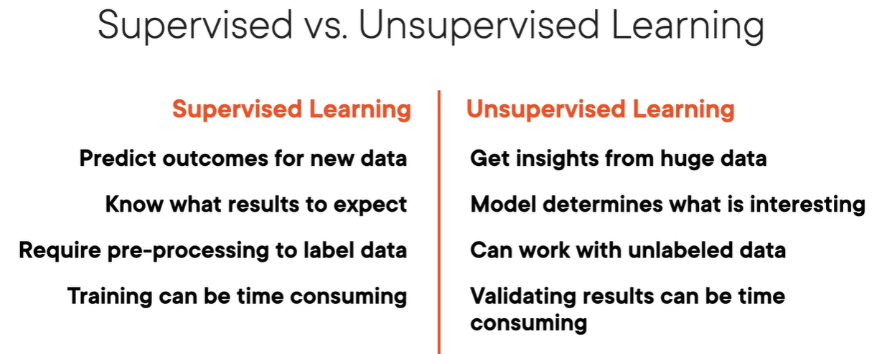

Recommendation Systems 🡪 These are used to recommend products that users might like in an e-commerce site. 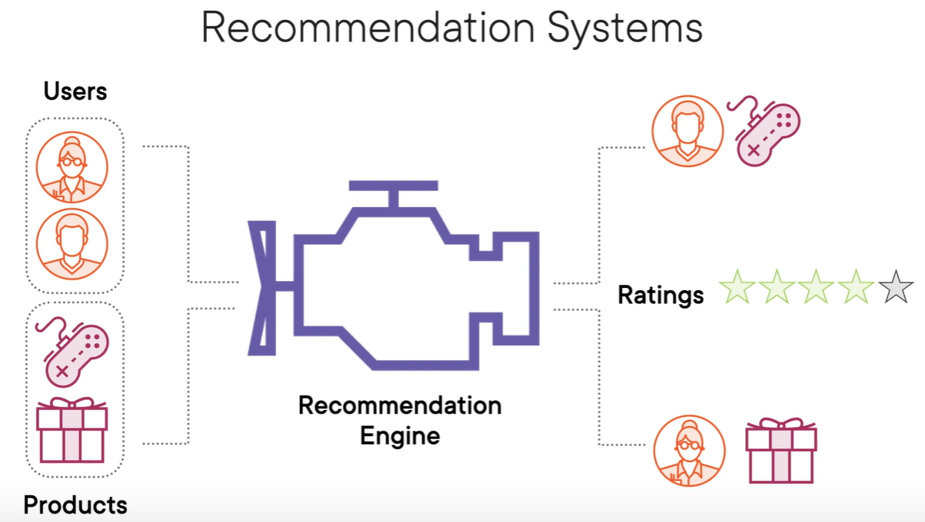

Inputs to the recommendation engine includes products sold on the site and users on the site. The recommendation engine will then try to predict how a particular user reads a product. If the user is likely to give the product a high rating, that product is recommended to the user. 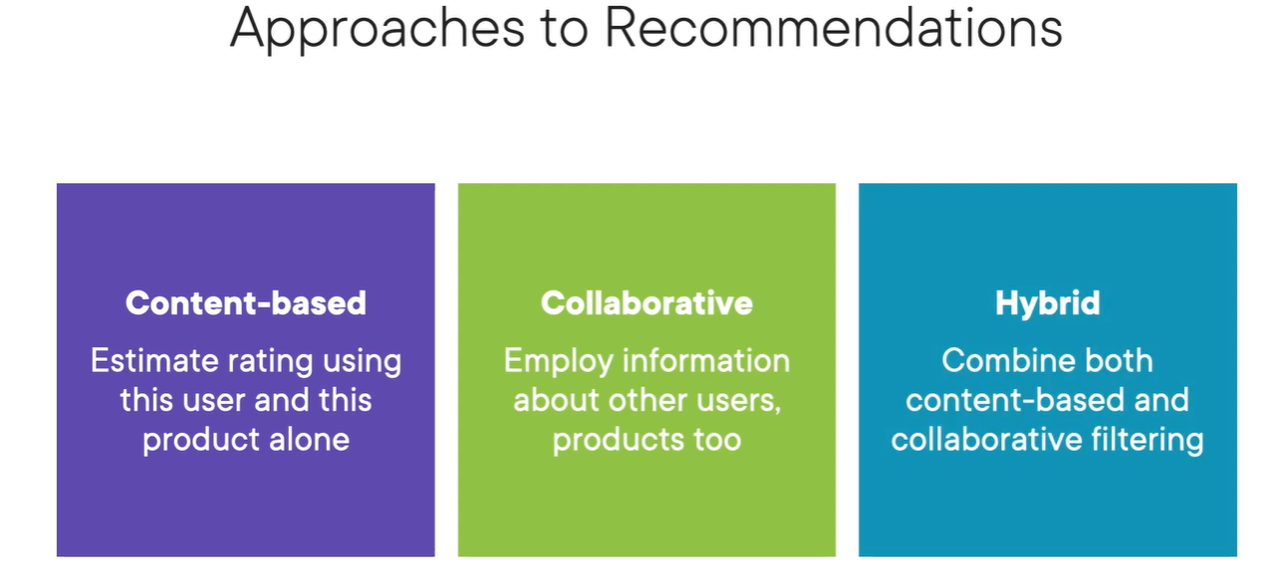 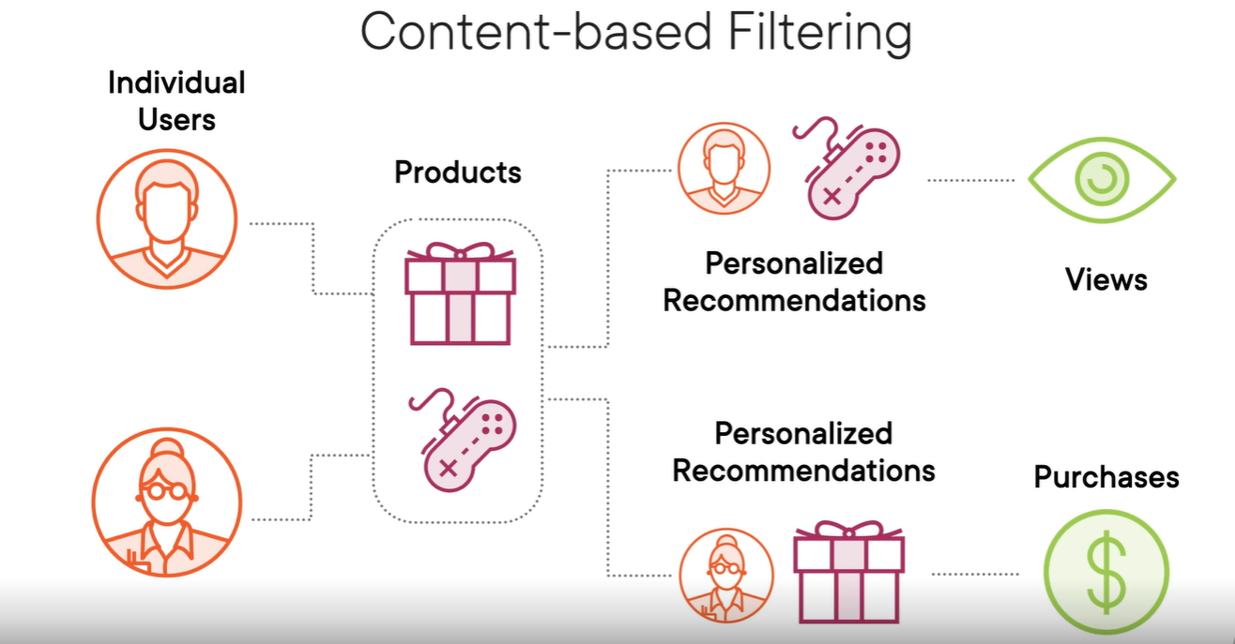

Content‑based filtering is useful if you have a system with very few users so it's hard for you to figure out which users are like other users. New items with few ratings where there isn't much of a purchase history associated with that item can be recommended to users using this technique.

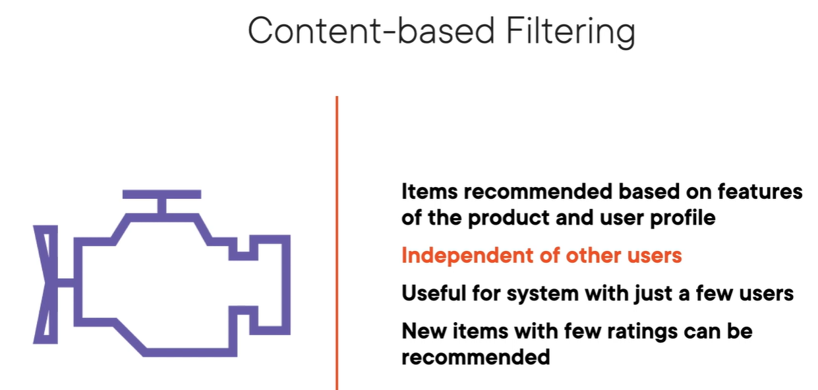

Collaborative Filtering 🡪

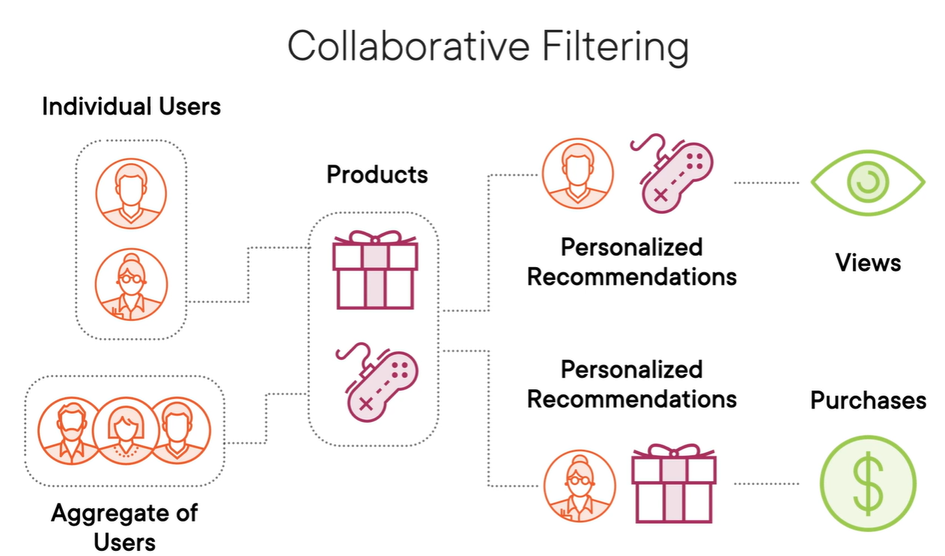 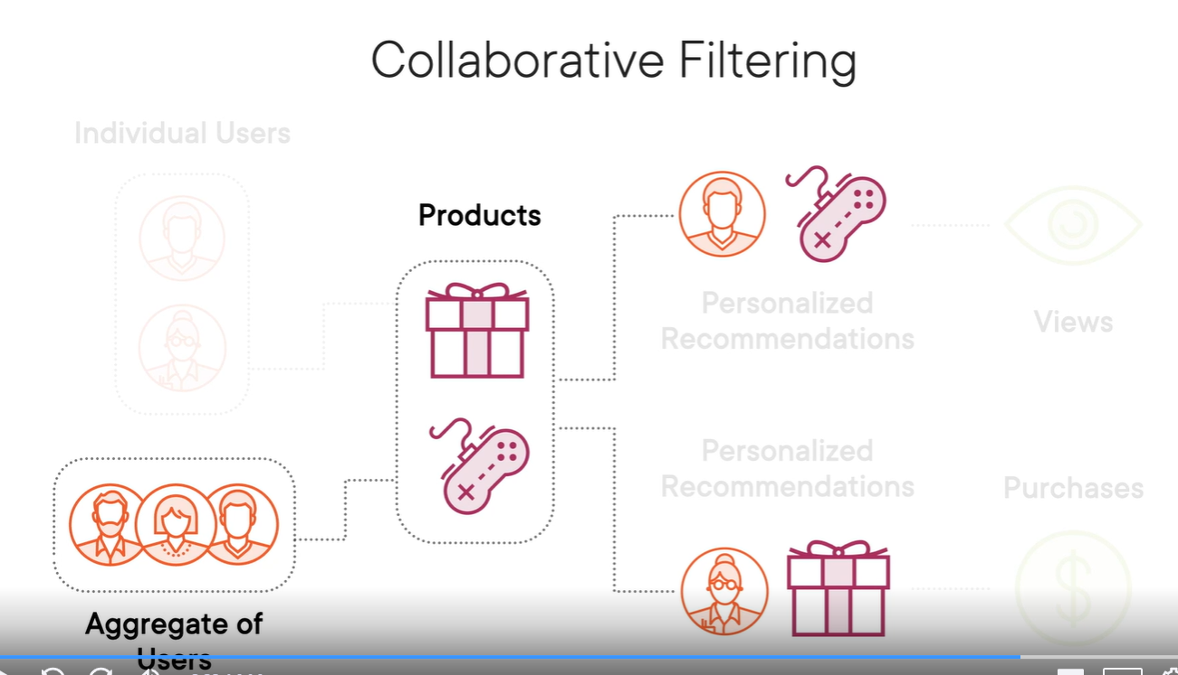

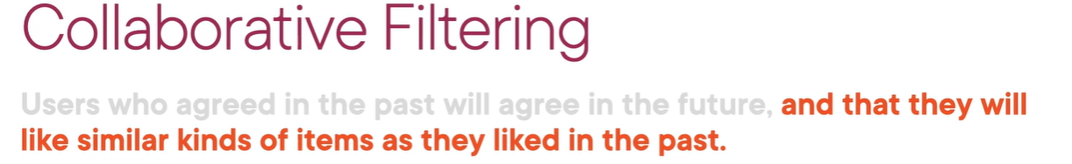

Association Rules Learning 🡪 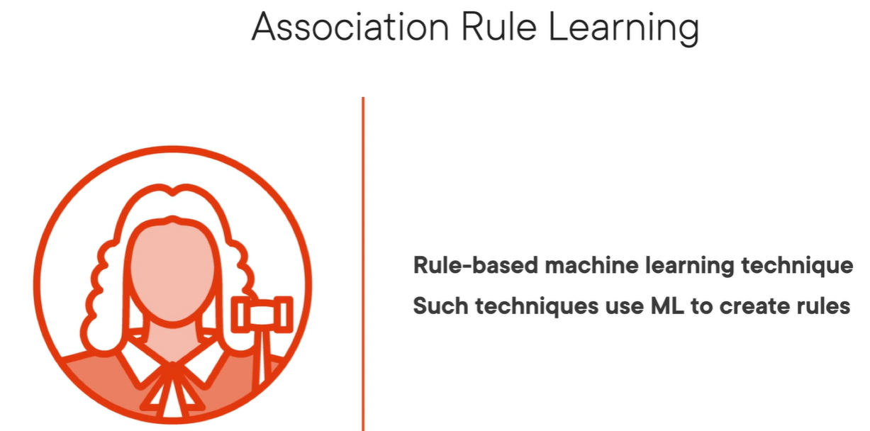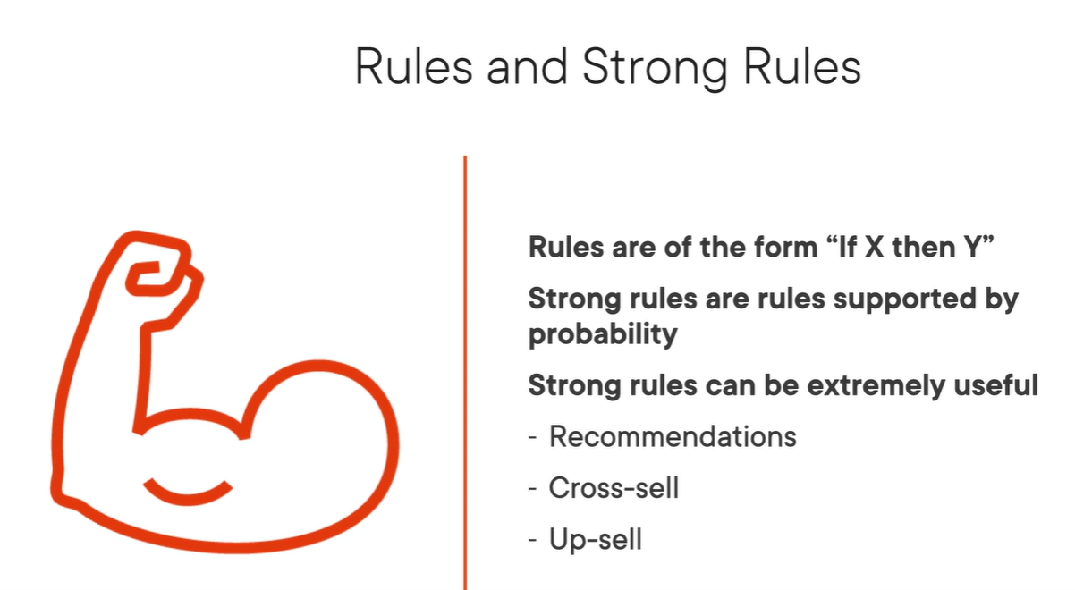

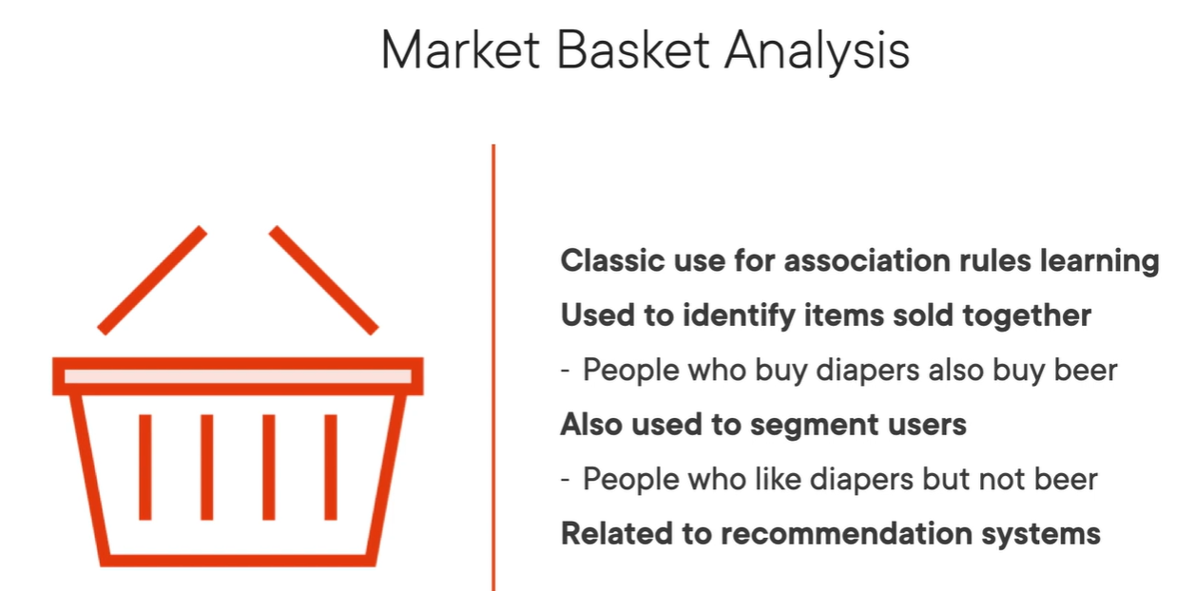

Reinforcement Learning 🡪 Train decision makers (agents) to take actions to maximize rewards in an uncertain environment. The whole idea behind reinforcement learning is that right actions are rewarded and wrong actions are penalized.

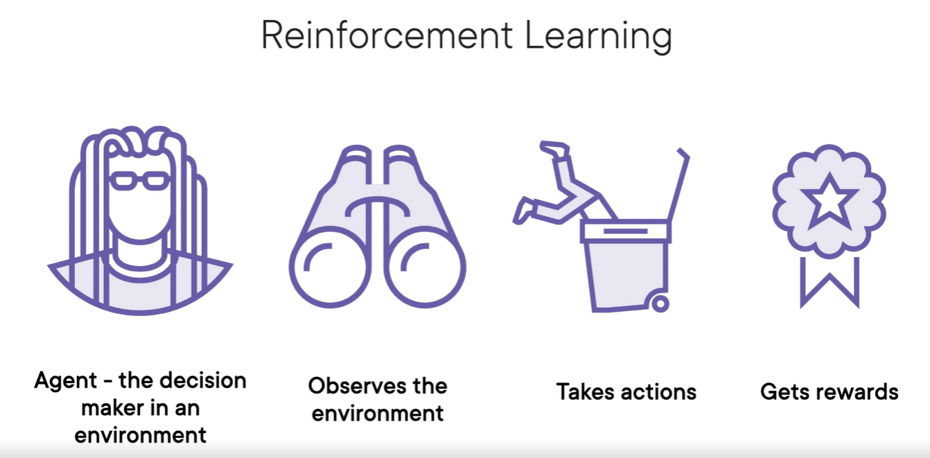 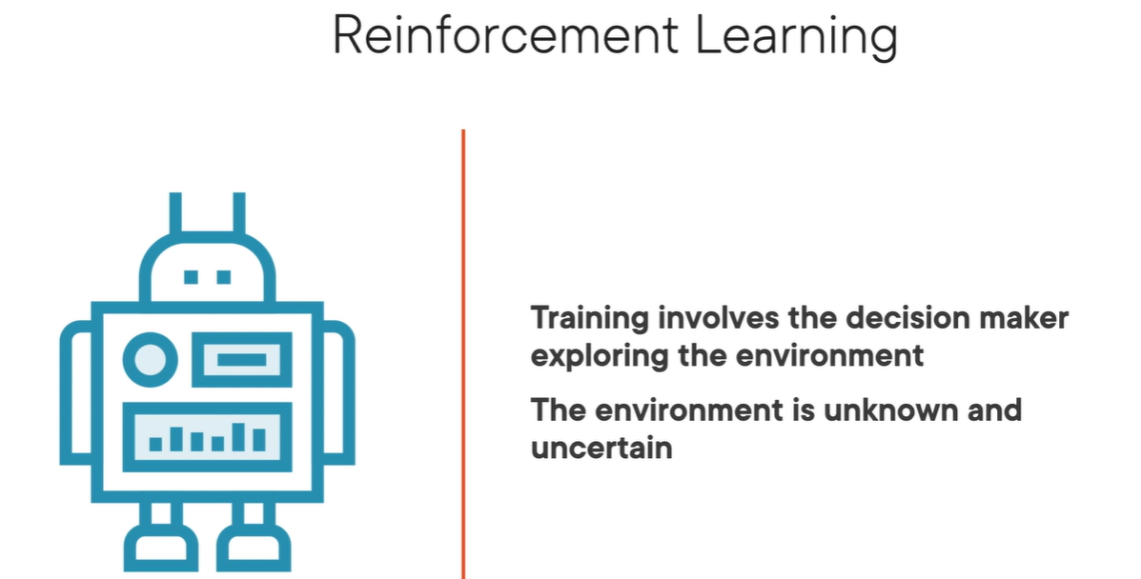

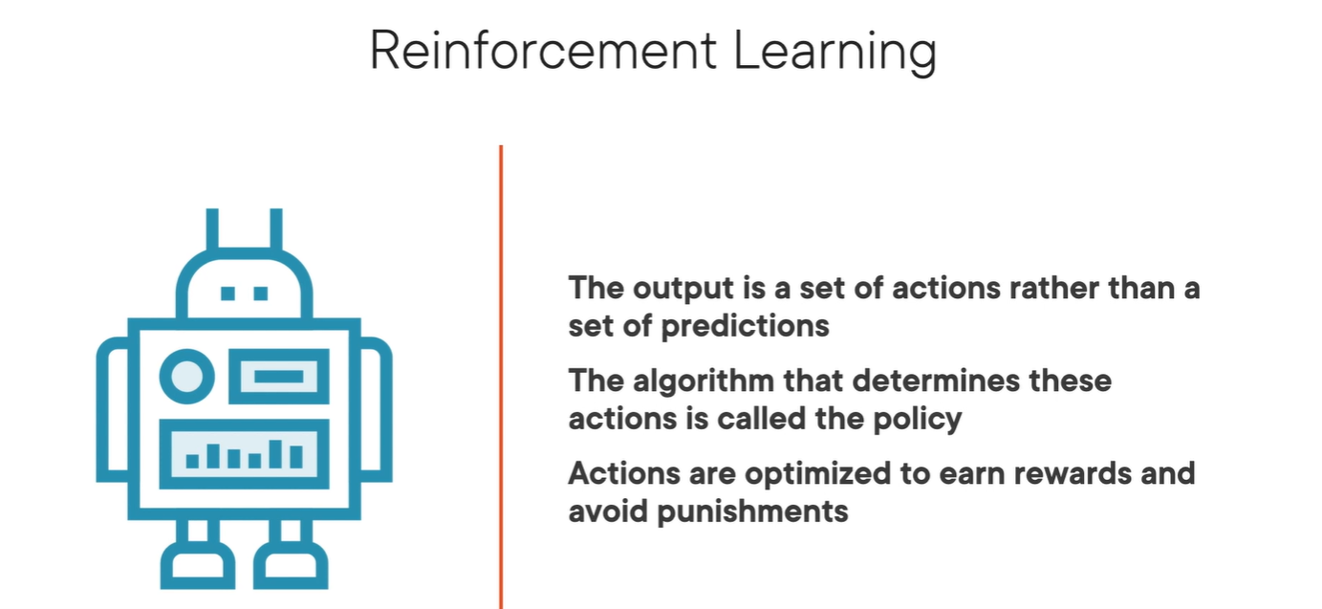 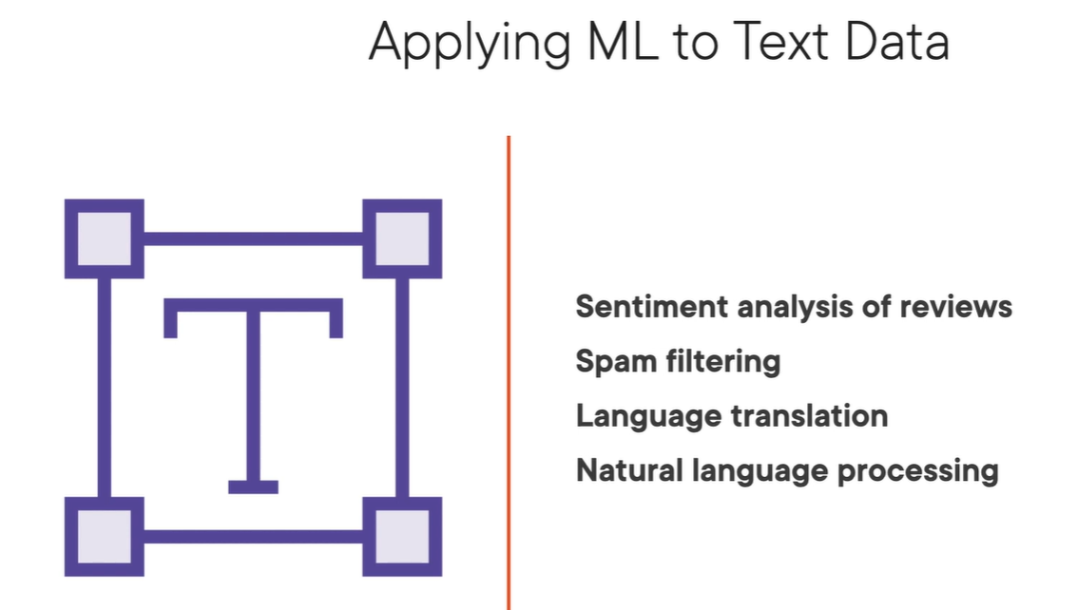

ML can be applied to text, image, speech recognition. 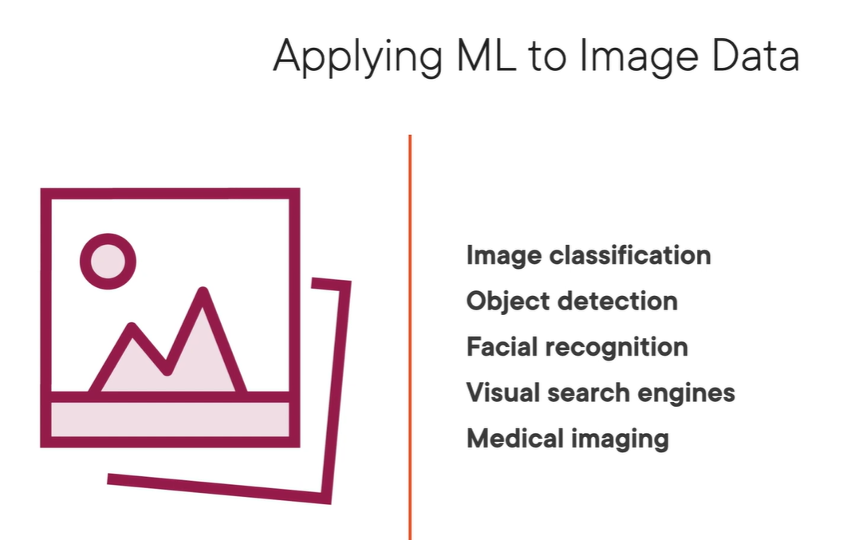 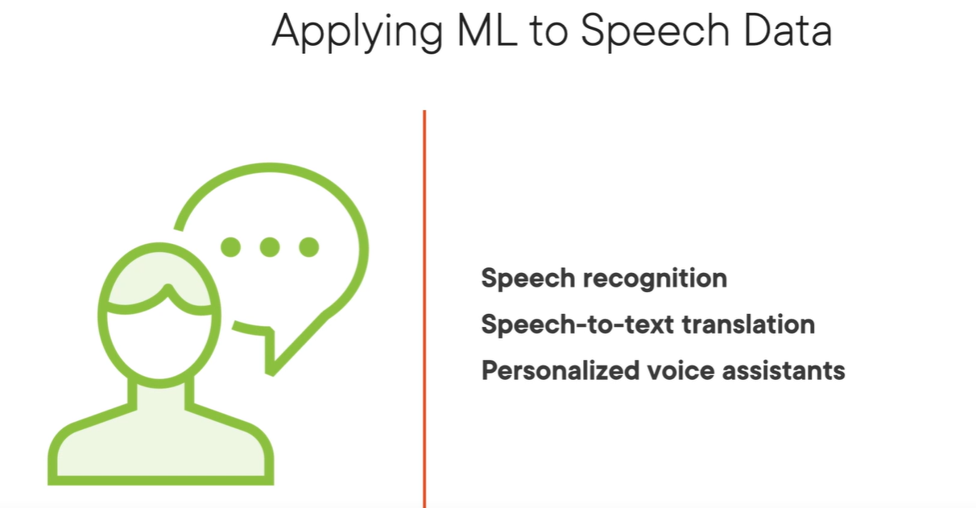

ML models can only process or work with numeric data not plain text. So if we plan to use plain text to ML model we need to encode this text in the form of numbers.

**Generative AI in healthcare:**

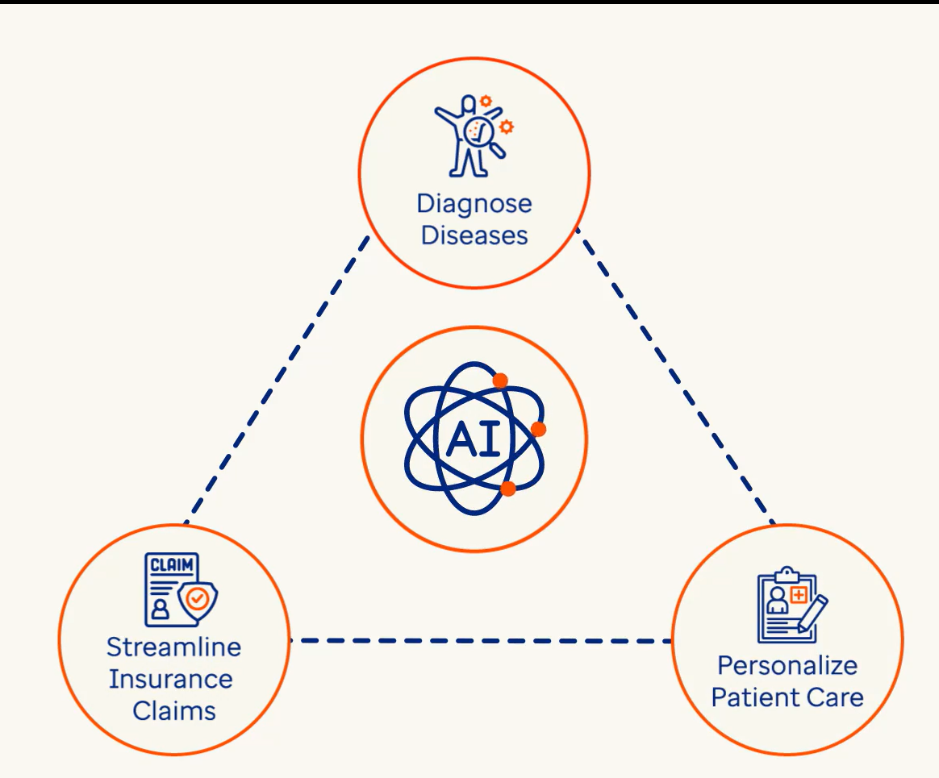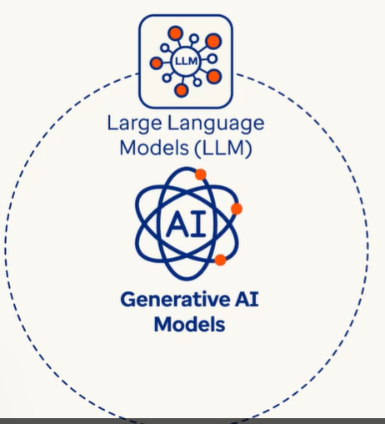

**NLP (Natural Language Processing):**

Data comes in mainly two forms: Structured data (mostly in rows & columns in ready format) and Unstructured data (social media post, audios, videos, emails etc.,).

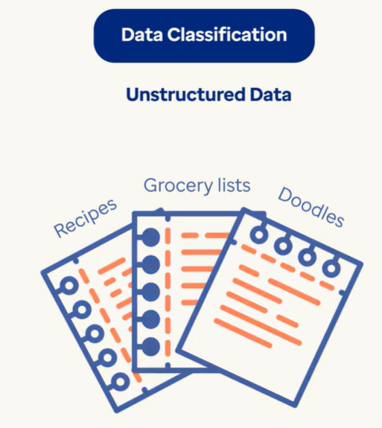 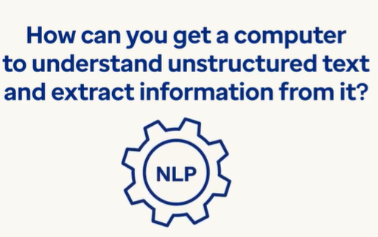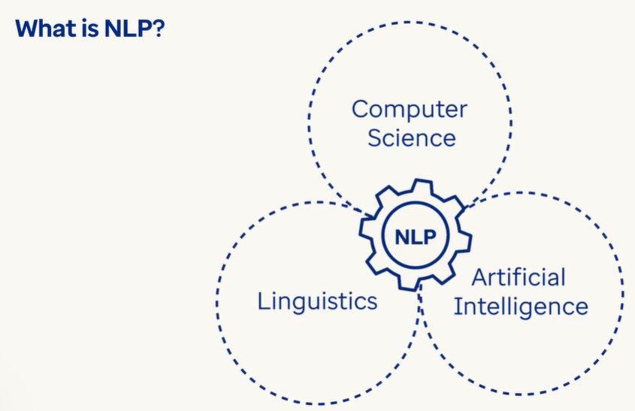

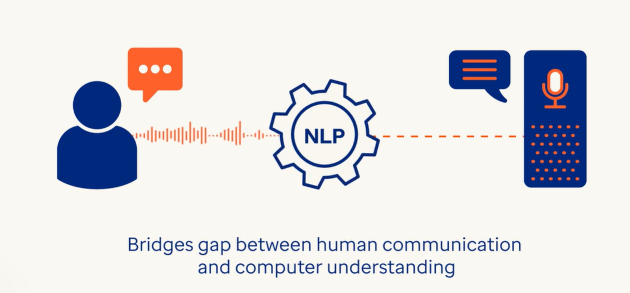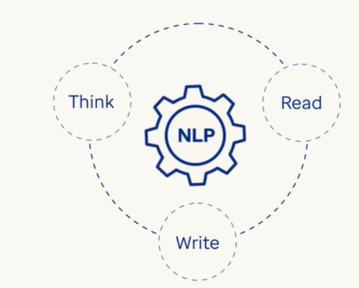

Text Generation 🡪 Need to write a poem or news article.

Speech Recognition 🡪 Siri or Alexa i.e.. turning our voice into text for action by the computer.

Language Translation 🡪 NLP powers machine language system that automatically converts one language to another.

Text Summarizing 🡪 Got a huge document to read ? NLP can do that for us.

Sentiment Analysis 🡪 Want to know how feel about a topic ?

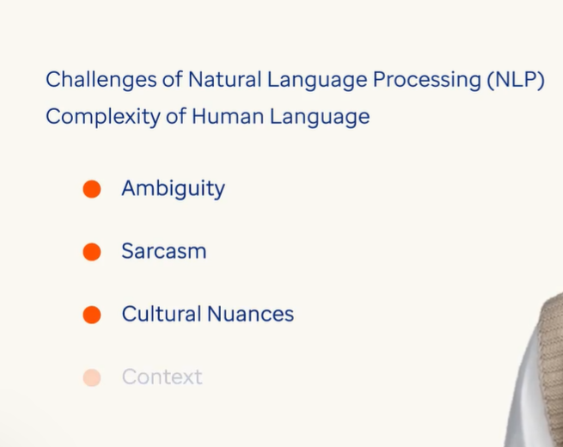 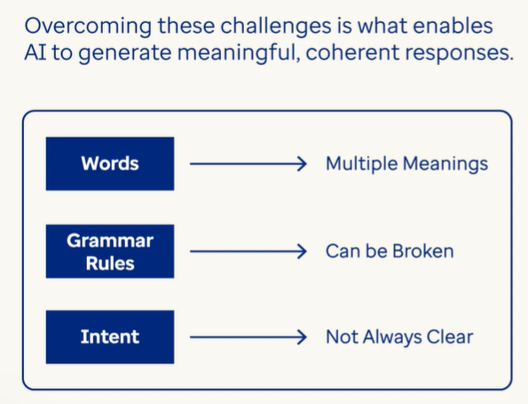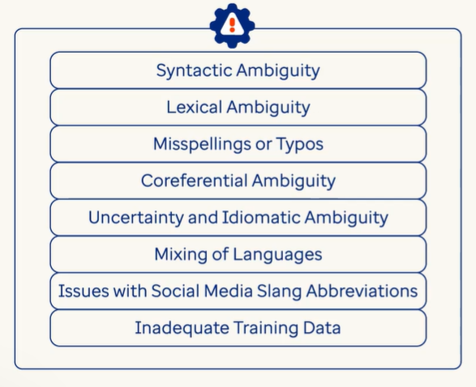

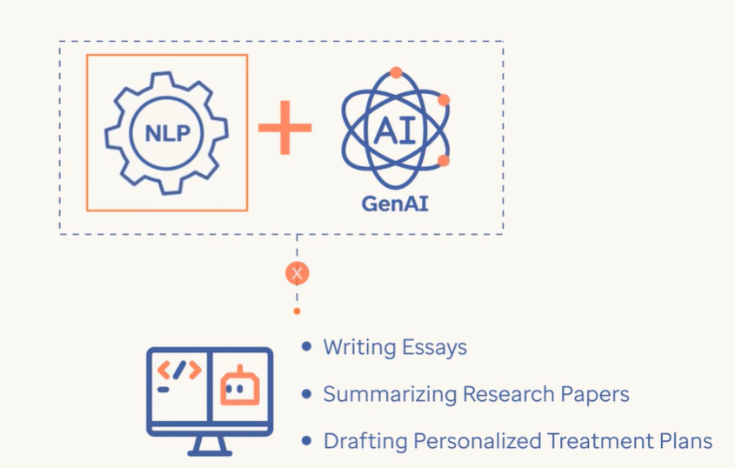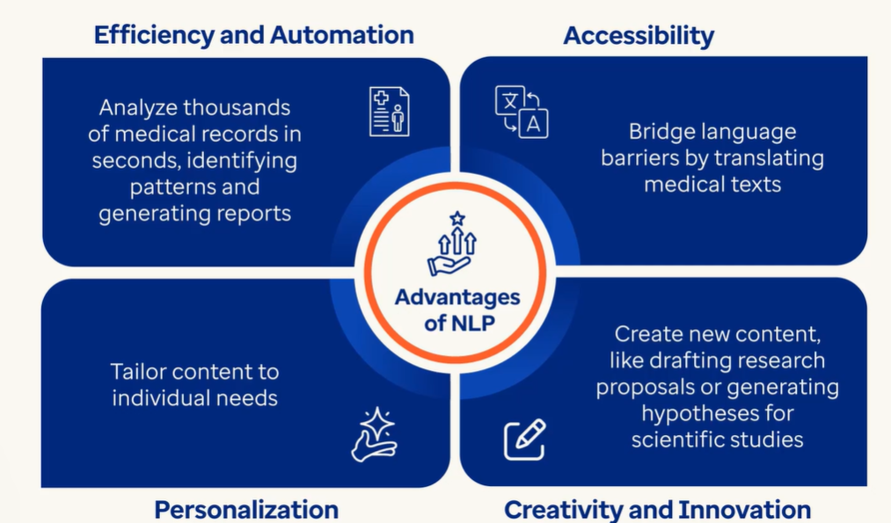

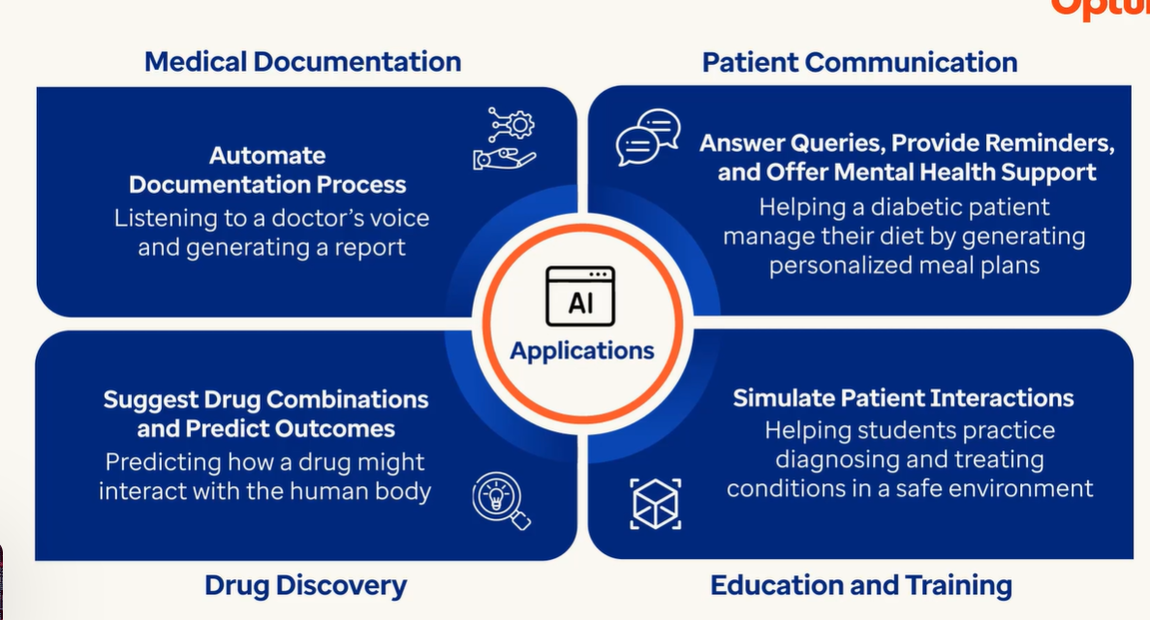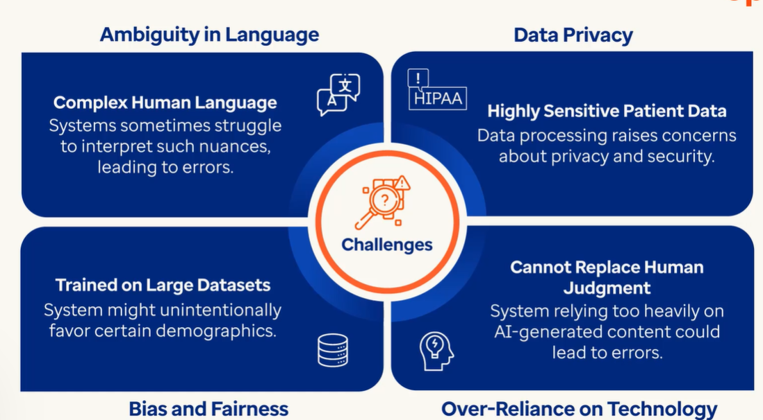

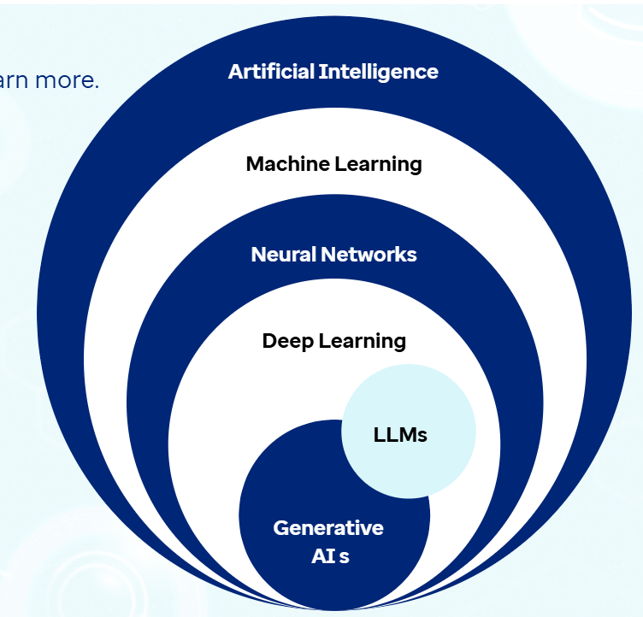

**AI 🡪** A field in computer science that enables machines to learn, adapt and think like human beings.

ML 🡪 It’s a subset of AI that focuses on training the algorithms with huge data so that these algorithms can make predictions.

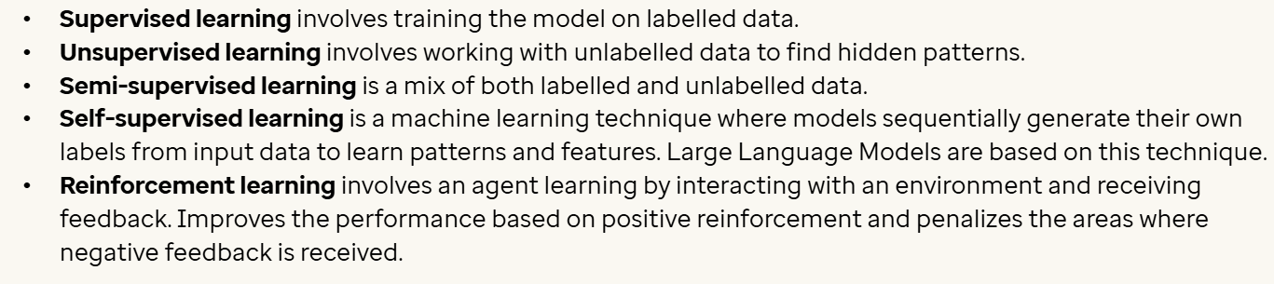

Neural Networks 🡪 It is a subset of ML that tries to mimic human brain. It contains interconnected neurons and each of them take an input and give the output to another neurons. These are designed to model complex non-linear relationships within data by adjusting the weights of these connections as they process information. A basic neural network has input, hidden & output layers.

Deep learning 🡪 It refers to multiple layers of neural networks and helps in training the algorithms from unstructured data like images, videos etc. It has more than input, hidden & output layers allowing them to process and understand much more complex patterns in the data.

LLMs 🡪 Within deep learning we have two individual subsets LLMs and Generative AI. LLMs are trained on huge volume of data that are specialized to interact with humans with NLP tasks by leveraging deep neural network architecture like transformers and encoders. Example: GPT 3.5, GPT 4, GPT 5. LLMs specialize in text generation.

Generative AI 🡪 Gen AI models like DALL-E, Midjourney extend the capabilities of deep learning for creating images and other forms of content.

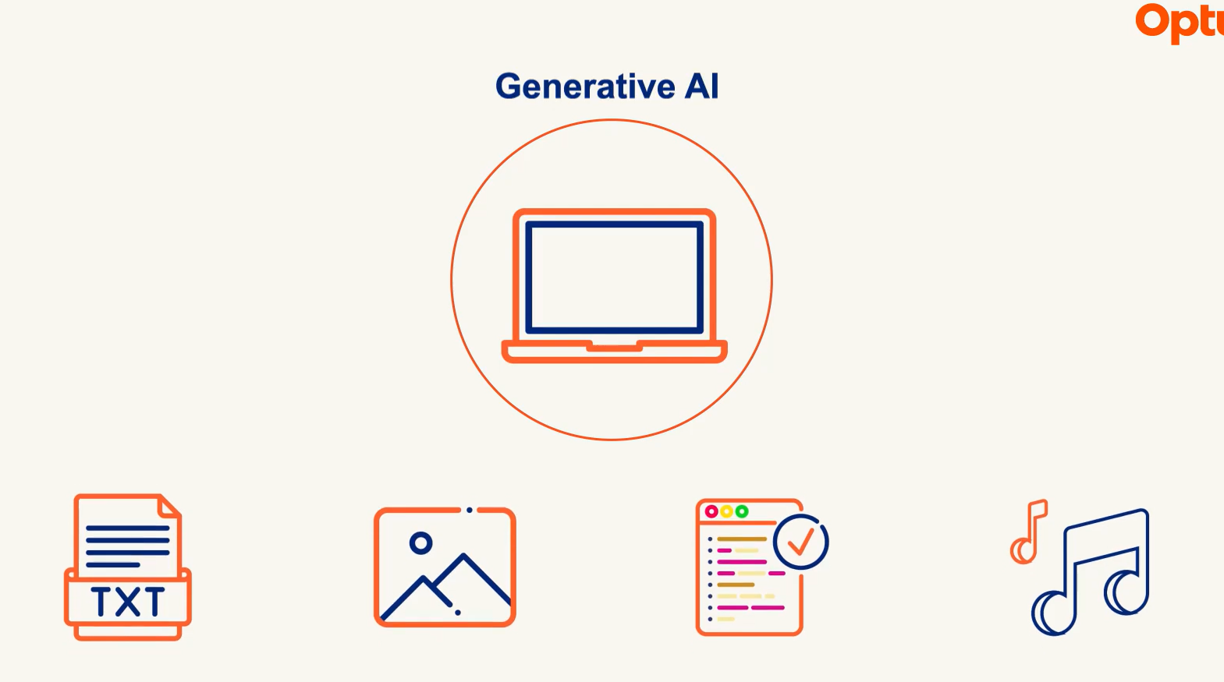

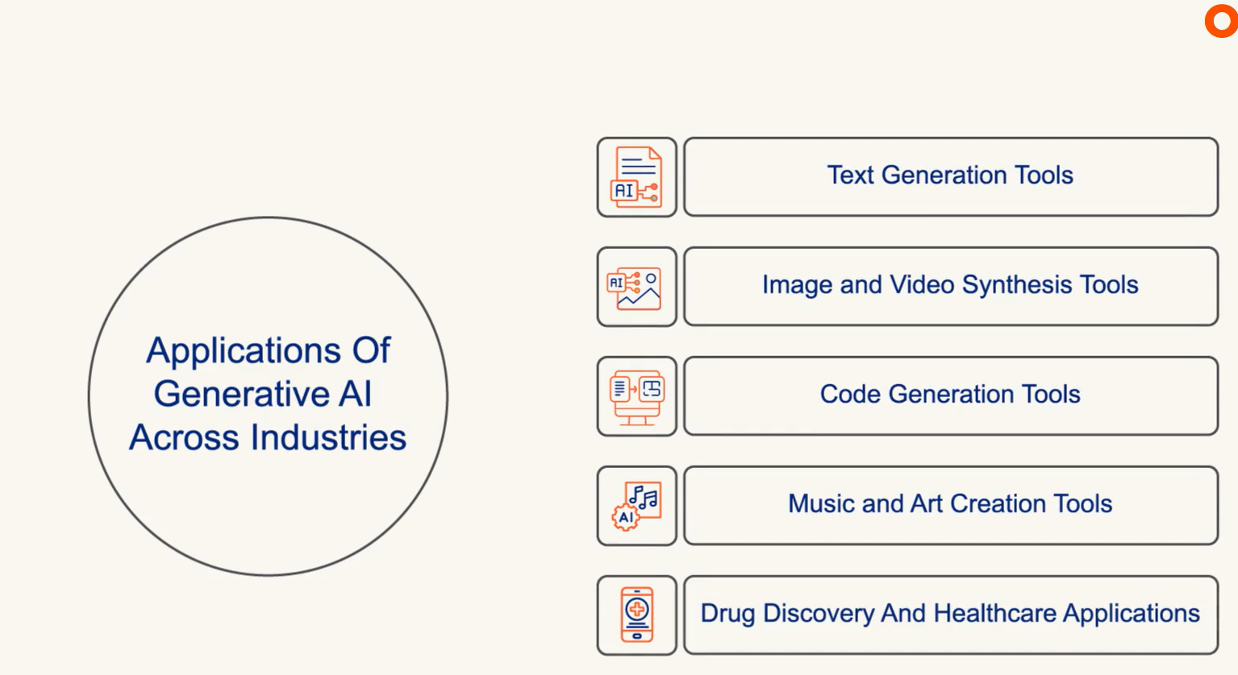

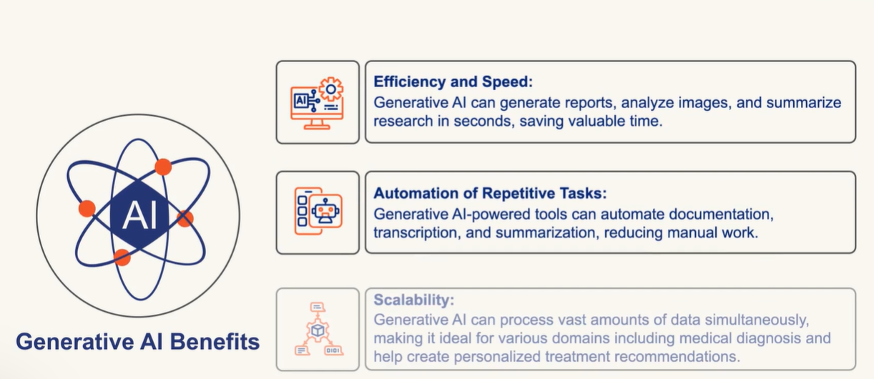

Challenges 🡪

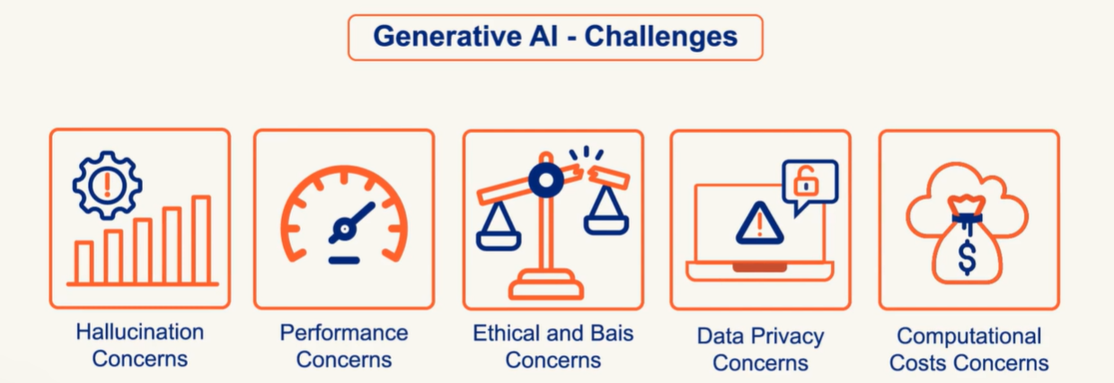

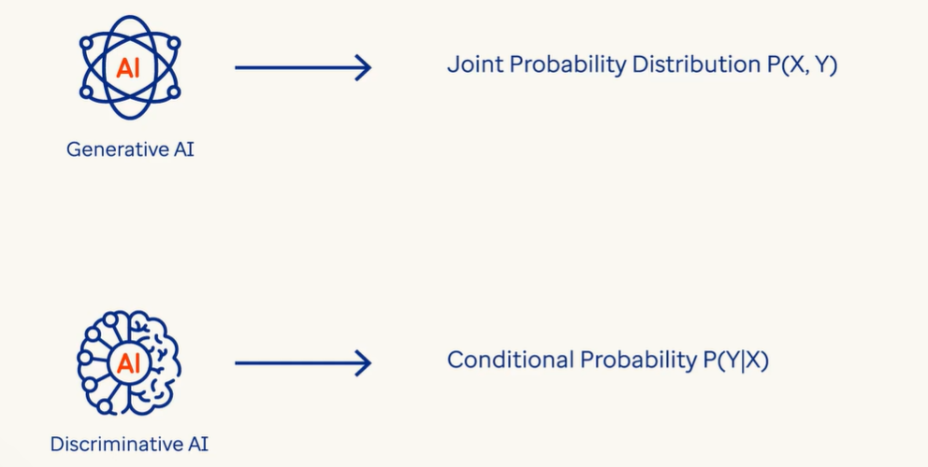

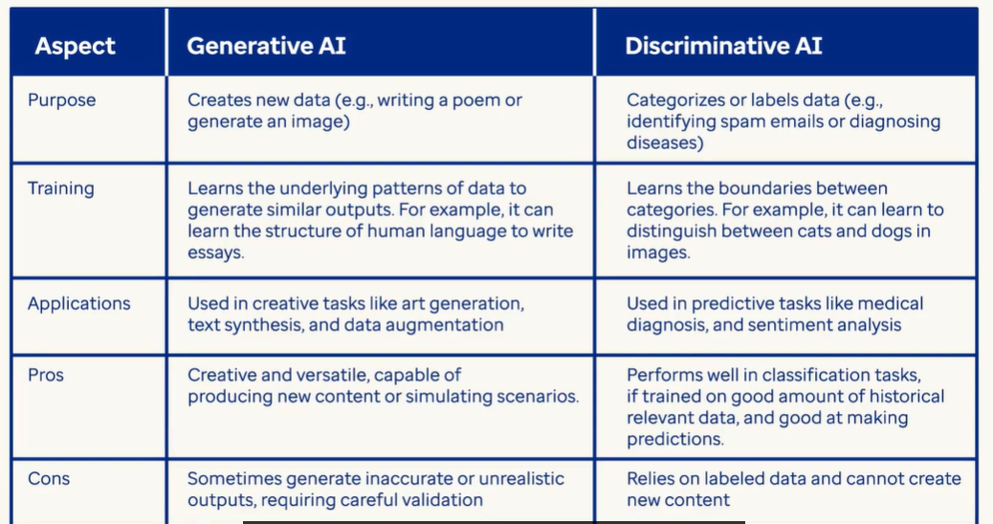

Large Language Models 🡪 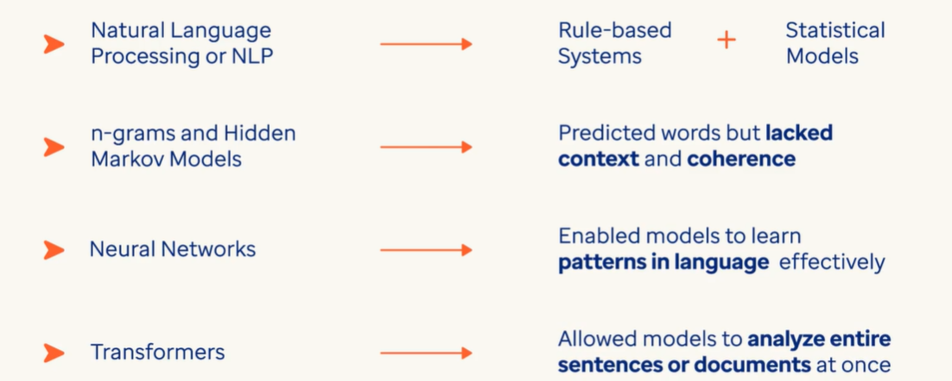

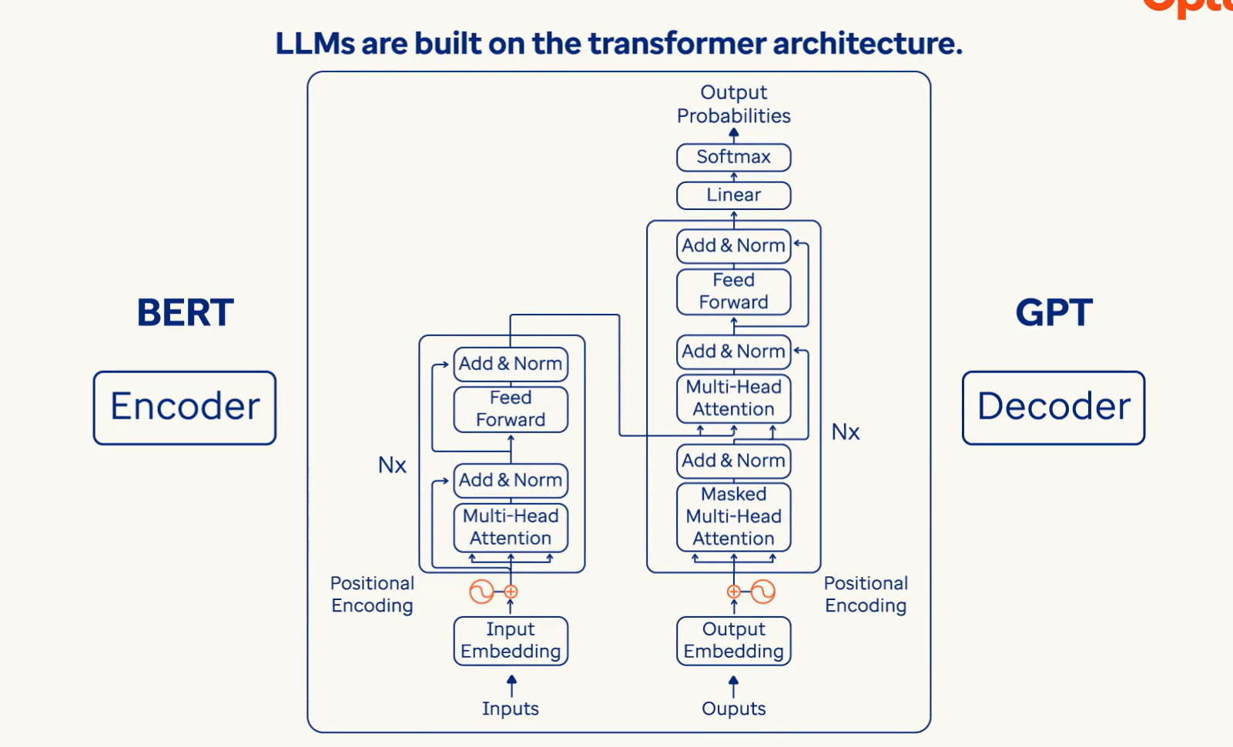

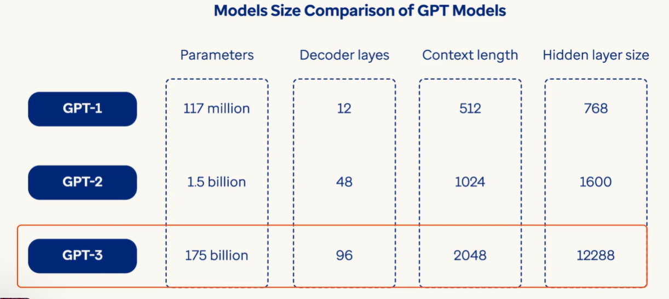

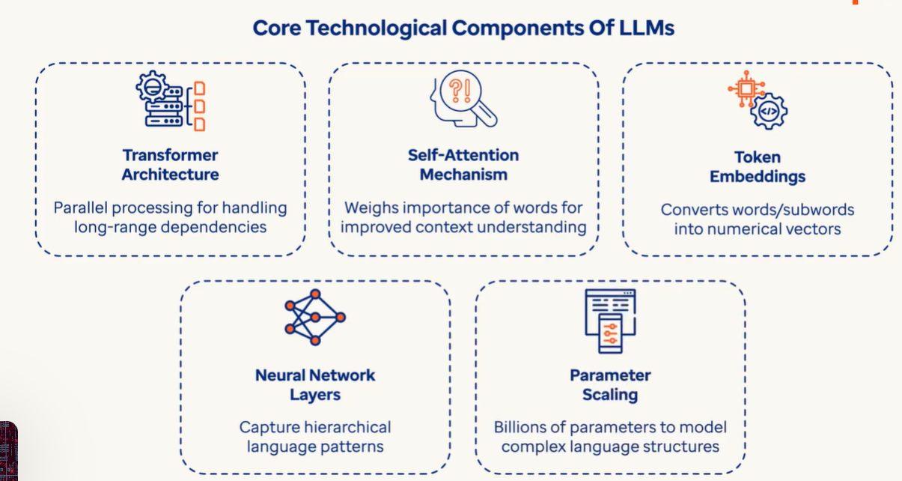

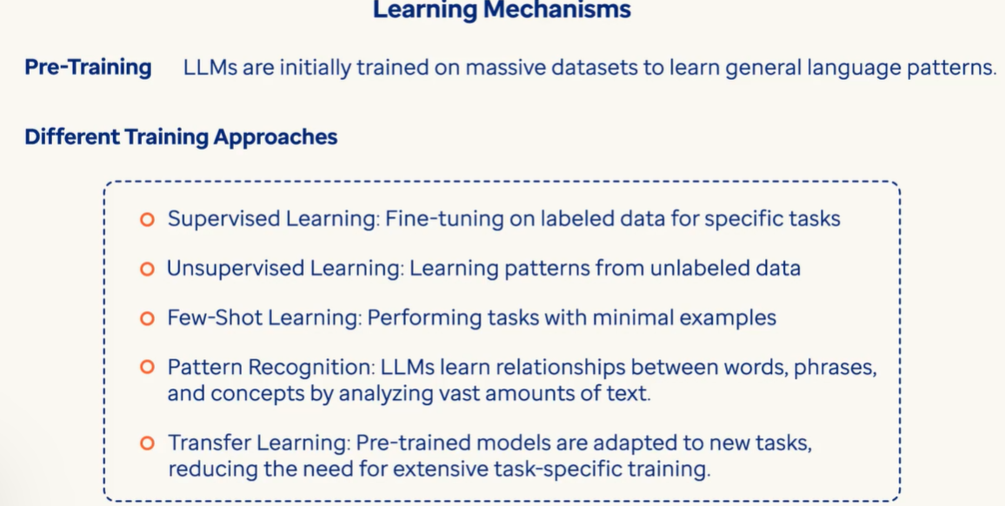

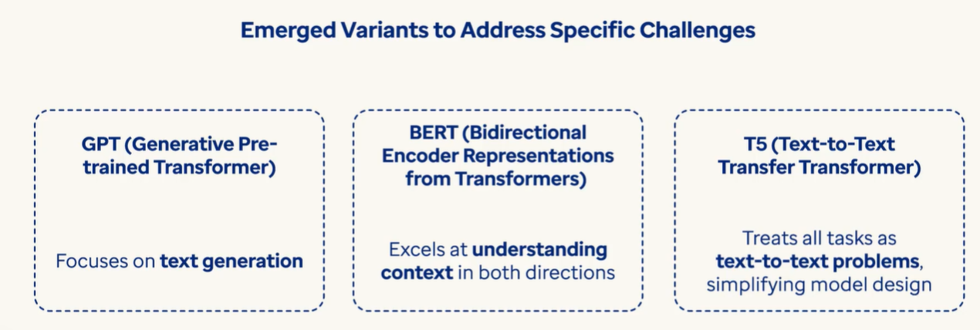

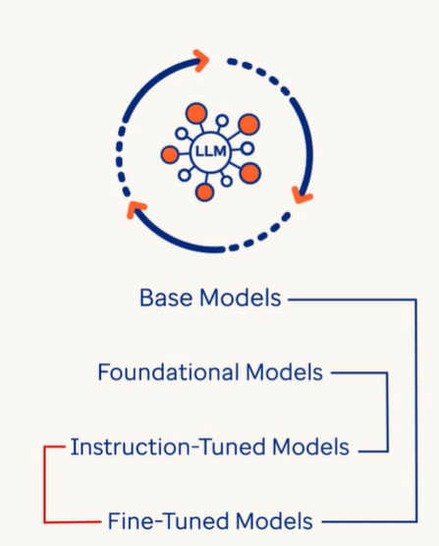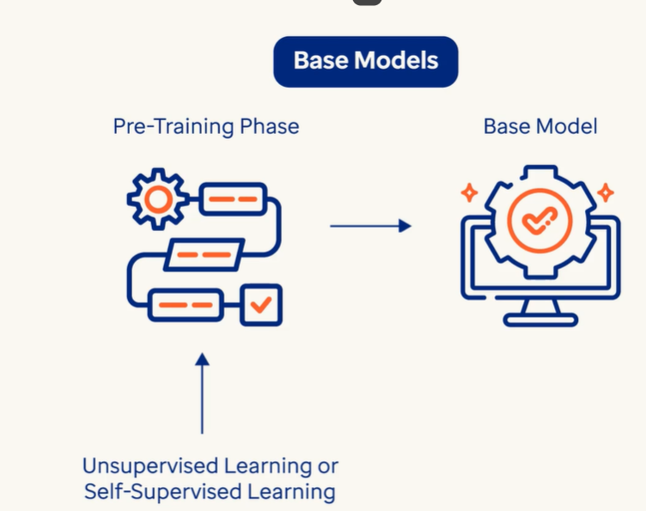

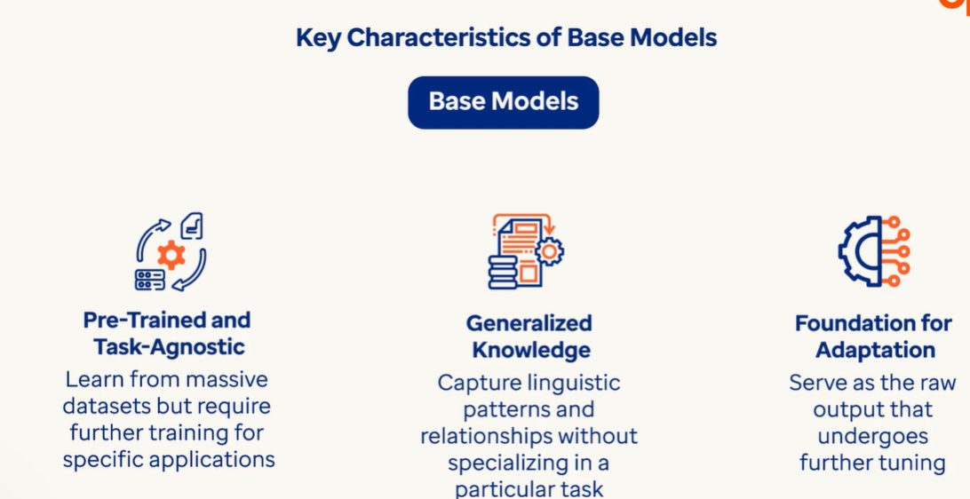

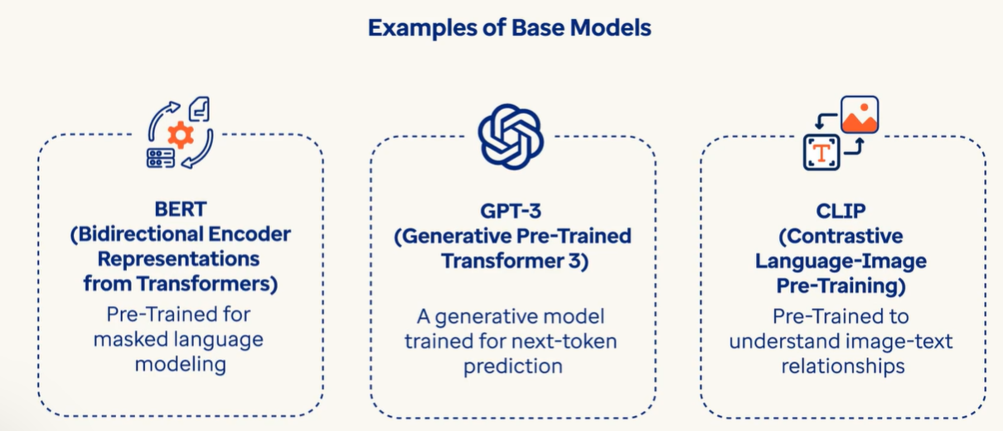

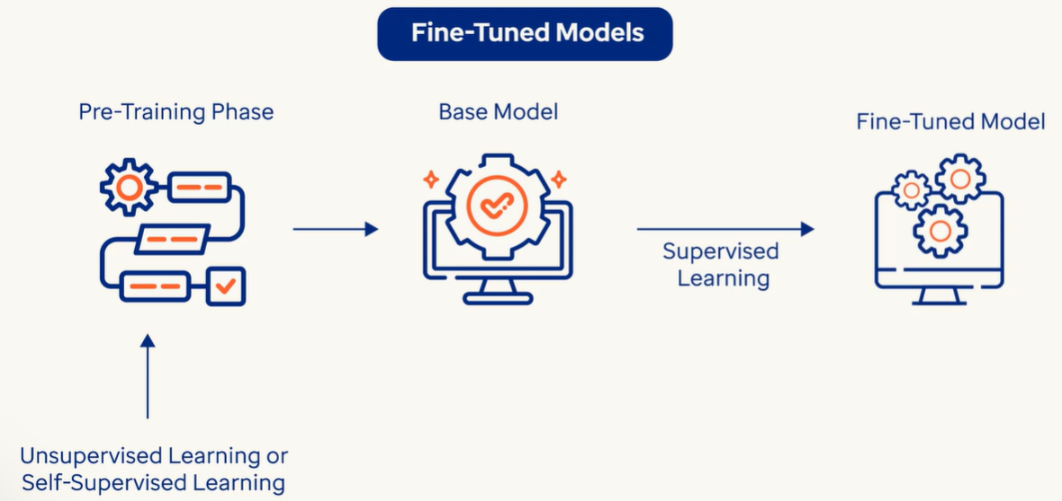

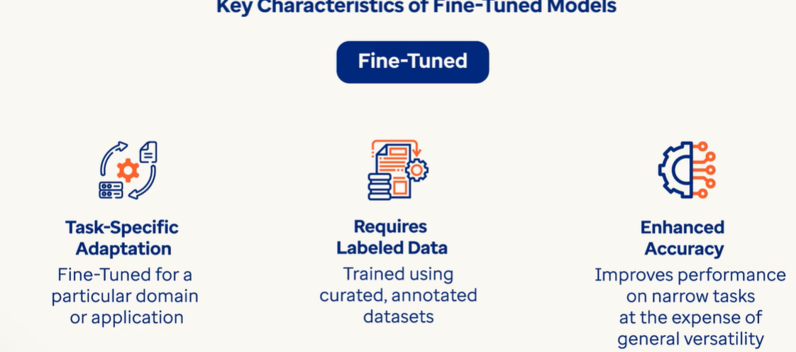

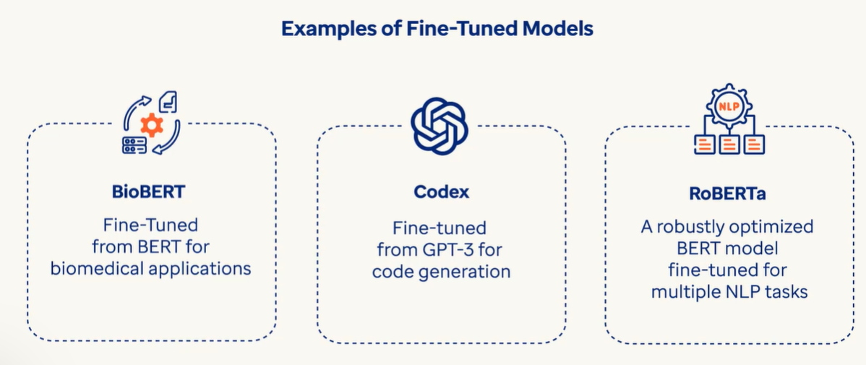

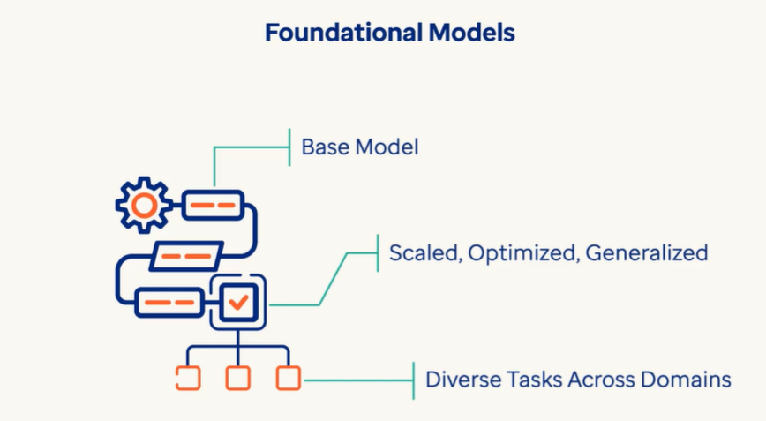

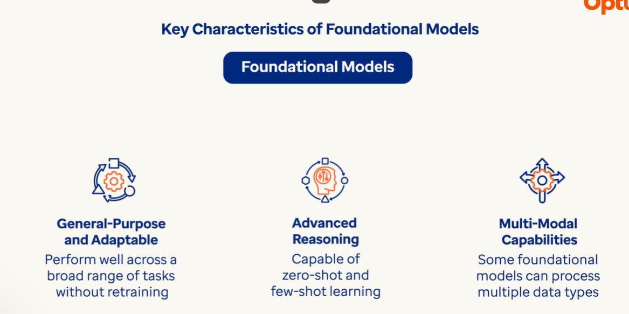

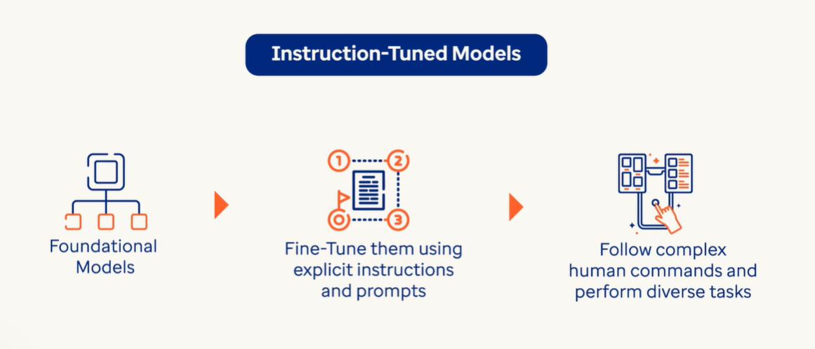

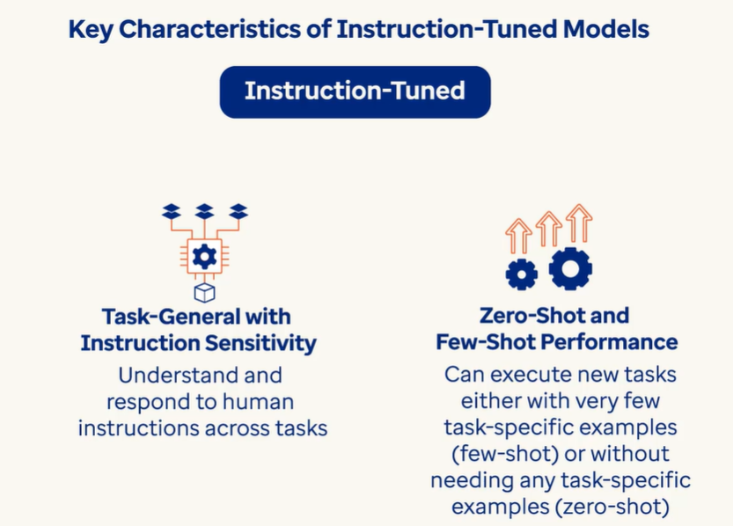

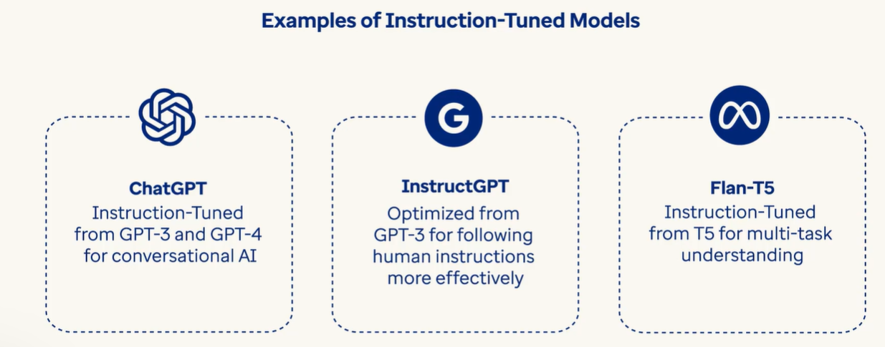

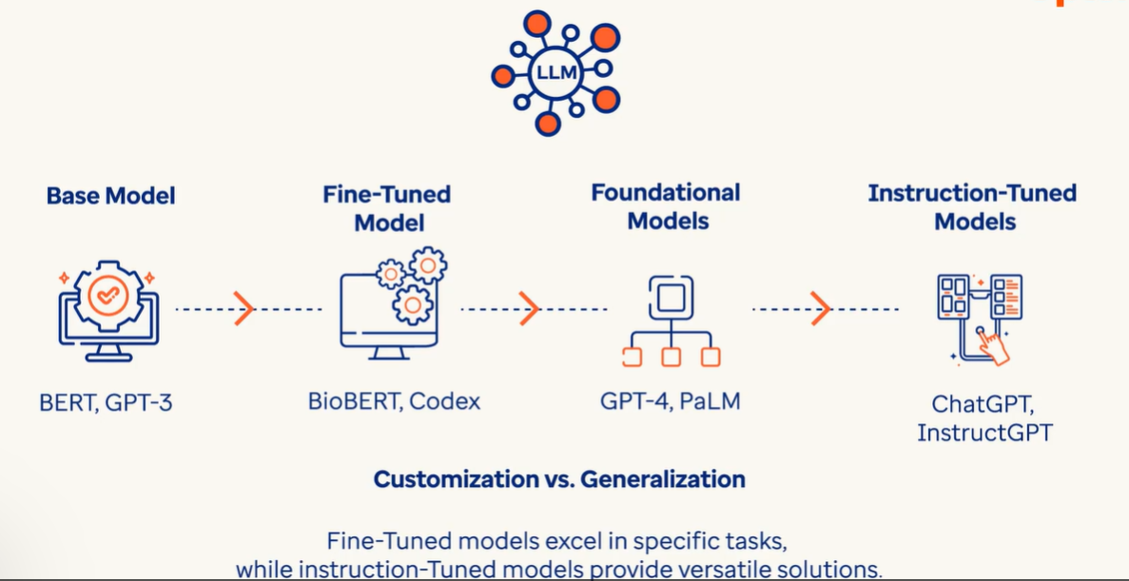

Supervised Learning 🡪 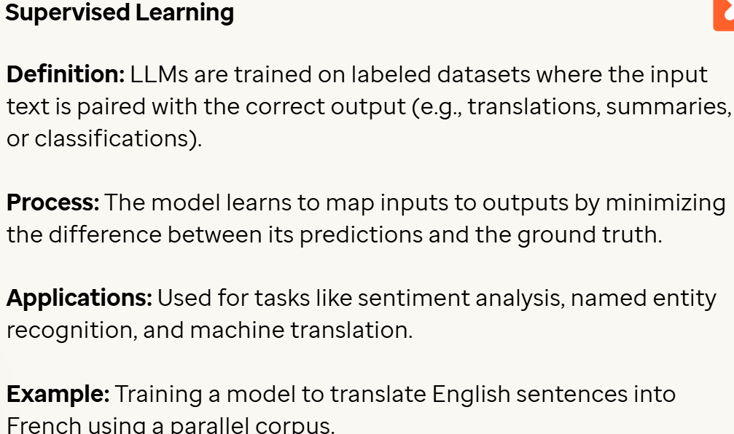

Unsupervised Learning 🡪 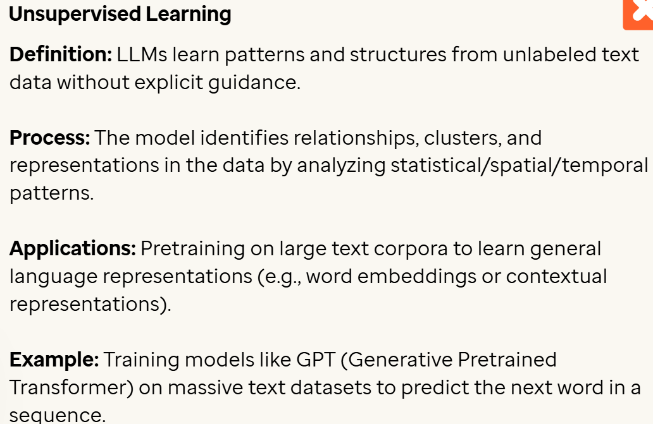

Self-Supervised Learning 🡪 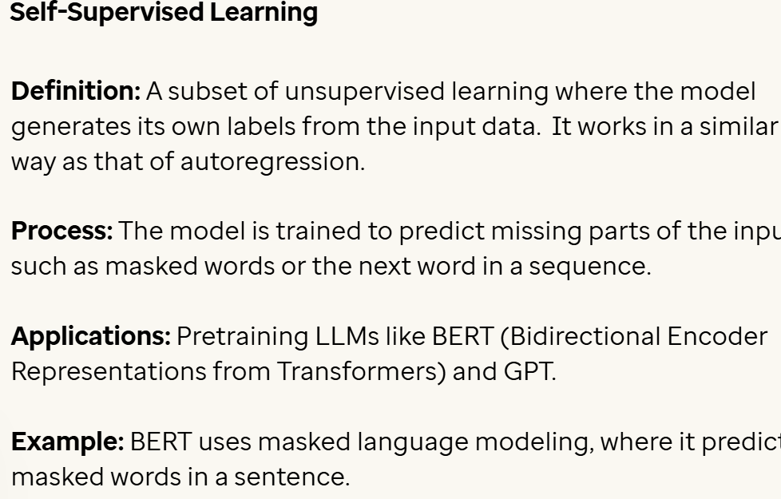

Reinforcement Learning 🡪 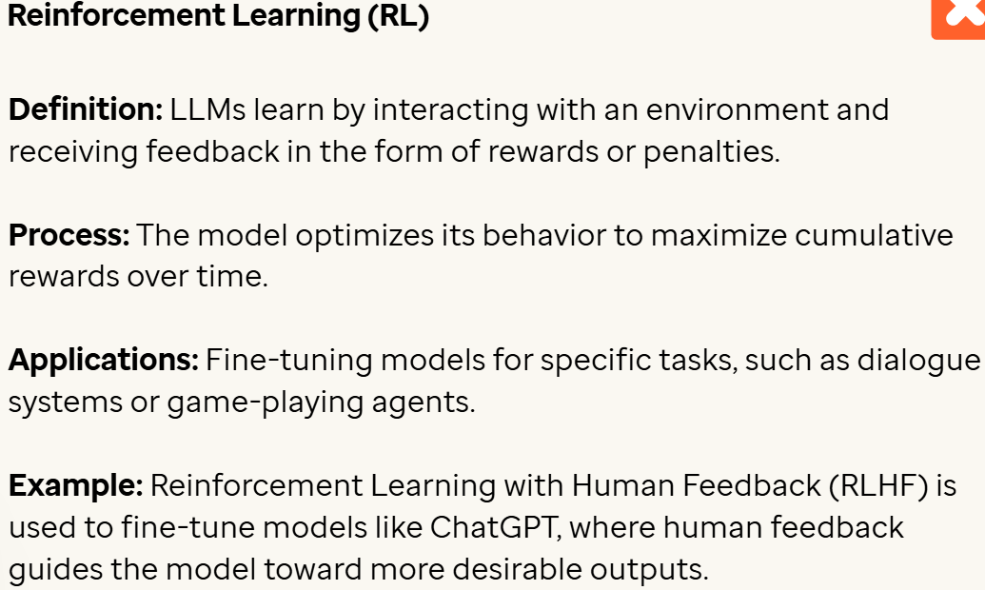

Transfer Learning 🡪 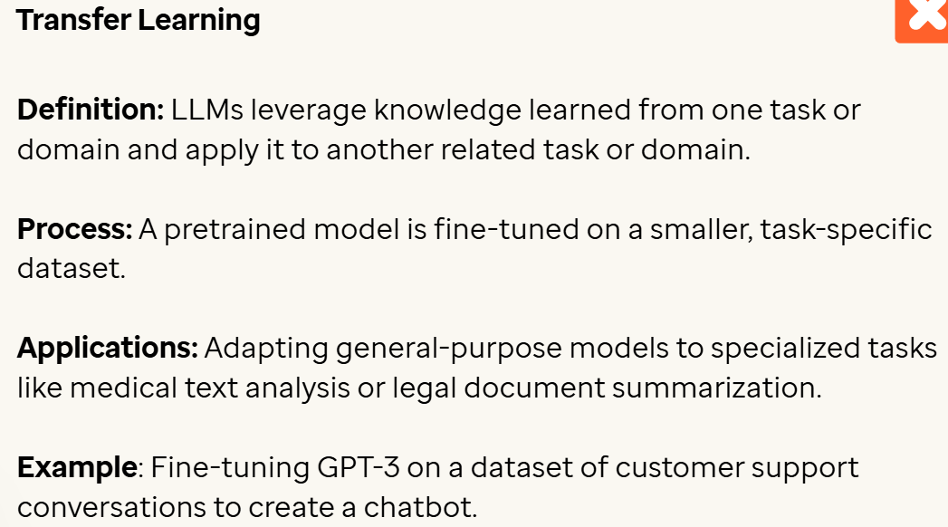

Few shot and Zero Shot learning 🡪 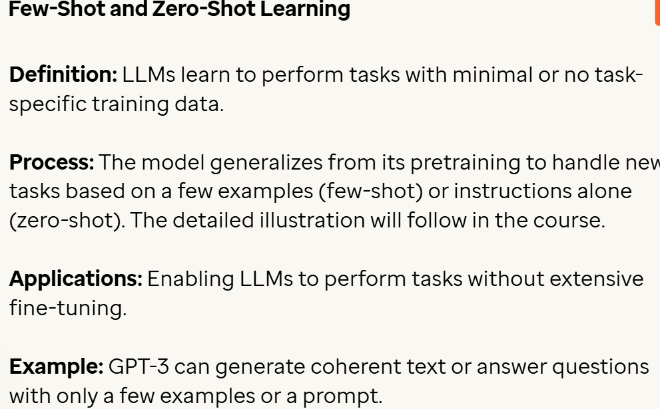

Multimodal learning 🡪 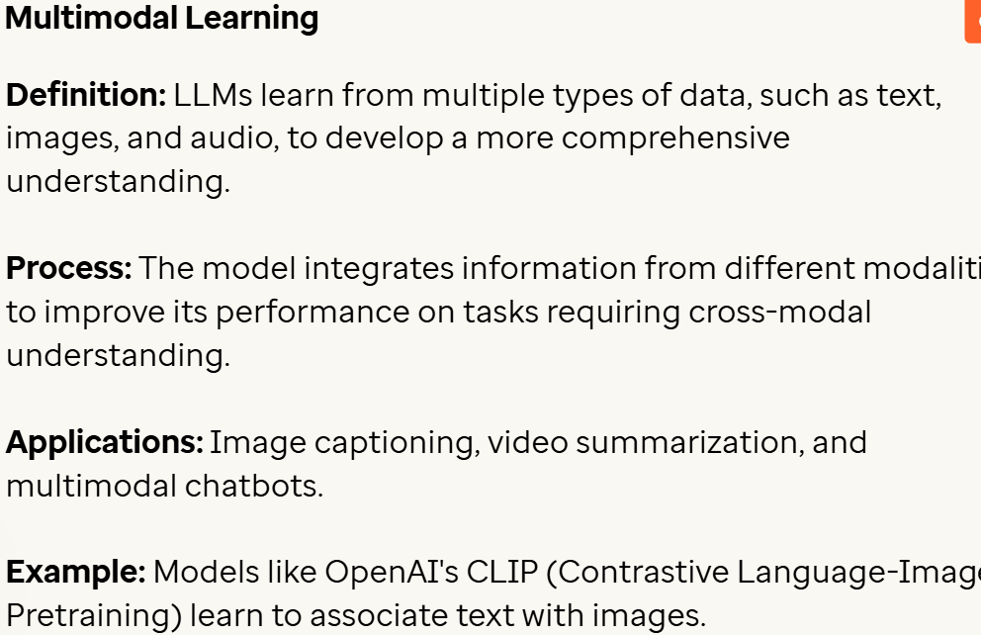

Continual Learning 🡪 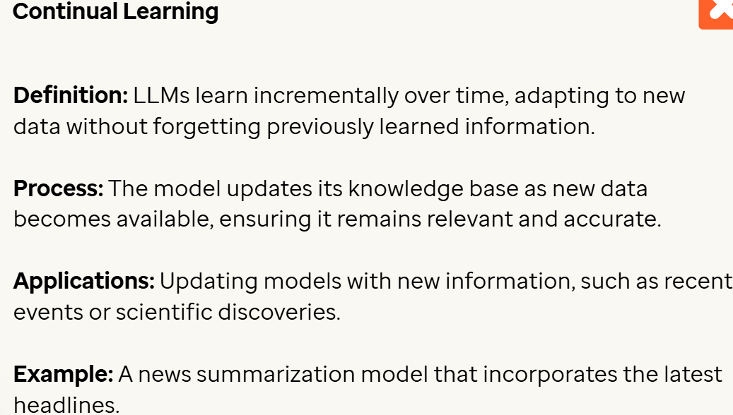

Active Learning 🡪 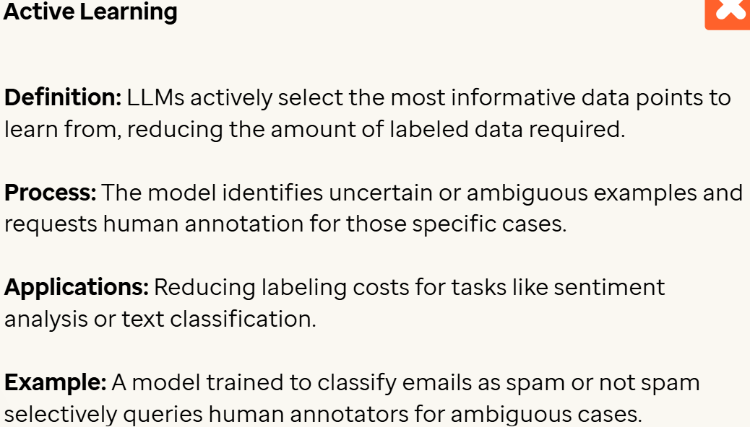

Curriculum Learning 🡪 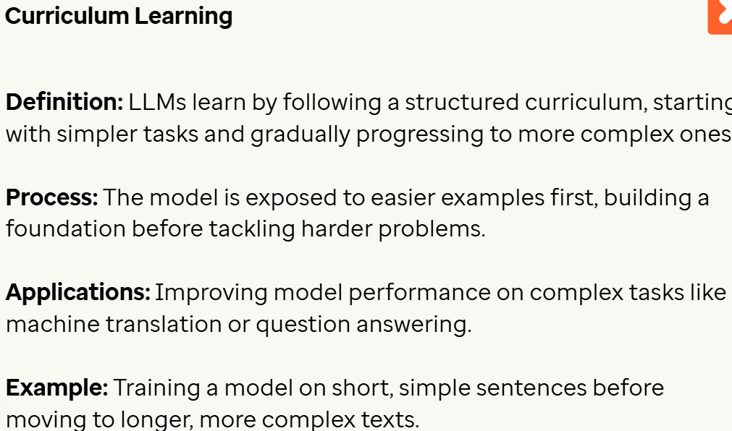

Meta Learning 🡪 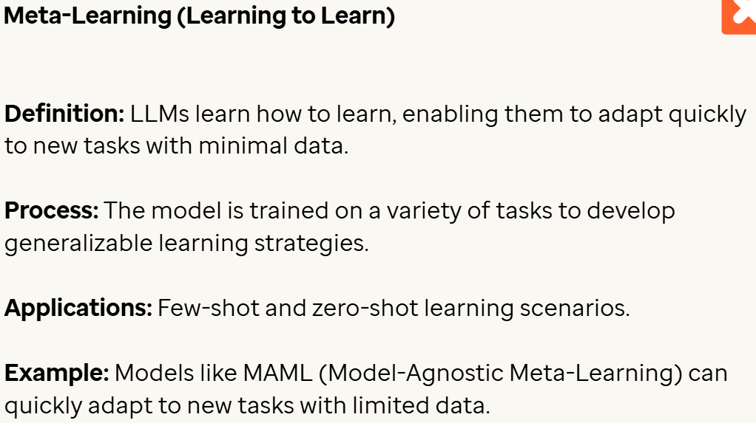

Distillation 🡪 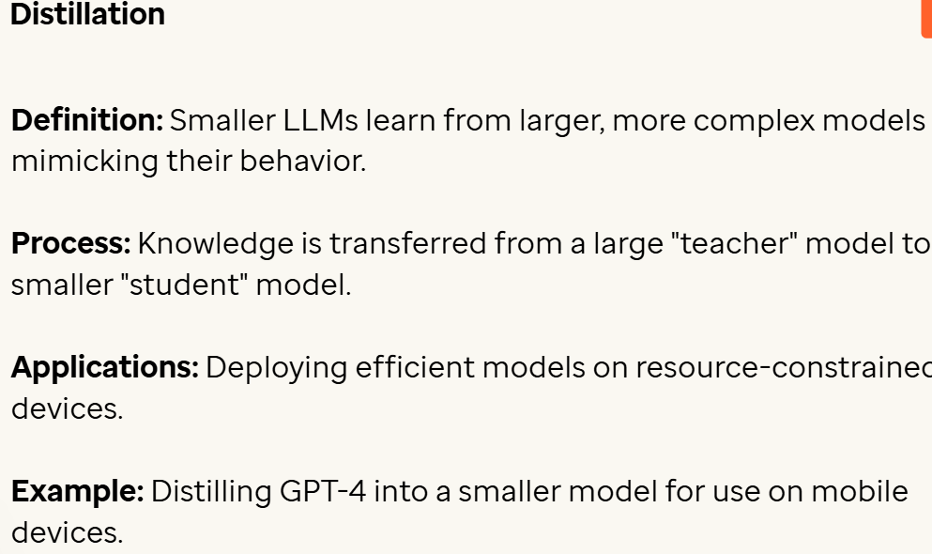

Federated Learning 🡪 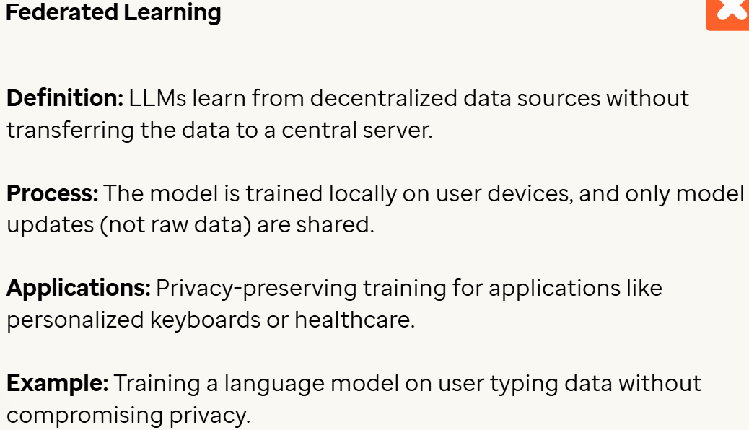

Adversarial Learning 🡪 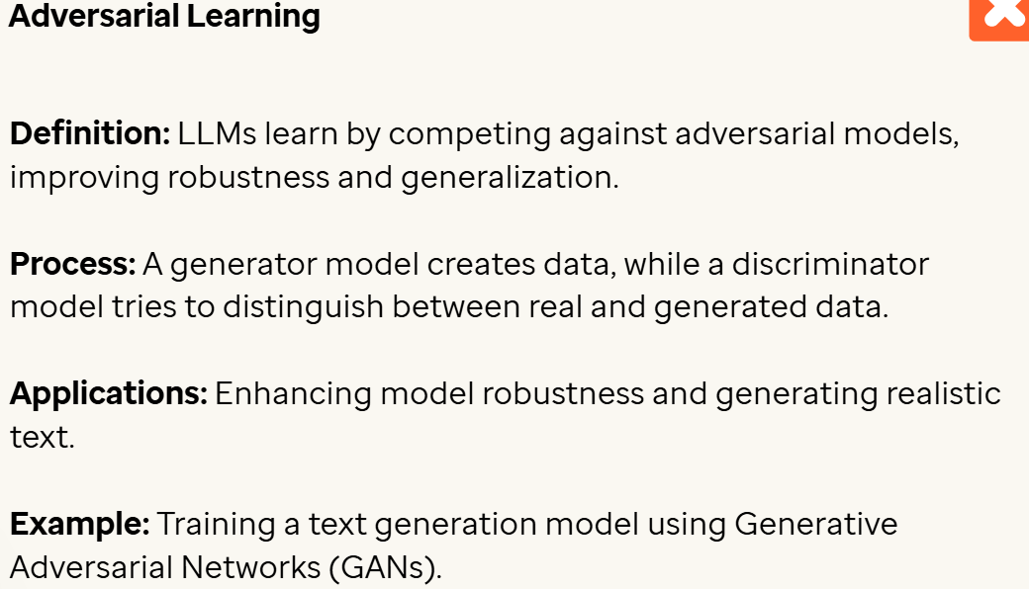

Instruction Tuning 🡪 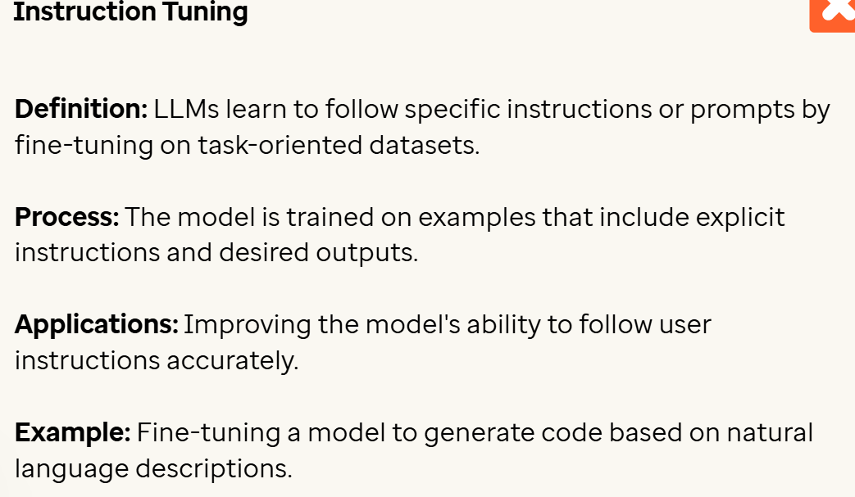

Human-in-the-loop learning 🡪 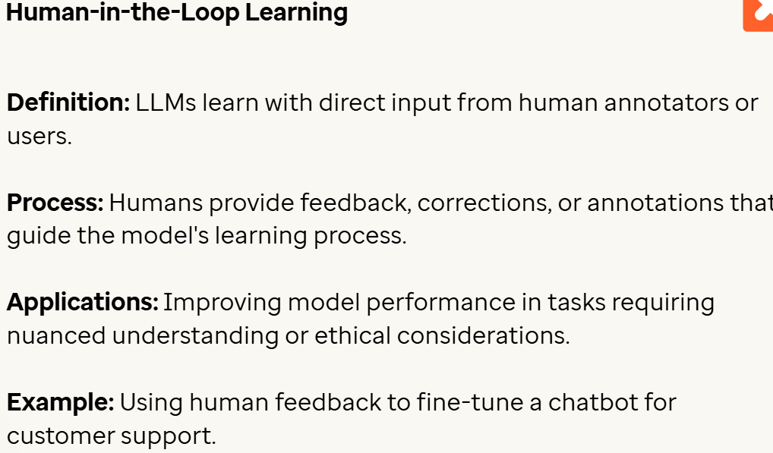

Contrastive Learning 🡪 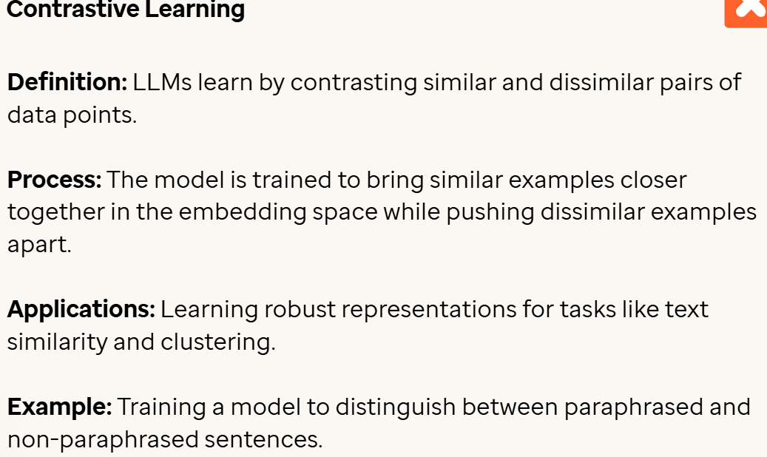

LLM’s architecture 🡪

Not all LLM’s are created equal. Below are the basic models of architecture of LLMs.

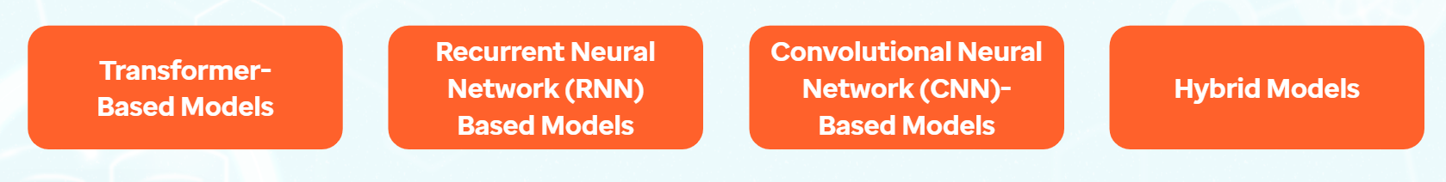

Transformer based models

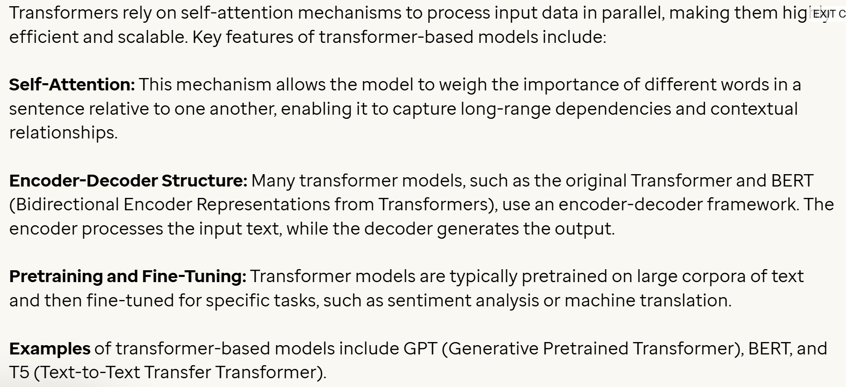

Recurrent Neural Networks (RNNs) models

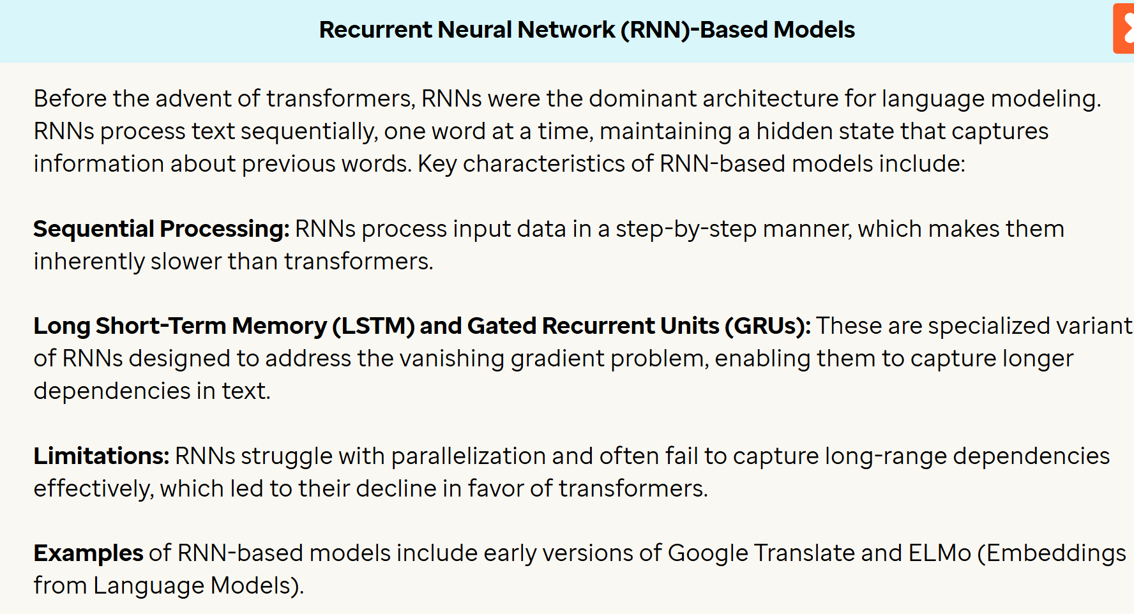

Convolutional Neural Networks

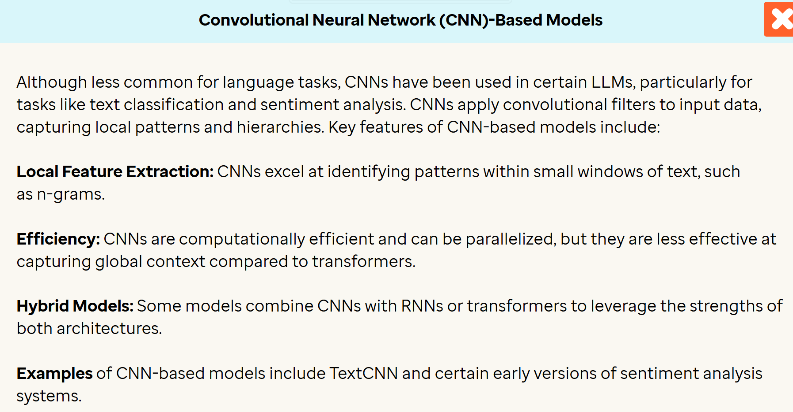

Hybrid Models

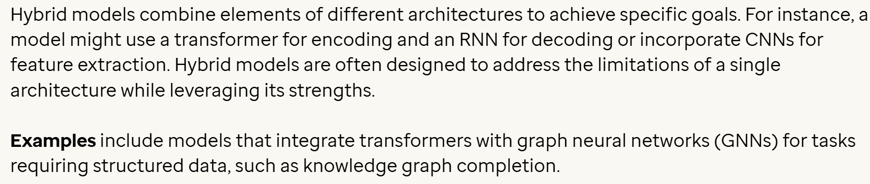

**Strengths:**

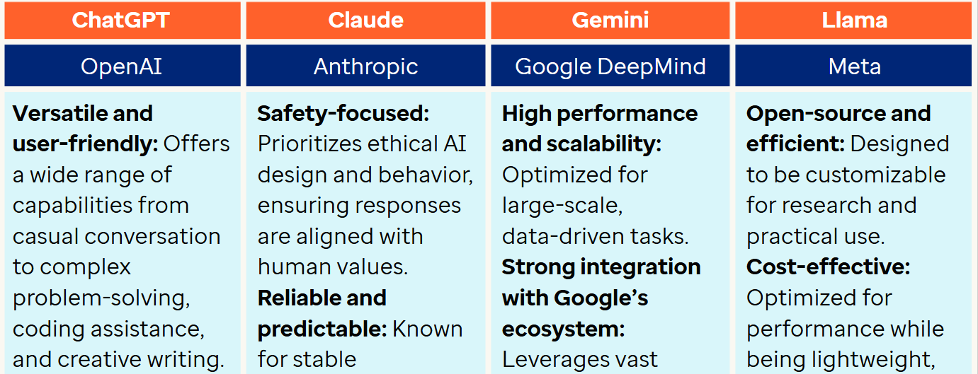

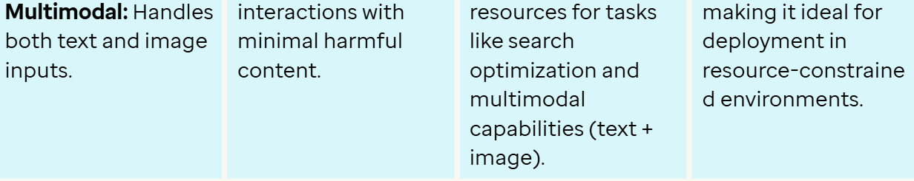

**Best Use Scenarios**

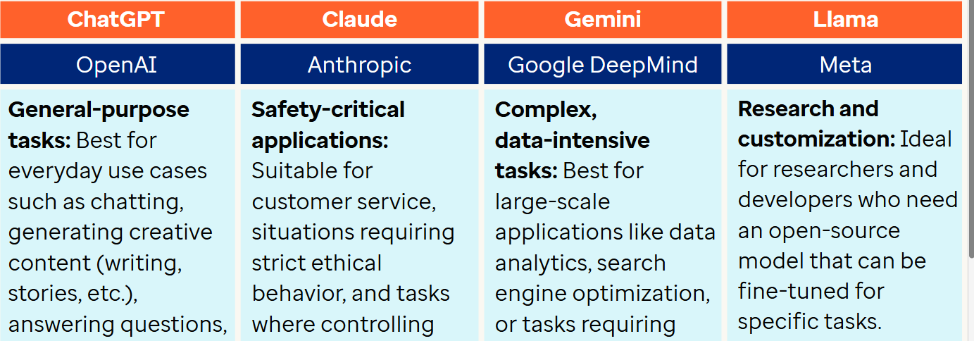

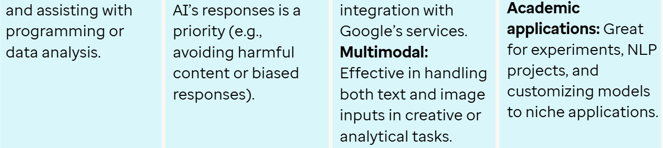

**Use Case**

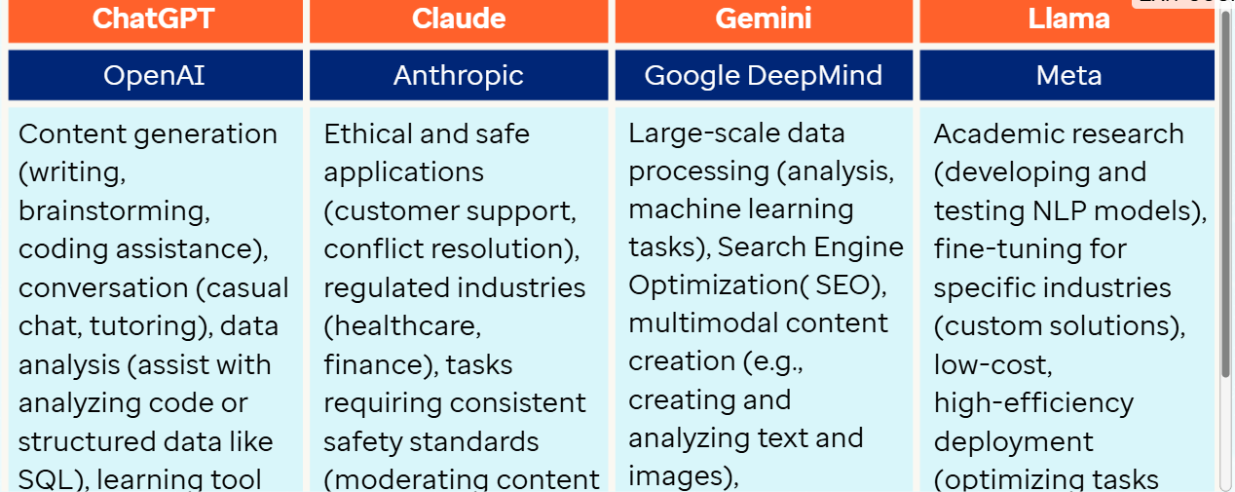

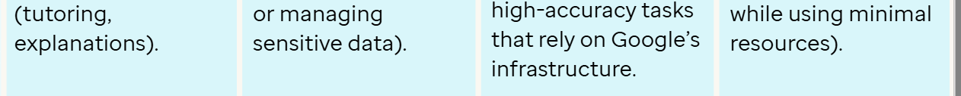

**Focus**

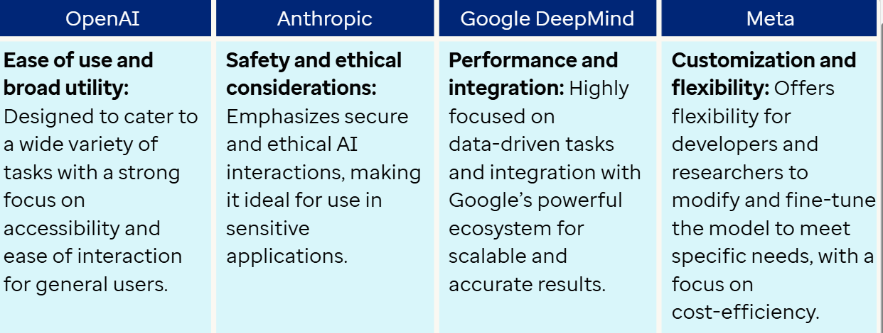

**Scalability**

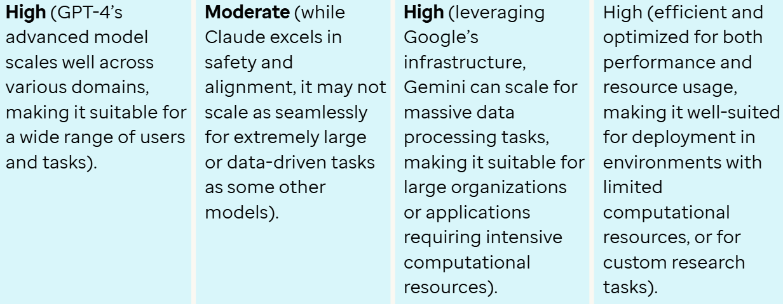

**How to use LLMs**

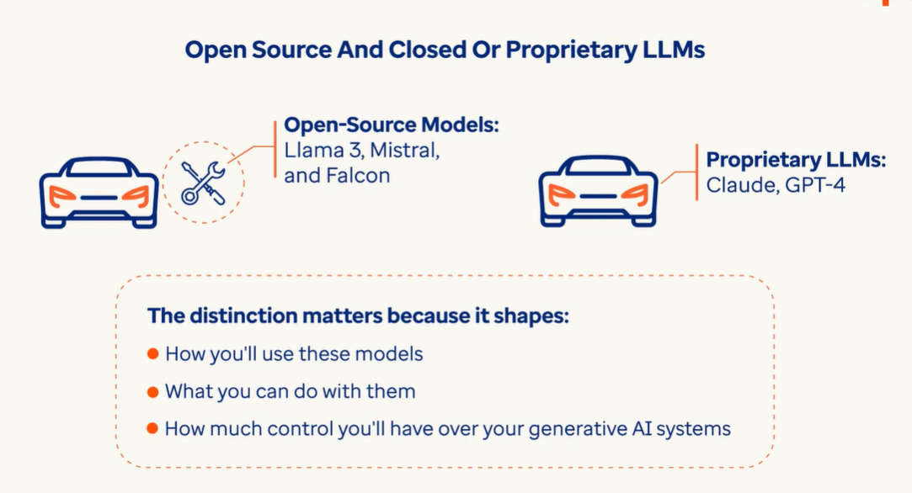

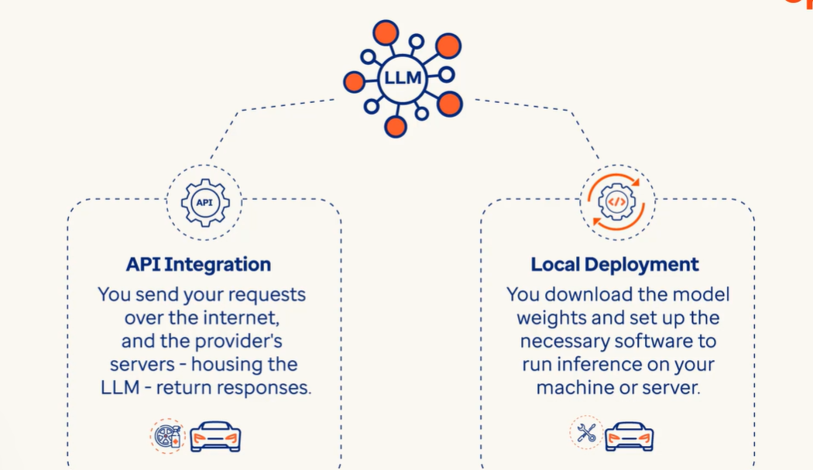

**Local Deployment:**

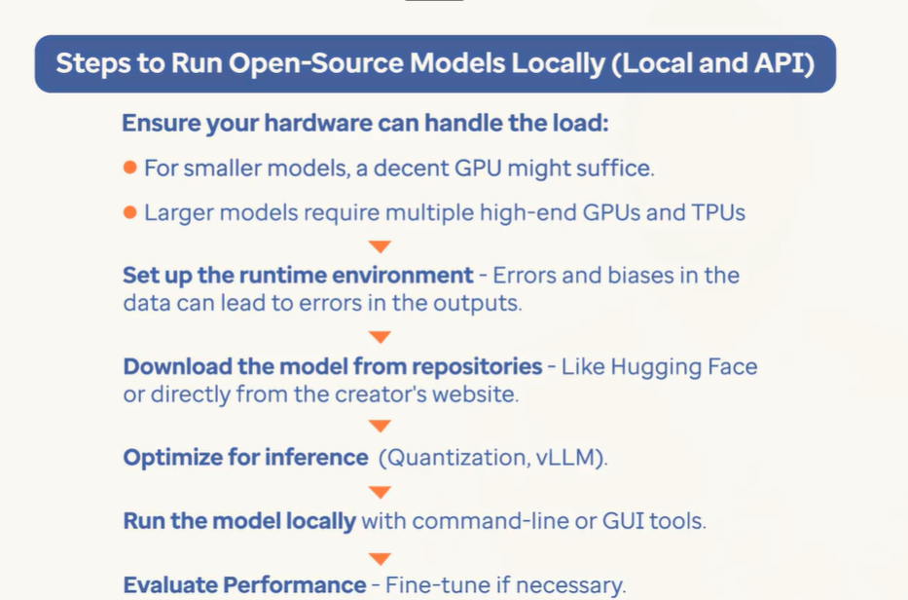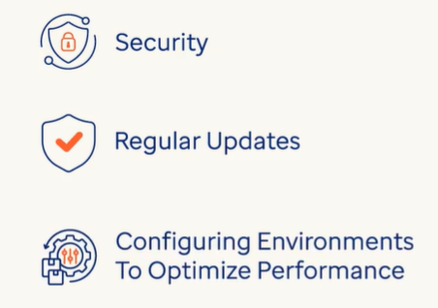

**Open source models via API Services:**

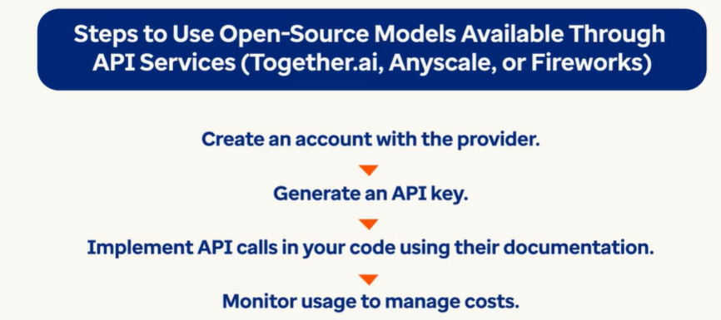

**Proprietary Models:**

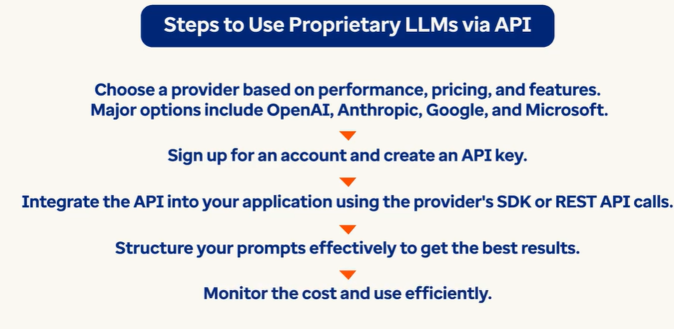

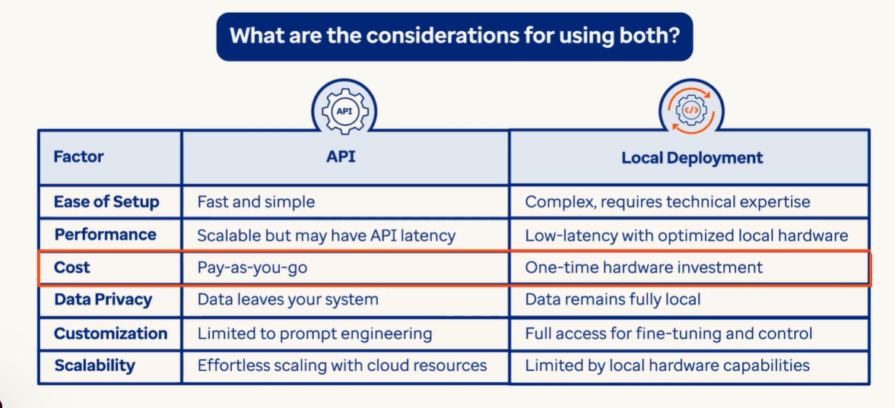

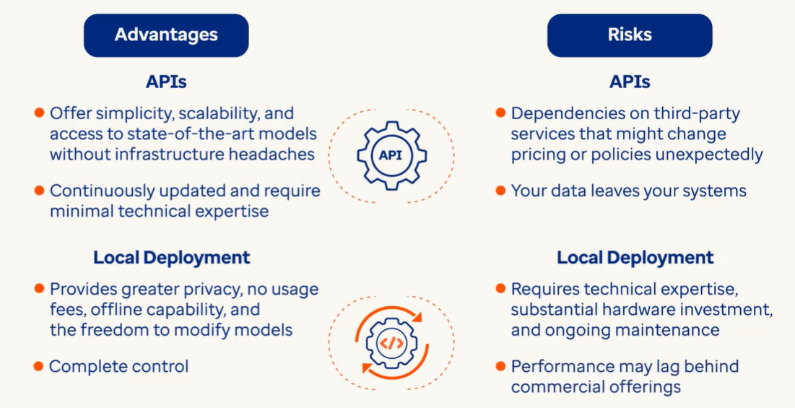

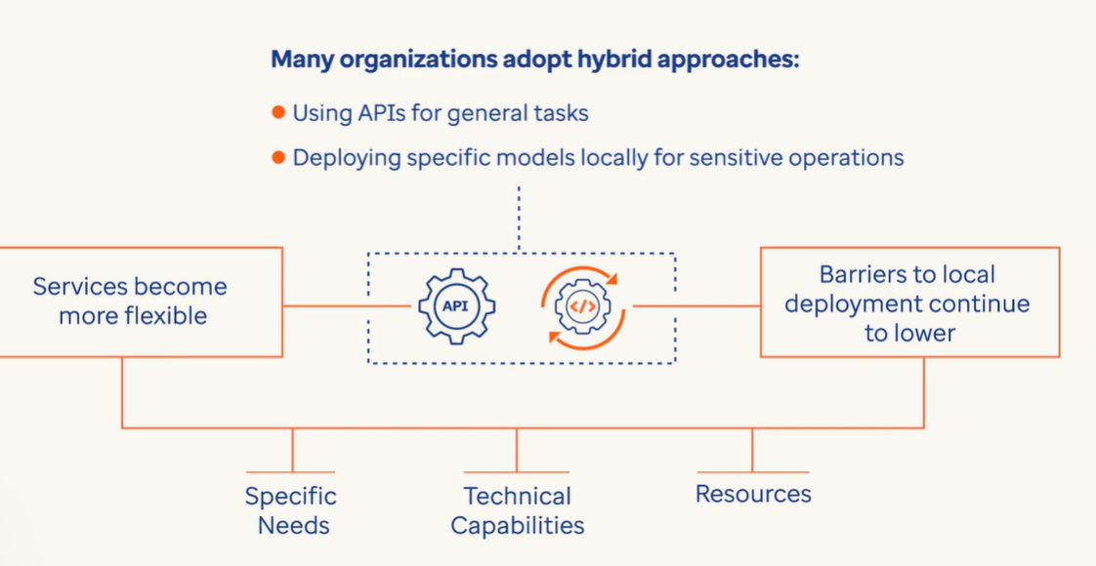

Sample Code:

* import openai
* import os
* import json
* import httpx
* from dotenv import load_dotenv
* from tenacity import (
* retry,
* stop_after_attempt,
* wait_random_exponential,
* )
* # Authentication:
* def get_access_token():
* auth = "https://api.uhg.com/oauth2/token"
* scope = "https://api.uhg.com/.default"
* grant_type = "client_credentials"
* with httpx.Client() as client:
* body = {
* "grant_type": grant_type,
* "scope": scope,
* "client_id": dbutils.secrets.get(scope="AIML_Training", key="client_id"),
* "client_secret": dbutils.secrets.get(scope="AIML_Training", key="client_secret"),
* }
* headers = {"Content-Type": "application/x-www-form-urlencoded"}
* resp = client.post(auth, headers=headers, data=body, timeout=60)
* access_token = resp.json()["access_token"]
* return access_token
* load_dotenv('./Data/UAIS_vars.env')
* endpoint = os.environ.get("MODEL_ENDPOINT")
* model_name = os.environ.get("MODEL_NAME")
* project_id = os.environ.get("PROJECT_ID")
* api_version = os.environ.get("API_VERSION")
* chat_client = openai.AzureOpenAI(
* azure_endpoint=endpoint,
* api_version=api_version,
* azure_deployment=model_name,
* azure_ad_token=get_access_token(),
* default_headers={
* "projectId": project_id
* }
* )

**Create a function to interact with the LLM**

Let us create a generic function to hit the LLM via API and get the responses, so that we can call this function for every task that we need to do. Let us use some of the parameters to set up the LLM. One can configure a few parameters to get different results for the prompts. Tweaking these settings are important to improve reliability and desirability of responses and it takes a bit of experimentation to figure out the proper settings for specific use cases. The parameters used in this code are:

* **prompt_messages:** The message that has to be passed to LLM as a prompt. This can be in JSON format and one can give multiple roles and content for each role.
* **max_tokens:** This is the maximum number of tokens the model can generate in a single response. The default value for GPT 4 is 4096. As we are using gpt-4o model, we will use this default value.
* **temperature:** The value of this parameter ranges from 0 to 2. Lower the temperature, the more deterministic the results in the sense that the highest probable next token is always picked. Increasing temperature could lead to more randomness, which encourages more diverse or creative outputs.
* **top_p:** The value of this parameter ranges from 0 to 1. If you are looking for exact and factual answers keep this low. If you are looking for more diverse responses, increase to a higher value.
* @retry(wait=wait_random_exponential(min=45, max=120), stop=stop_after_attempt(6))
* def query_llm(prompt_messages, max_tokens=4096, temperature=1.0, top_p=1.0):
* response = chat_client.chat.completions.create(
* messages=prompt_messages,
* max_tokens=max_tokens,
* temperature=temperature,
* top_p=top_p,
* model=model_name
* )
* return {'text': response.choices[0].message.content}

**Simple Query to LLM**

Let us test the connection by writing a simple query. When we write query message, it can be of a different role, which influences how the model may interpret the input. Following are the various roles:

* **user:** When user role is used, the message is treated as a request. It is similar to messages you would type in ChatGPT as an end user.
* **developer:** When developer role is used, the instructions given are prioritized ahead of user messages, following a chain of command. This role is going to instruct the model how it should behave and how it should respond to an end user. Older versions of LLMs had system as a role for the same purpose.
* **assistant:** assistant is for messages the model generated earlier. It can also be used to provide examples to the model for how it should respond to the current request.
* query = "List top 5 commonly used classification models used in machine learning"
* prompt_messages = [
* {"role": "user", "content": query}
* ]
* response = query_llm(prompt_messages)
* print(response['text'])

**Comments on model output:**

* The user query to list 5 commonly used classification models in ML, is passed to LLM and LLM responds with 5 models.
* Please note that output of LLM is always non-deterministic, and the above output may vary for each execution. Also, if there is a change in LLM model (like gpt-4o-mini, gpt-3.5-turbo etc.), then there will be a variation in output display format as well.

**Text Summarization**

AI based summarization falls in two categories :

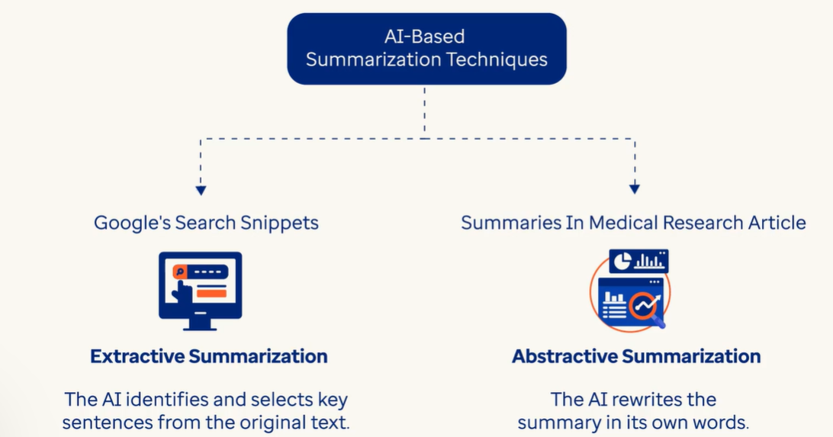

Sentiment Analysis:

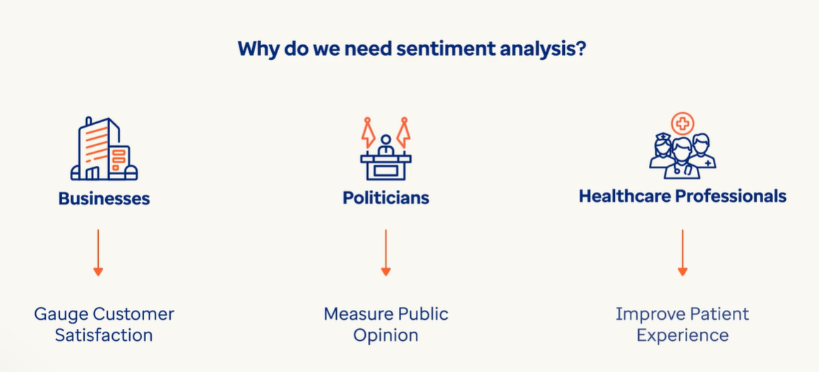

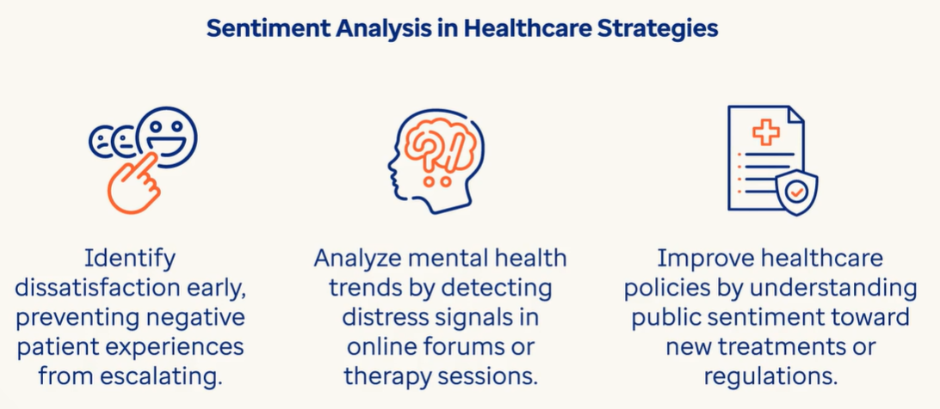

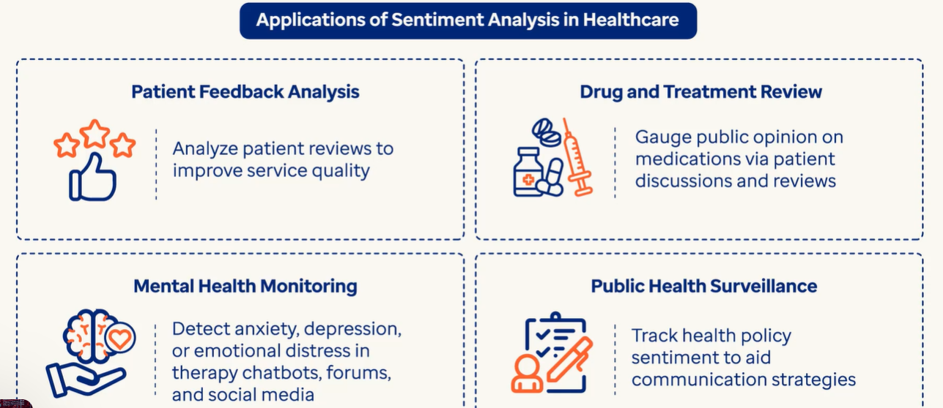

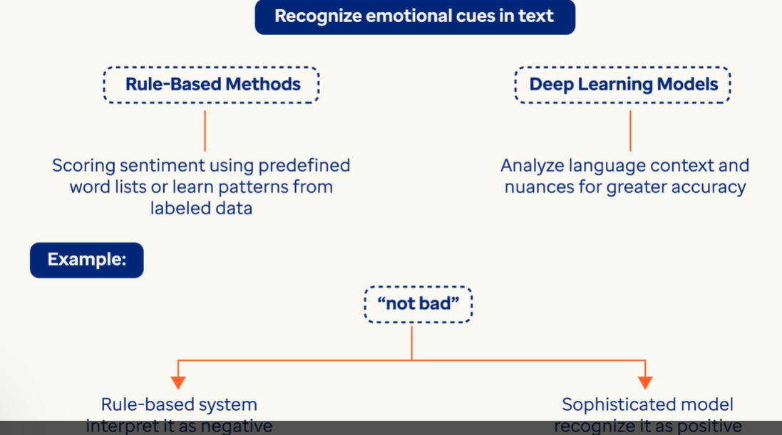

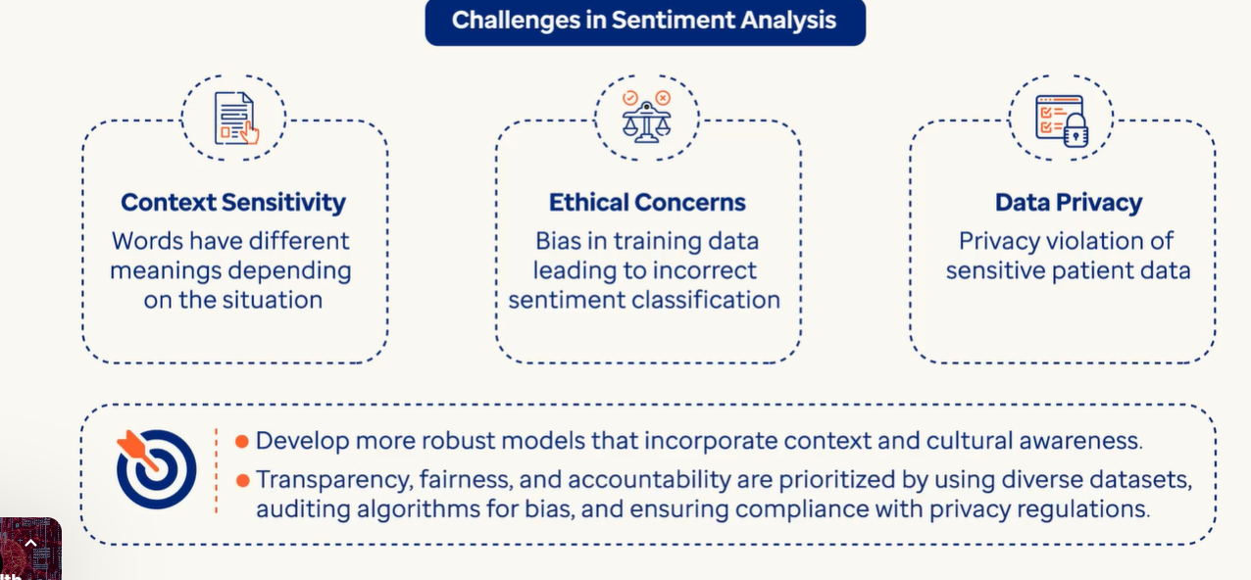

Fine Tuning

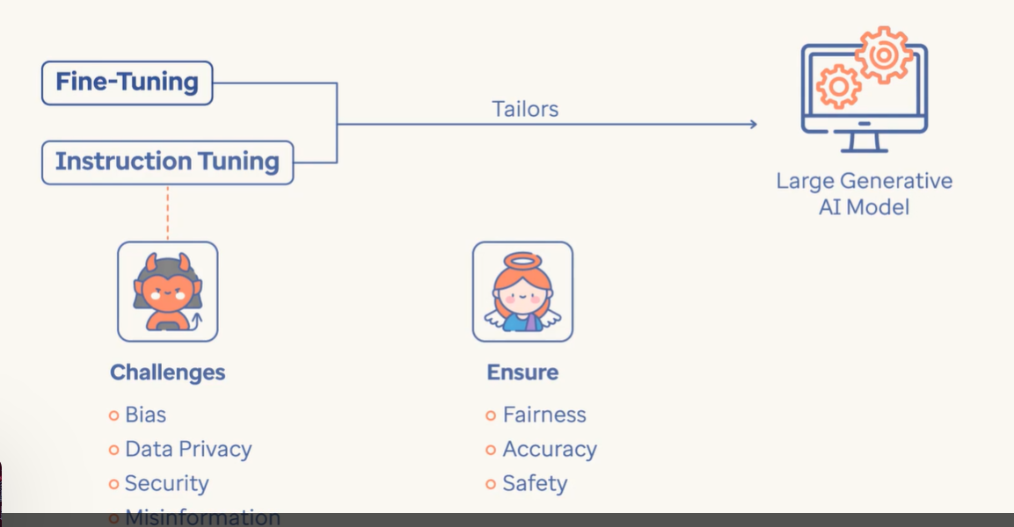

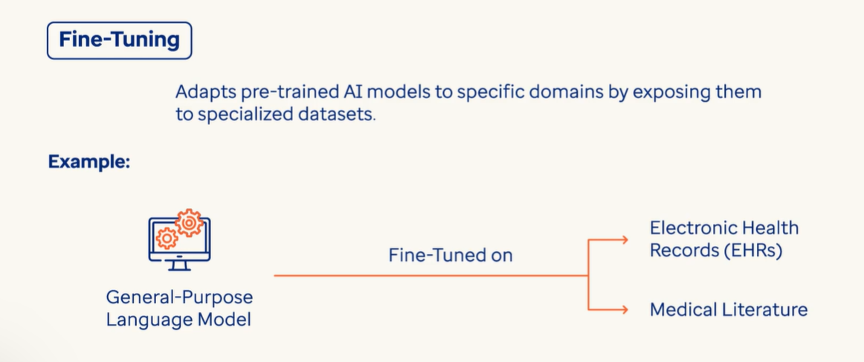

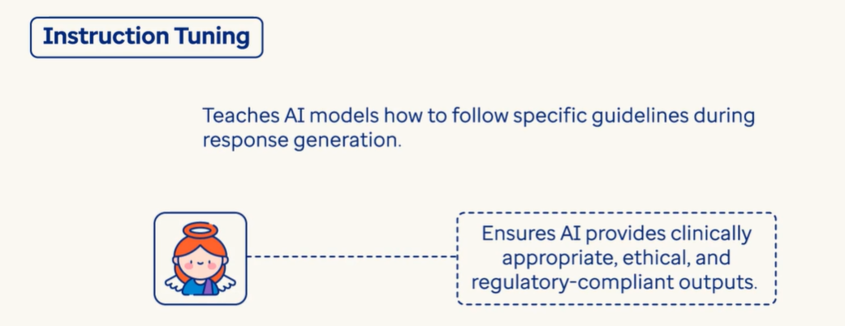

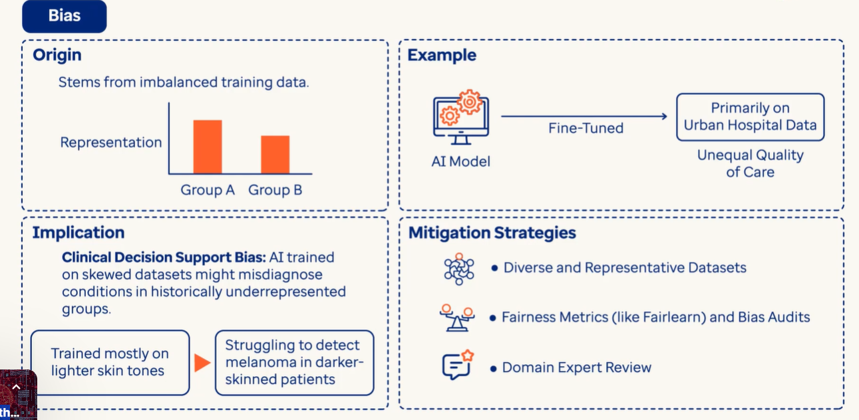

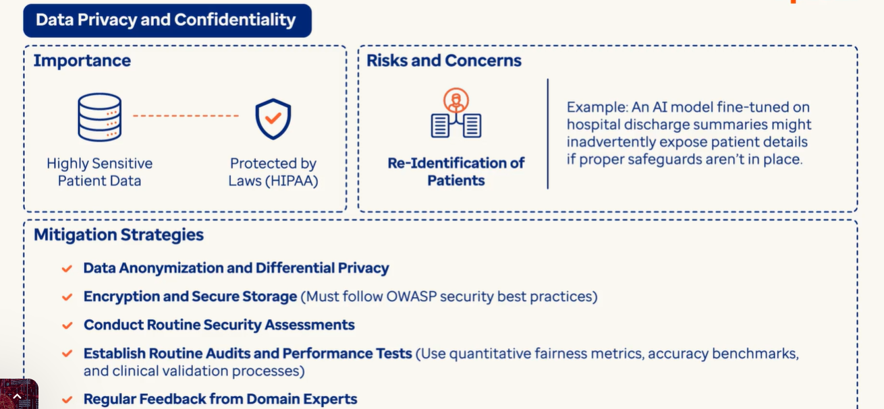

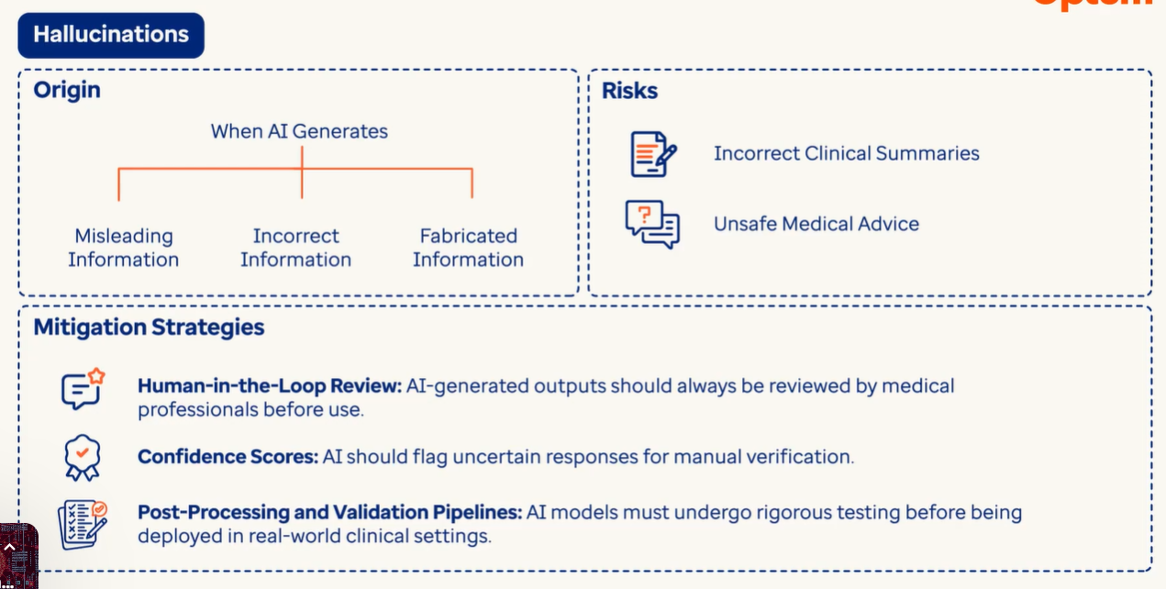

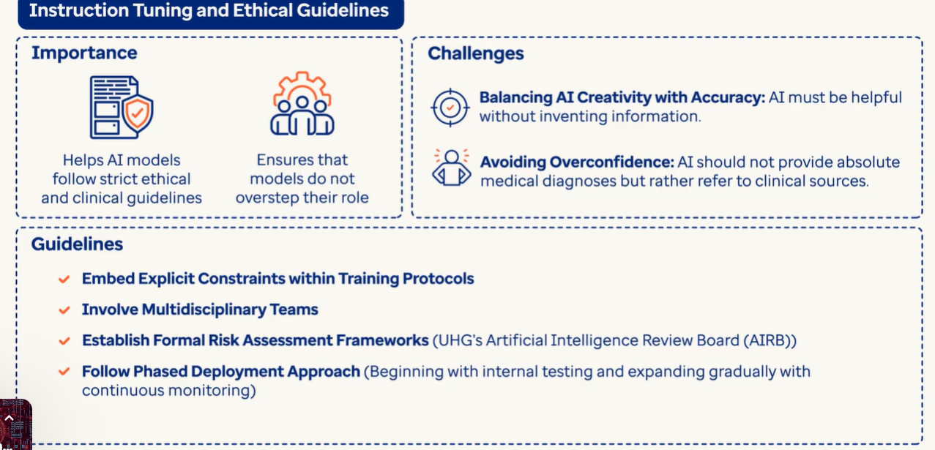

**Prompt Engineering:**

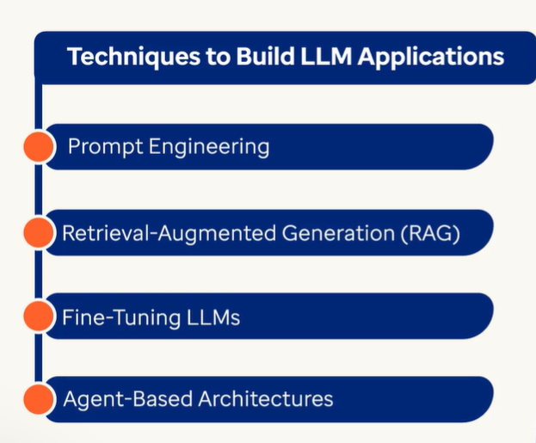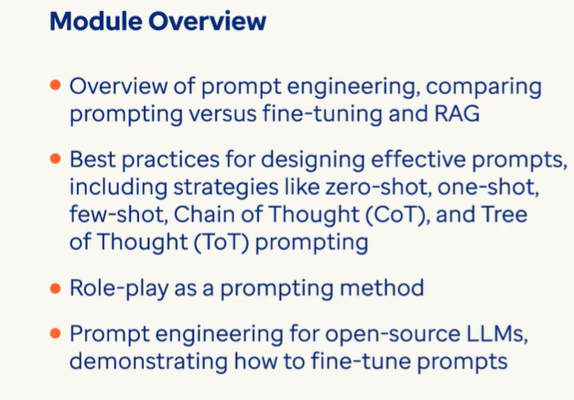

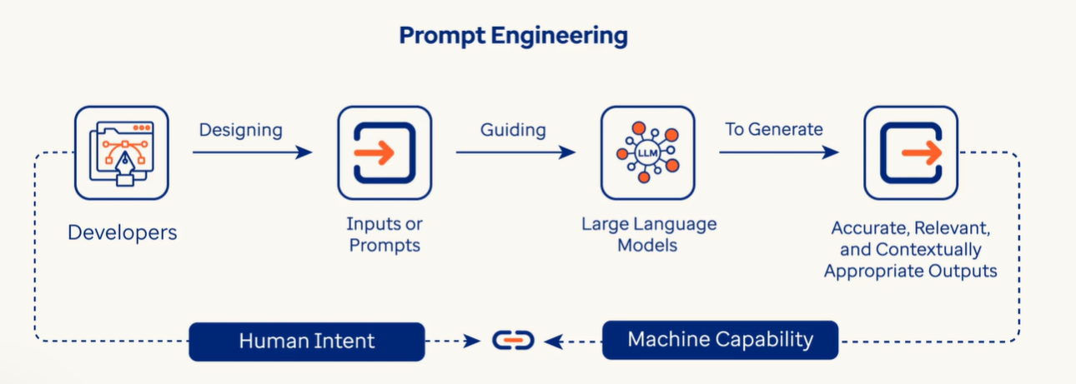

* **Prompt Engineering** is the art and science of designing and optimizing prompts to guide AI models, particularly Large Language Models (LLMs), towards generating the desired responses.
* Following key-elements helps to design a good prompt:
  + **Context:** Providing relevant background information to help the model understand the task.
  + **Instructions:** Clearly stating what the model needs to do.
  + **Examples:** Showing the model how to respond in specific situations.
  + **Format:** Using appropriate language and structure for the prompt.

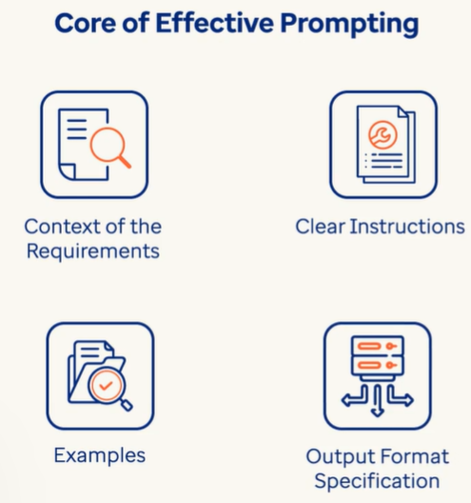

* 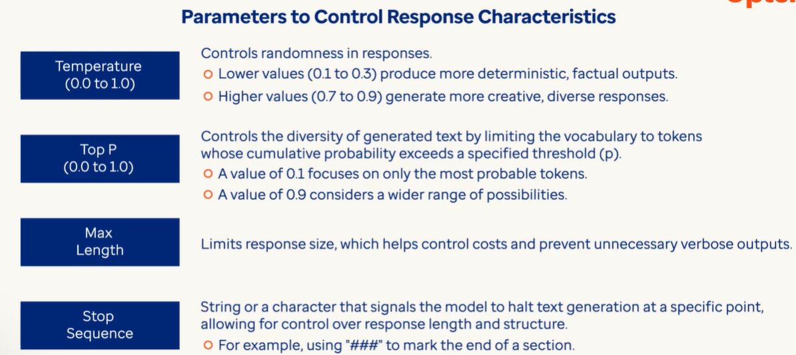

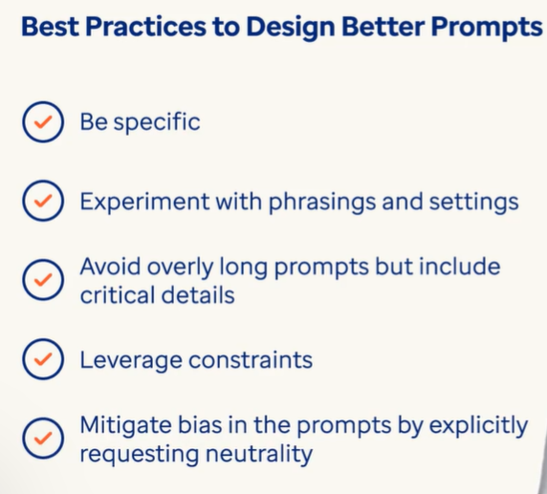

**Fine Tuning LLMs:**

* 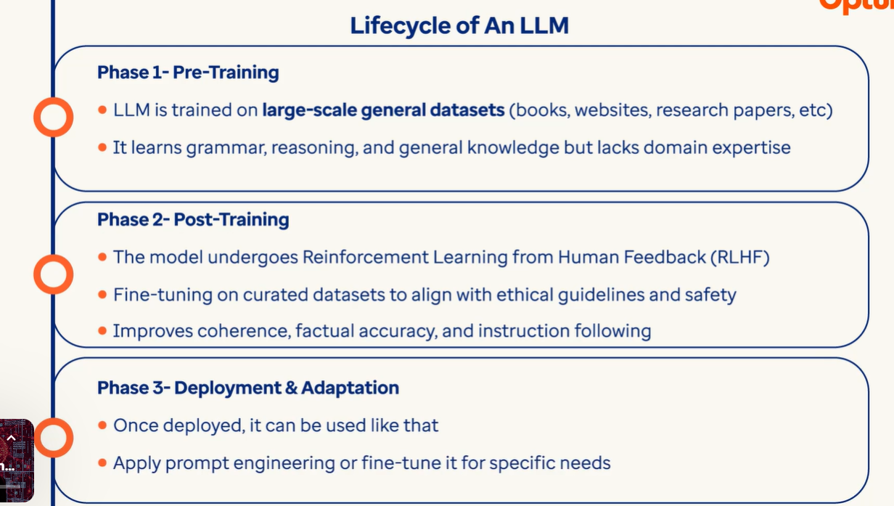

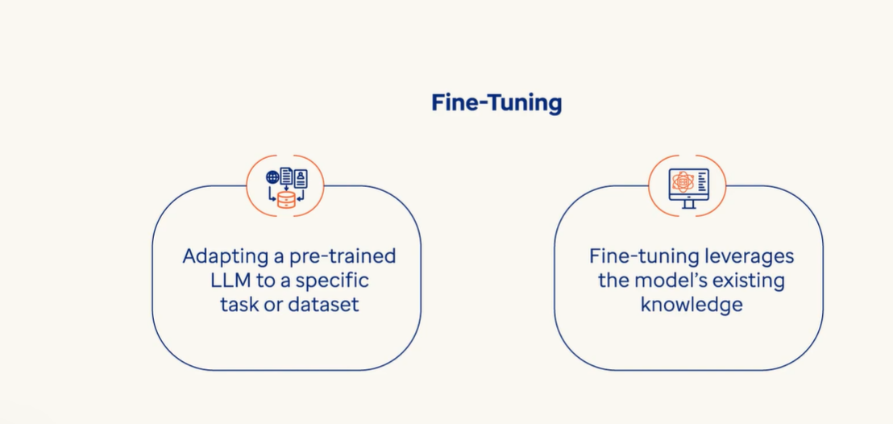

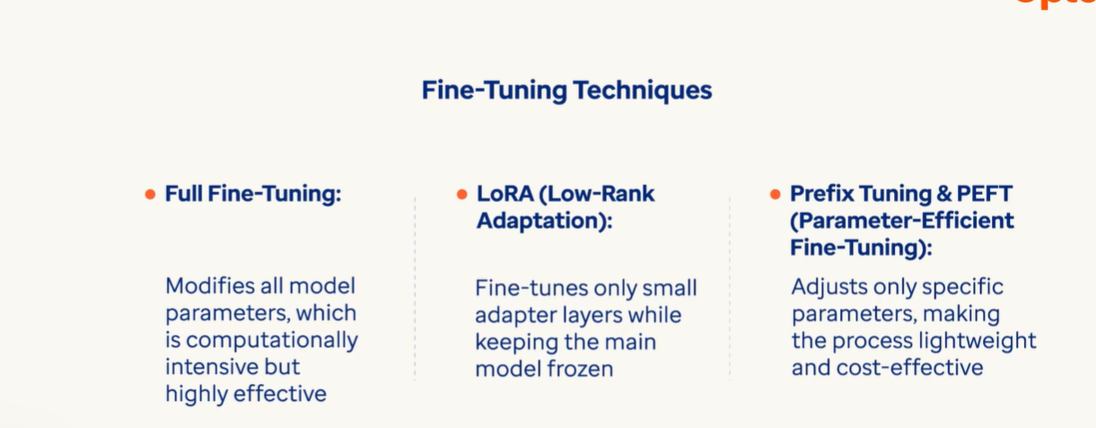

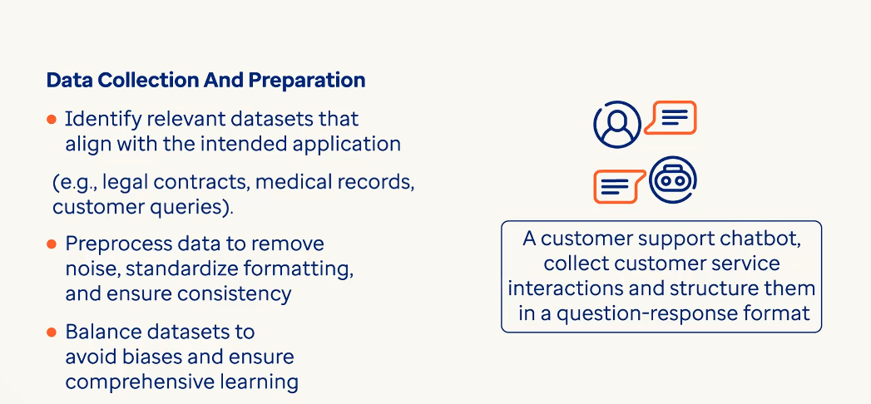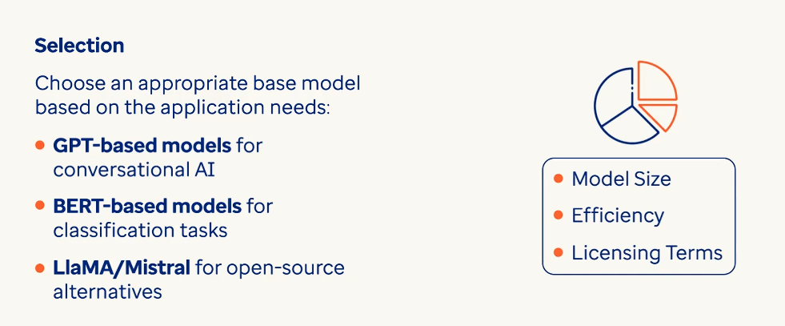

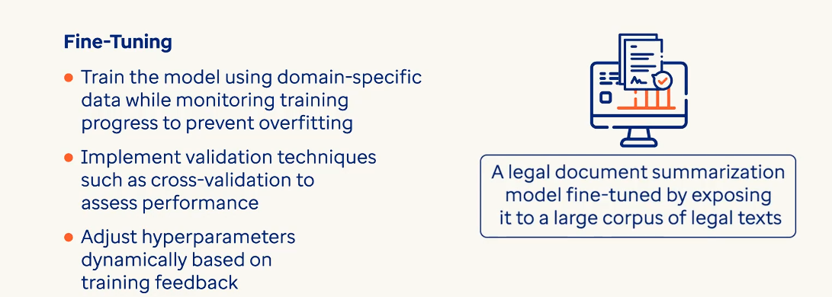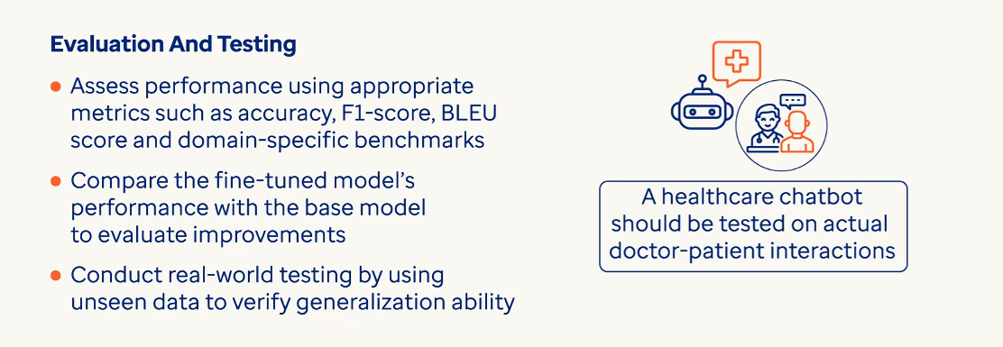

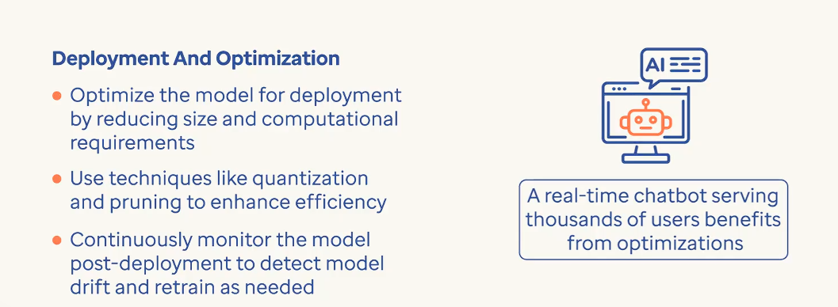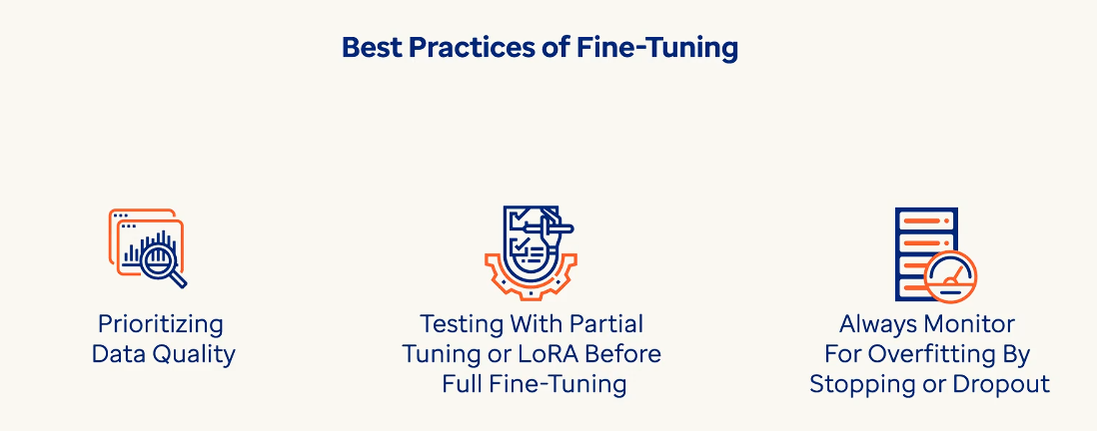

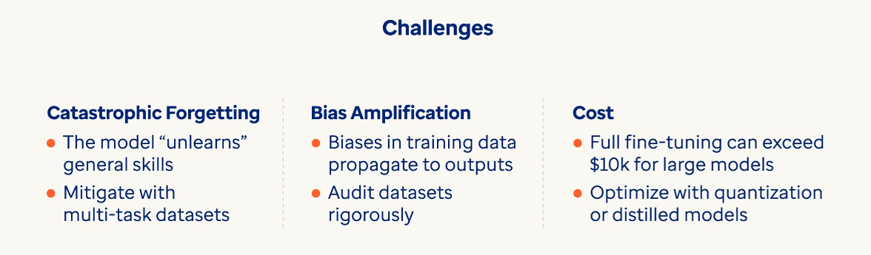

**RAG (Retrieval Augmented Generation) 🡪** It equips LLMs to look for real time data and for any domain specific information from external sources before generating a response. It’s effectiveness relies on the input sources provided through RAG model. These sources include mostly a list of documents that help RAG model to retrieve accurate and contextual data compared to retrieving information from a generic LLM.

0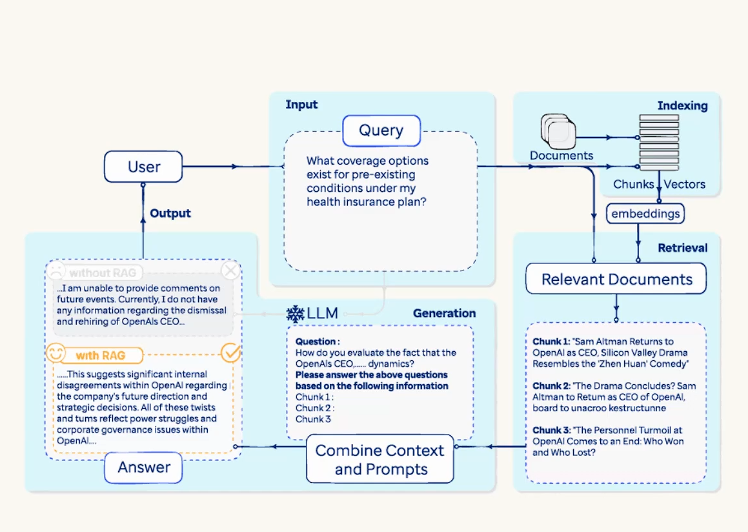

0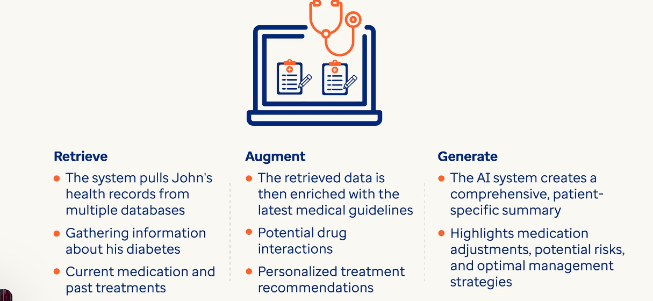

RA G uses **indexing** a technique where documents are processed and converted into searchable embeddings, **retrieval** a technique where relavant documents are identified based on user’s query context and retrieved information is merged with original query, **generation** when the LLM generates a contextually rich response.

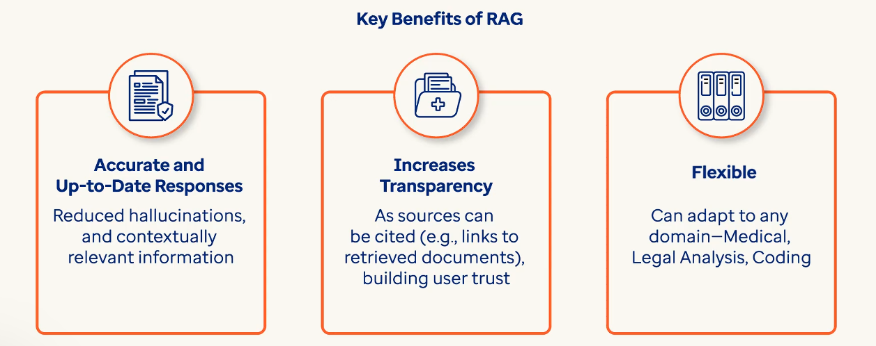

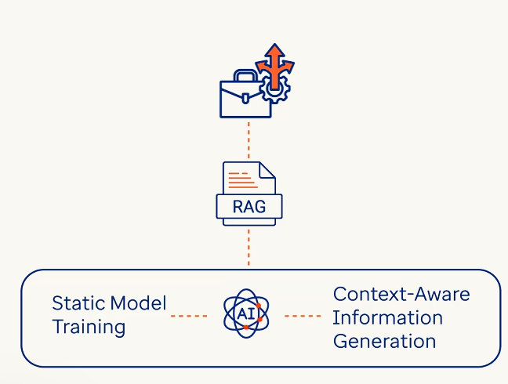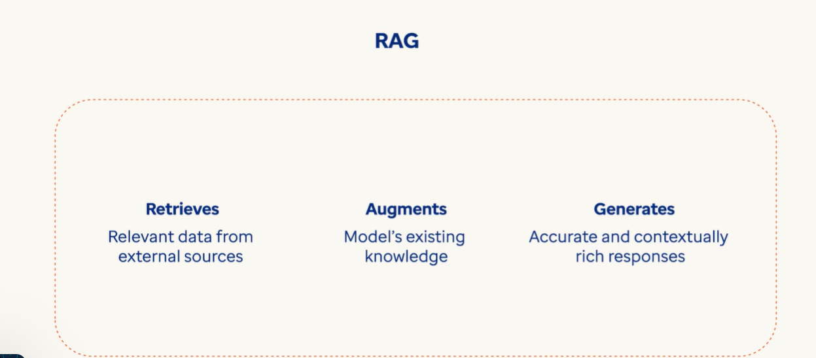

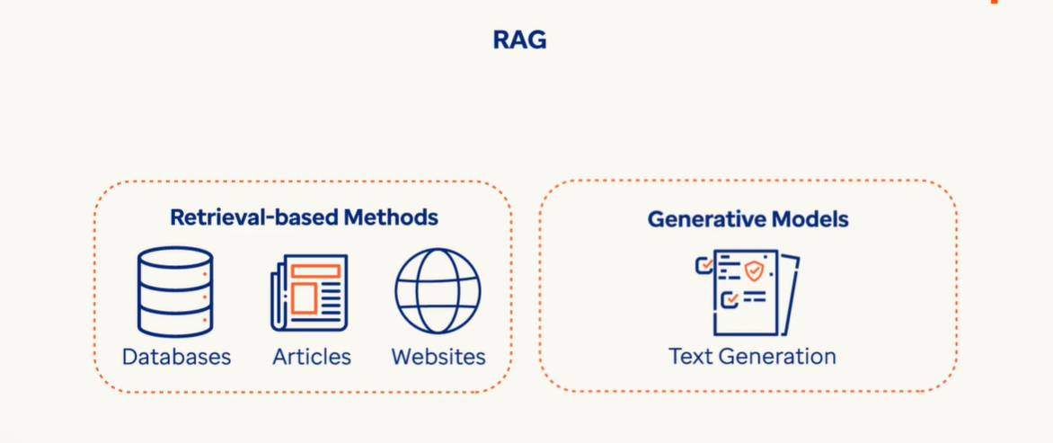

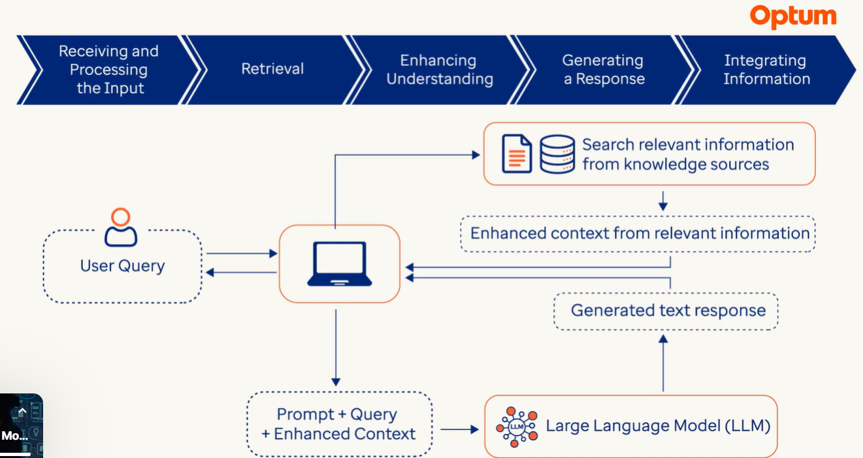

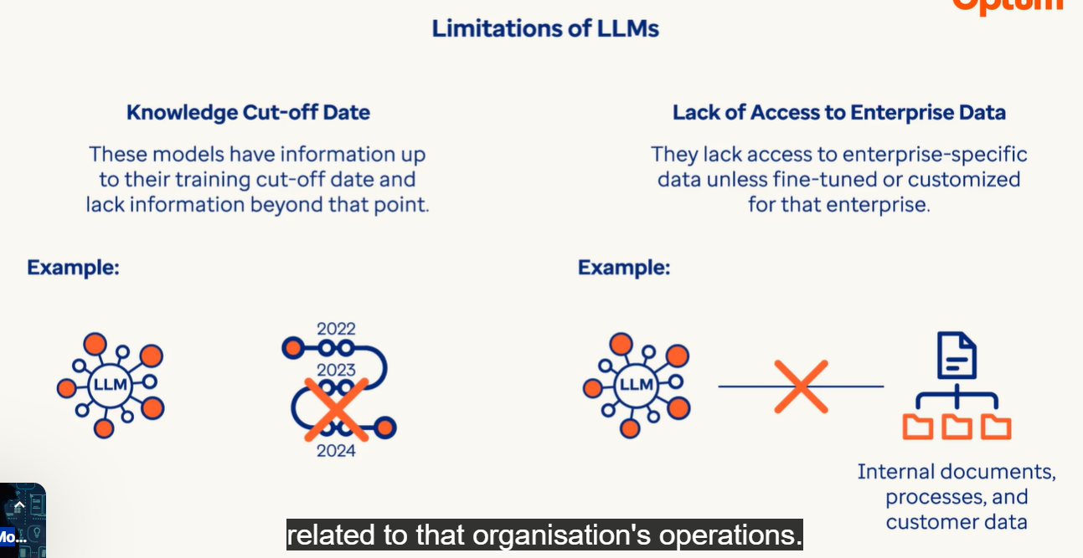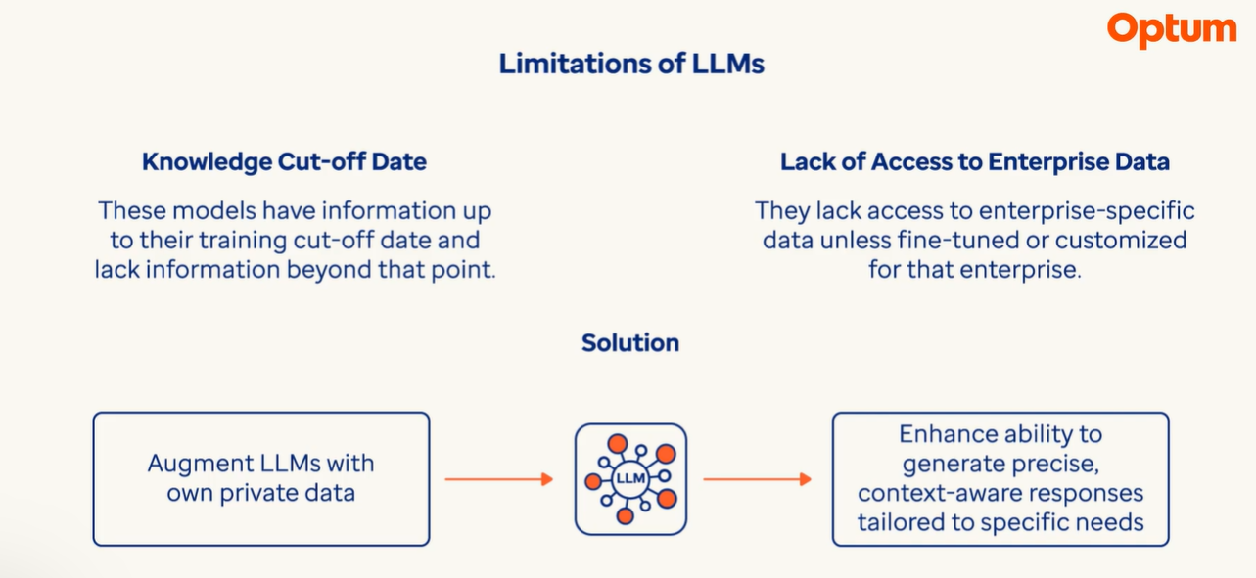

The idea behind RAG is to store your data into a vector database where it’s indexed and embedded into vectors.

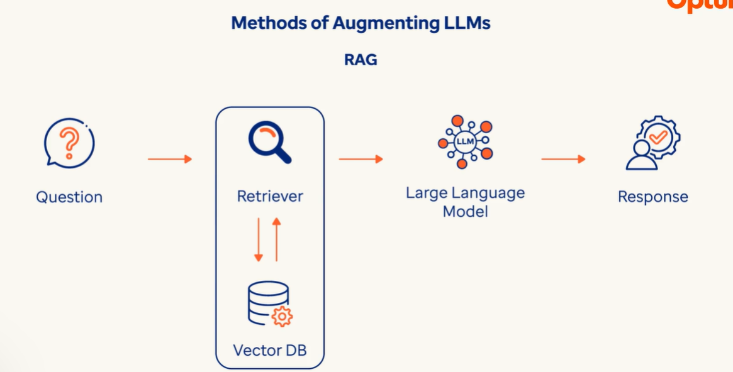

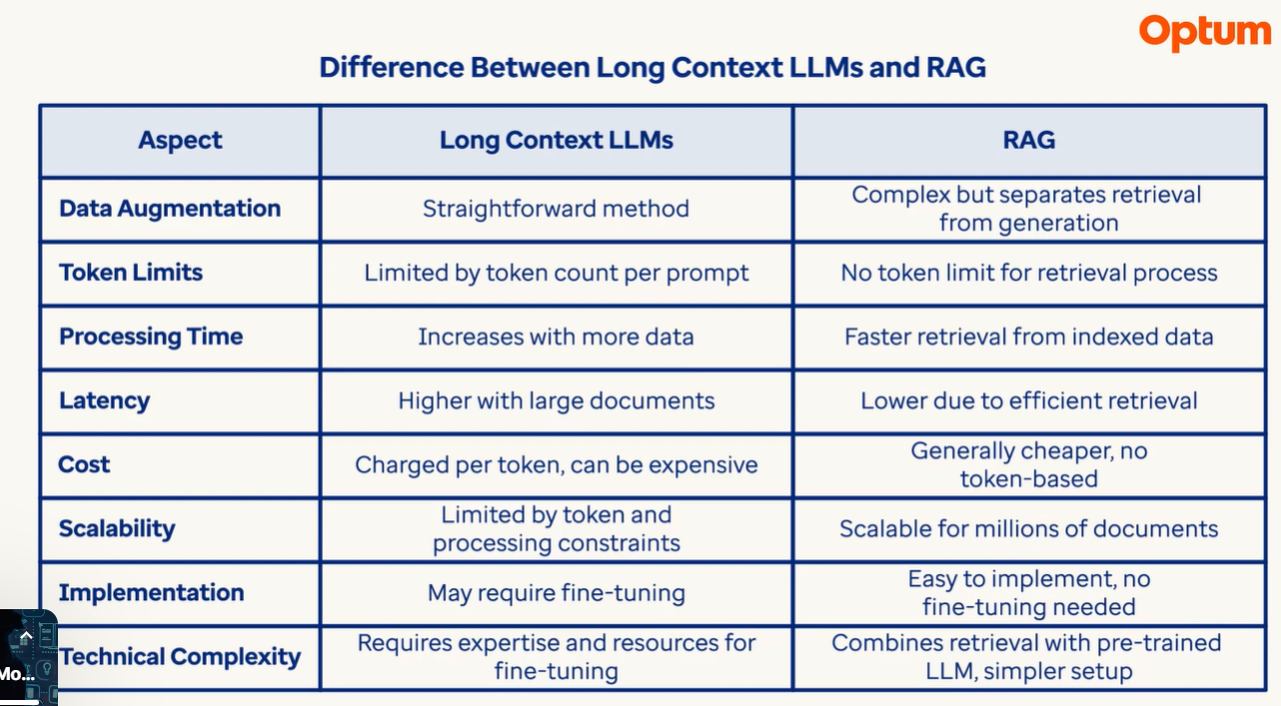

**RAG Framework**

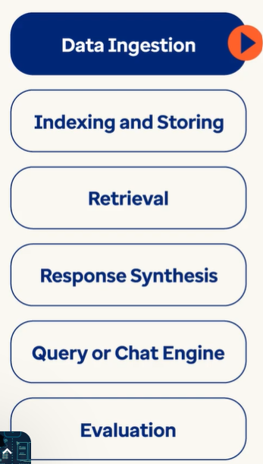

Data Ingestion 🡪 System gets the required data from documents, databases, API or online content. Here the data can be either structured, unstructured or programmatic data generated by API.

Indexing and Storing 🡪 In this phase each document is split into various chunks and necessary vector embeddings are created for them. A vector embedding is a numeric representation of textual data. Now all these vectors are stored in a vector database.

Retrieval 🡪 The main goal in this step is retrieve documents that could contain answers to user’s query. User’s query is converted to query embedding and retriever algorithm identifies relavant embeddings/chunks related to user’s query from the vector database. This picks up Top K chunks.

Response Synthesis 🡪 In this step top k relavant chunks along with user’s query are passed to this module. This module has the LLM to generate the right response.

Query or chat Engine 🡪 In this step all the compoents come together. Retrieval and Response synthesis in conjunction with Query or Chat engine create a RAG pipeline. This pipeline allows users to query in natural language and receive responses making the whole process seamless and efficient. Example: A chatbot introduced in EHR can answer complex questions like ‘Show the data of all patients who BP has been more than 180 in the last 2 months’.

Evaluation 🡪 It is relavant to evaluate the RAG pipeline from time to time to see the answers it generates.

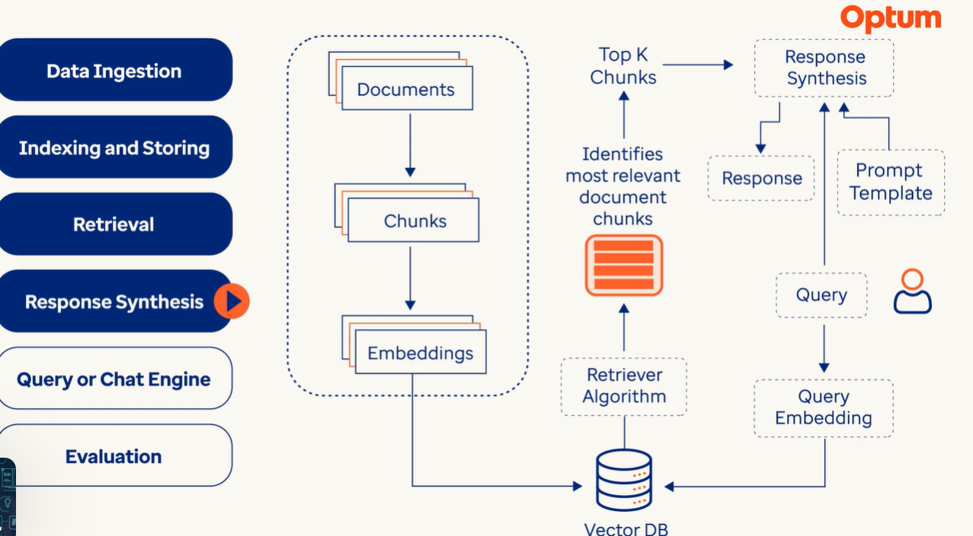

**Agentic AI Systems:**

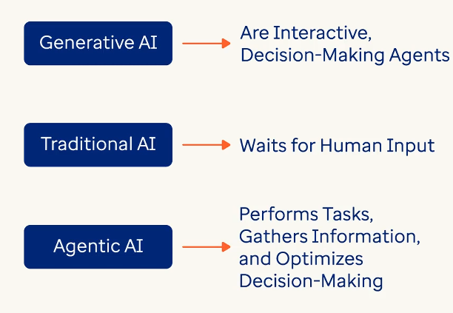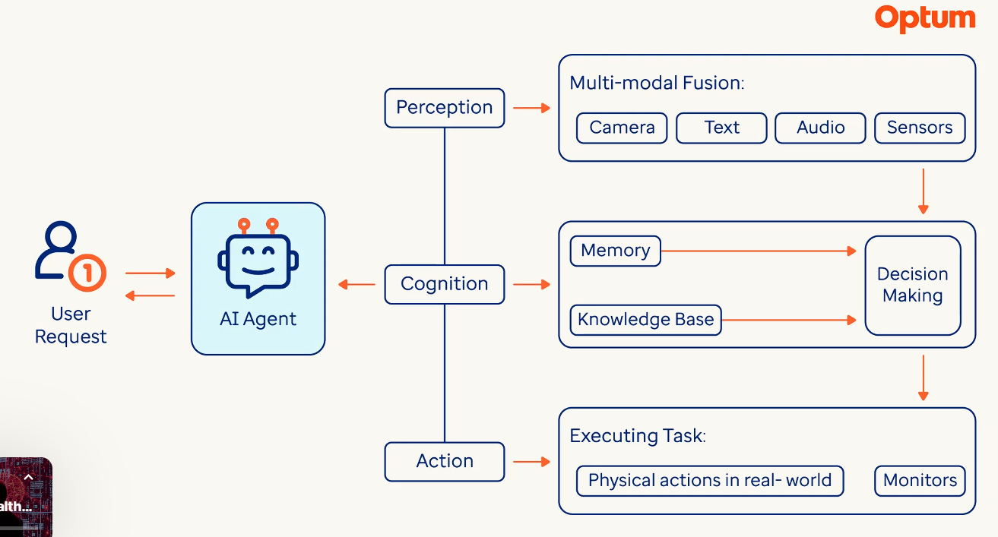

**Agentic AI Systems** refer to AI systems that autonomously analyze, reason and act on their beyond just generating outputs.

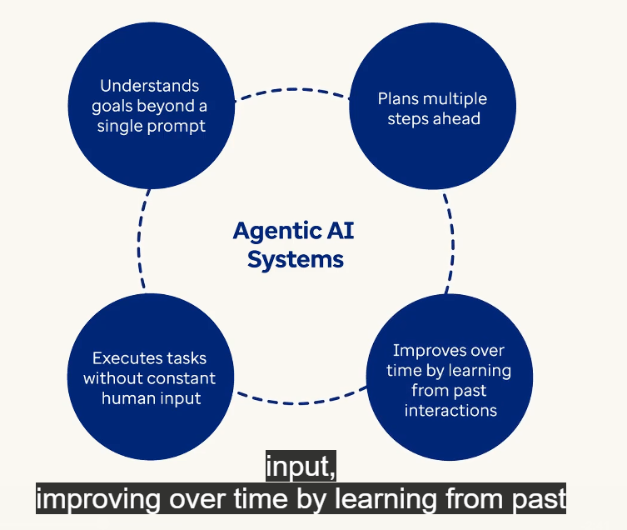For example: If a developer may ask for bug fixes Agentic AI systems can plan for the best approach, like debug the code step by step and take actions independently, for example run tests and suggests fixes. These abilities make Agentic AI best for automating complex tasks.

Agentic AI is best suited for multi step dynamic environments where traditional AI models would require constant human interaction.

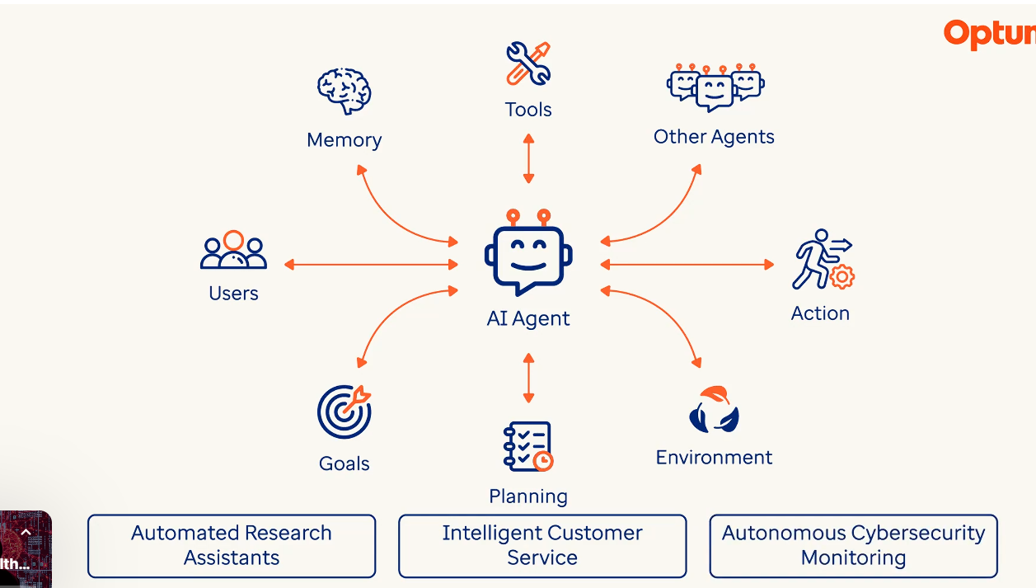

Multi Agents:

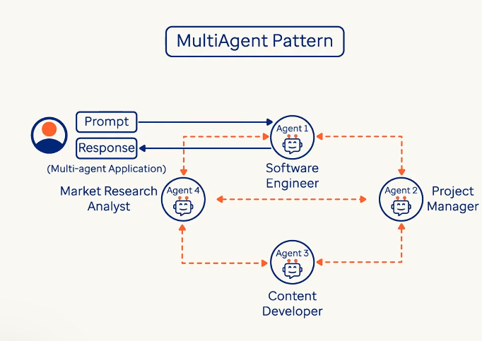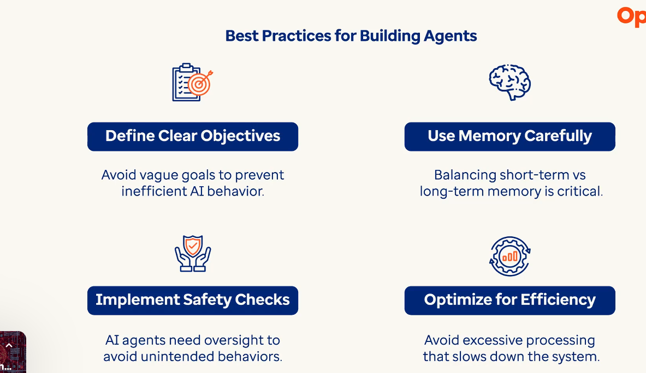

**Prompt Engineering Techniques:** LLMs process the prompts sequentially passing each token to predict the next logical output based on the patterns in their training data.

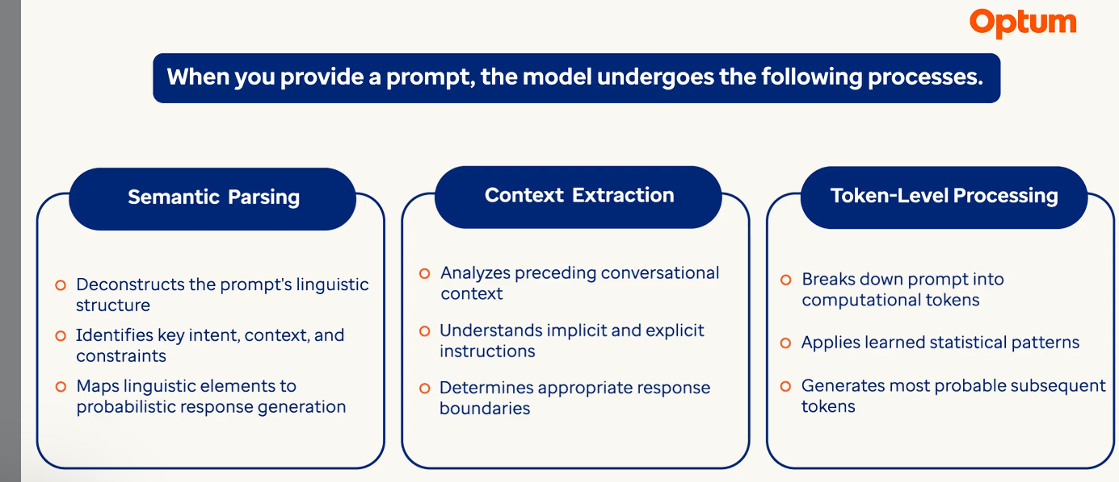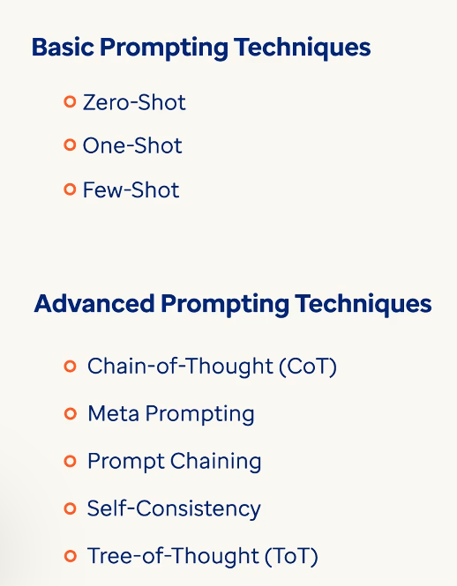

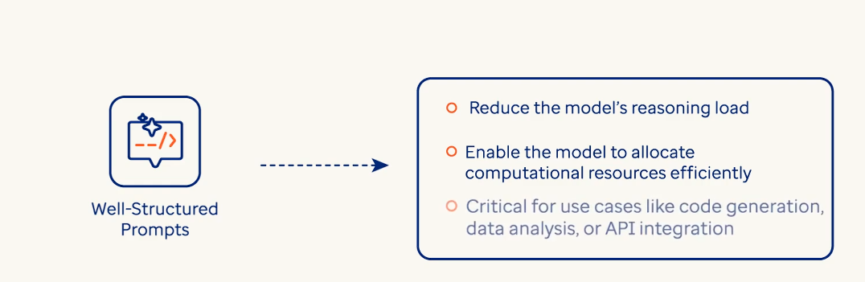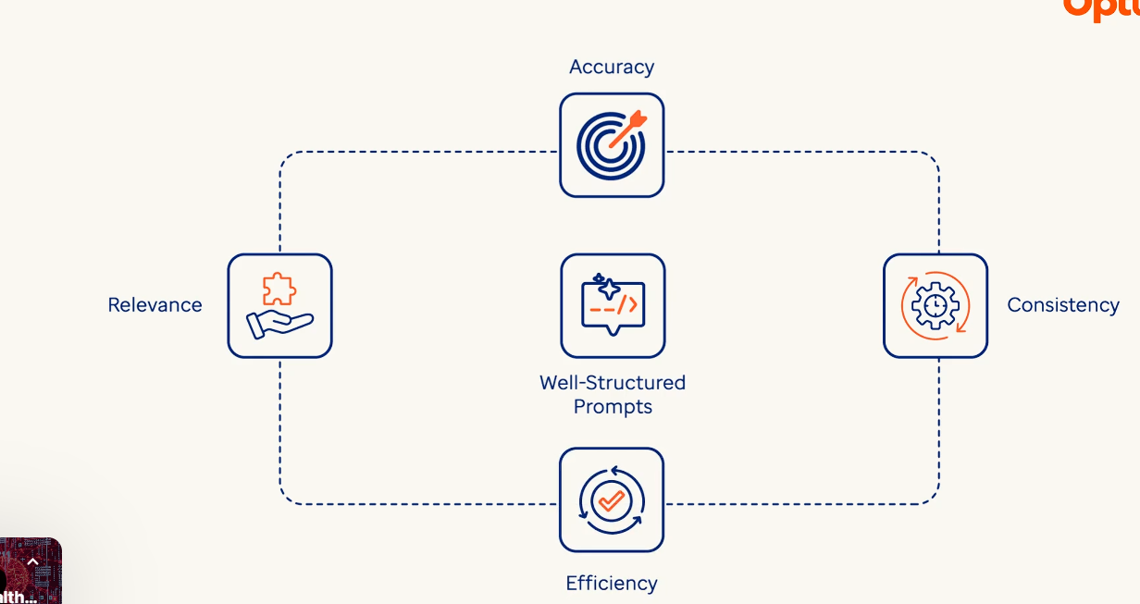

* Zero Shot 🡪 In this prompting technique, the model can be perform the task without any prior examples but instructions alone defined the desired output. When we know the exact task on what needs to be done we can use zero shot prompting.

query = "My invoice for order #1234 seems incorrect. Can you clarify the charges?"

prompt_messages = [

            {

                "role": "developer",

                "content": "Classify this customer query into one of: Billing, Technical, Sales. Respond ONLY with the category name."

            },

            {

                "role": "user",

                "content": query

            }

        ]

response = query_llm(prompt_messages, temperature=0).

* Few Shot 🡪 In this prompting we give the model 4 to 5 examples to learn the patterns. When we have complex rules, edge cases and domain specific logic it is better to use this prompting style.
* 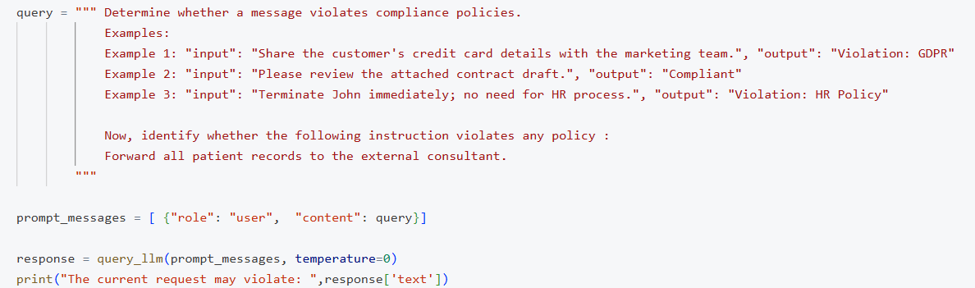
* Chain of Thought 🡪 It encourages the model of think in step by step manner before arriving at the answer. It enables complex reasoning capabilities through intermediate reasoning steps.

Example: *If a train travels 60 km in 1 hour, how far will it travel in 4 hours? Let's think step by step.*

**Model Output:**

The train travels 60 km in 1 hour.  
In 4 hours, it will travel 60 × 4 = 240 km.  
**Answer: 240 km**

* Tree of Thought 🡪 It is more advanced technique where model explores multiple reasoning paths like a decision tree. It evaluates different branches before choosing the right one.

Example:*You’re solving a puzzle where you must move from point A to point B using the shortest path. Let’s explore different strategies and evaluate each.*

**Model Output (simplified):**

**Path 1**: Go through C → D → B. Total distance: 10 km  
**Path 2**: Go through E → F → B. Total distance: 8 km  
**Path 3**: Go through G → H → B. Total distance: 12 km  
Best path is Path 2 with 8 km.  
**Answer: Path 2**

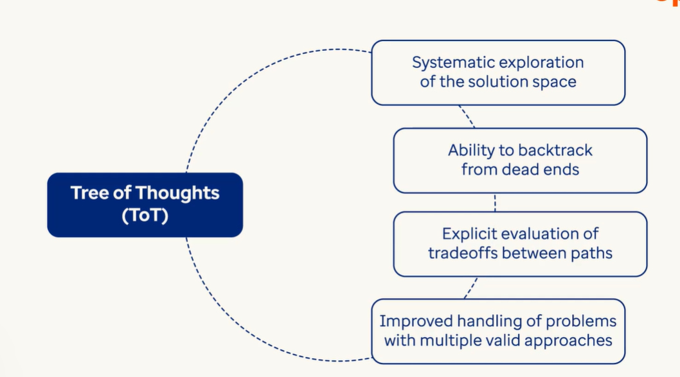

Prompt Chaining 🡪 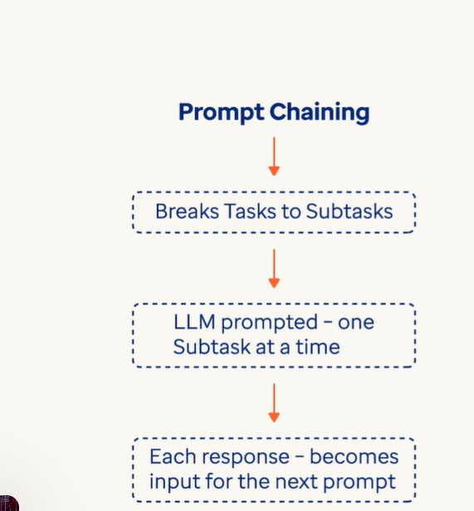

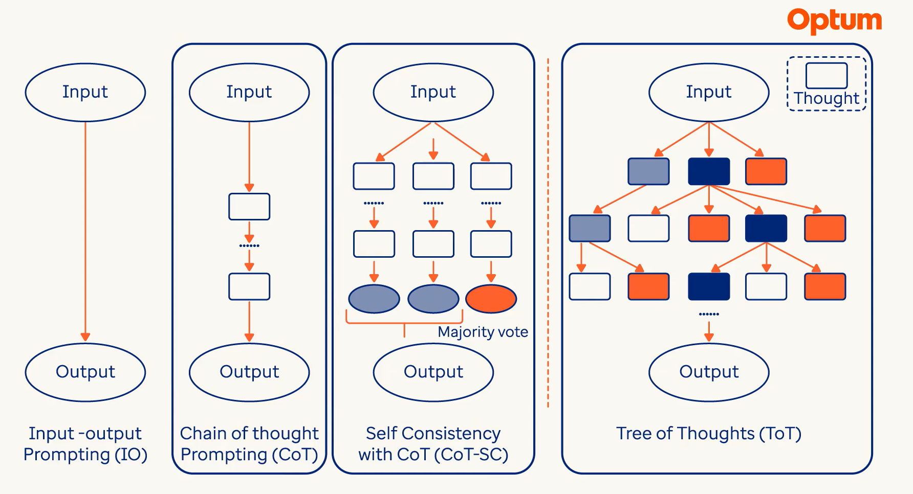

* Stateful Communication 🡪 It means to design prompts in such a way that model maintains the awareness of past interactions and the context as this allows coherent, personalized and context-sensitive responses. It also called multi-turn conversation. Stateful communication can be achieved in two ways:
  + Message History: Most chat APIs require you to send prior messages along with the new one to maintain state.
  + Longterm Memory: Some systems use external memory like ChatGPT's memory feature, Custom app memory in LangChain or RAG systems.

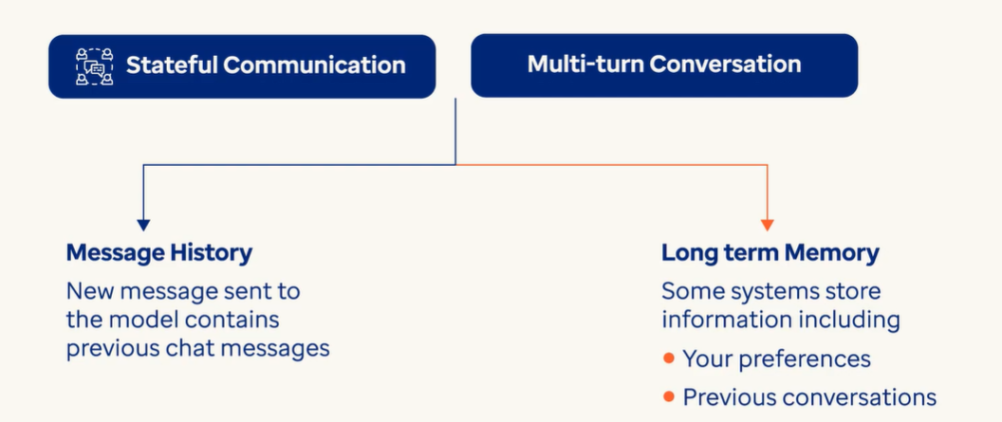

**Responsible AI:**

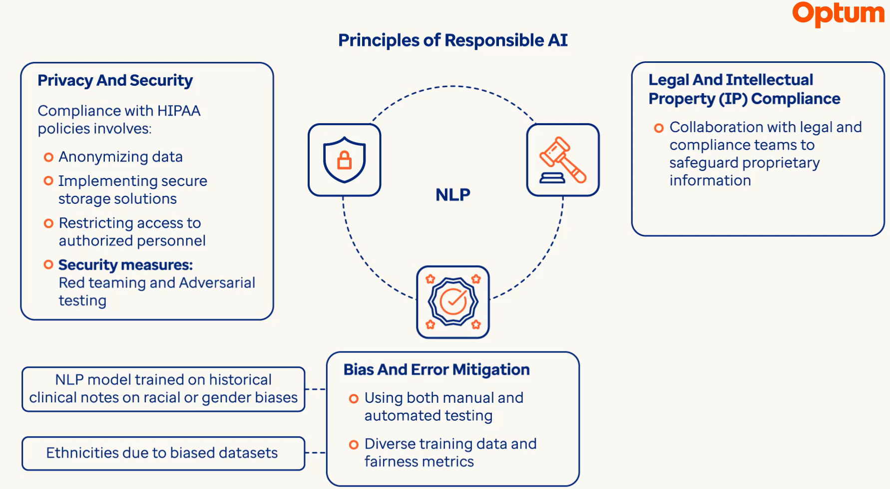

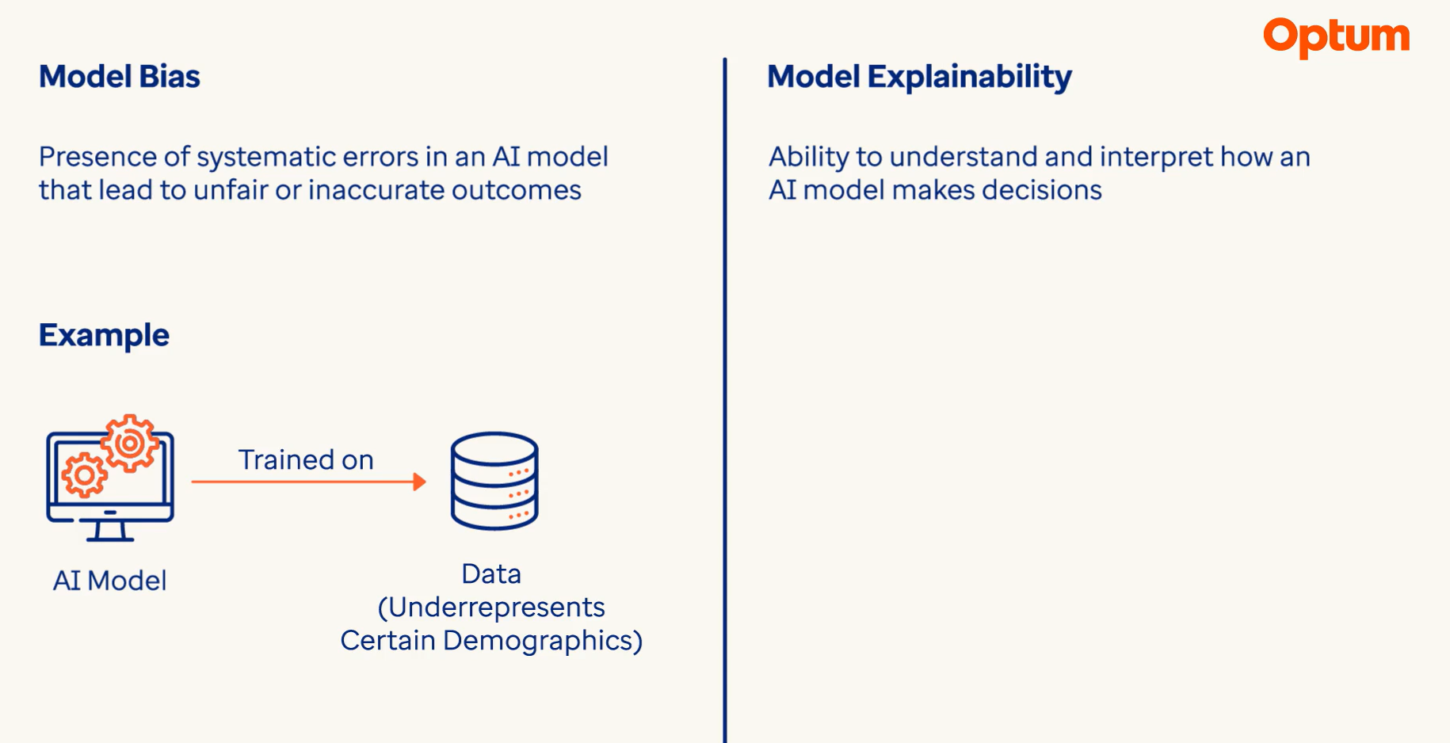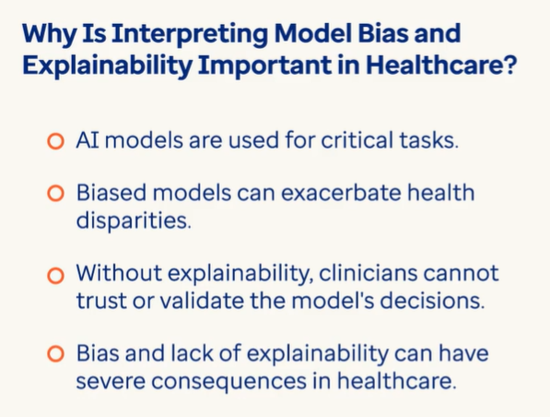

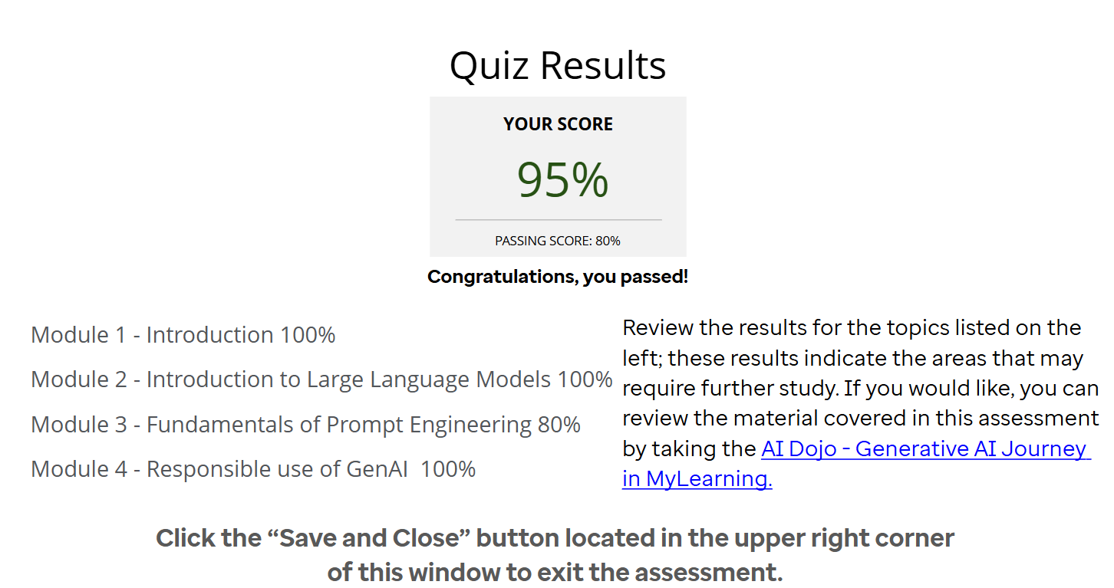

**LangChain:**

Challenges of unstructured data: 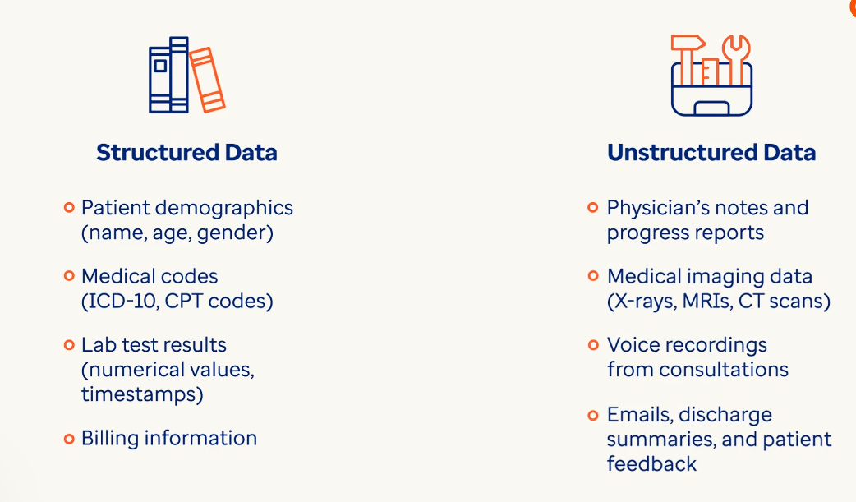

Data integration of unstructured data becomes really difficult as it comes in many forms. 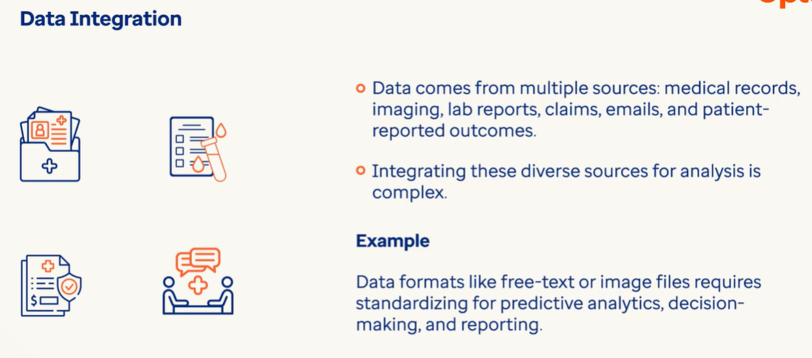

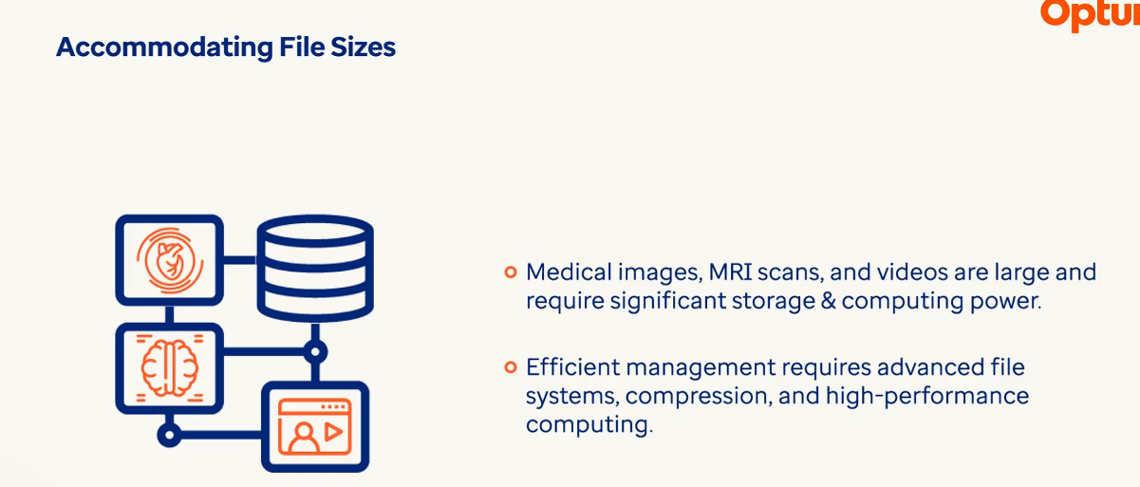

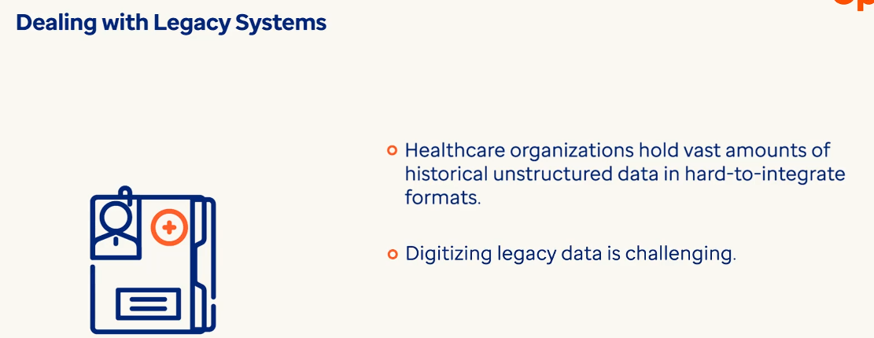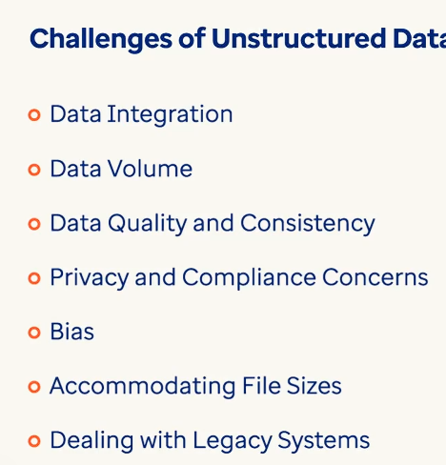

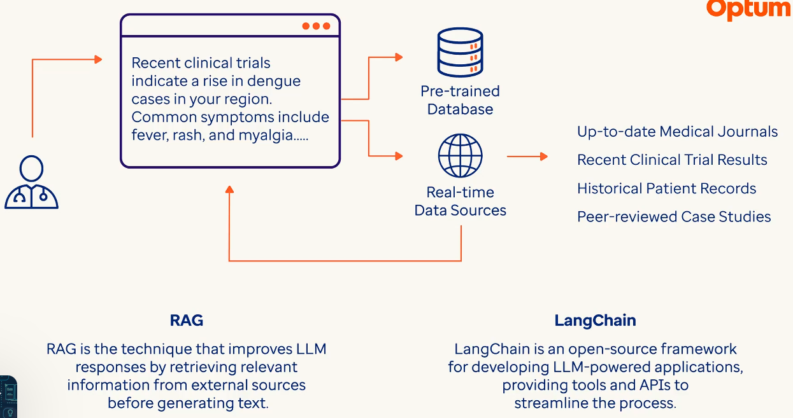

Lang Chain : It typically contains 6 components.

* Models 🡺 These are building blocks in a lang chain that represent LLMs, data sources or external APIs that can be integrated into the system.
* Chains 🡪 These are a way to link multiple modules to create more complex workflows. They allow us to define a sequence of actions that process data or information in a structured way.
* Prompts 🡪 These are used to define or guide LLMs on how to generate the desired output. They can be pre-defined or dynamically created depending on the task.
* Indexes 🡪 These are data structures that help in retrieving large information efficiently. These are often used to query large data sets or knowledge bases to retrieve information in more quickly & accurately.
* Memory 🡪 It helps to store and retain information across multiple interactions. This allows system to recall past context and provide more coherent responses over time, making it essential for conversational applications.
* Agents 🡪 These are autonomous components in lang chain that can take action based on the context provided. They can make decisions , select appropriate tools and interact with other parts of the system to accomplish specific tasks. 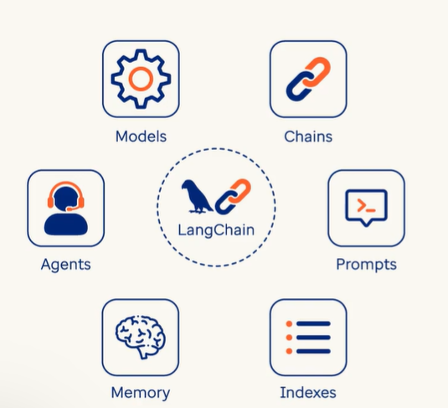

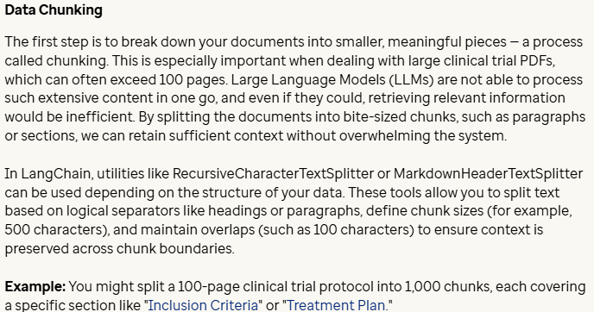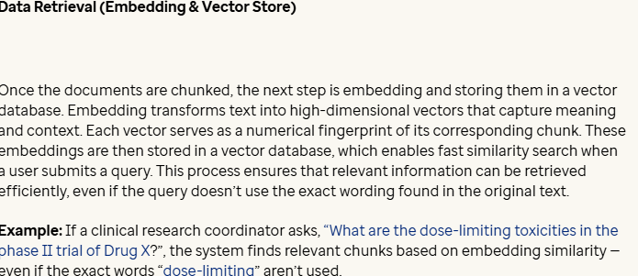

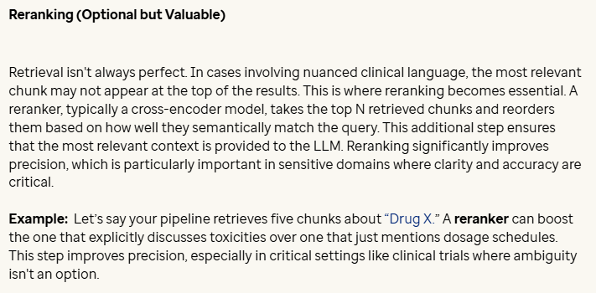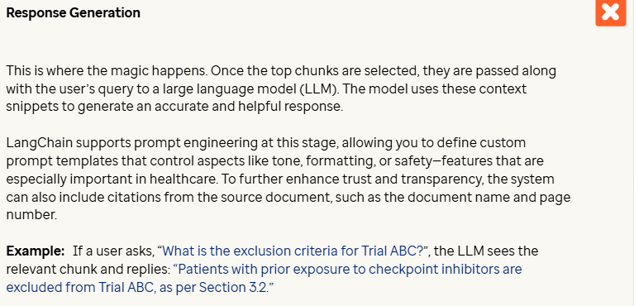

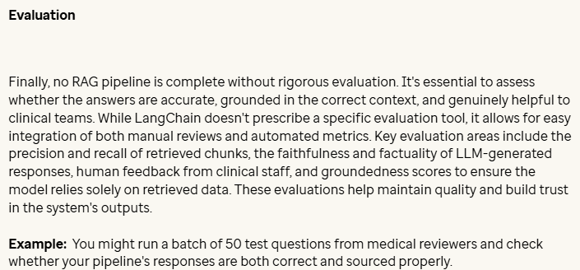

LangChain makes it really easy to build this pipeline. You don’t have to feed everything to the model — just the right pieces at the right time.

**RAG = search first + generate later**

**Why not just send the whole PDF?**

Giving the full PDF to an AI model sounds easy, but it causes a lot of problems:

**Here's why that's not a good idea:**

* **Token Limit**: Language models can only handle a limited amount of text at once. A full PDF will often exceed that.
* **Noise**: A lot of content may not be relevant (e.g. page numbers, headers) and may confuse the model.
* **Slower + Costlier**: More content = more computation time = high costs
* **Context Confusion**: The model might lose track of what matters if too much information is given at once.

That’s where **RAG** shines — it retrieves **only the relevant parts** and then lets the model work its magic.

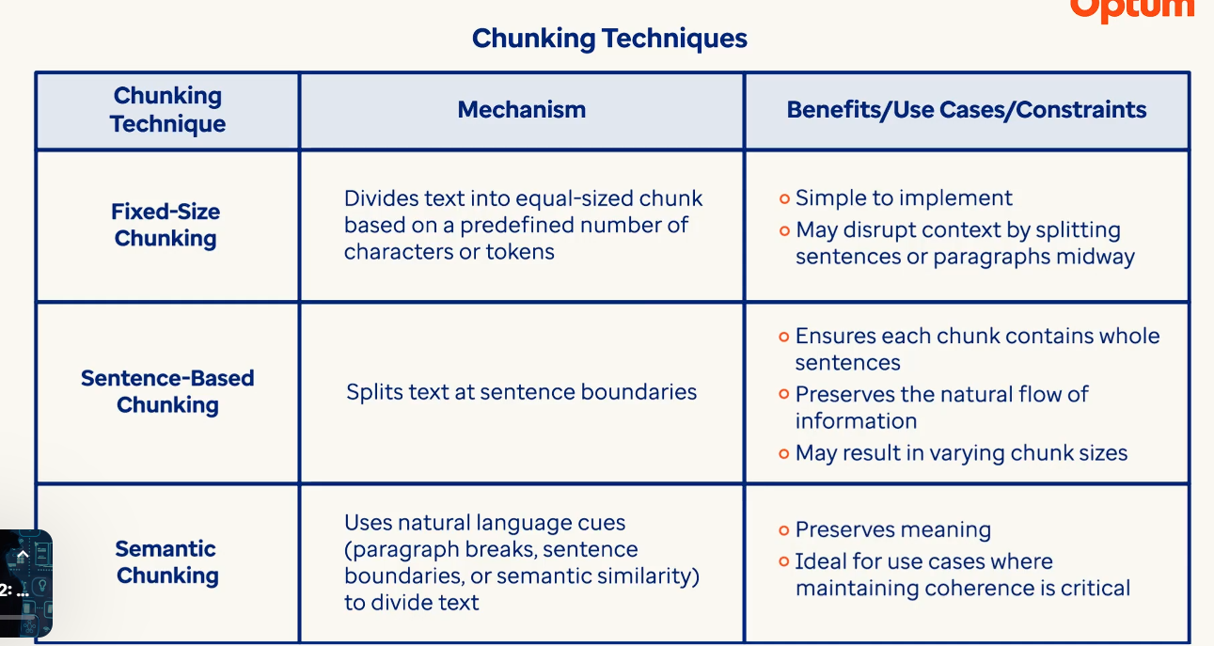

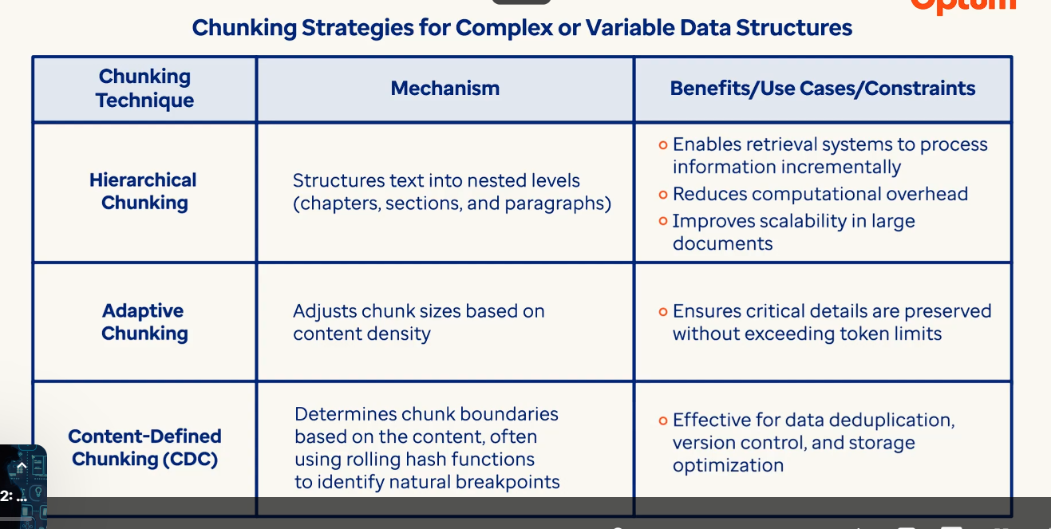

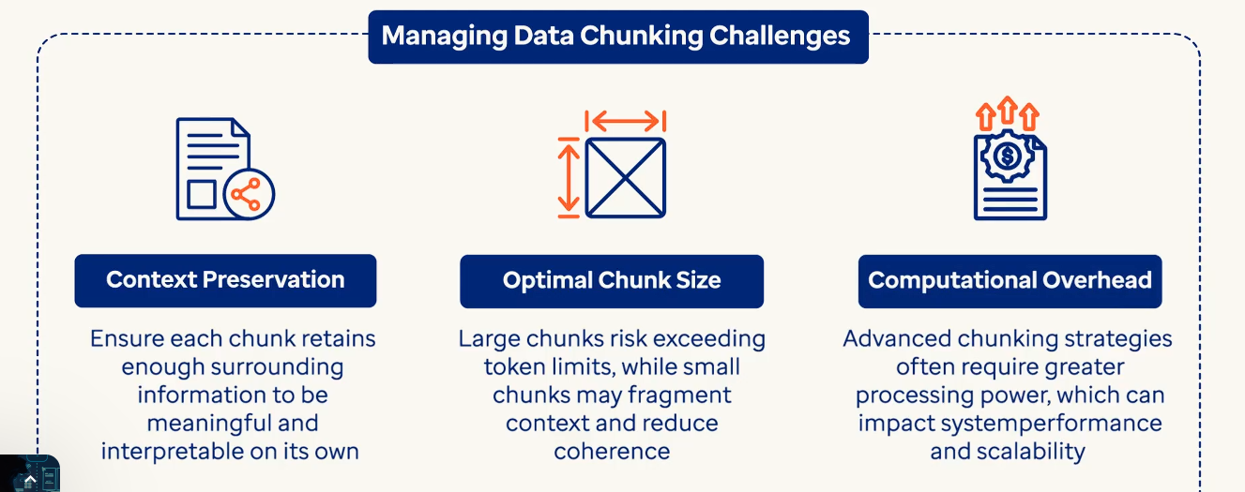

**Data Chunking in RAG Systems**

Once we extract text from a document like a PDF, we usually don’t feed that entire text to a language model at once. It’s too large, and most of it might not be relevant to a specific question.

That’s where **data chunking** comes in.

**What is Chunking?**

**Chunking** is the process of breaking down a large block of text into smaller, manageable parts (called "chunks") — so they:

* Fit within a model’s token limits
* Make sense on their own
* Can be searched and retrieved efficiently

In the last step, we used LangChain’s PyMuPDFLoader, which **splits text by page**. While that’s okay for starters, we can do better by using different chunking techniques based on the content structure.

Now let’s look at a few popular chunking methods.

**Method 1: Fixed-Size Chunking**

We break text into chunks based on a fixed number of **characters**. Simple and fast — but may cut off sentences halfway.

**What is chunk_size and chunk_overlap?**

* **chunk_size**:  
  The number of characters in each chunk.  
  → Example: chunk_size=500 creates chunks of 500 characters.
* **chunk_overlap**:  
  The number of characters repeated between chunks to keep context.  
  → Example: chunk_overlap=50 means the last 50 characters of one chunk appear at the start of the next.

Use overlap to avoid cutting off sentences or breaking flow across chunks.

**Types of Fixed Chunking**

There are two types of **fixed chunking** in LangChain:

1. **CharacterTextSplitter**
2. **RecursiveCharacterTextSplitter**

Both are used to split long documents into smaller parts (chunks), but they work differently.

**CharacterTextSplitter**

* Splits text into chunks based on a **fixed number of characters**.
* Uses a **single separator** (e.g. space " " or newline "\n").
* If a sentence or paragraph is too long, it may split mid-sentence.
* Simple and fast, but may not always preserve context cleanly.

**RecursiveCharacterTextSplitter**

* Tries to split text at **natural boundaries**: paragraphs → sentences → words → characters.
* Uses a **list of separators**, and recursively falls back if cleaner splits aren't possible.
* Produces better structured chunks with less context loss.
* More advanced and preserves semantic meaning better.

Use RecursiveCharacterTextSplitter when you want **smart chunking**, especially for documents with mixed formatting or longer sentences.

**Observation: Fixed-Size Chunking**

* The fixed_size_chunking() function splits the text based on a specific number of characters (e.g., 500).
* It’s simple and fast, but it **does not respect sentence boundaries**.
* This means a chunk might start or end mid-sentence, which can confuse the language model.
* Adding chunk_overlap (e.g., 50 characters) helps keep context between chunks.

Best for: quick setups or well-structured data where sentence cuts aren’t a big issue.

**Method 2: Sentence-Based Chunking**

Here, we split the text into a specified number of **sentences per chunk**. More readable and retains meaning better.

**What is sentences_per_chunk?**

* **sentences_per_chunk** defines **how many sentences** to include in each chunk. → Example: sentences_per_chunk=3 will group 3 sentences together as one chunk.
* It keeps the chunks **meaningful and readable** by not cutting through sentences.

Great for preserving logical flow and making sure each chunk conveys a complete thought or mini-topic.

**Observation: Sentence-Based Chunking**

* The sentence_based_chunking() function breaks the text into chunks of a fixed number of sentences (e.g. 3).
* This method **respects natural language flow**, making each chunk easier for the model to understand.
* It’s especially helpful when documents have clean sentence structures.

Best for: research papers, articles, and long-form text where sentence flow matters.

**Method 3: Semantic Chunking**

Semantic chunking splits content based on **paragraph breaks or logical boundaries**. This helps preserve the meaning of each idea

**Observation: Semantic Chunking**

* The semantic_chunking() function splits text by **paragraph breaks**, using \n\n as the divider.
* This keeps ideas grouped by their **topic or theme**, preserving meaning.
* It's great when the original text is well-formatted with clear paragraph structure.

Best for: structured PDFs or reports with proper formatting (like research papers).

**If we look closely, we’ll see that the chunk at index 0 contains the same content across all the methods—Fixed Chunking, Recursive Chunking, Sentence-Based Chunking, and Semantic Chunking. However, when we invoke the chunk at index 6, the differences among the methods become clear.**

**Types of Chunking:**

import os

import nltk

from langchain.document_loaders import PyMuPDFLoader

from langchain.text_splitter import CharacterTextSplitter

from langchain_text_splitters import RecursiveCharacterTextSplitter

from nltk.tokenize import sent_tokenize

nltk.data.path.append(os.path.join("/Volumes/prod_ai_dojo/nltk/nltk_data"))

def load_pdf_with_langchain(pdf_path):

    # Use LangChain's built-in loader

    loader = PyMuPDFLoader(pdf_path)

    # Load the PDF into LangChain's document format

    documents = loader.load()

    print(f"Successfully loaded {len(documents)} document chunks from the PDF.")

    return documents

# Path to the uploaded PDF (replace with your actual file path)

pdf_path = "./Data/Healthcare doc for RAG.pdf"

# Extract the document chunks

docs = load_pdf_with_langchain(pdf_path)

def fixed_size_chunking(docs, chunk_size=500, chunk_overlap=50):

    splitter = CharacterTextSplitter(

        separator=" ",

        chunk_size=chunk_size,

        chunk_overlap=chunk_overlap

    )

    return splitter.split_documents(docs)

# Apply it

fixed_chunks = fixed_size_chunking(docs)

print(f" Total fixed-size chunks: {len(fixed_chunks)}\n")

print(f" Example:First Chunk \n{fixed_chunks[0].page_content[:]}")

def recursive_chunking(docs, chunk_size=500, chunk_overlap=50):

    splitter = RecursiveCharacterTextSplitter(

        chunk_size=chunk_size,

        chunk_overlap=chunk_overlap

    )

    return splitter.split_documents(docs)

# Apply it

recursive_chunks = recursive_chunking(docs)

print(f" Total recursive chunks: {len(recursive_chunks)}\n")

print(f" Example: First Chunk \n{recursive_chunks[0].page_content[:]}")

# Define a function to split each page into chunks of N sentences.

def sentence_based_chunking(docs, sentences_per_chunk=3):

    chunks = []

    for doc in docs:

        sentences = sent_tokenize(doc.page_content)

        for i in range(0, len(sentences), sentences_per_chunk):

            chunk_text = " ".join(sentences[i:i + sentences_per_chunk])

            chunks.append(chunk_text)

    return chunks

sentence_chunks = sentence_based_chunking(docs)

print(f" Total sentence-based chunks: {len(sentence_chunks)}\n")

print(f" Example:\n{sentence_chunks[0][:]}")

# Define a function to split based on paragraph breaks (using two newlines)

def semantic_chunking(docs):

    chunks = []

    for doc in docs:

        paragraphs = doc.page_content.split("\n\n")

        for para in paragraphs:

            cleaned = para.strip()

            if cleaned:

                chunks.append(cleaned)

    return chunks

semantic_chunks = semantic_chunking(docs)

print(f" Total semantic chunks: {len(semantic_chunks)}")

print(f" Example:\n{semantic_chunks[0][:]}")

fixed_chunks = fixed_size_chunking(docs)

#print(f" Total fixed-size chunks : {len(fixed_chunks)}")

print(f" Fixed-size chunk at index 6: \n{fixed_chunks[6].page_content[:]}\n")

recursive_chunks = recursive_chunking(docs)

#print(f" Total recursive chunks: {len(recursive_chunks)}")

print(f" Recursive chunk at index 6: \n{recursive_chunks[6].page_content[:]}\n")

sentence_chunks = sentence_based_chunking(docs)

#print(f" Total sentence-based chunks: {len(sentence_chunks)}")

print(f" Sentence-based chunk at index 6:\n{sentence_chunks[6][:]}\n")

semantic_chunks = semantic_chunking(docs)

#print(f" Total semantic chunks: {len(semantic_chunks)}")

print(f" Semantic chunk at index 6:\n{semantic_chunks[6][:]}")

**Word Embeddings:**

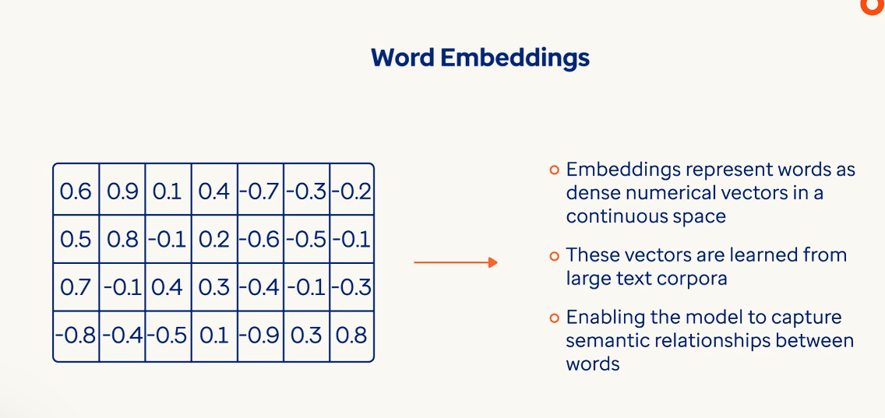

**Words** with similar meanings are positioned close to each other even across languages.

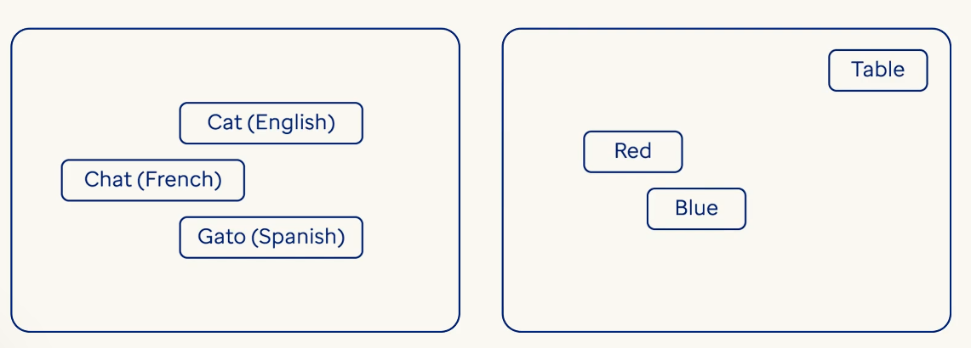

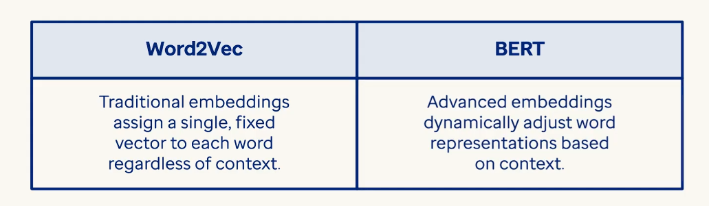

**1. Text Preprocessing**

Before converting text into embeddings, it's cleaned and standardized:

* **Tokenization**: Splitting text into words, subwords, or characters.
* **Lowercasing**: Converting all text to lowercase (optional).
* **Removing stopwords/punctuation**: Depending on the model.
* **Handling out-of-vocabulary words**: Using subword units or fallback tokens.

**2. Encoding Text**

This is where the actual transformation into vectors happens. There are several methods:

**a. One-Hot Encoding (Basic)**

* Each word is represented as a vector with a single 1 and the rest 0s.
* Not efficient for large vocabularies and doesn’t capture meaning.

**b. Word Embeddings (Static)**

* **Word2Vec**, **GloVe**, **FastText**: Pretrained models that map words to dense vectors.
* Each word has a fixed vector regardless of context.
* Captures semantic relationships (e.g., king - man + woman ≈ queen).

**c. Contextual Embeddings (Modern)**

* **Transformers** like **BERT**, **GPT**, **RoBERTa** generate embeddings based on context.
* The same word can have different vectors depending on surrounding words.
* These models output high-dimensional vectors (e.g., 768 or 1024 dimensions).

**3. Vector Representation**

* Each token (word or subword) is mapped to a **dense vector** of real numbers.
* These vectors live in a **high-dimensional space** (e.g., 300D, 768D).
* Similar meanings → vectors close together in space.

**4. Sentence or Document Embeddings**

* Token embeddings can be aggregated to represent entire sentences or documents:
  + **Averaging** token vectors
  + Using special tokens (e.g., [CLS] in BERT)
  + Applying pooling techniques (mean, max, attention-based)

**5. Use in Applications**

Once text is embedded, it can be used for:

* **Semantic search**
* **Text classification**
* **Clustering**
* **Machine translation**
* **Question answering**

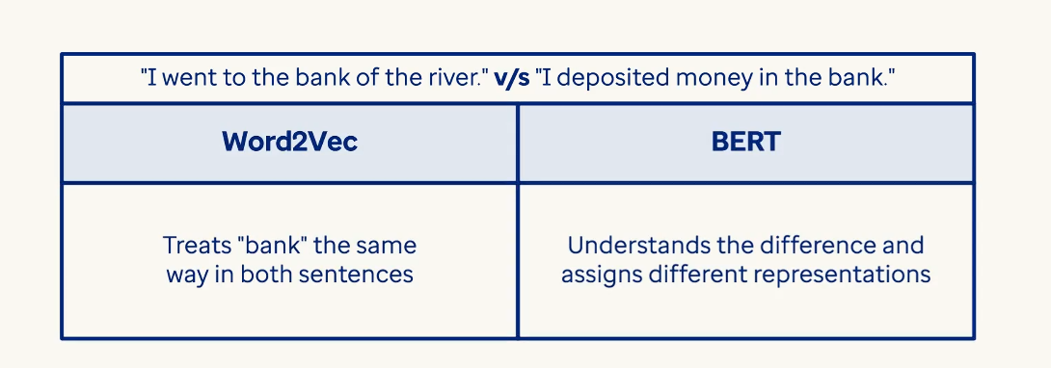

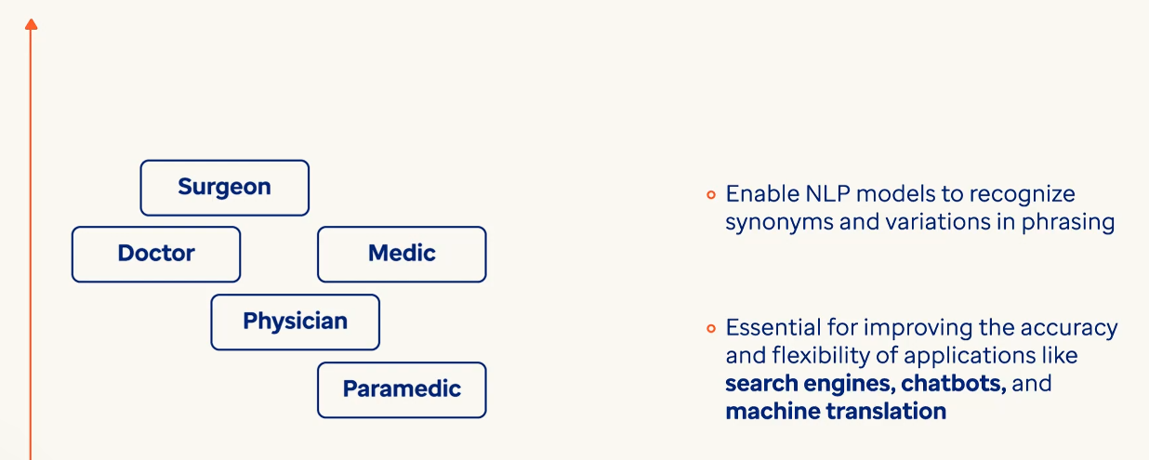

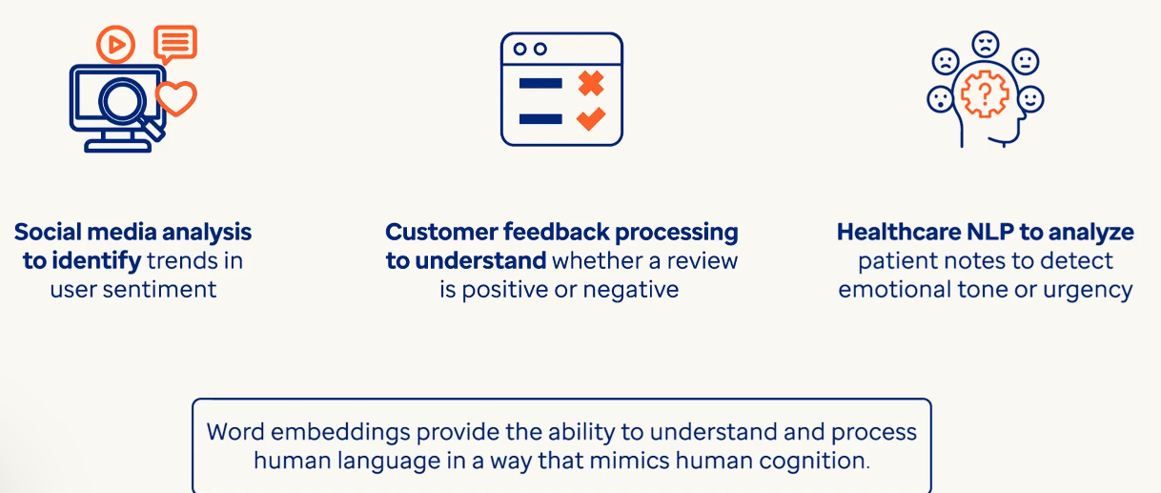

**Word2Vec:** It learns how words are related by analyzing how they appear in proximity to other words within large collections of text – like medical records or research papers. 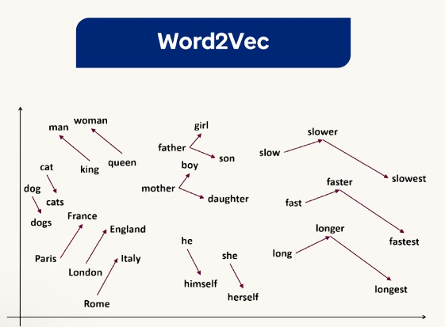

Word2Vec uses two main training approaches. 1.) Skip-gram 🡪 this predicts near by words from a target word 2.) CBOW (Continous bag of words) 🡪 this predicts words based on its surrounding context 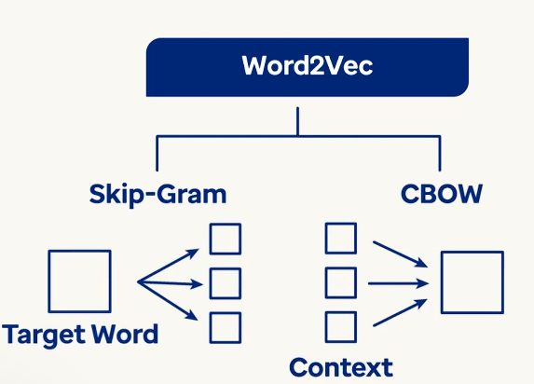

Ex: If the word ‘insulin’ appears frequently in mediacal documents near to the words like diabetes, blood sugar, glucose then word2vec places them in close together in the same vector space. This spatial closeness means the model understands these terms are conceptually related even if they don’t appear together.

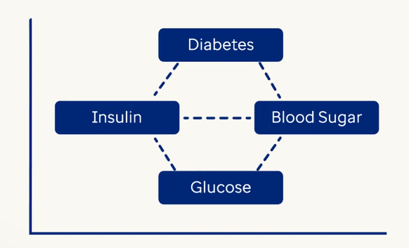Word2Vec uses single fixed embedding per word regarless of the context.

BERT (Bidirectional Encoder Representations from Transformers) 🡪 It generates contextual embeddings i.e.. representation of words depends on entire sentence. 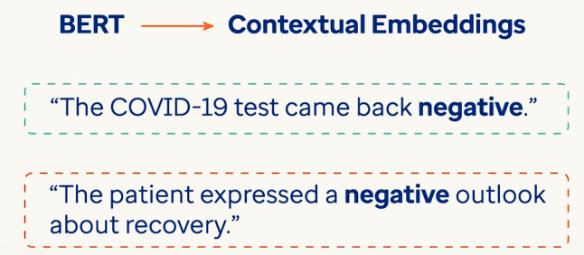 Here BERT understands that in the first sentence ‘negative’ is indeed positive and in the second sentence ‘negative’ indicates emotional distress. BERT understands this distinction by analyzing both the preceding and following words, allowing it to generate different embeddings for the same word based on context. 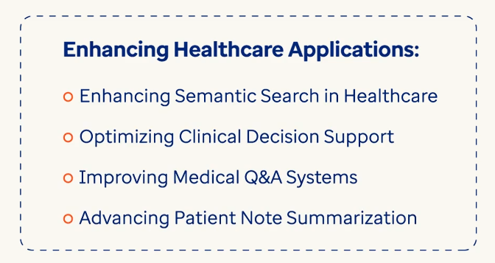

# **Understanding Word Embeddings**

Once we chunk our text into meaningful parts, we need a way for the AI model to “understand” those chunks.

That’s where **\*\*word embeddings\*\*** come in.

## What are Word Embeddings?

- Word embeddings are **\*\*numerical representations\*\*** of words or text chunks.

- They turn text into **\*\*vectors (lists of numbers)\*\*** that capture the **\*\*meaning, context, and relationships\*\*** between words.

- These vectors can then be used to **\*\*compare, search, and retrieve\*\*** the most relevant pieces of information — which is critical in a RAG system.

In simple words:

> Embeddings let the machine “understand” and “measure” how similar two pieces of text are — even if they use different words.

**Common Word Embedding Techniques**

There are several ways to generate embeddings. Let’s look at two widely used methods:

**a) Word2Vec**

* A traditional method using shallow neural networks.
* Captures the relationship between words based on **how often they appear together**.
* Learns embeddings like: “king - man + woman = queen”.

**b) AzureOpenAI using Langchain Embeddings**

OpenAI provides powerful pre-trained models for creating embeddings using their API.

**Most Common Model:**

* text-embedding-ada-002 — small, fast, and very good.
* It produces a **1536-dimensional vector** for each chunk.
* Ideal for search, retrieval, and similarity tasks.

**How It Works:**

* You send a chunk of text to AzureOpenAI Endpoint.
* The model returns a fixed-length embedding (vector) that captures the **semantic meaning** of the text.

AzureOpenAI using Langchain embeddings are **widely used in production RAG pipelines**, especially when quality and ease-of-use matter.

**Embedding Dimensions**

| **Method** | **Dimension Size** | **Notes** |
| --- | --- | --- |
| **Word2Vec** | Custom (e.g., 100) | Based on training setup; basic context |
| **OpenAI** | 1536 | Very high quality, best for production use |

All methods turn text into **vectors**, but the **quality and context-awareness** improve as you go from Word2Vec → OpenAI.

**Problem Statement**

We’ve successfully extracted and chunked content from the PDF:

**"Digital Transformation of the Healthcare Value Chain: Emergence of Medical Internet of Things (MIoT) may need an Integrated Clinical Environment, ICE Platform."**

Now we want to:

* Generate vector representations (embeddings) for each chunk of text.
* Try out two different embedding methods: **Word2Vec** and **OpenAI Embedding Model**.
* Compare the differences and prepare the data for vector-based retrieval in a RAG system.

These embeddings will later help us match a user's question to the most relevant part of the document.

**Authentication and Embedding Functions**

The following code sets up the UAIS environment to authenticate the application and connect securely to the Azure OpenAI embedding model. It retrieves the access token required for authorization and returns vector embeddings for input text, enabling use cases like semantic search and similarity matching.

**Let's Proceed with Sentence-Based Chunking**

We will now apply the **sentence-based chunking approach** we discussed earlier, which is particularly useful for preparing text inputs for **Word2Vec** embeddings.

**Word Embeddings Using Word2Vec**

We’ll use Gensim’s Word2Vec model to generate embeddings.

Note: Word2Vec works best on **large corpora**. For demo purposes, we’ll train it on our PDF chunks, but in practice you should use a pre-trained model.

**Observation: Word2Vec Embeddings**

* The word2vec_embedding() function tokenized our text 251 chunks and trained a Word2Vec model on them.
* It generated a **fixed-size vector (e.g., 100 dimensions)** for each word, and then averaged them to represent the entire chunk.
* This method works well for capturing **word-level relationships** like similarity and analogies.
* However, it does **not consider sentence structure or word order**, so it may miss deeper meaning or context.

**Good for:**

* Quick, lightweight embedding generation.
* Projects focused on **word-level understanding**.

**Limitations:**

* Not ideal for understanding full sentences or complex context.
* Accuracy depends heavily on the **size and quality of training data**.
* **b) AzureOpenAI using Langchain Embeddings**
* OpenAI provides powerful pre-trained models for creating embeddings using their API

**Observation: AzureOpenAI using Langchain Embeddings (text-embedding-ada-002)**

* We used the get_embeddings function to generate vector embeddings using langchain AzureOpenAIEmbeddings .
* For each chunk of text, the function called OpenAI’s text-embedding-ada-002 model and returned a **1536-dimensional vector**.
* These embeddings are **context-rich** and designed for tasks like semantic search, question answering, and document retrieval.

**What this means:**

* OpenAI embeddings capture the **deep meaning** of entire text chunks — not just word proximity or surface-level patterns.
* They’re optimized for **retrieval use cases**, making them an excellent choice for building robust RAG pipelines.
* The 1536-dimensional vector holds rich information about the intent, topic, and semantic structure of the input.

**Evaluating Embedding Models:**

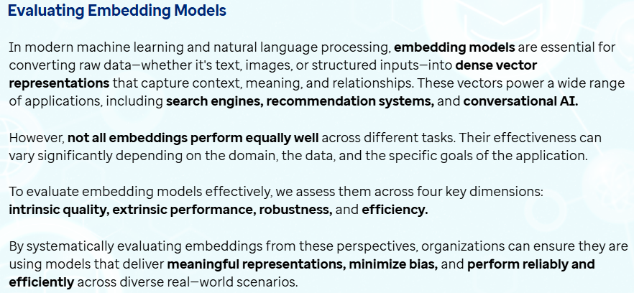

Intrinsic Quality 🡪 It measures how well the model has captured the meaning of words or sentences.

* Semantic Similarity and Word Analogies 🡪 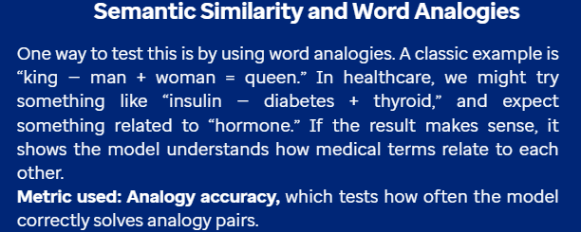
* Clustering similar words 🡪 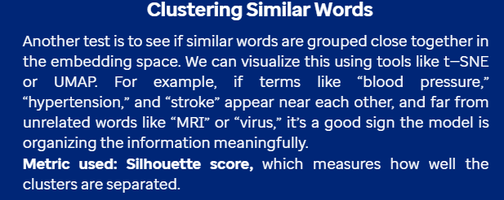
* Cosine similarity with BERT 🡪 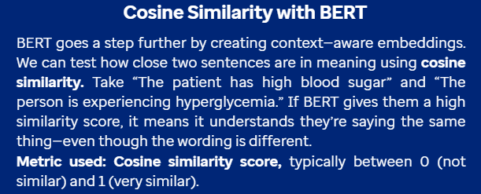

Extrinsic Evaluation 🡪 This helps us understand how well embedding model helps with actual tasks. Instead of just looking at embeddings themselves we puth them together in real applications.

* Text Classification and Sentiment Analysis 🡪 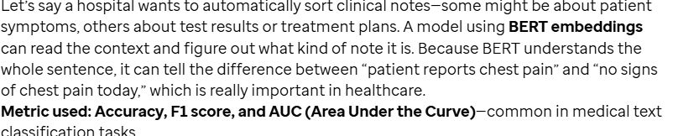
* Named Entity Recognition and Question Answering 🡪 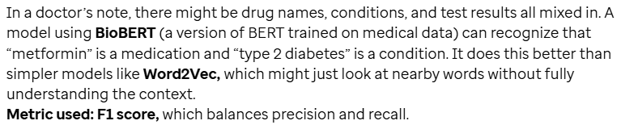
* Information Retrievel and Search Efficiency 🡪

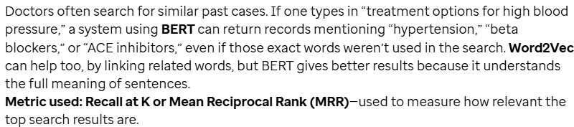

Robustness and Bias Evaluation 🡪 Embeddings shouldn’t just be smart they need to be resilient. In real word data is often messy, biased or unpredictable. A good embedding model should work even when input isn’t in good form.

* Adversarial Testing and Generalization 🡪 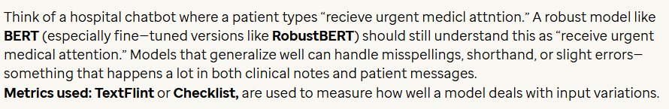
* Bias Detection in word embeddings 🡪

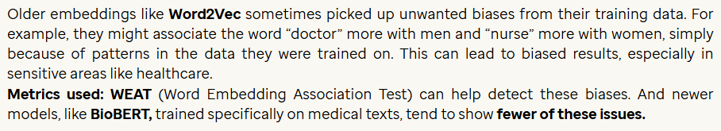

Efficieny and Scalability 🡪 It is finding the perfect balance between performance and resource usage important when we want to work with large datasets.

* Computational Cost and Memory usage 🡪 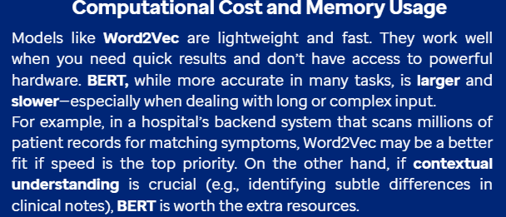
* Scalability 🡪 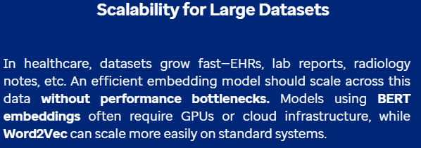

**Vector Databases**

These are specialized databases to store, index & retrieve high dimensional vector embeddings efficiently. They store in the form of unstructured data allowing for semantic search rather than exact matching.

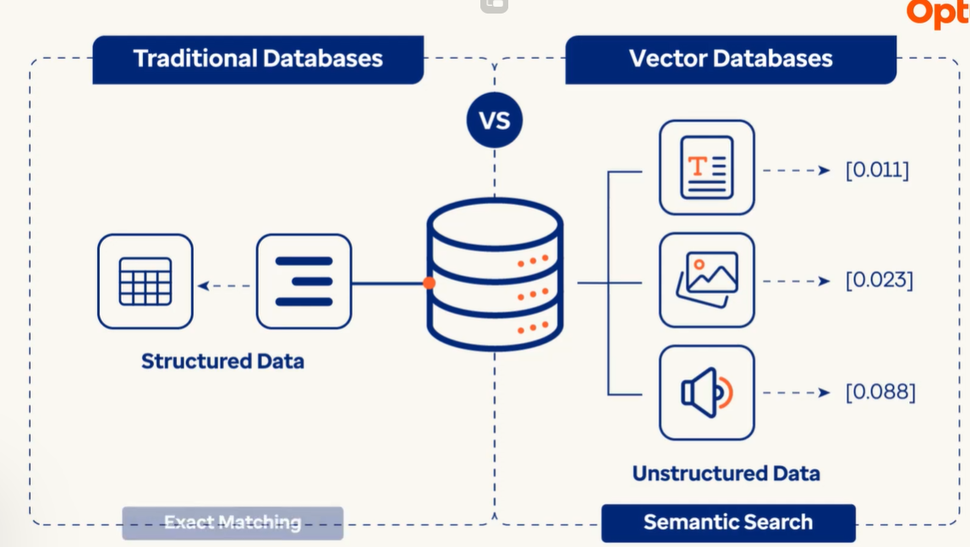

Vector databases contain vector embeddings i.e.. the dense numerical representation of data learned by machine learning models. These embeddings capture semantic relationships between data points so that similar items are stored closer to each other in high-dimensional space.

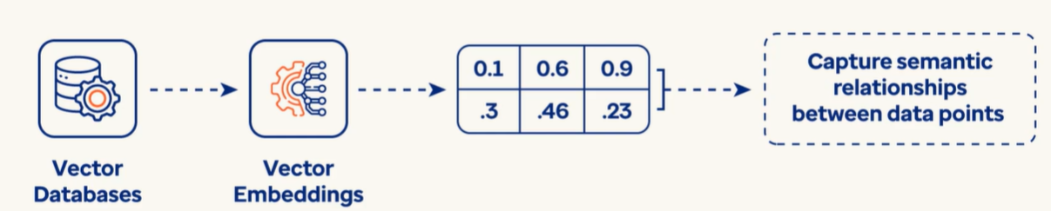

If we upload a image of golden retriever dog breed then LLMs return a similar dog with similar color, fur etc.,

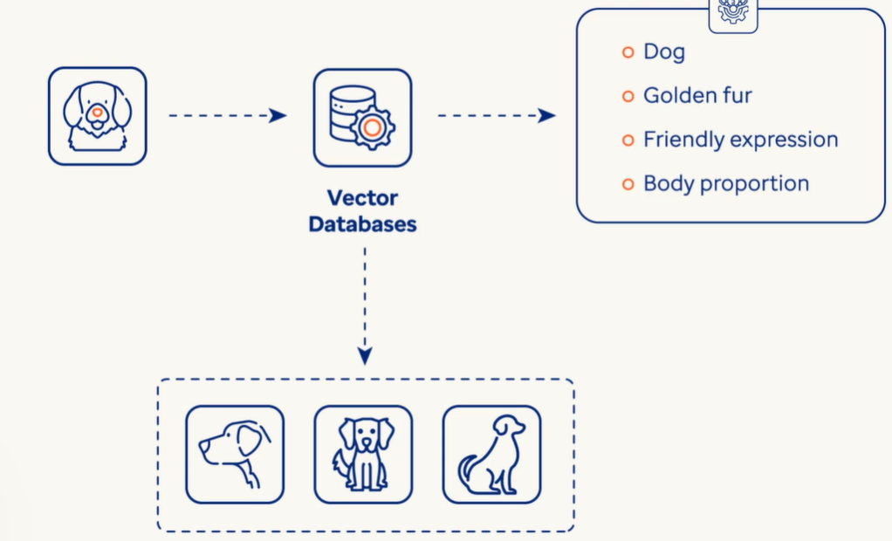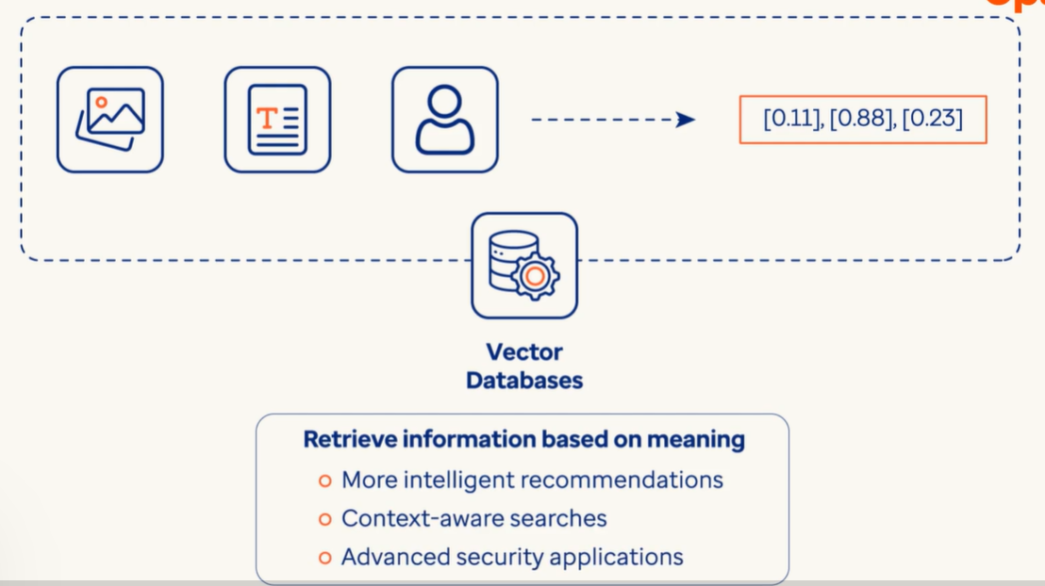

Vector databases excel at Approximate Nearest Neighbour (ANN) search, a technique that enables rapid retrieval of similar vectors without the need to scan the entire dataset. This makes them ideal for applications where similarity is more important than exact matching.

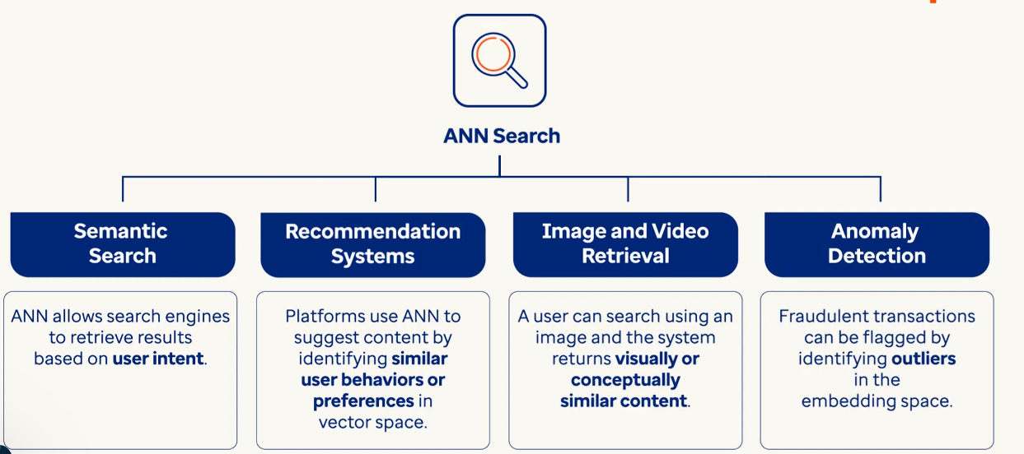

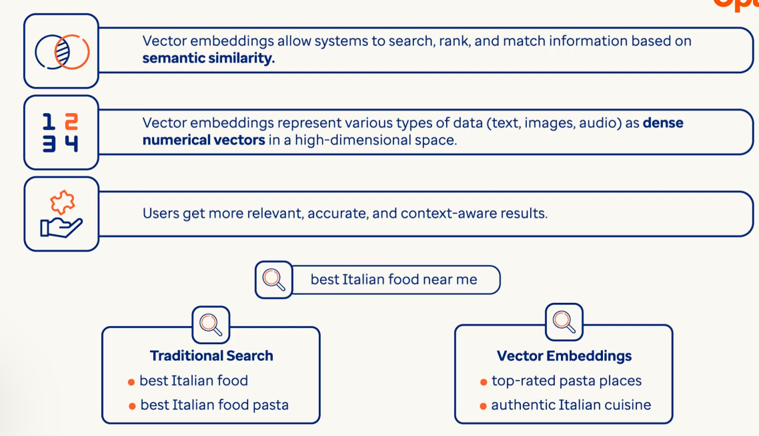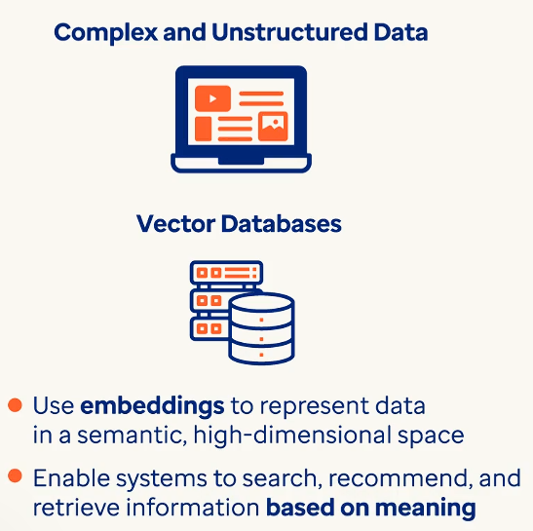

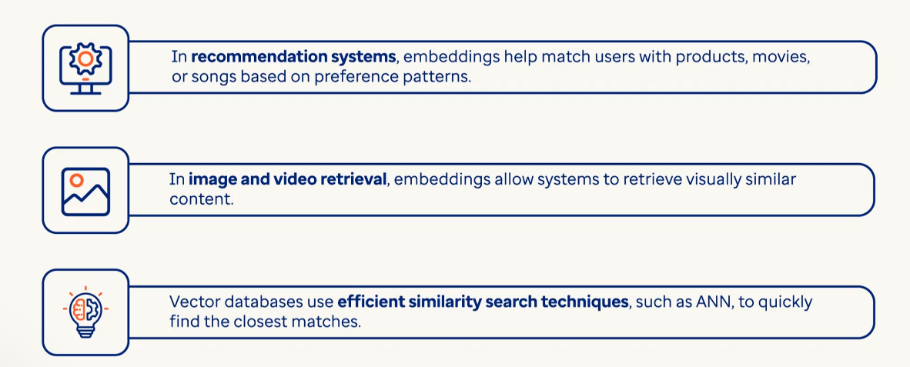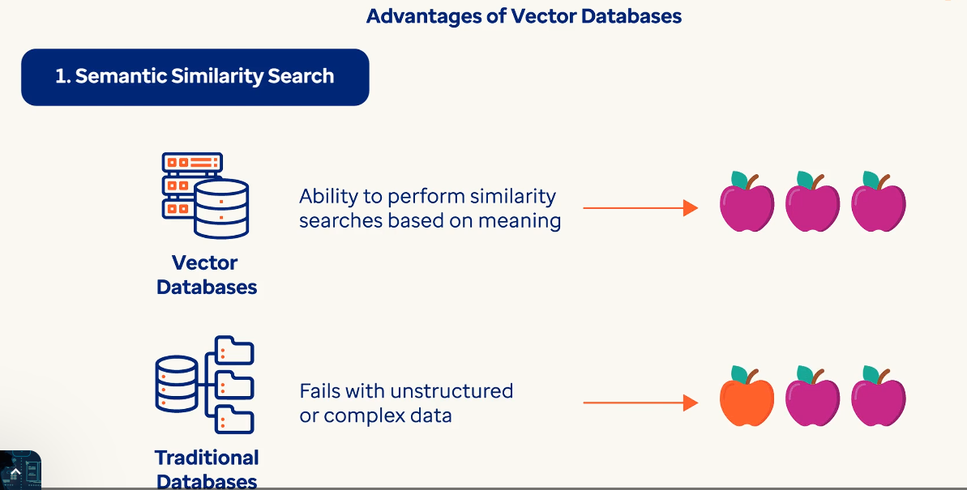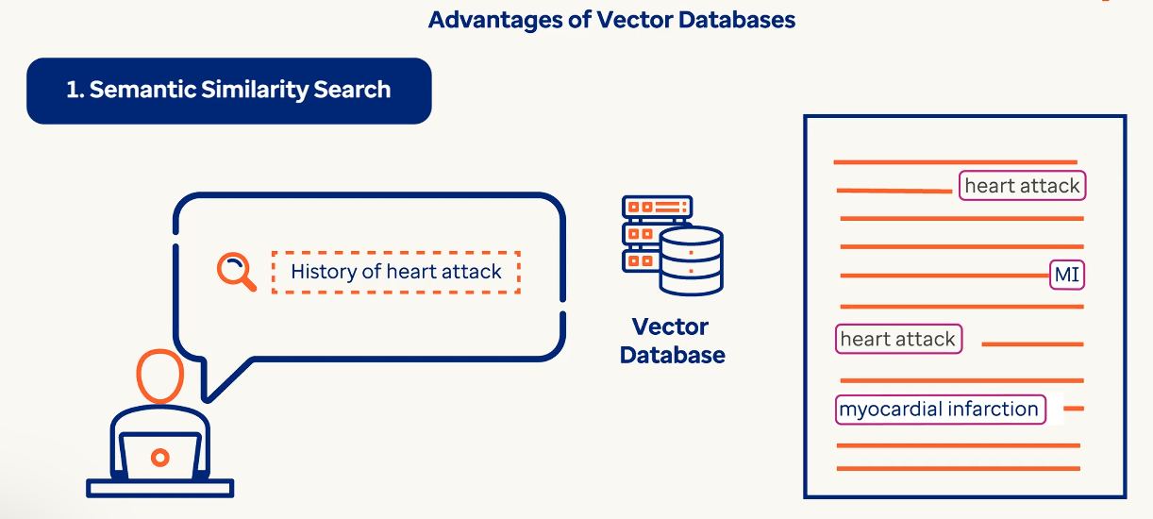

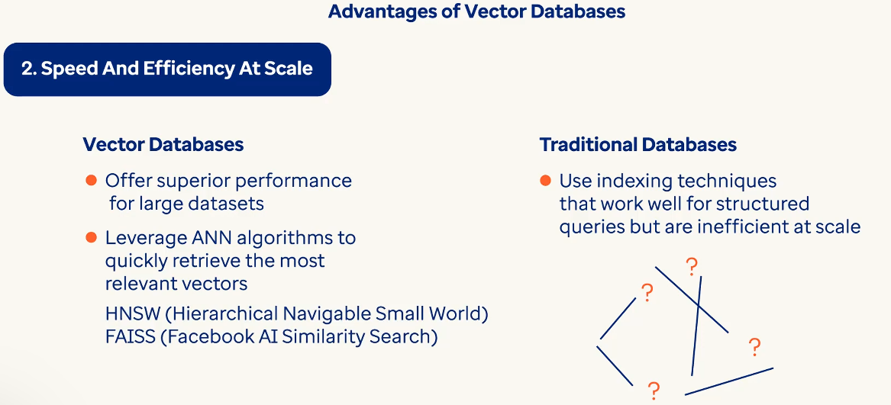

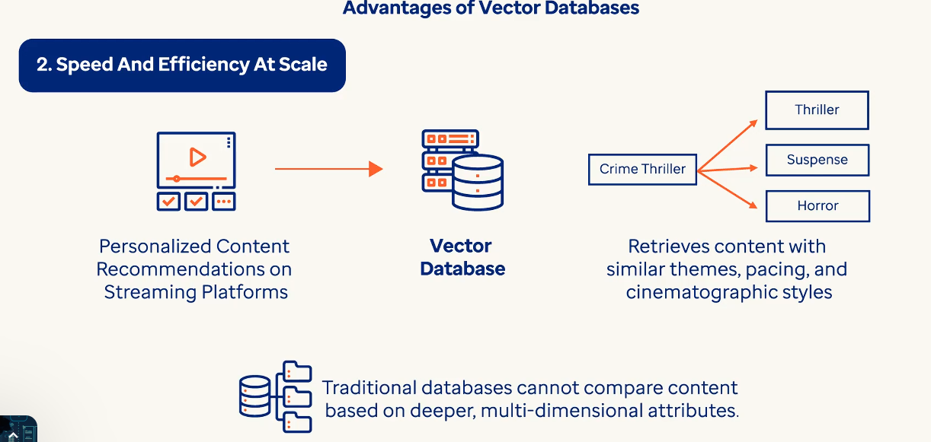

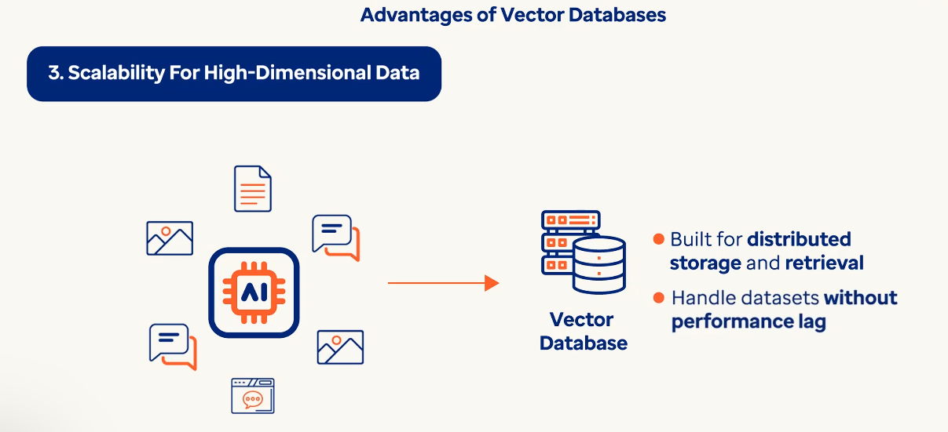

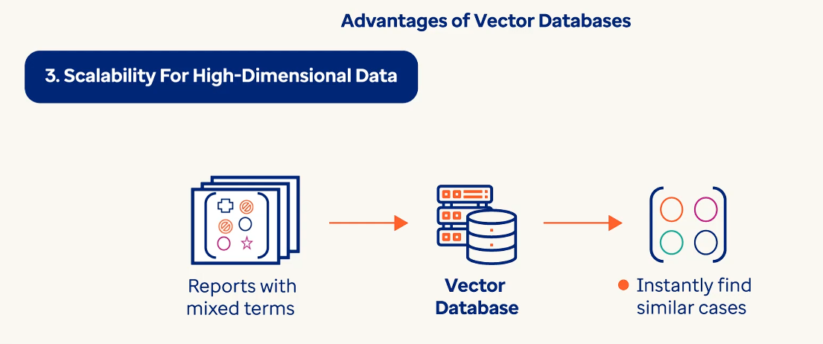

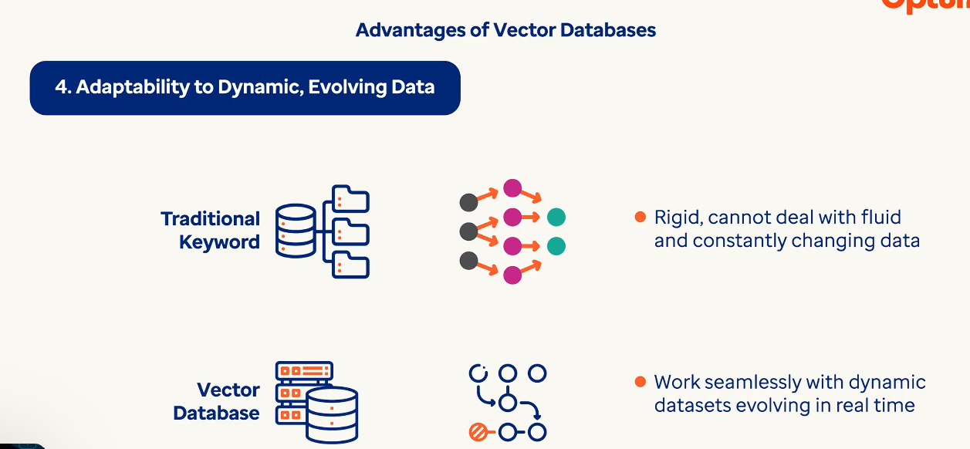

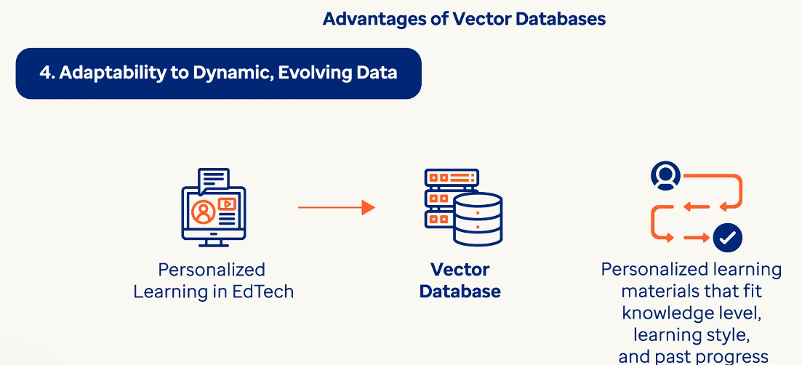

**What is a Vector Database?**

After converting text into embeddings (vectors), we need a way to **store**, **search**, and **retrieve** the most relevant vectors when a user asks a question.

That’s where a **Vector Database (Vector DB)** comes in.

**What it does:**

* Stores vector embeddings (numerical representations of text).
* Lets us run **similarity searches** — finding which vector (and text) is most similar to a user query.
* Enables **semantic search**, which means it looks for meaning instead of exact keywords.

This is a core part of the RAG (Retrieval-Augmented Generation) pipeline.

**What is a Vector Database?**

After converting text into embeddings (vectors), we need a way to **store**, **search**, and **retrieve** the most relevant vectors when a user asks a question.

That’s where a **Vector Database (Vector DB)** comes in.

**What it does:**

* Stores vector embeddings (numerical representations of text).
* Lets us run **similarity searches** — finding which vector (and text) is most similar to a user query.
* Enables **semantic search**, which means it looks for meaning instead of exact keywords.

This is a core part of the RAG (Retrieval-Augmented Generation) pipeline.

**What is ChromaDB?**

**ChromaDB** is a simple and powerful open-source vector database that integrates really well with LangChain.

**What it can do:**

* Store large numbers of vectorized documents.
* Let you search through those documents using a vector query (like a user’s question).
* Easily plug into LangChain tools for question answering and retrieval.

It's perfect for local, fast, and easy vector storage when building AI applications.

**Create model Client**

Following is the code to set-up the UAIS environment for establishing the connection to LLM and to get authentication.

**Authentication and Embedding Functions**

The following code sets up the UAIS environment to authenticate the application and connect securely to the Azure OpenAI embedding model. It retrieves the access token required for authorization and returns vector embeddings for input text, enabling use cases like semantic search and similarity matching.

**Embedding Initialization**

This code initializes the AzureOpenAIEmbeddings model, which is integrated with ChromaDB to convert textual documents into high-dimensional vector embeddings.  
These embeddings enable efficient semantic search, similarity matching, and retrieval operations within the vector database.

**Tiktoken Cache Configuration**

This code sets up a custom cache directory for Tiktoken by defining TIKTOKEN_CACHE_DIR as an environment variable.  
Caching tokenization results locally helps improve performance and reduces redundant computation during repeated embedding or tokenization operations.

**Important Note**

**Please do not run the ingestion code again and again** without clearing or managing your ChromaDB properly.  
Otherwise, your documents will be **appended multiple times** into the same persist_directory.

Consequently, when you later **retrieve the chunks**, you will **keep getting the same chunks repeatedly**, because **duplicates have been inserted** into the vector database.

**Data Retrieval Techniques in RAG**

In a RAG (Retrieval-Augmented Generation) system, **data retrieval** is the step where we search for the most relevant information (or chunks) to a user's question — **before** giving it to the AI model to generate an answer.

**Why is it important?**

* Large Language Models (LLMs) like GPT are powerful, but they **don’t know your documents** unless you tell them.
* Retrieval finds and feeds the **most relevant chunks** from your documents to the model.
* This improves **accuracy**, **relevance**, and reduces hallucinations.

In our case, we’ve already:

* Chunked the PDF data from the research paper,
* Created embeddings using BERT, Word2Vec, or OpenAI,
* Stored them using ChromaDB.

Now it’s time to **retrieve the best matches** from that database.

**Retrieval Techniques in RAG**

There are multiple ways to retrieve text chunks, but here are two major ones:

**a) Semantic Retrieval**

* Uses vector similarity to find chunks **most semantically similar** to a user's question.
* Example: If someone asks "How is IoT used in healthcare?", this will match with chunks even if they don’t use the exact words — like "MIoT is transforming patient monitoring."

**b) Hybrid Retrieval**

* Combines **semantic retrieval** (meaning) and **keyword search** (exact match).
* Useful when:
  + You want **precision + context**.
  + Your documents are a mix of structured and unstructured content.
* **Method 1: Semantic Retrieval**

This method uses **vector similarity** (cosine similarity) to find the most relevant chunks based on **meaning**, not just keywords.

* **Method 2: Hybrid Retrieval (BM25 + Semantic)**

Hybrid retrieval combines:

* **BM25** (keyword-based scoring),
* and **vector similarity** (semantic understanding).

This gives a balanced result that captures **meaning** and **exact matches**.

**Observation: Data Retrieval in RAG**

We implemented two retrieval methods on top of our vector store:

**Semantic Retrieval**

* Uses embedding similarity.
* Very strong at understanding meaning and rephrased questions.
* Great for open-ended queries or conversational AI.

**Hybrid Retrieval**

* Combines BM25 keyword search + vector similarity.
* Best of both worlds: finds **relevant words** and **relevant meanings**.
* Ideal when documents include technical terms or formal language.

**Summary:**

* Retrieval is what allows a RAG system to **"look up"** information from your document.
* The **quality of retrieval directly affects the quality of the answer** from the language model.
* You can pick the best method based on:
  + Document type
  + Use case (chatbot, search, Q&A)
  + Accuracy vs. performance needs

Next up: we’ll feed these retrieved chunks into a **Language Model (LLM)** to complete the full **RAG loop**!

**What is Reranking in RAG?**

In a RAG (Retrieval-Augmented Generation) system, we retrieve multiple chunks of text related to the user’s question — but:

* Not all retrieved chunks are equally relevant.

**Reranking** is the step where we:

1. Take the top N retrieved chunks,
2. Ask a smart model (like GPT) to re-evaluate and sort them,
3. Pass the most relevant chunks to the final language model for answer generation.

**Why is this important?**

* Without reranking, we might feed the LLM irrelevant or less useful chunks.
* Reranking helps us **improve accuracy**, **reduce hallucination**, and **deliver more precise answers**.

**LLM-Based Reranking Using OpenAI (Semantic + LLM-Based)**

This method sends the query and each chunk to OpenAI’s GPT model.

* Asks a **Language Model (like GPT)** to score or rank the relevance of each chunk.
* Understands meaning, tone, and nuance — not just keywords.
* It then asks GPT to evaluate which chunks are most relevant and return them in sorted order.

**Key Inferences**

* GPT is used to **rerank document chunks** based on how well they answer the user's query.
* The model makes semantic judgments rather than relying on vector similarity alone.
* The output is a **refined list of the most relevant chunks**, improving final answer quality.

**How llm_rerank_with_openai Function Works**

* **1. Prompt Construction**

The function builds a prompt containing the user's query and all retrieved document chunks, asking GPT to rank them by relevance.

* **2. GPT-Based Reranking**

The prompt is sent to GPT (via get_response), which returns a ranked order of chunks (e.g., Chunk 1, Chunk 3, Chunk 2).

* **3. Reorder and Return**

The function parses the ranking and reorders the original chunks accordingly, returning the most relevant ones.

* **Important Note:**  
  The reranked order of the chunks may change across runs because the ranking is decided by **gpt-4o-mini**, which is a non-deterministic model.  
  This means results can slightly vary each time depending on the model’s internal reasoning.

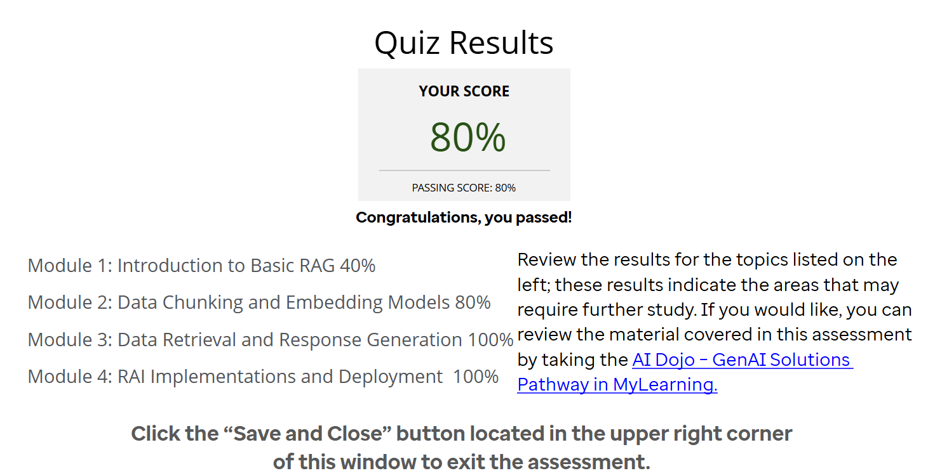

**Agentic AI**

Agentic AI systems are designed to act autonomously, making decisions and adapt to challenges, much like a human. 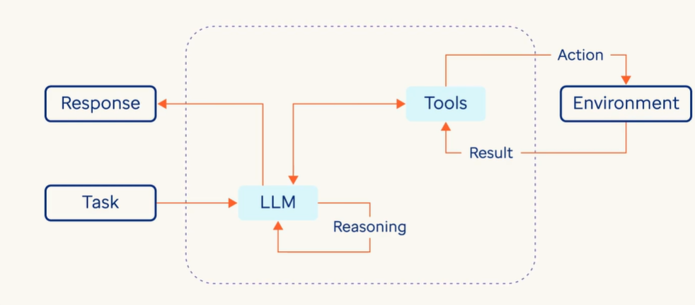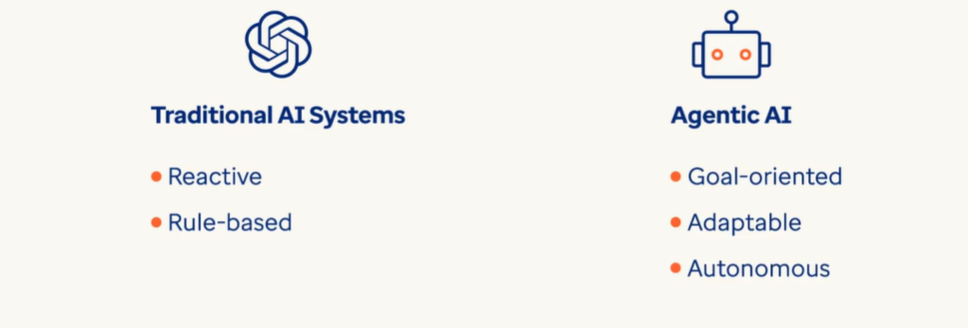

It consists of agency, the capacity to understand real world problems, perceive the environment, set objectives, make decisions and take actions to achieve desired outcomes to solve real world problems.

This capability emerges through leveraging LLMs as reasoning engines, planning mechanisms and continuous feedback loops that help the system improve its performance over time.

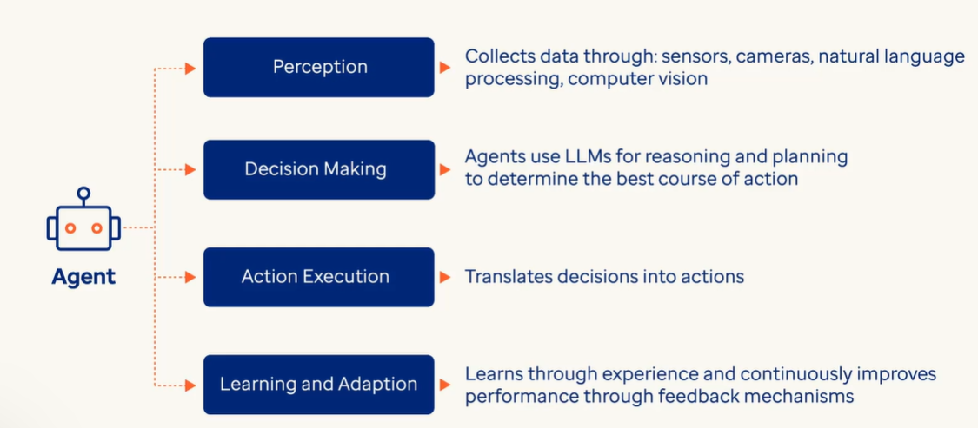

Industries ranging from robotics and autonomous vehicles to customer service and healthcare are relying more on AI systems that can independently navigate complex challenges autonomously by reasoning, planning, observing and taking the right actions.

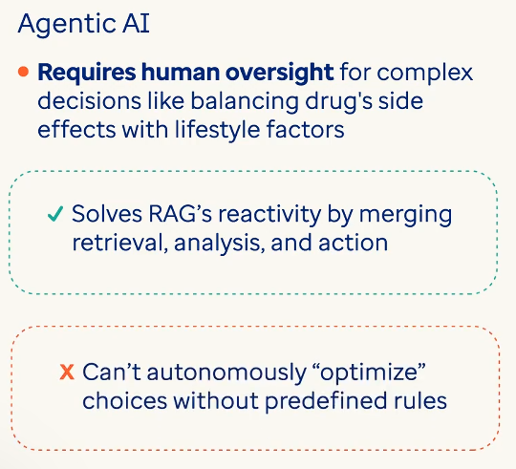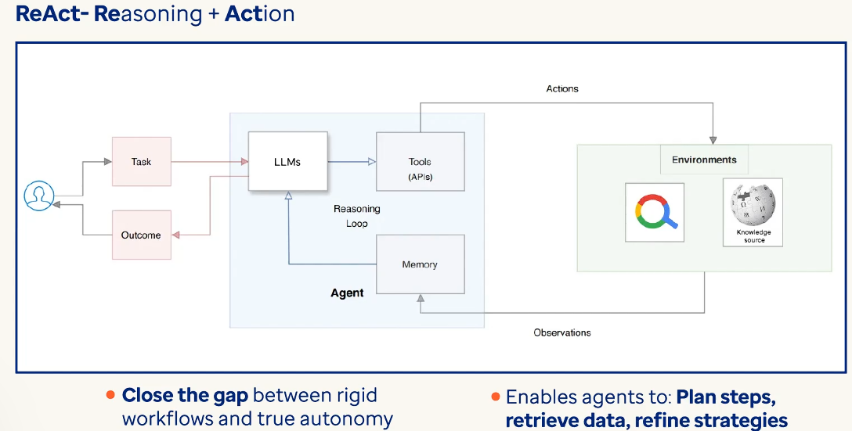

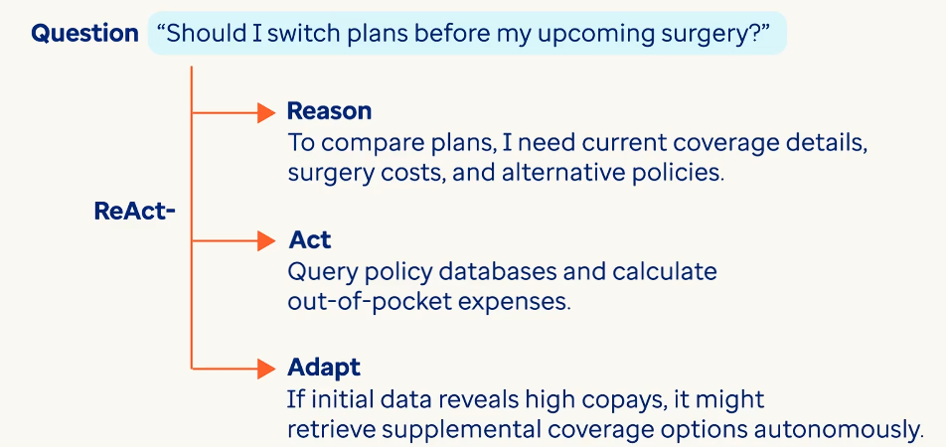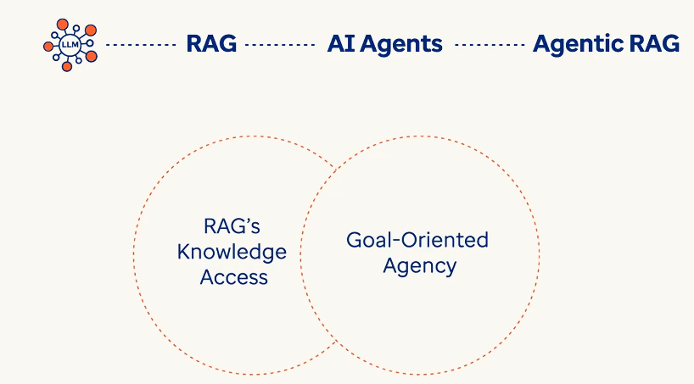

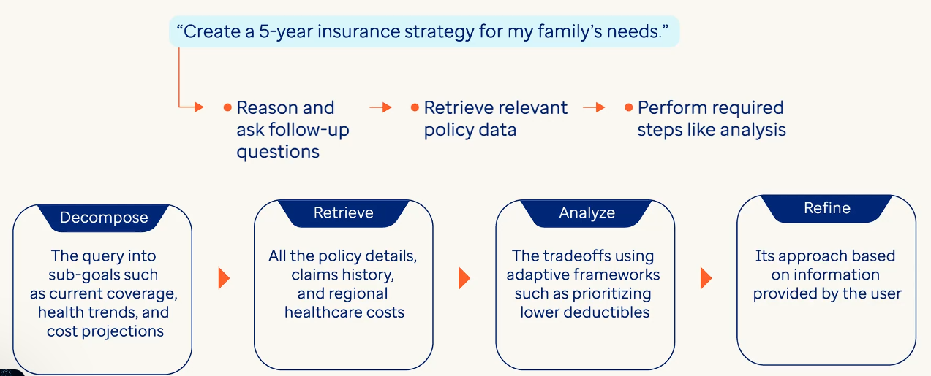

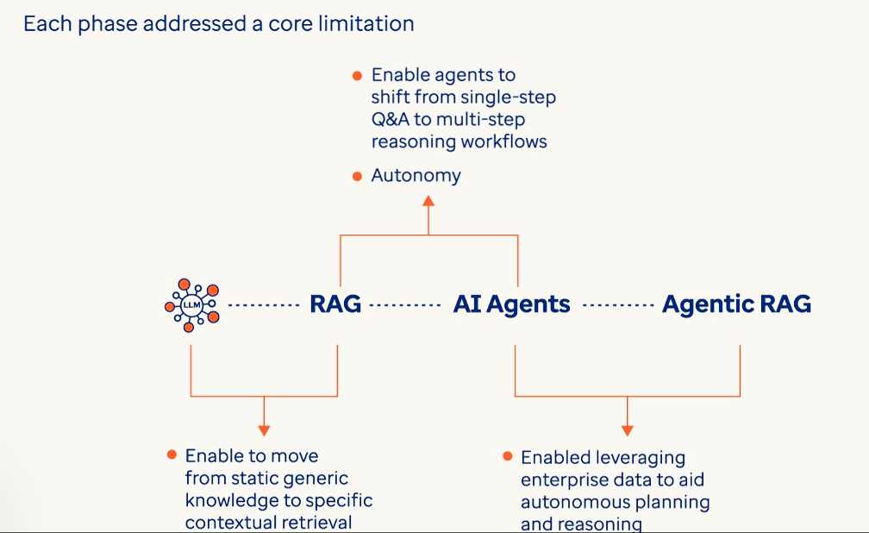

Components of Agentic AI systems:

* Planning
* Tool Utilization
* Memory

**Planning: Strategic Reasoning**

Planning transforms Agentic AI from reactive tools into proactive problem-solvers. Powered by Large Language Models (LLMs), it involves:

* **Task Decomposition**: Breaking complex goals into subtasks such as “Compare health plans → Check coverage limits → Calculate annual costs”.
* **Self-Reflection**: Iteratively refining strategies based on feedback, for example, revising cost estimates if initial data is incomplete.
* **Adaptive Learning**: Adjusting decisions using frameworks like ReAct (Reasoning + Action), which interleaves reasoning with tasks such as “What information is missing?” and actions that may include “Retrieve deductible details from policy documents”.
* For example, when a user asks a ReAct based healthcare agent, “What’s the newest treatment plans for Diabetes Type 2?*”* it follows the think – act – and observe. For this query the Agent would

**Think or reason by**

1. Parsing the query, recognizing the “newest” implies real-time updates and since it doesn't have enough information it decides that it would need to access external information.
2. Hence, it plans to “Access trusted medical sources (e.g., PubMed, clinical trial databases) using a Web Search tool available to the Agent, for studies published after its latest 2023 training cutoff date.”

**Next it would Act**:

1. The Agent calls a **Web Search Tool** with parameters such as *“Diabetes Type 2 treatment guidelines 2023-2025”*to retrieve recent peer-reviewed findings.
2. Then it filters results to prioritize FDA approvals or major consensus updates, for example the 2024 ADA guidelines.

**As the next step to Observe**:

1. The Agent analyzes retrieved data: *“New GLP-1 agonists and combo therapies show improved A1C control, per 2024 studies.”*
2. Then flags the gaps such as, conflicting trial results and verifies sources.

**For the final response**:

1. The agent may summarize the findings as *“*Latest options include [Drug X] (approved 2023) and [Therapy Y] but consult your doctor for eligibility.”
2. As a follow-up action based on how the Agent has been instructed, it might call a Booking Tool to help schedule an appointment with an endocrinologist.

It is important to consider that while the Agentic system automates complex information retrieval and comparative analysis, it requires explicit evaluation metrics to produce rankings, balancing objective assessment with transparency about the limitations of its recommendations, preserving user autonomy for final decisions.

This technique is an enhancement of the Chain-of-Thought (CoT) workflow, where step-by-step reasoning is explicitly tracked to avoid errors like hallucinations and then proceeds to take relevant action after gathering additional information via tool calling.

**Tool Utilization: Extending Capabilities with Tool-Use**

Agentic AI leverages external tools to bridge gaps in LLMs’ static knowledge. Key tools include:

* **APIs/Databases**: Fetch real-time data (e.g., querying insurer APIs for policy updates).
* **Code Interpreters**: Execute calculations (e.g., projecting annual premiums based on usage patterns).
* **Search Engines**: Retrieve the latest guidelines and information (e.g., CDC recommendations for preventive care coverage).

Agentic AI design patterns, like Tool-Use, embed tool calling and usage directly into the reasoning process.

Remember, in LLM-powered Agentic systems the LLM decides what tools to call at each step and gets relevant information for answering any query. Then the LLM synthesizes the tool responses which becomes new information to answer the question, only once it reasons that it has enough info to answer the question.

**Memory Systems: Contextual Recall with Vector Databases**

Memory enables continuity across tasks through:

* **Short-Term (Working) Memory**: Maintains context during a session. For instance, recalling a user’s stated budget while comparing plans.
* **Long-Term Memory**: Stores historical interactions and user preferences in **vector databases**, allowing rapid retrieval (e.g., “This user prefers low-deductible plans”).

For example, a hypothetic wellness advisor Agentic AI

1. Uses short-term memory to track a user’s weekly fitness goals.
2. Leverages long-term memory to suggest annual check-ups based on past medical history.

**Multi-Agent Collaboration: Specialized Roles**

In more complex scenarios, multiple agents can collaborate to achieve goals. For instance:

* A **Policy Analyst Agent** interprets insurance terms.
* A **Cost Calculator Agent** projects expenses.
* A **Compliance Agent** ensures recommendations align with regulations like HIPAA.

For example, when prompted with *“*Design a diabetes management plan,*”* agents debate tradeoffs:

* *“*Lower premiums vs. higher drug coverage” → Negotiate based on user’s glucose monitoring needs.

**Self-Monitoring & Safety: Ethical Guardrails**

Agentic AI self-audits using:

* **Chain-of-Thought Verification**: Tracing logic steps to catch errors for example “Did I confuse copay vs. coinsurance?”. However, it is important to consider the fact that the Agents will do this as long as relevant instructions have been given to it via system prompts and such.
* **Ethical Frameworks**: Enforcing privacy such as anonymizing health data during analysis and bias checks, for example, flagging discriminatory coverage suggestions.

For example, a financial advisor agent avoids recommending high-risk plans to elderly users by cross-referencing FDA guidelines on age-related health risks.

**Integration in Practice**

Consider an Agentic AI managing corporate wellness programs:

* **Planning**: Uses ReAct to structure employee health assessments.
* **Tools**: Pulls wearable device data via APIs, calculates risk scores with code interpreters.
* **Memory**: Recommends personalized screenings based on past participation.
* **Multi-Agent Collaboration**: A Compliance Agent audits recommendations against ERISA regulations.

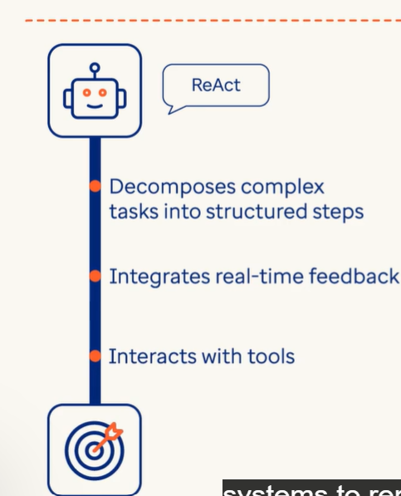

ReAct 🡪

* It beings with Reasoning where LLMs act as brain for these agents.

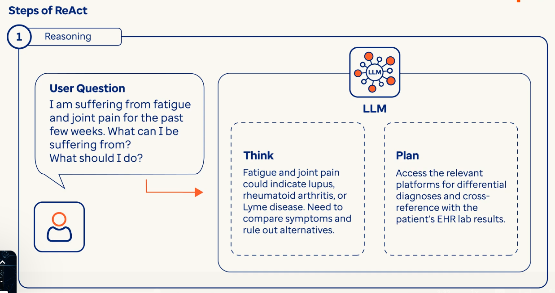

* 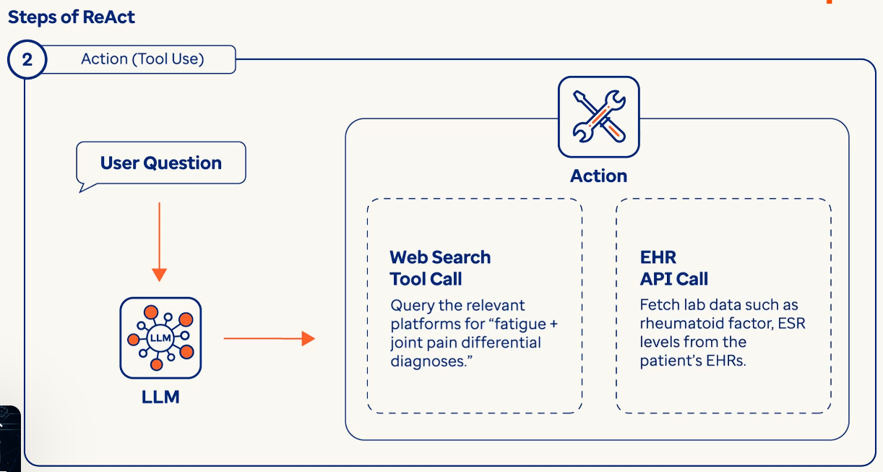
* 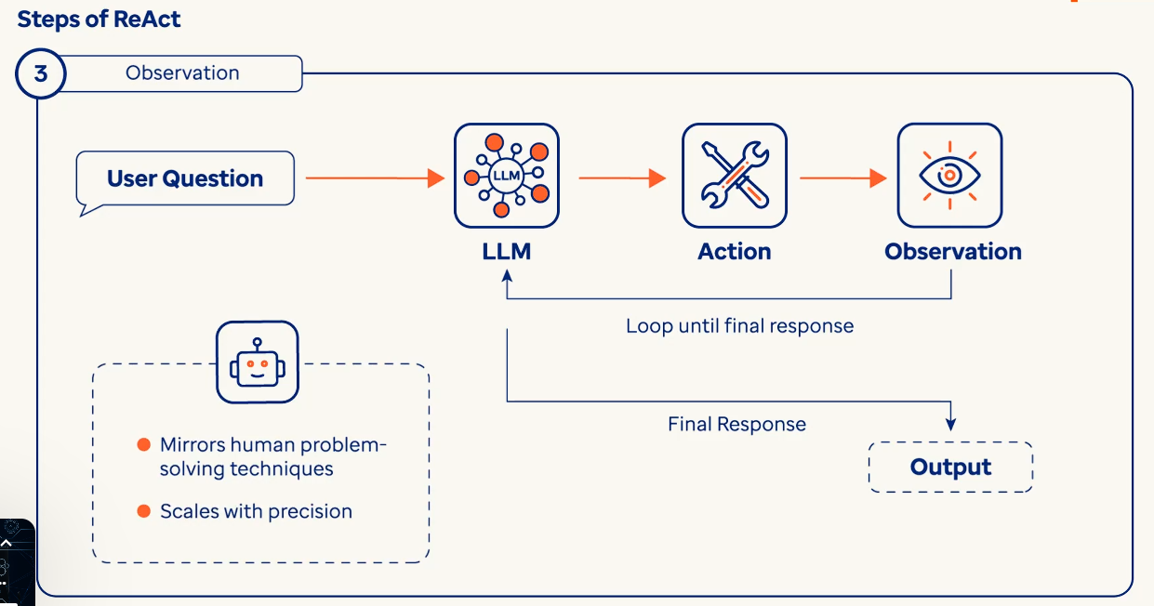
* ReAct operates in a continous loop in a cyclic workflow of thought or reasoning, action, observation

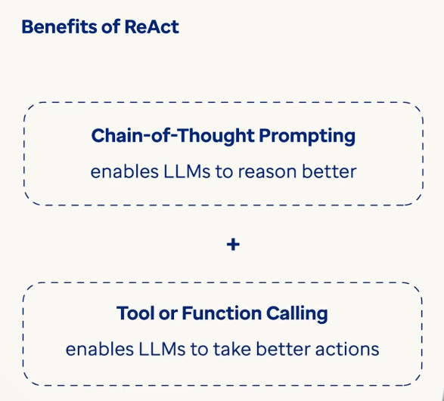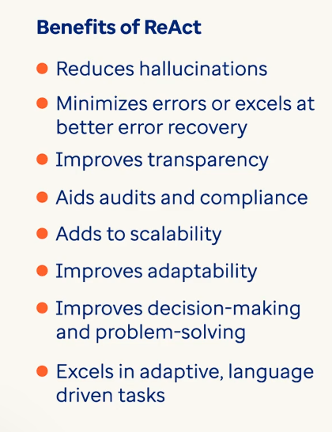

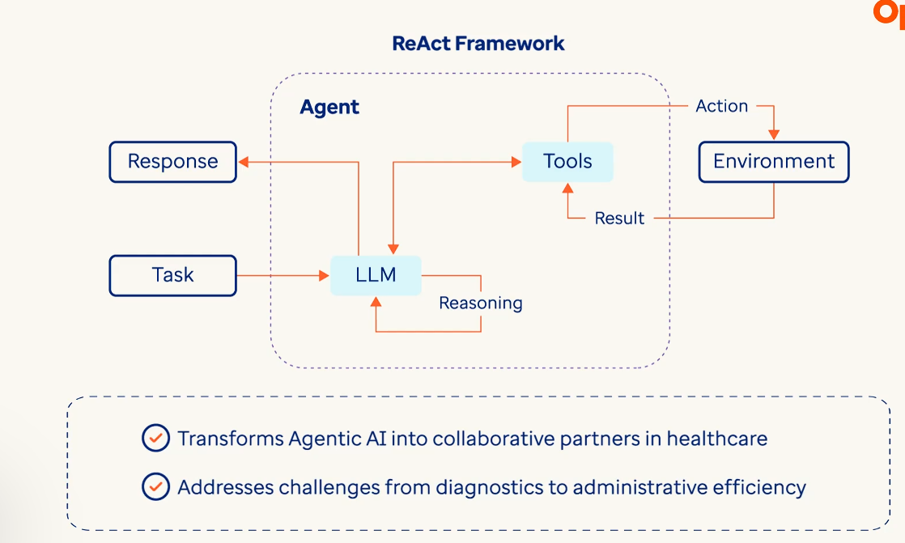

**Agentic AI Types**

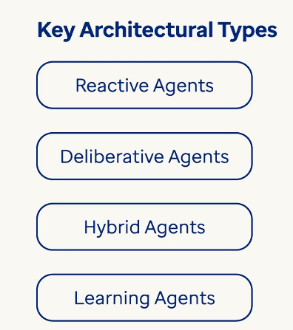

Reactive Agents 🡪 They operate on immediate stimilus response without memory or long term planning. They following streamlined loop of sense, think, act loop perception that detects real time data through various sources such as sensors, API, etc., Actions triggers predefined responses such as alerts, API calls to tools, platforms.

Example: An insurance fraud detection system acts as an agent 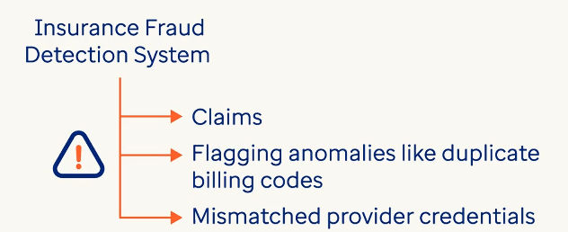

*Challenges*: Reactive agents lack contextual awareness for ex: they can’t distinguish between clerical errors and intentional fraud. They rigid rules may fail in ambiguos scenarios like when users raise high volume claims during disaster scenarios.

Deliberative Agents 🡪 They use symbolic reasoning and multi-step planning 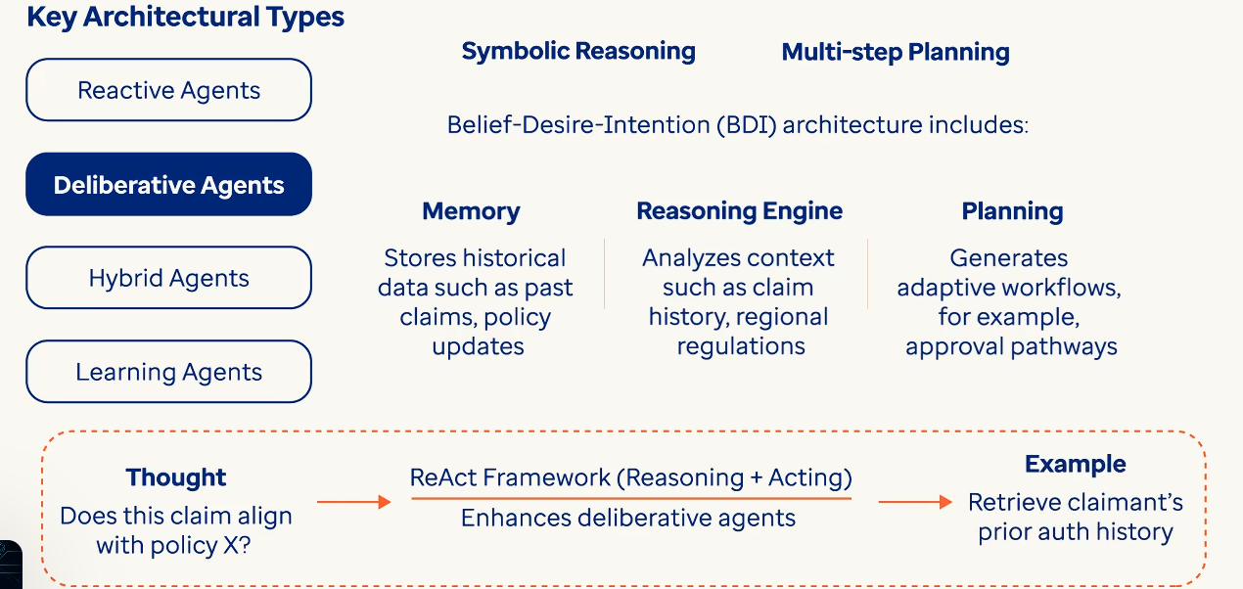

For example A prior authorization agent may use ReAct to reason : need to verify if the MRI scan is covered in policy Y, act: query policy databases and patient eligibility, adapt : if denied suggest alternative imaging options as per guidelines

*Challenges:* High computational costs for complex reasoning and the risk of bias if training data lacks diversity such as outdated documents.

Hybrid Agents 🡪 They balance between speed and strategy. They merge reactive speed with deliberative depth using a layered design that includes reactive layer that can handle urgent tasks such as claim validation checks, deliberative layer that manages strategic planning for example: optiming approval workflows. Shared memory coordinates between layers. 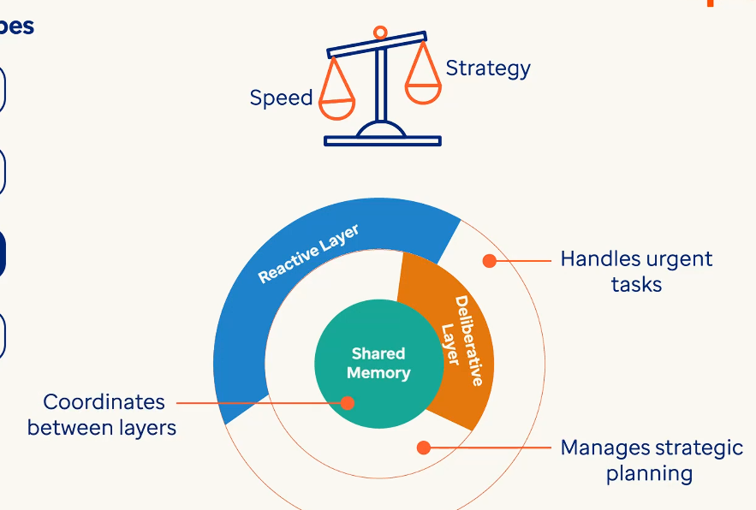

Learning Agents 🡪 These evolve through feedback loops and reinforcement learning.

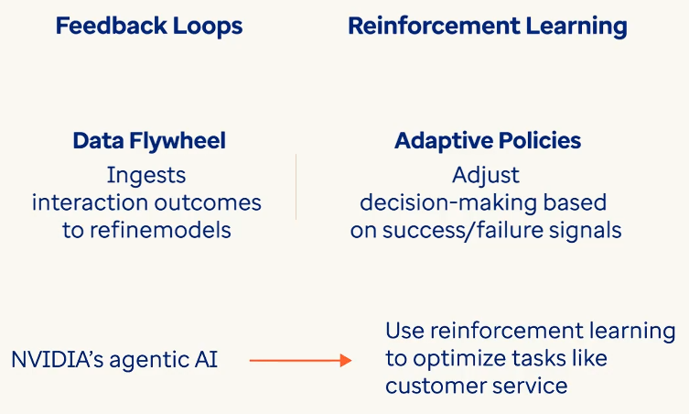 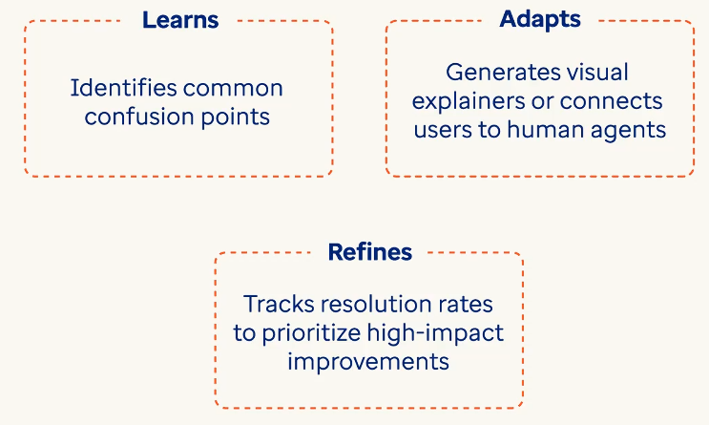

**Architectures and Frameworks of Agentic AI**

AI agent architectures combine specialized frameworks and workflows to enable autonomous decision-making in complex environments.

**Pre LLM-Powered Agentic AI Era**

**1. Cognitive Architectures**

Cognitive architectures model human-like reasoning using structured memory and learning systems:

* **SOAR**: Uses rule-based reasoning and memory systems (long-term procedural, short-term working) for tasks like insurance claims adjudication. For example, SOAR agents apply policy rules and historical cases to validate claims, adjusting decisions based on new regulatory updates.
* **ACT-R**: Integrates declarative (fact-based) and procedural (action-based) knowledge. A prior authorization agent using ACT-R might cross-reference patient history (declarative) with insurer guidelines (procedural) to approve/reject requests.
* **OpenCog**: Combines symbolic logic with neural networks. A hospital billing agent could use OpenCog to parse unstructured payer emails (neural NLP) while applying formal billing codes (symbolic rules).

**2. Classical Agent Architectures**

* **Reactive Architectures**: Use stimulus-response loops for real-time tasks. Example: A fraud detection agent triggers alerts for unusual billing patterns (e.g., 10+ MRI claims/hour) using predefined thresholds.
* **Deliberative (BDI) Architectures**: Employ Belief-Desire-Intention frameworks for complex planning. A prior authorization agent’s belief (patient records), desires (approve valid claims), and intentions (submit documentation) guide multi-step workflows.
* **Hybrid Architectures**: Layer reactive and deliberative systems. A patient service chatbot handles routine FAQs reactively but escalates complex billing disputes to human agents after deliberation.

**3. Decision-Making Frameworks**

* **Utility-Based**: Maximize predefined metrics (e.g., patient satisfaction). A claims processing agent assigns utilities to outcomes (e.g., fast approval = +0.7, regulatory breach = -1.0) to prioritize actions.
* **Planning Systems**: Generate action sequences using Hierarchical Task Networks (HTN). Example: An agent automating Medicaid enrollment breaks tasks into subtasks (verify income, check residency, submit forms).
* **Search-Based**: Apply algorithms like A* for cost-optimized paths. A hospital scheduling agent uses Monte Carlo Tree Search (MCTS) to allocate staff across departments while minimizing overtime costs.

**4. Learning Architectures**

* **Reinforcement Learning (RL)**: Agents learn via trial and error. Example: A prior authorization bot improves approval rates by observing which document bundles reduce rework.
* **Imitation Learning**: Mimic human experts. A claims adjuster agent trained on historical decisions replicates senior auditors’ patterns to resolve disputes.
* **Meta-Learning**: Adapt to new tasks rapidly. A customer service agent uses Model-Agnostic Meta-Learning (MAML) to handle novel insurance queries after minimal training.

**LLM-Powered Agentic AI Era**

* **Tool-Use Agents**   
  These agents integrate external tools (APIs, databases) via frameworks like ReAct and function calling. For example, a prior authorization agent uses OCR tools to scan policy PDFs and APIs to verify coverage rules. They follow structured workflows: *Reason* (“Check Plan X’s MRI auth rules”), *Act* (call policy database), *Observe* (analyze results). Tool selection prioritizes relevance (e.g., CMS databases for Medicare rules). Used in claims processing, eligibility checks, and data retrieval.
* **Reflection-Based Agents**   
  They critique and refine outputs using memory systems. A fraud detection agent cross-references current claims with long-term memory (vector databases storing past fraudulent patterns) to flag anomalies. Working memory tracks context (e.g., active claims) to avoid hallucinations. For example, retrieving historical denial reasons to improve appeal responses. Combines retrieval (semantic search) with iterative self-correction.
* **Planning Agents**   
  Break complex tasks into subgoals using Chain-of-Thought logic. A diagnostic agent plans: “1. Retrieve differential diagnoses, 2. Compare lab results, 3. Rule out alternatives.” For insurance claims, they decompose steps: verify deductible status → check auth rules → calculate costs. Synthesizes subtask outputs (e.g., EHR data + policy clauses) into final answers.
* **Multi-Agent Systems**   
  Specialized agents collaborate via protocols. Example: Hospital resource agents (staffing, equipment) negotiate allocations using contract-net protocols. A patient service agent might coordinate with insurance verification (via natural language messaging) and CRM tools (Salesforce) to resolve billing issues. Emergent behaviors arise from simple rules, like pharmacy agents stabilizing drug pricing collectively.

Tool-use underpins most architectures (e.g., Planning Agents use ReAct + function calls). Multi-agent systems often combine planning and reflection (e.g., fraud detection with memory). Hybrid designs enable scalable, precise automation while mitigating LLM limitations.

**Practical Frameworks**

* **LangChain**: Chains LLMs with tools and Agent Executor for tool calling. Example: A hospital chatbot uses LangChain’s memory modules to retain conversation history across sessions.
* **AutoGPT**: Autonomous task management. An insurer’s marketing agent generates personalized outreach plans (emails, SMS) using goal-driven decomposition.
* **LangGraph:** A low-level orchestration framework (from LangChain) for building stateful, graph-based agents. It enables customizable workflows (e.g., loops, memory) to handle complex tasks like claims processing. Developers define nodes (agents/tools) and edges (transitions), supporting human-in-the-loop validation. Ideal for multi-step processes requiring precise control, such as prior authorization workflows that integrate policy checks, EHR data retrieval, and denial reasoning.
* **Microsoft Semantic Kernel:**A framework designed for integrating LLMs with plugins for task execution. Offers built-in support for planning workflows and managing context-aware interactions.
* **AutoGen:**  A Microsoft-developed framework for event-driven multi-agent systems. Agents (e.g., customer service, policy analysis) communicate via messages and trigger actions based on events (e.g., claim submission). Supports dynamic coordination, like routing tasks between specialized agents (NLP for forms, APIs for coverage checks). Used in scalable systems requiring real-time collaboration, such as hospital resource allocation or insurance claim triage.
* **CrewAI:** Focuses on high-level orchestration using "Crews" (agent teams) and "Flows" (task sequences). Simplifies creating autonomous agents (e.g., sales teams automating lead research → outreach). Offers granular control via Python APIs—like defining a medical research Crew (Researcher Agent pulls studies, Analyst Agent compares treatments). Balances simplicity for common workflows with flexibility for custom logic, such as insurance plan comparisons or patient intake automation.

**Design Patterns for Architecturing Agentic AI systems:**

Imagine a senior citizen care facility using a home health monitoring system designed to support elderly residents. The system uses sensors to track vital signs while AI agents coordinate care , predit emergencies and notify caregivers.

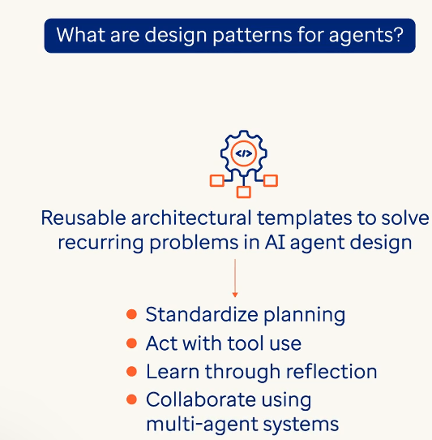 An agent monitoring a patient’s sleep pattern might use a planning pattern to schedule check-ins or a tool use pattern to pull data from a wearable device. These patterns ensure agents behave predictably even in dynamic environments.

Design patterns help developers avoid reinventing the wheel.

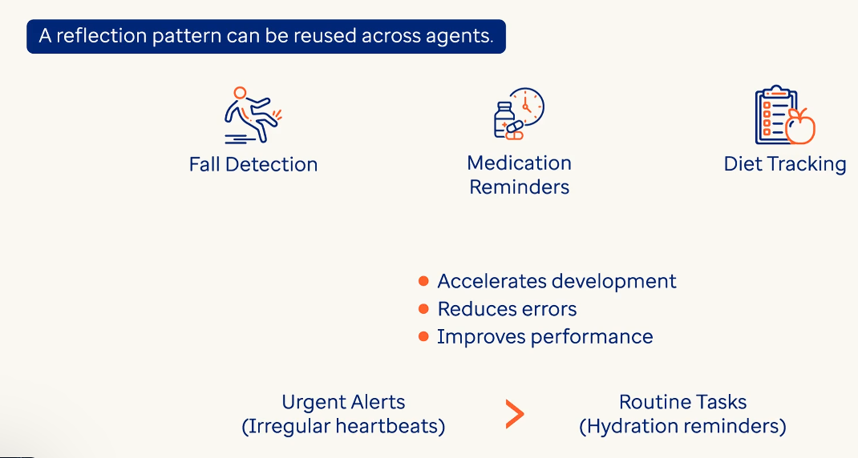 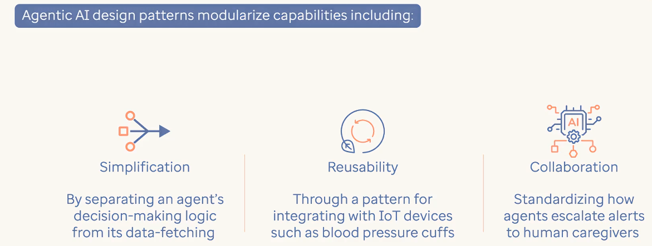

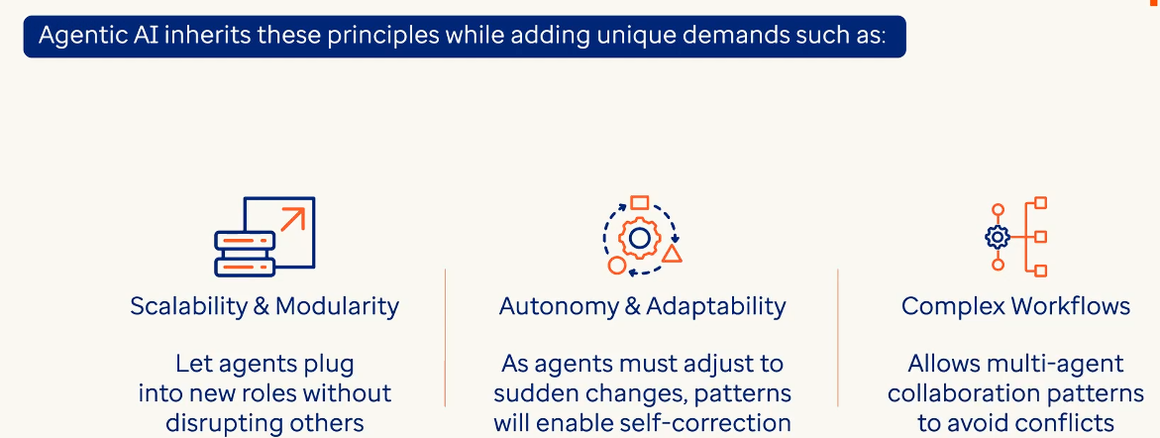

Reflection Pattern 🡪 For example a nutrition adivser might revise meal plans after observing patient’s consistent sodium spikes. The key components for this patern include memory module, evaluator and feedback loop among others. One of the best advantages is that it reduces the repetitive mistakes

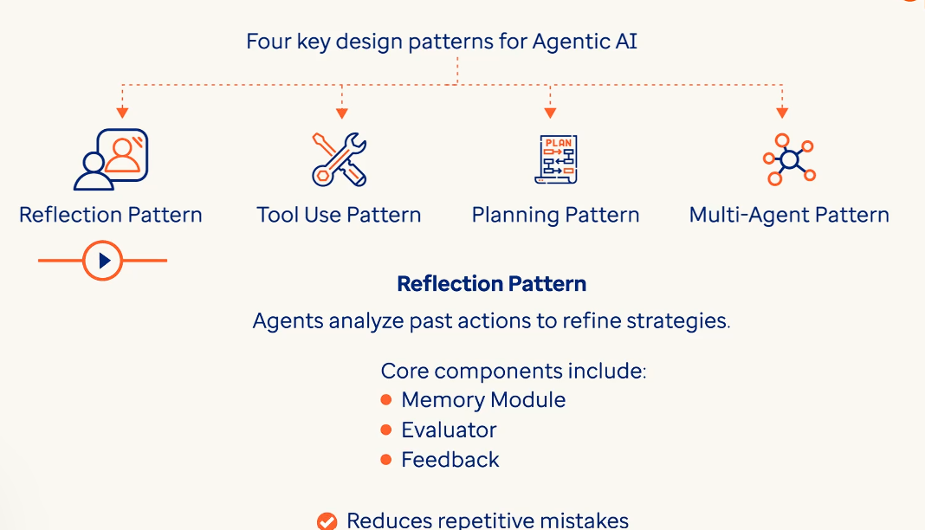

Tool use pattern 🡪 Agents will first reason and select the best tools to be used before calling to access external tools like APIs & databases.

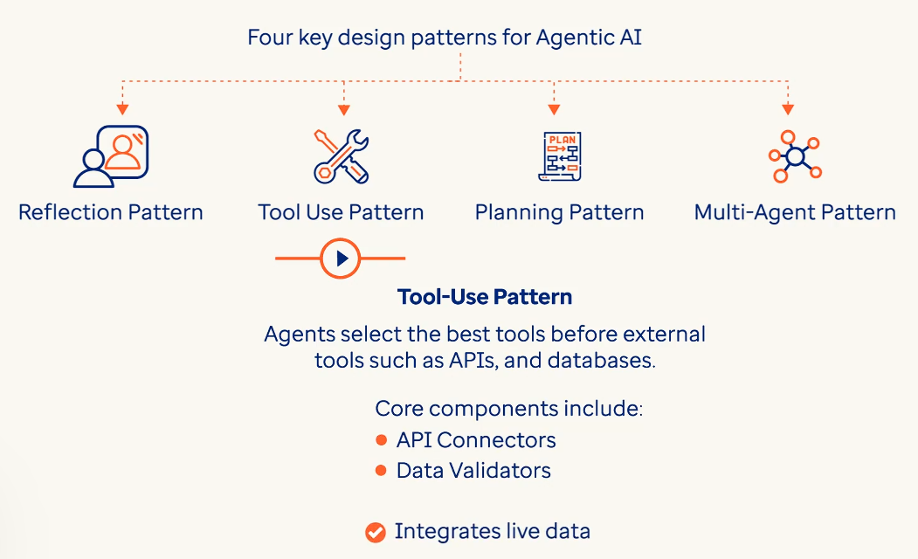

Planning Pattern 🡪 This is like scheduling physiotherapy sessions for a week without any conflicts.

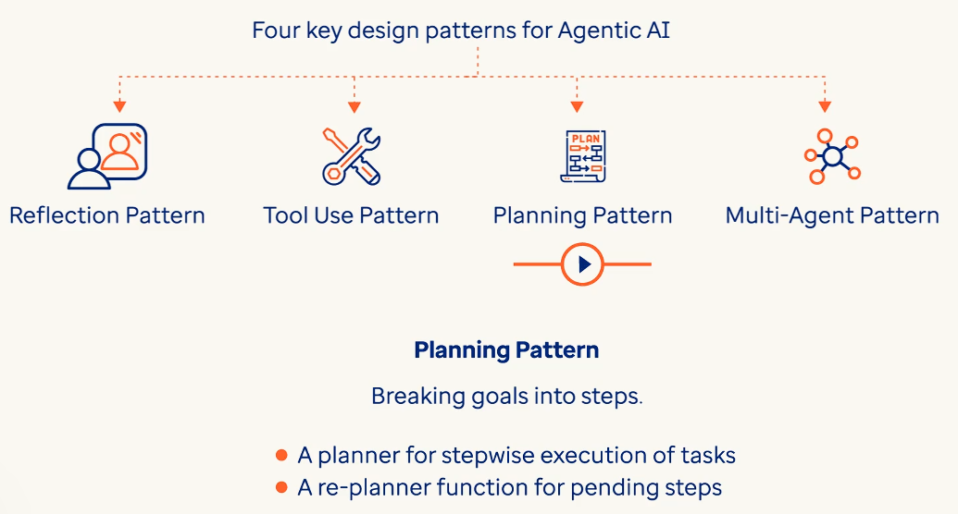

Multi Agent Pattern 🡪 Here multiple agents specialize and coordinate with each other.

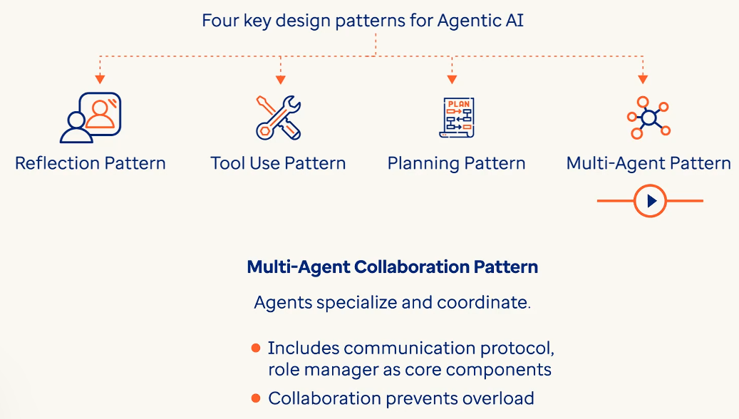

For example: A planning agent schedules a video call with a doctor while a tool use agent books an appointment while a clinic’s API. A reflection agent analyzes call outcome to improve future scheduling. Multi agent collaboration ensures seam less handoffs for ex: transferring patient’s call outcome notes to a diet planner agent. Together these patterns create great systems. 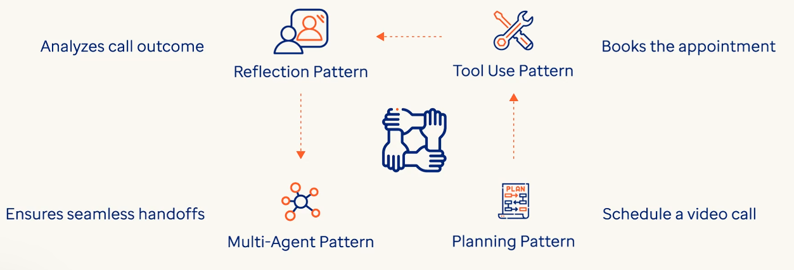

**LangGraph:** Imagine having a home health monitoring system where different agents perform different tasks. To manage these interconnected agents we need a framework that balances autonomy with control.

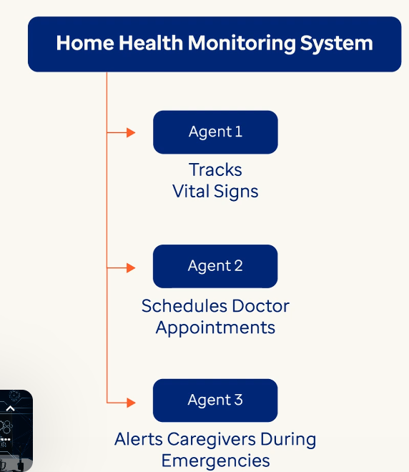

**LangGraph** is a python library used to build stateful graph based workflows for agentic AI systems. It models agents as dynamic graphs where nodes are steps which execute in the agent and edges connects these steps to control the flow of execution in the agent.

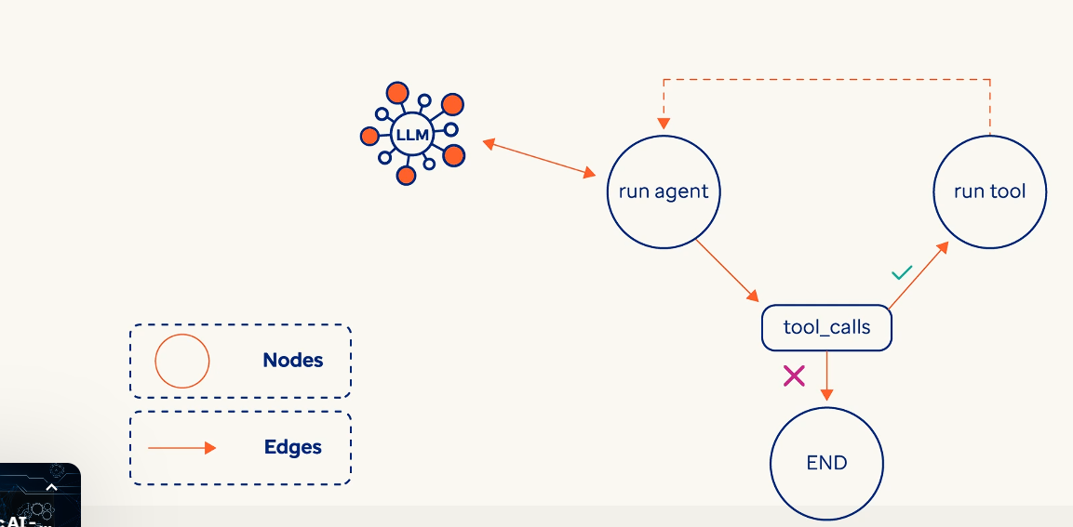

A node is usually a single step in the agent but we can build more complex agents like multi agent systems where a node can also be an agent.

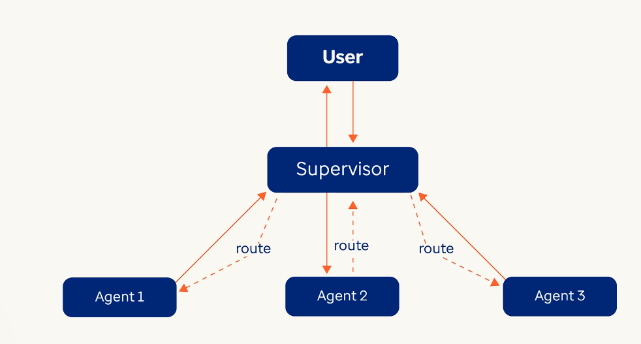

LangGraph allows a host of features, functions and capabilities of which the most important ones are controllability that allows developers to find rules for when and how agents act.

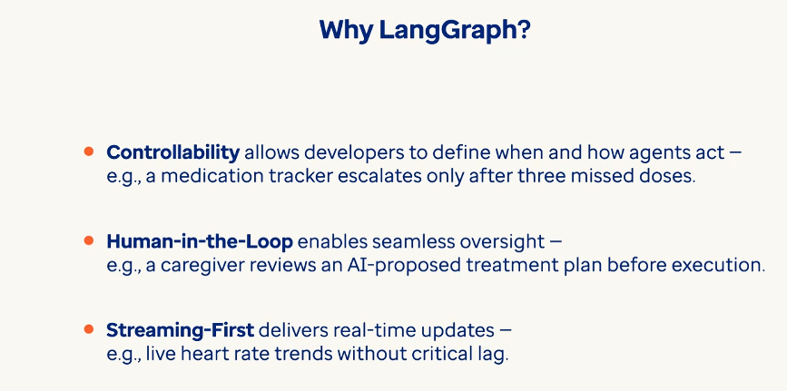 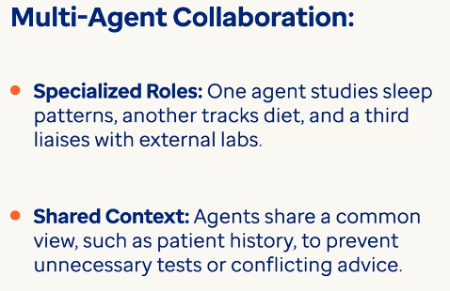

LangGraph power relies in it’s graph architecture where agents refer to as nodes and decision pathways refer to as edges form adaptive workflows. The key features that sets LangGraph apart are their cylical structures that allow agents to loop until a goal is met. For ex: a symptom checker agent might re ask questions if responses are unclear. Systems retain context using stateful execution across interactions like remembering patient’s allergy history during diagnosis. 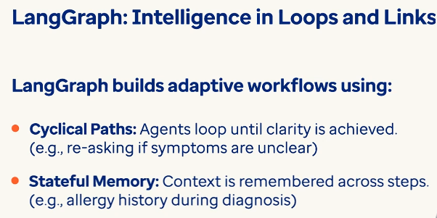

**Nodes**

* A aingle step in an agent that performs discrete tasks. Each step in the agent is coded as python function where we define what logic will be executed in the agent when it goes to that step i.e..node.

For example: a data collector node can pull glucose levels from wearables and an alert generator node can flag abnormal readings. 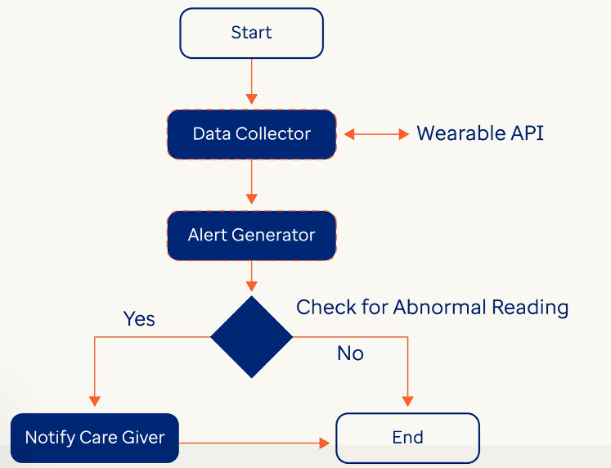

* In more complex systems a step can be an agent or sub agent. A node can behave like agent or sub agents like Cardiologist, Radiologist and can share data to diagnose heart conditions accurately.

**Edges**

* These route data between nodes. For ex: A normal edge will send lab results from a test analyzer to a report generator and a conditional edge will route severe symptoms to an emergency responsder while for non-severe symptoms it might route to a doctor’s appoinment.

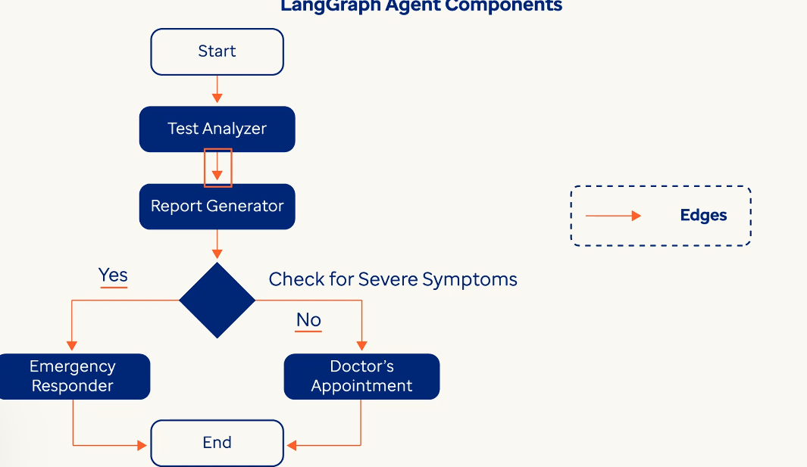 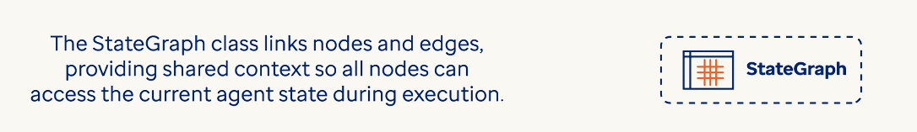

For example if a tool call response was generated in a tool node it is accessible by the LLM reasoning node to leverage that information to answer the user question which itself is also stored in the agent state. 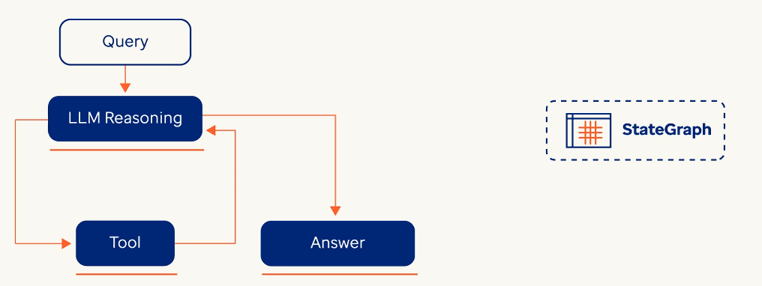

**Features of StateGraph** 🡪

StateGraph & Schema 🡪

This is typically used to find the overall state of the graph which includes the schema, that is, variables and data types which would be passed throughout the different nodes in the graph as the agent executes. It also defines data structure for example PatientState defines the vitals, medications, alerts, appointments_info or any notes ensure that nodes interpret the data consistently. The state schema defines the overall schema of the data variables which will be passed throughout the agent graph of life cycle.

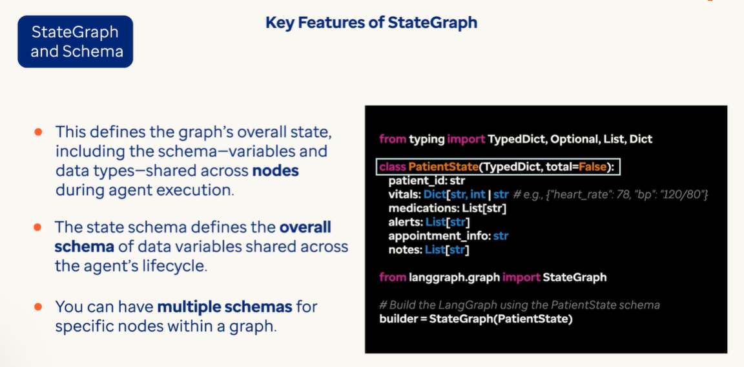

In LangGraph, StateGraph class serves as the foundational structure for defining and managing the flow of data and operations within a graph-based workflow.

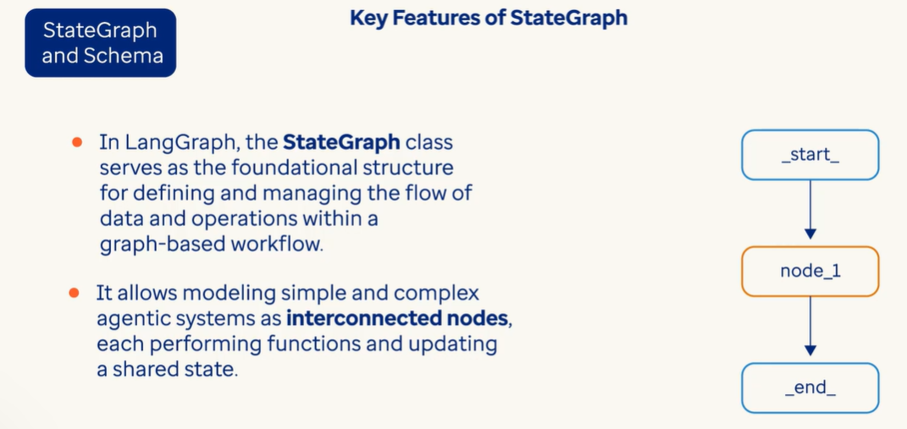

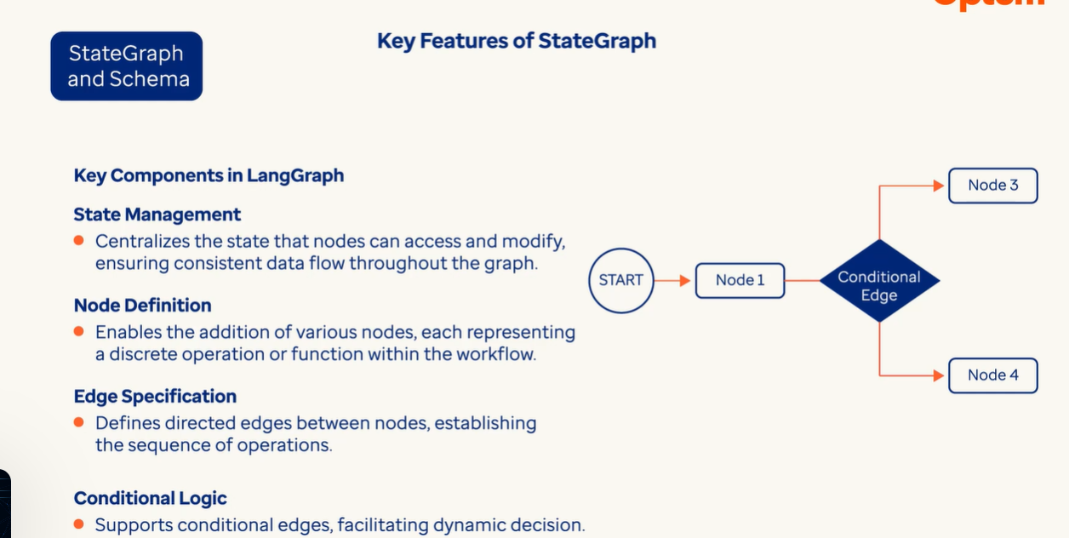

Reducers 🡪 Merges updates into a state. For ex: appending latest lab results to patient history instead of overriding it. In LangGraph, reducers are functions that define how updates are applied to specific keys within the state.

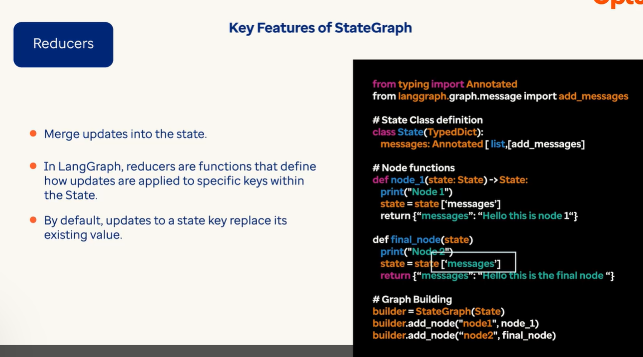

Here “add_messages” is reducer designed to handle list of messages within the state ensuring new messages are appened instead of existing one getting overwritten. It also manages message IDs to prevent duplication and allows for the removal of specific message when needed. This function is then associated with a node using the Add conditional edges method. This mechanism enables to adapt to workflows that responds to varying conditions during execution.

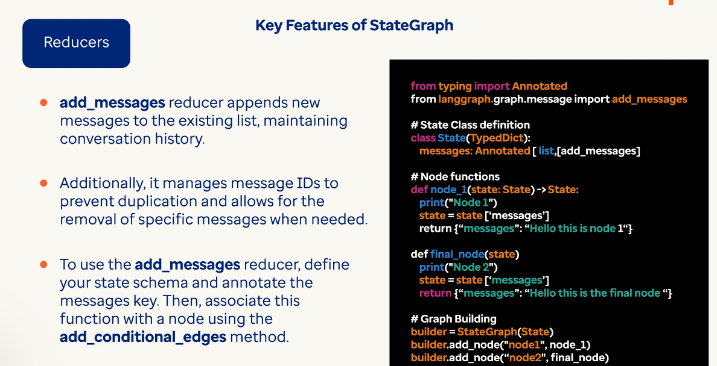

**Tool Nodes**

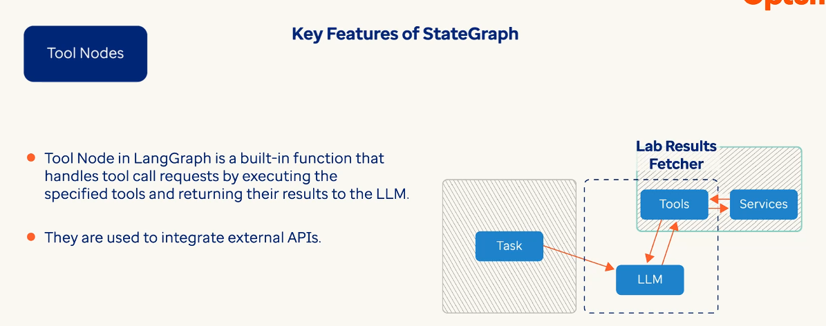

It is a built-in function of LangGraph that takes in a list of tools and as it gets tool call requests, it executes them and returns the results to the LLMs in the agent.

**Edges**

Edges are of two types : Normal Edges & Conditional edges

Normal edges go directly from another node to another where each node is a step, where as conditional node calls a conditional routing function to determine which node or nodes to go next in the lang graph.

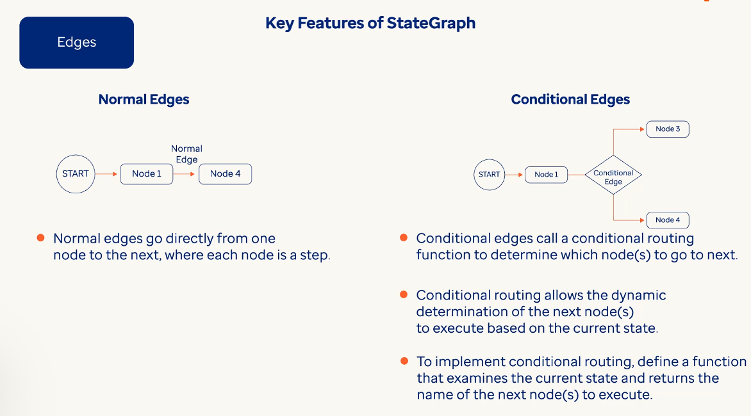

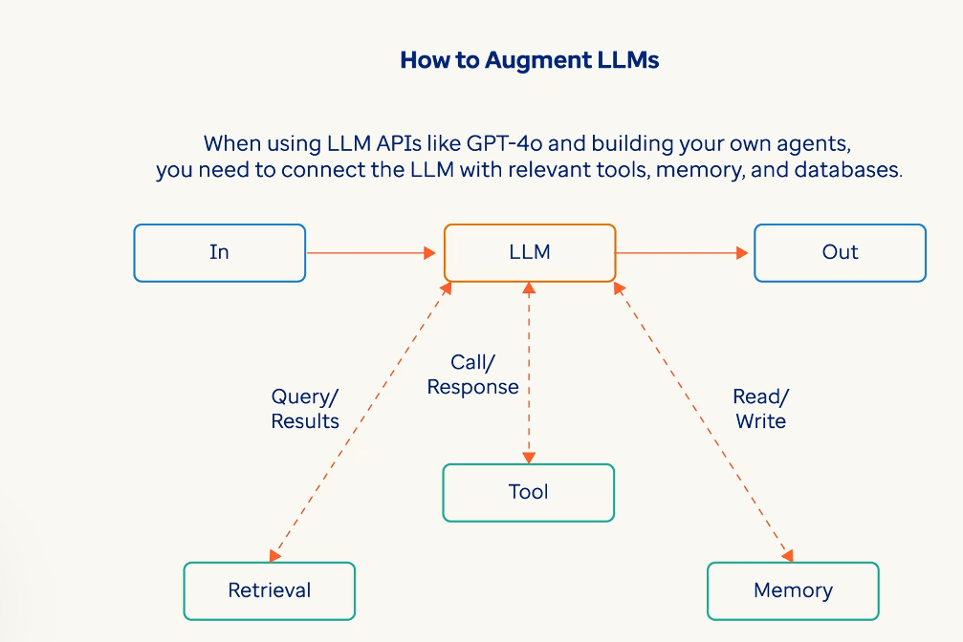

Then these augmented LLMs can then generate the search queries, select appropriate tools and determine what information to retain.

Tool node acts as a specialized node responsible for executing predefined tools within the Graph workflow.

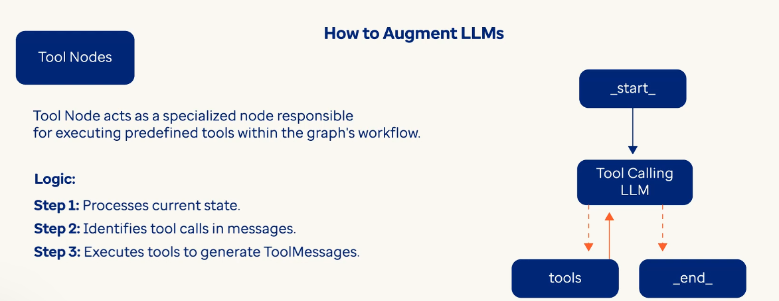

Tool Condition serves as the conditional routing function that determines the graph’s execution path based on the presence of tool calls.

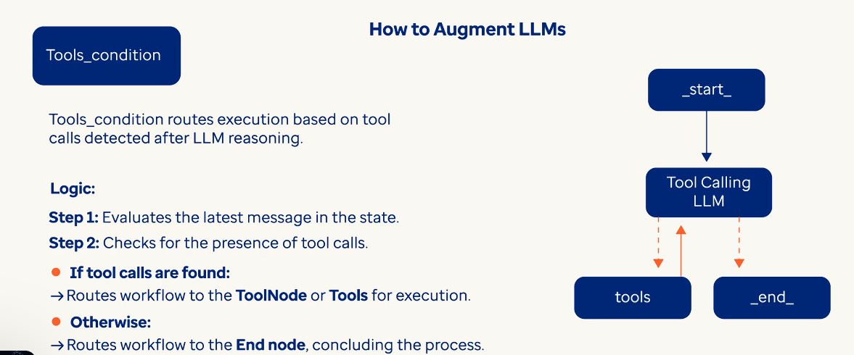

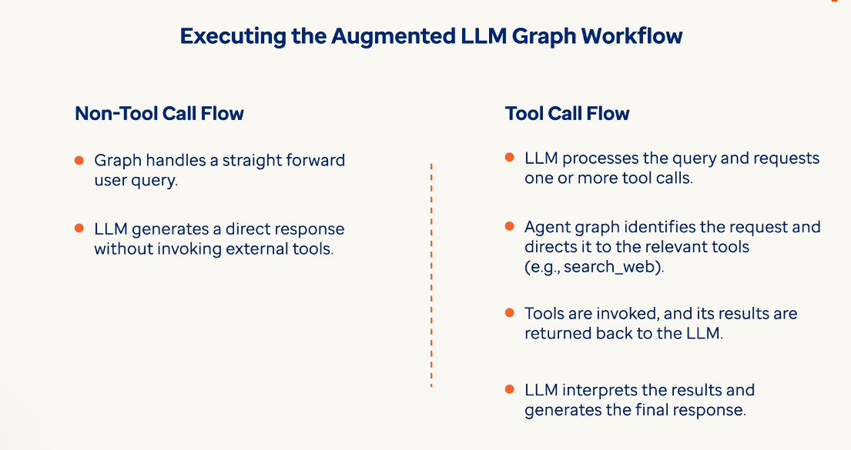

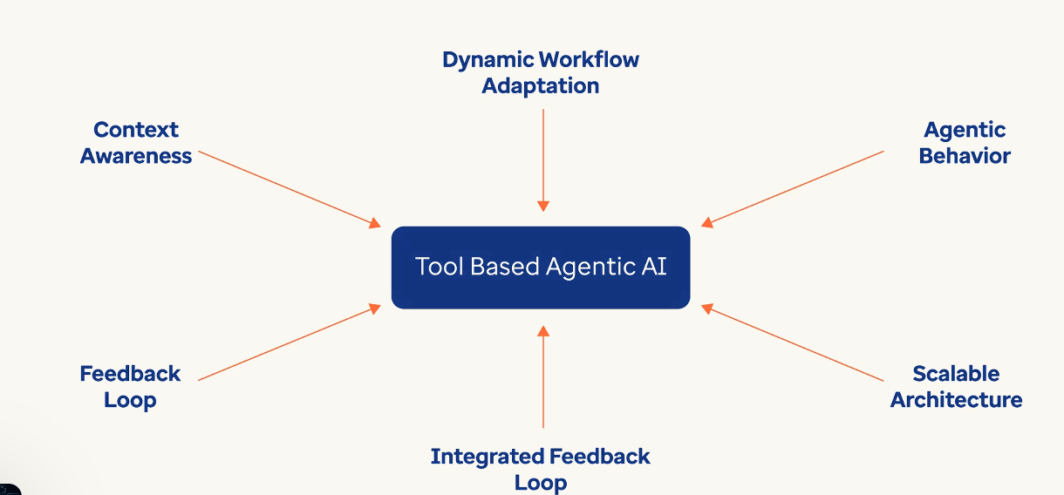

LangGraph transforms AI from static tool to adaptive partner. In healthcare, this means systems that can think, plan, act, tool use and learn stateful memory, all while keeping humans in control.

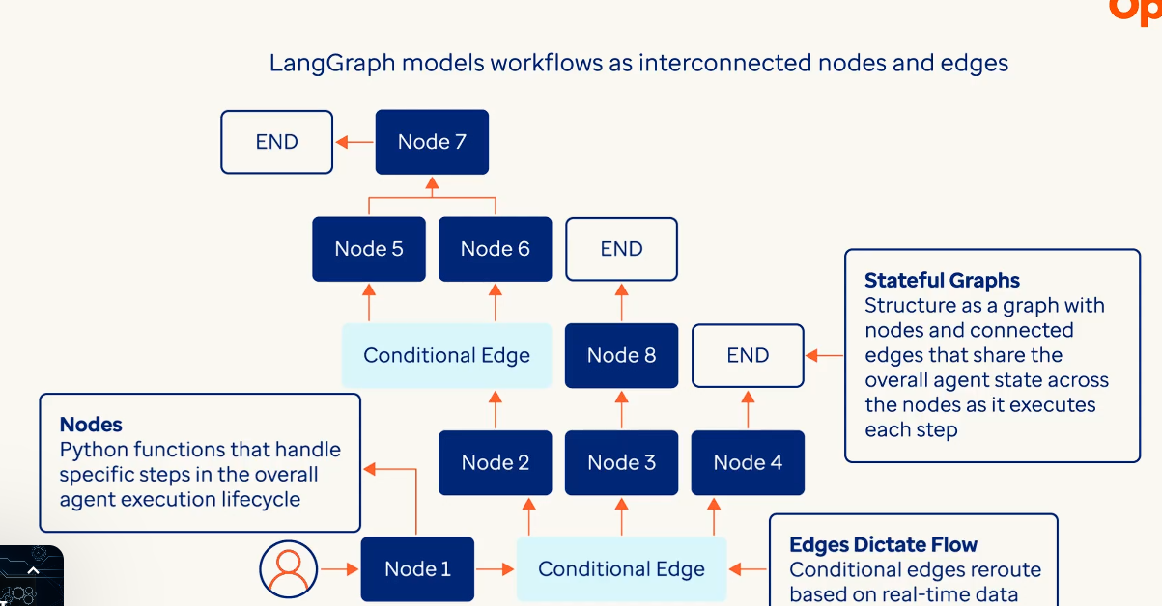

**Memory Toolbox of LangChain:**

LangChain’s memory toolbox provides specialized memory constructs to balance context and efficiency.

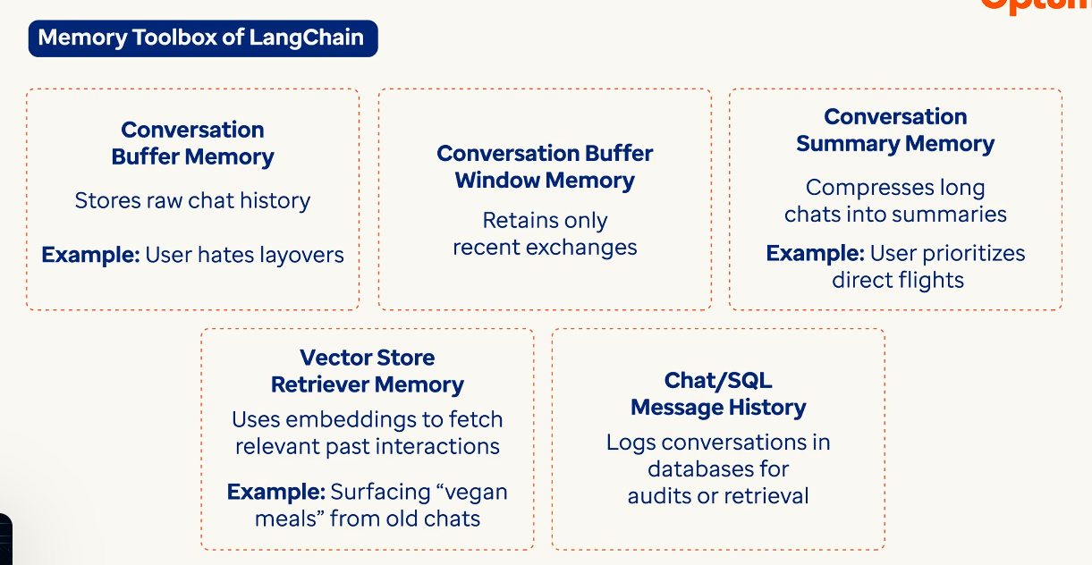 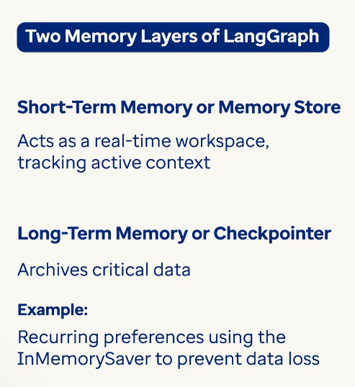

When the user says’ Book a hotel in Paris with gym’, now this prompt is stored in memory then LLM process the request and suggests hotels as response. The response will now be stored as next message in the memory. The check pointer keeps saving every step’s output and input in the overall short term memory as a sequence of messages. The long term memory on the other hand is where certain user preferences are stored overtime and uses an LLM to extract that from the earlier messages. So the for the next request when the user asks ‘Book a hotel in Tokyo’ the system automatically prioritizes gym equipped hotels extracting the information from long term memory. 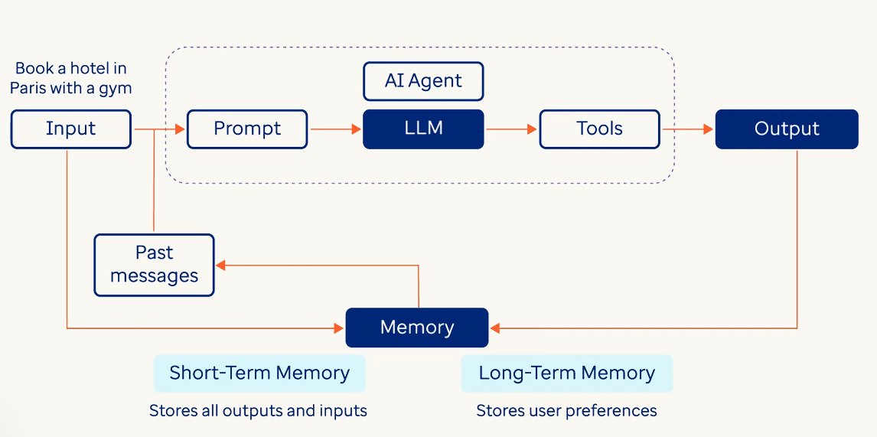

LangGraph uses threads to isolate converstations and each thread has it’s own unique ID and it’s own memory checkpoint pair.Checkpointing acts like a save button. If the system fails it reloads from the last checkpoint 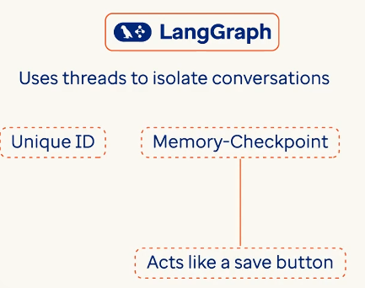

The conversational Agent Graph employs in memory persistence for speed, sotring active threads in RAM. 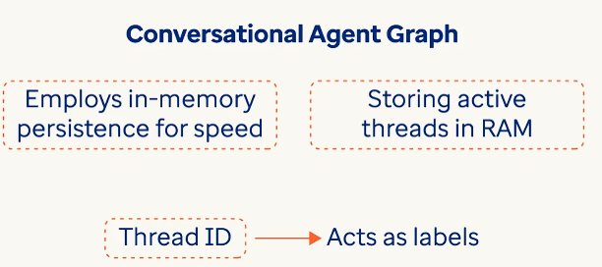 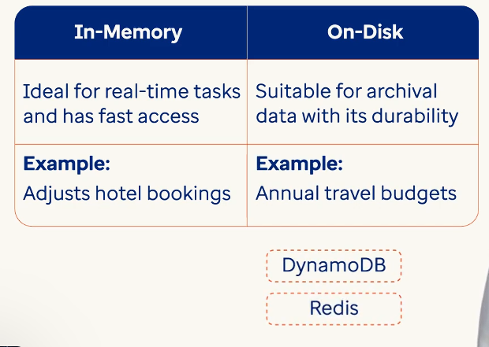

Long conversations strain systems by token overload:storing every message slows responses 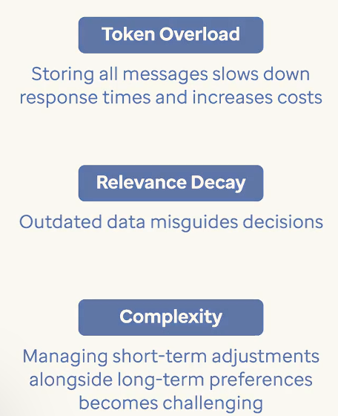

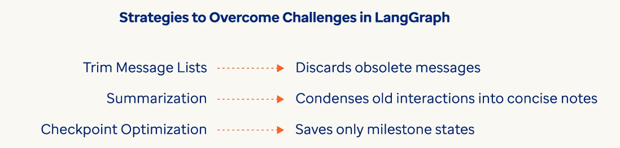

**Best Practices for building Complex Single-Agentic AI system workflows:**

**The Single-Agent Advantage (and Its Trade-offs)**

|  |  |
| --- | --- |
| **Pros** | **Cons** |
| 1. **Simplified Coordination**: Without inter-agent communication overhead, single-agent systems reduce latency and complexity. Imagine a solo project manager handling a campaign versus coordinating a team. 2. **Unified Context**: Maintains end-to-end awareness of user interactions. For instance, a customer support agent tracking a user’s inquiry from complaint to resolution avoids fragmented data. 3. **Easier Auditing**: Debugging and compliance checks are streamlined when all decisions originate from a single entity. | 1. **Scalability Limits**: Handling high-volume parallel tasks (e.g., processing thousands of real-time transactions) strains single-agent resources. 2. **Brittleness**: Over-reliance on one agent risks system-wide failure if critical components malfunction. Additionally, as more tools are added it becomes difficult for the agent to reason and decide which tool calls are needed and in which order. 3. **Limited Expertise**: Single agents may lack depth for highly specialized subtasks (e.g., translating rare languages or detecting niche fraud patterns). |

**Core Design Patterns for Single-Agent Workflows**

To mitigate these challenges, developers blend design patterns that enhance adaptability without sacrificing coherence:

**1. Tool-Use Modularity**

* **Concept**: Equip the agent with a curated toolkit of APIs, databases, and logic modules.
* **Workflow Example**: A financial advisory agent uses separate tools for *portfolio analysis* (SQL queries), *risk modeling* (statistical APIs), and *compliance checks* (rule engines).
* **Why It Works**: Modular tools enable specialization without fragmenting the agent’s decision-making core.

**2. Stateful Planning with Reflection Loops**

* **Concept**: The agent breaks goals into steps, executes them, and iteratively refines strategies based on outcomes.
* **Workflow Example**: For a travel booking request, the agent:

1. *Plans*: Validate dates → check flights → reserve hotels.
2. *Reflects*: If hotels are unavailable, adjust dates or suggest alternatives.

* **Why It Works**: Combines structured planning with adaptive learning.

**3. Hierarchical Memory Management**

* **Concept**: Segment memory into short-term (active session data) and long-term (user history, preferences) layers.
* **Workflow Example**: A retail assistant uses short-term memory to track items in a user’s current cart and long-term memory to recall past purchases for personalized recommendations.
* **Why It Works**: Balances immediacy with persistent context.

**4. Conditional Routing**

* **Concept**: Dynamically pivot workflows based on real-time conditions or user feedback.
* **Workflow Example**: If a user asks, “Cancel my subscription,” the agent routes the request to a retention subroutine if the user is high-value.
* **Why It Works**: Avoids rigid, one-size-fits-all logic.

**Best Practices for Robust Single-Agent Systems**

**1.** **Design Iteratively with Edge Cases**

* **Why**: Single agents face unpredictable scenarios.
* **How**: Test workflows with adversarial inputs (e.g., “Refund an order placed 366 days ago” for a 365-day return policy). Use frameworks like **LangGraph** to simulate state transitions and edge case handling.

**2. Embed Human-in-the-Loop (HITL) Triggers**

* **Why**: Autonomy risks critical errors in high-stakes decisions.
* **How**: Define thresholds for human escalation. For example, flag transactions above $10K for manual review in a fraud detection agent.

**3. Enforce State Schema Discipline**

* **Why**: Poorly structured state data leads to inefficiency.
* **How**: Define a **state schema** early (e.g., UserState with active_session, preferences, transaction_history). Use validators to ensure data integrity.

**4. Optimize Tool Execution Order**

* **Why**: Redundant tool calls waste resources.
* **How**: Chain tools logically. For instance, verify inventory locally before invoking a global warehouse API.

**5. Plan for Graceful Degradation**

* **Why**: Systems fail; recovery mechanisms build trust.
* **How**: If a payment gateway times out, the agent queues the request and notifies the user: “We’re experiencing delays. Your order is safe.”

**Workflow in Action: e-Commerce Customer Support**

Let’s walk through a single-agent workflow for handling product returns:

1. **User Query**: “I need to return a damaged blender.”
2. **State Initialization**: The agent loads the user’s purchase history (long-term memory) and opens a session (short-term memory).
3. **Planning Phase**:

* Validate receipt → check return window → inspect damage claim.

1. **Tool Execution**:

* Use a *receipt validator* tool (database API).
* Trigger a *damage assessment* tool (image analysis API).

1. **Conditional Routing**:

* If valid, route to *refund processor*.
* If invalid, invoke *manual review* and notify the user.

1. **Reflection & Checkpointing**:

* Log the outcome.
* Save progress to resume if interrupted.

**Single agents struggle in**:

* **Complex workflow:**Complex tasks involving a lot of tools which need complex reasoning and to be executed in the right order. For agents that need some tools to be called and then the output of that needs to be fed into other tools in a certain order.
* **Highly Distributed Tasks**: Real-time coordination across geographies (e.g., global inventory sync).
* **Multimodal Workloads**: Simultaneous image, text, and voice processing.
* **Extreme Scale**: Managing millions of concurrent user sessions.

**Best practices for building Complex Multi-Agentic AI System Workflows**

The Promise and pit falls of Multi-Agentic systems:

|  |  |
| --- | --- |
| **Pros** | **Cons** |
| 1. **Specialization**: Agents excel in niche tasks. For example, in a financial trading system, one agent analyzes market trends, another executes trades, and a third monitors compliance. 2. **Scalability**: Workloads distributed across agents. During peak demand (e.g., holiday sales), additional agents scale horizontally to handle order processing or fraud detection. 3. **Fault Tolerance**: Failure in one agent doesn’t cripple the system. If a logistics agent crashes, others continue managing inventory or customer notifications. 4. **Parallel Processing**: Agents tackle interdependent tasks simultaneously. In a media production pipeline, one agent edits video, another generates captions, and a third optimizes streaming quality—all in parallel. | 1. **Coordination Overhead**: Managing communication between agents adds complexity. Misaligned timing or conflicting goals (e.g., two agents updating the same inventory record) risk errors. 2. **Debugging Challenges**: Tracing failures across distributed agents is like finding a needle in a haystack. 3. **Resource Intensity**: Running multiple agents demands significant compute power and memory. 4. **Design Complexity**: Ensuring agents collaborate without bottlenecks or deadlocks requires careful planning. |

**Core Design Patterns for Multi-Agent workflows:**

**To mitigate these challenges, developers rely on proven architectural patterns:**

**1. Supervisor Agents**

* **What: A supervisor agent delegates tasks to worker agents and monitors their output.**
* **Example: In a supply chain system, a supervisor assigns tasks:**
  + ***Agent A* predicts demand.**
  + ***Agent B* sources raw materials.**
  + ***Agent C* schedules production.   
    The supervisor validates outputs (e.g., ensuring production schedules align with demand forecasts) and reroutes tasks if errors occur.**
* **Advantage: Centralized oversight simplifies conflict resolution.**

**2. Network Agents: Each agent can communicate with every other agent. Any agent can decide which agent to call next.**

**3. Supervisor Agent (tool-calling): Special case of supervisor architecture. Individual agents can be represented as tools. The supervisor agent uses a tool-calling LLM to decides which of the agent tools to call and arguments to pass.**

**4. Hierarchical Agents: Multi-agent system with a supervisor of supervisors. This is a generalization of the supervisor architecture and allows for more complex control flows.**

**5. Custom multi-agent workflow: Each agent communicates with only a subset of agents. Parts of the flow are deterministic, and only some agents can decide which other agents to call next.**

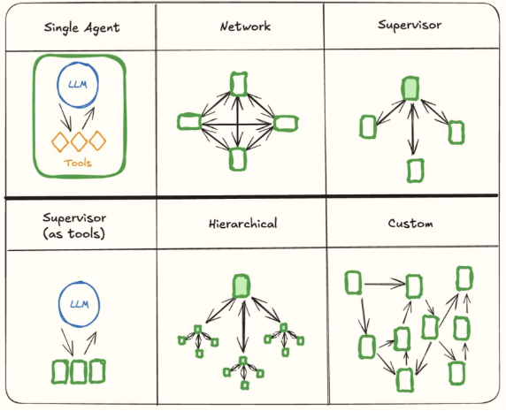

Best Practices for Architecting Multi-Agent systems:

**1. Define Clear Agent Roles and Boundaries**

* **Why**: Overlapping responsibilities cause conflicts.
* **How**: Explicitly scope each agent’s domain. In a fraud detection system:
  + *Fraud Detector*: Flags suspicious transactions.
  + *Risk Assessor*: Calculates risk scores.
  + *Alert Dispatcher*: Notifies human analysts.

**2. Standardize Communication Protocols**

* **Why**: Inconsistent messaging formats derail collaboration.
* **How**: Use frameworks like **LangGraph** to enforce state schemas. For example, agents in a customer support system share data using a standardized format.

**3. Implement Conflict Resolution Mechanisms**

* **Why**: Agents may propose conflicting actions (e.g., two agents trying to allocate the same budget).
* **How**: Use **voting systems** or **priority queues**. In a content moderation system, if one agent flags a post as harmful and another clears it, a third agent arbitrates based on predefined rules.

**4. Design for Observability**

* **Why**: Distributed systems are opaque without monitoring.
* **How**: Integrate logging and tracing tools. Track metrics like:
  + Agent latency.
  + Task completion rates.
  + Conflict frequency.

**5. Use Stateful Checkpointing**

* **Why**: System crashes shouldn’t erase progress.
* **How**: Tools like **LangGraph’s InMemorySaver** periodically save agent states. In an e-commerce system, checkpointing ensures that a payment agent’s transaction log persists even if the system reboots.

**6. Balance Autonomy and Control**

* **Why**: Overly restrictive agents stifle adaptability; overly autonomous ones create chaos.
* **How**: Apply **reinforcement learning** to let agents learn coordination policies. For example, delivery route planners learn to avoid overlapping paths.

Workflow-Example:

Let’s walk through a simplified workflow:

1. **Market Data Aggregator Agent**: Fetches real-time stock prices, news, and social sentiment.
2. **Trend Predictor Agent**: Analyzes data to forecast price movements.
3. **Risk Assessor Agent**: Evaluates potential trades against risk thresholds.
4. **Execution Agent**: Places buy/sell orders on approved trades.
5. **Compliance Agent**: Audits trades for regulatory adherence.

Collaboration Flow:

* The *Market Data Aggregator* updates a shared blackboard.
* The *Trend Predictor* proposes trades, which the *Risk Assessor* validates.
* Approved trades route to the *Execution Agent*, while the *Compliance Agent* monitors in real time.
* If compliance flags an issue, the *Supervisor Agent* halts the trade and triggers an audit.

When to Avoid Multi-agent systems:

Multi-agent frameworks excel in **dynamic, distributed environments** but are overkill for:

* **Simple Tasks**: A single agent suffices for routine data entry.
* **Low-Latency Requirements**: Coordination delays may hinder real-time responses.
* **Resource-Constrained Environments**: Running multiple agents on edge devices strains hardware.

***What Makes Agentic AI Different?***

Agentic AI diverges from conventional rule-based or predictive AI by emphasizing *proactive decision-making* and *adaptive behavior*. Unlike systems that merely follow pre-programmed instructions or analyze historical data, Agentic AI agents:

* **Perceive Context**: Interpret real-time data from diverse sources (e.g., sensors, user inputs, market trends).
* **Make Decisions**: Use reasoning capabilities to choose actions aligned with business goals.
* **Learn Continuously**: Improve performance through feedback loops and environmental interactions.
* **Act Autonomously**: Execute tasks with minimal human intervention while adhering to ethical and operational guardrails.

This autonomy makes Agentic AI ideal for complex workflows like supply chain optimization, customer service, or financial forecasting, where rigid systems struggle to adapt.

***A Step-by-Step Framework for Implementation***

Deploying Agentic AI requires a structured approach to balance innovation with operational stability. Below is a scalable framework business can adopt:

**1. Define the Problem Space**

Start by identifying high-impact areas where autonomy and adaptability add value. Ask:

* **Where are current workflows bottlenecked?** (e.g., slow decision-making in logistics)
* **Which tasks require rapid, context-sensitive responses?** (e.g., fraud detection)
* **What processes suffer from scalability limitations?** (e.g., personalized customer interactions)

*Example*: A retail company struggling with inventory mismatches might target demand forecasting and warehouse management as priority areas.

**2. Design the Agent’s “Personality”**

Agentic AI isn’t a one-size-fits-all solution. Define the agents’:

* **Objectives**: Clear goals (e.g., “Reduce delivery delays by 20%”).
* **Boundaries**: Constraints like budget limits, compliance rules, or ethical guidelines.
* **Interaction Model**: How the agent communicates with humans (e.g., alerts, recommendations, or fully autonomous actions).

This phase ensures the agent operates within a controlled, purpose-driven framework.

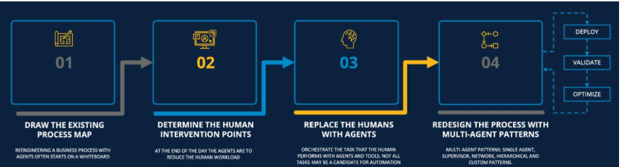

***Build Modular Intelligence***

Agentic AI thrives on modularity. Break down the system into reusable components:

* **Sensors**: Data ingestion tools (APIs, IoT devices) to gather real-time inputs.
* **Reasoning Engine**: Algorithms for decision-making (e.g., reinforcement learning, graph-based analytics).
* **Actuators**: Mechanisms to execute decisions (e.g., automated emails, robotic process automation).

Modular design simplifies updates and allows businesses to scale capabilities incrementally.

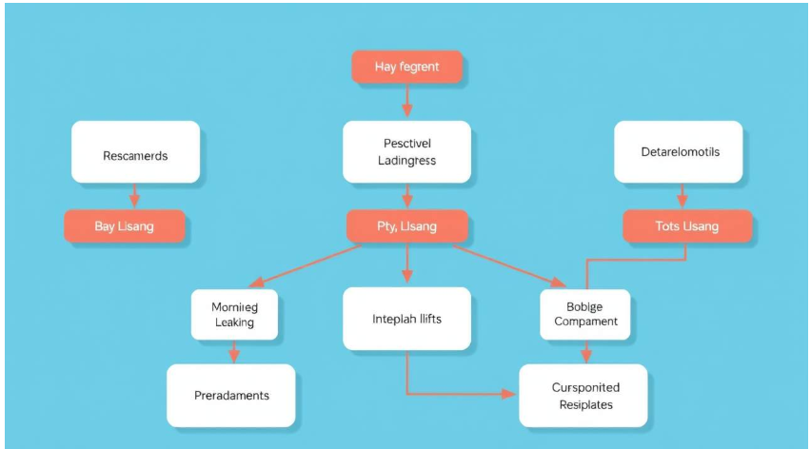

* ***Integrate with Human Workflows***

Agentic AI should augment—not replace—human teams. Strategies include:

* + **Hybrid Decision-Making**: Critical decisions involve human oversight (e.g., approving AI-generated financial strategies).
  + **Explainability Tools**: Provide transparent logs or visualizations to help users trust and validate AI actions.
  + **Feedback Channels**: Allow employees to correct or refine the agent’s behavior (e.g., flagging incorrect inventory orders).

A healthcare provider, for instance, might deploy an Agentic AI to triage patient data but require doctor sign-off on treatment plans.

* ***Implement Continuous Learning Loops***

Static AI grows obsolete; Agentic AI evolves. Embed mechanisms for ongoing improvement:

* + **Reinforcement Learning**: Reward the agent for desirable outcomes (e.g., minimizing energy costs in a smart grid).
  + **Human-in-the-Loop Training**: Use expert feedback to refine decision-making patterns.
  + **Environmental Adaptation**: Adjust algorithms based on shifting conditions (e.g., supply chain disruptions).

*Example*: A customer service agent could learn from resolved tickets to handle nuanced queries more effectively over time.

* ***Monitor and Govern***

Autonomy demands accountability. Establish:

* + **Performance Metrics**: Track KPIs like error rates, response times, or cost savings.
  + **Ethical Safeguards**: Audit for bias, privacy breaches, or unintended consequences.
  + **Fail-Safe Protocols**: Define triggers for human intervention (e.g., system anomalies).

Regular audits ensure the agent remains aligned with organizational values and regulatory requirements.

* ***Overcoming Implementation Challenges***

While promising, Agentic AI adoption comes with hurdles:

* + **Data Quality and Integration**: Agents rely on clean, unified data streams. Invest in data governance and interoperability standards to avoid “garbage in, garbage out” scenarios.
  + **Cultural Resistance**: Employees may distrust autonomous systems. Foster buy-in through training, transparent communication, and involving teams in agent design.
  + **Ethical Risks**: Autonomy can lead to unintended harm. Embed ethical frameworks (e.g., fairness checks) and maintain human oversight for high-stakes decisions.
  + **Scalability Costs**: Start small. Pilot agents in controlled environments before enterprise-wide deployment to manage risks and costs.
* ***Real-World Applications***

Agentic AI is already driving value across sectors:

* + **Healthcare**: Autonomous diagnostic systems analyze patient histories and lab results to suggest treatments, reducing clinician workload.
  + **Manufacturing**: Smart agents predict equipment failures and schedule maintenance, slashing downtime.
  + **Finance**: Fraud detection agents monitor transactions in real time, blocking suspicious activity while minimizing false positives.
* ***The Future of Agentic AI in Business***

As AI matures, Agentic systems will transition from task-specific tools to strategic partners capable of end-to-end process management. Imagine supply chains where AI agents negotiate with suppliers, adjust production schedules, and reroute shipments autonomously—all while collaborating with human supervisors.

To stay competitive, businesses must:

* + **Prioritize Use Cases**: Focus on areas where autonomy delivers measurable ROI.
  + **Invest in Infrastructure**: Build data pipelines, cloud ecosystems, and cybersecurity frameworks to support AI agents.
  + **Cultivate Adaptability**: Embrace a culture of experimentation and continuous learning.
* ***Conclusion***

Agentic AI represents a leap forward in intelligent automation, transforming workflows from static sequences into dynamic, adaptive processes. By following a structured implementation framework—grounded in problem identification, modular design, human collaboration, and ethical governance—businesses can harness this technology to thrive in an increasingly complex world. The key lies in balancing autonomy with control, ensuring AI agents act not as rogue operators but as empowered allies in achieving organizational goals.

As the line between human and machine collaboration blurs, Agentic AI isn’t just a tool; it’s the foundation of tomorrow’s agile, resilient enterprise.